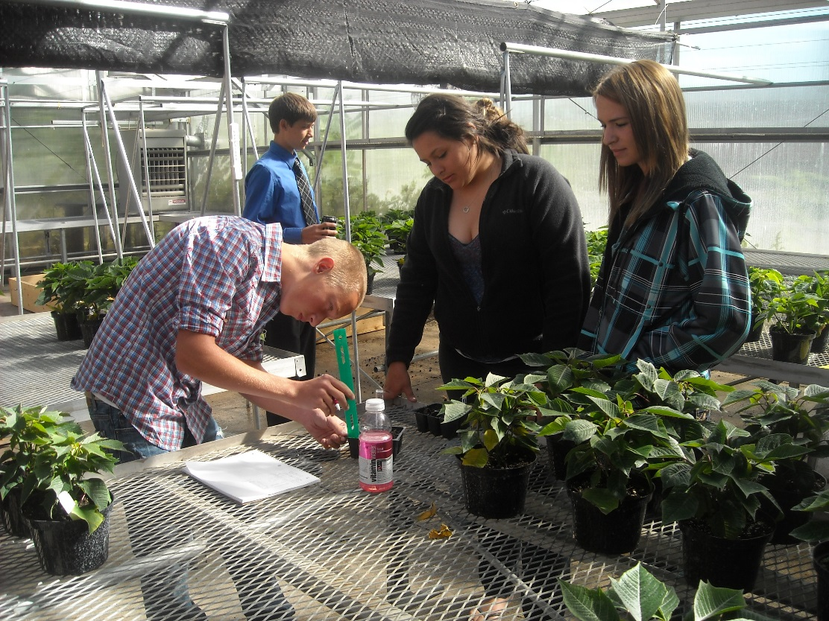 |  | Agricultural Education  - at Waterford Union High School  - January 26th, 2015

Successful Individuals, Vibrant Communities, and a More Sustainable World.
Students at work in the Ag Dept Lab.

What is Agricultural Education?

Waterford has a nationally-renown agricultural education program that incorporates 21st century teaching strategies in order to ensure that students have maximum preparation for college and for their future careers. To understand how and why Waterford has become a national model, it is important that you understand the basic principles of agricultural education.
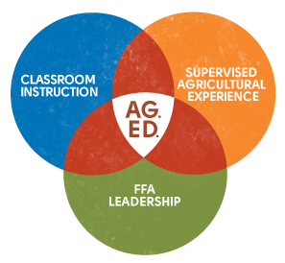
The Three Circle Model
Agricultural Education is composed of three fundamental components. These are:
- Classroom &
Laboratory Instruction.
- Career Experiences
and Preparation.
- Personal Development.
Agricultural education is not just a subject in high school – it is a comprehensive program that is designed to provide students with the education, experiences, and personal development necessary in order to ensure that every student is able to pursue a secure future. Just as a stool needs three legs to stay upright, a student needs a full education with all three components to be fully prepared for college and for careers.
How it Works
In agricultural education, classroom instruction consists of interdisciplinary inquiry-based STEM education in a wide variety of fields that reflect the diversity and technical complexity of the American agriculture industry. From ecology and animal science to marketing and economics to medicine and biotechnology, agricultural education addresses almost every subject taught in the high school using college-level standards to assess student performance.
Classroom and laboratory instruction is augmented by career preparatory experiences. Knowing that the classroom alone cannot fully prepare students for the work place, all agricultural students are expected to gain direct experience in a career through job shadowing, part time work, and entrepreneurial ventures under the supervision of an adult’s guidance. These supervised career experiences are absolutely vital for ensuring that students gain the opportunity to explore careers firsthand before deciding on their post-graduation plans.
Finally we know that students need personal development in order to become effective employees in their future career path and valuable citizens in life. Through opportunities in the National FFA Organization, students gain regular opportunities to grow as individuals and become stronger as leaders.
Through these three components, “ag ed” seeks to create students who are the most prepared for college and for careers.
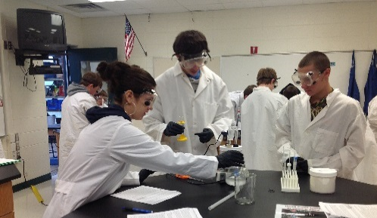
Agricultural Education is Hands-on
In agricultural classes, students learn best when they are forming hypotheses, testing ideas, and collecting evidence to prove or disprove their claims. Most weeks involve a lab, activity, or challenge that requires students to use knowledge, communication, critical thinking, and problem solving skills that they will need in order to succeed in the workplace and in their lives.
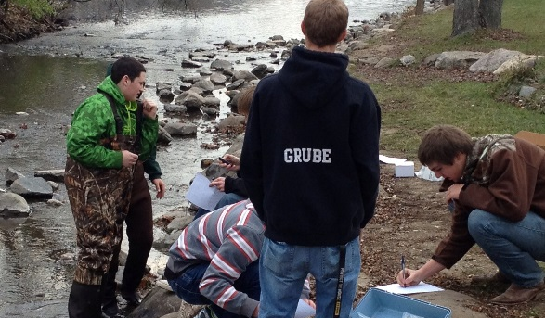
Students assessing the health of the Fox River.
Ag Ed Happens in the Real World
Through each of the three components of agricultural education, students become prepared to apply their knowledge and skills to solve real world problems in their lives and in their careers.
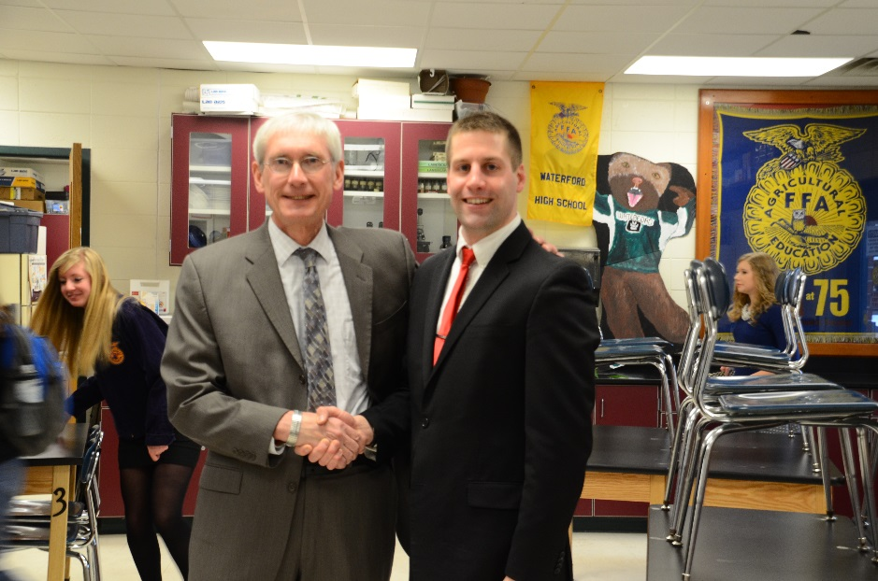
Dr. Evers visits WUHS, Feb. 2014

Waterford’s Impact

Waterford’s Agricultural Sciences Program has had a major impact on agricultural education across Wisconsin and the United States. Some examples include…
- A widely-used curriculum: all of the material used in Waterford’s agricultural courses was written by Craig Kohn to ensure that students are taught the most current material using the most effective, advanced practices. These materials are freely available on the department website and are accessed by thousands of instructors per year across the U.S.

The Future
Waterford Agricultural Sciences aims to continue to have a major impact on agricultural education for years to come by providing the most relevant and rigorous content in its curriculum, by continuing to develop innovative strategies for career exploration and preparation, and by enhancing the manner in which students become more responsible adults and more effective leaders.
To do this, we will need to address the following:
- Shortage of Qualified Instructors: The biggest threat to agricultural education at the local, state, and national level is a shortage of agricultural instructors. Currently we have one instructor for nine courses (of which seven are different classes). State and nationally, the number of instructors leaving the profession is greater than those entering it, and most new instructors do not stay in the profession beyond five years.
- Enhanced Innovation: Increasingly we will need educational programs that blur the line between the school and the community and smoothen the transition from high school to college. To do so, education will have to change to become independent like college and be assessed like the workplace. Learning will have to become more student-centered and student-driven. Data collection from authentic assessments will determine the pace of independent instruction via multiple kinds of media. A 5-day, 8-hour instructional style may have to be replaced by unscheduled student-driven instruction measured by real-world assessments scheduled individually between the student and the teacher.
- Student Professional Development: Students will need opportunities within the high school to gain career preparatory experiences that will prepare them for the career opportunities that they will need outside of the high school before they graduate. These opportunities may also serve as the venue for the kinds of authentic assessment needed to measure the progress of independent instruction. For this to be feasible, schools will need facilities that can enable opportunities that resemble the careers for which students are being prepared.
- Teachers as Trusted Facilitators: Teachers will need to blend traditional teaching with independent instruction and offsite career preparatory experiences in order to create a learning environment that prepares students for all components of their future. For this to be feasible, teachers will need the professional support and development to make independent decisions on a case by case basis based on the needs of their students. These needs will need to be determined through both data collection as well as through fostering deep and meaningful personal relationships with small groups of students in moderately-sized classes.
- State and National Standards: Kohn was on the committee that wrote Wisconsin’s Ag, Food, and Natural Resources (AFNR) academic standards in 2013. Kohn currently serves as a national content expert and is writing the new national AFNR academic standards that will be released later this year.
- Program Innovation: Waterford’s program design is currently serving as a national model for integrating career experience preparation into classroom instruction and FFA participation. Because of his program’s innovative approaches, the National Council for Agricultural Education asked Kohn to serve on the Supervised Agricultural Experience (SAE) Renewal Committee in order to develop this model.
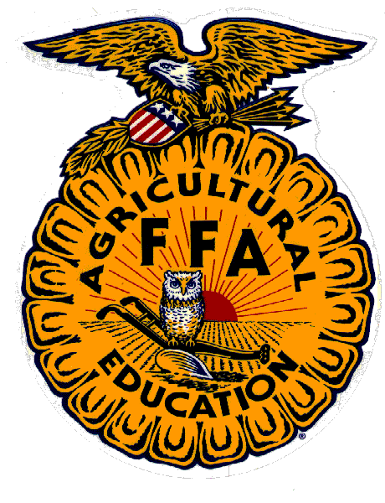
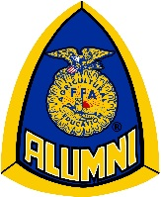
- Excellence in FFA: Waterford has a very strong FFA chapter which has been modeled after a business cooperative. Student members are paid dividends based on their involvement and contribution to fundraisers, similar to returns on investment from a cooperative. A board of directors composed of elected officers hire and manage a team of managers and interns who oversee the day to day operations of the program. In 2014 Waterford was visited by both the National FFA Officers and by State Superintendent Dr. Tony Evers to view the program’s innovative model. Waterford is a current state nominee for program of the year and Kohn received the National Outstanding Young Educator Award from NAAE in 2013. Waterford FFA has competed at the national level in 2011, 2012, and 2013 and remains one of the largest and most active student organizations at Waterford Union High School.

