Goat Mendelian Genetics Worksheet by C Kohn, WUHS
Partner Names: Hour Date:
Date Assignment is due: Why late? Score: + ✓ -
^{Day of Week} ^{Date} If your project was late, describe why
Directions: Complete this lab in your assigned groups of 2. Use Rock, Paper, Scissors to determine the genotype and phenotype of your goat. Each gene mentioned in this lab is a simply inherited trait, meaning every goat has only two alleles for that trait. For each trait, you will play R/P/S twice. Each game of R/P/S represents an allele. The older person will be the “dominant” allele and the younger person will be the “recessive” allele. If the older person wins R/P/S, record it as dominant. If the younger person wins, record it as recessive. Play R/P/S twice for each trait (because each trait has two alleles). Record the phenotype created by the genotype. Finally, draw your goat created by its genotype and phenotype and answer the questions in back.
Traits:
- Horns: Dominant: no horns (polled); Recessive: horns
- Wattle (lobe found on the neck): Dominant: wattle; Recessive: no wattle
- Hair: Dominant: long hair; Recessive: short hair
- Ears: Dominant: long ears; Recessive: short ears
- Behavior: Dominant: Nervous; Recessive: Docile (tame)
- Markings: Dominant: Alpine; Recessive: Solid colored

- Horns: 1st Winner: Dominant recessive 2nd Winner: Dominant recessive
Genotype: HH Hh hh Phenotype:
- Wattle: 1st Winner: Dominant recessive 2nd Winner: Dominant recessive
Genotype: WW Ww ww Phenotype:
- Hair: 1st Winner: Dominant recessive 2nd Winner: Dominant recessive
Genotype: LL Ll ll Phenotype:
- Ears: 1st Winner: Dominant recessive 2nd Winner: Dominant recessive
Genotype: EE Ee ee Phenotype:
- Behavior: 1st Winner: Dominant recessive 2nd Winner: Dominant recessive
Genotype: BB Bb bb Phenotype:
- Markings: 1st Winner: Dominant recessive 2nd Winner: Dominant recessive
Genotype: MM Mm mm Phenotype:
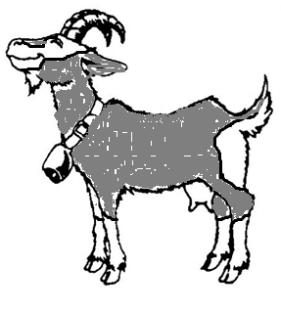
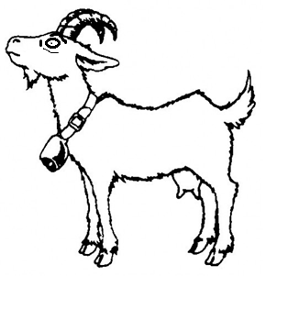
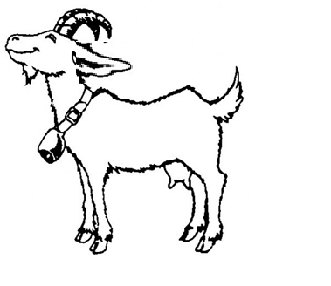
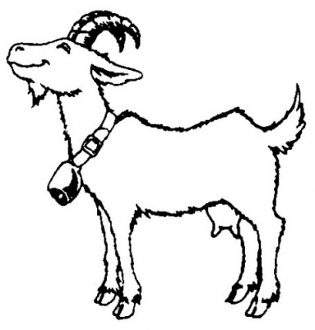
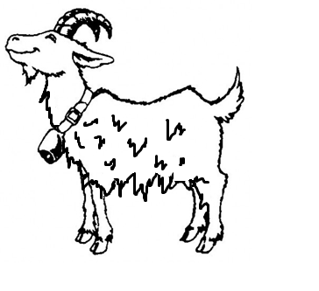
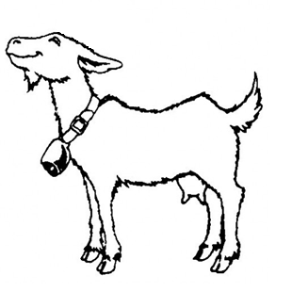
No horns (polled) is
dominant to horns
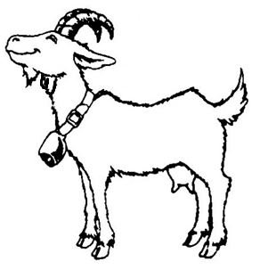
Long ears are dominant to short ears
Wattle (on neck) is
dominant to no wattle
Long hair is
dominant to short hair
Alpine markings are dominant to solid color
Nervous behavior is dominant to docile behavior
- Describe your goat before based on the six traits you flipped for.
_
_
_
_
_
_
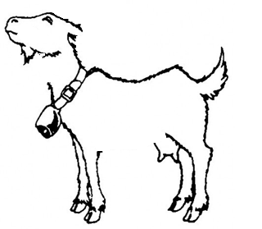
- Draw your goat below.

- Next, identify three traits that you think are most valuable in your goats and list them below:
Trait_
Trait _
Trait _
NOTE: these can be any of the six traits; for example, if your goats are docile, this might help them to sell as pets. If your goats have long hair, they might sell well for making fabrics. Pick three traits that make your goats the most valuable for production traits or sale value.
- After each trait above, state whether it is dominant or recessive.
- Next, choose another person’s goat to mate with. List the genotypes and phenotypes for your goat’s mate below for all six traits:
Phenotype_ Genotype
Phenotype_ Genotype
Phenotype_ Genotype
Phenotype_ Genotype
Phenotype_ Genotype
Phenotype_ Genotype
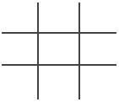
- In the space below, do a Punnett Square for the three traits you chose above. Use the genotype of your goat and the genotype of the mate of your goat (a goat from another group).
- In the space below, describe what the offspring of your goat pair will most likely look like.
_
_

