Marketing Unit Project by C. Kohn, Waterford WI
Partner Names: Hour Date:
Date Assignment is due: Why late? Score: + ✓ -
If your project was late, describe why
+ = exceeded expectations. ✓= expectations were met but not exceeded. - = redo assignment
In this project you will create a marketing plan for a hypothetical product or service. While the product or service is hypothetical, you should focus on a product or service that is realistic for someone in high school (or recently out of high school) to sell. A roadside vegetable stand, lawn-mowing service, or pet-sitting service are realistic options for a teenager. A brand of soda, athletic shoes, or automobiles are probably not realistic options for a teenager to sell.

You will be working with a partner of your choice on this project. Be aware that you will each get the same grade, so be sure that you and your partner are communicating and checking each other’s work for consistency and quality.

While many factors will be considered for grading, the primary factor will be whether or not your instructor is convinced to purchase your product or service. In other words, your ability to sell your product through targeted marketing strategies and effective use of the Four P’s will be the primary determinant of your final grade.

Treat this product or service as if it were your sole source of income. This means that you would have to have enough customers and sales income to earn a living wage.

- Describe the product or service that you intend to sell:
- Which of the following pricing strategies will you use? a. Cost-plus b. Value-based c. Competitive d. Going-Rate e. Skimming f. Discount g. Loss-leader h. Psychological. List all that apply:
- Why did you choose this pricing strategy? Justify your choice:

- How will you distribute your product or service? Direct sales or retail (Intensive Distribution, Selective Distribution, or Exclusive Distribution)? List all that apply:

- Why did you choose this distribution strategy? Justify your choice:
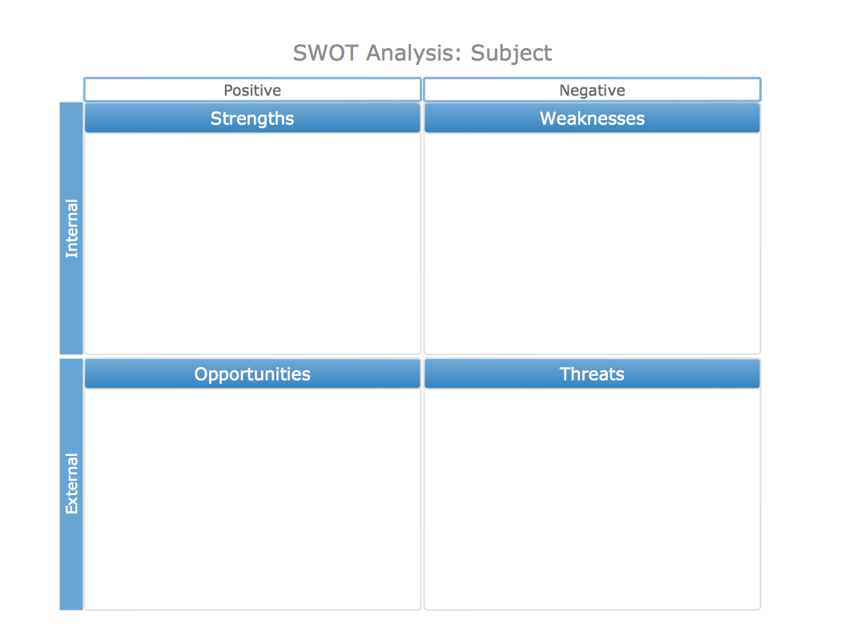
- Perform a SWOT Analysis in the area below for your product or service.
- How will you utilize your product’s strengths most effectively?
- How do you fix or negate the weaknesses of your product?
- How will you capitalize on the opportunities that exist to sell your product?
- How will you prevent or negate the threats to the sales of your product?
- In the space below, describe four kinds of people who would be most likely to buy your product or service.
Type One – General Description:
Specifics (geographics, demographics, psychographics, behavioral, benefits sought):
Type Two – General Description:
Specifics (geographics, demographics, psychographics, behavioral, benefits sought):

Type Three – General Description:
Specifics (geographics, demographics, psychographics, behavioral, benefits sought):
- Of the three types you described, which do you think is most likely to purchase from you?
Type: . Why is this group more likely to buy from you than any other?
- Answer the following: Is this specific group… (NOTE: do not use this group unless you know it is ‘YES' for all).
  - Measurable and specific – are you able to tell who is a part of this segment and who is not?
Explain:
  - Able to be reached by your available methods of communication? Explain:
  - Relatively steady, stable, and unchanging? Explain:
  - Sizeable enough to be profitable? Explain:
  - Able to participate - do customers must have the money and willingness to buy the good or service offered?
Explain:

- What are the Unique Selling Points (or Points of Differentiation) for your product that are specific and appealing to this particular market segment? Consider product quality, convenience, customer values, cost, service, etc. What can you provide with your product bundle that no one else can to the same extent?
USP 1:
USP 2:
USP 3:
USP 4:
- Why is your product better for this group than all other similar products? Explain by comparing your product to your most likely competitors:
Your closest competitor (describe that competitor):
Why yours is better for your target market:
A second competitor (describe that competitor):
Why yours is better for your target market:
A third competitor (describe that competitor):
Why yours is better for your target market:
- Write a position statement in the space below. The standard formula for a position statement is:
For [describe target market], the [product] is the [unique selling point(s)] because [reason why your product is the best for this group].
E.g. For World Wide Web users who enjoy books, Amazon.com is a retail bookseller that provides instant access to over 1.1 million books. Unlike traditional book retailers, Amazon.com provides a combination of extraordinary convenience, low prices, and comprehensive selection.
For our
- Describe your positioning strategy in the space below. How will you acquire a sizeable portion of your target market in order to make your operation profitable?
- What is your vision statement? A vision statement is a one-sentence description of what you want your company to become in the future based on the needs of your targeted market segment and your company’s unique abilities. It should be designed to be specific to the unmet needs of your target market.
- What is your mission statement? A mission statement defines the purpose of a company. Mission statements for a business should address the following: 1) What are the specific market needs the company exists to address? 2) What does the company do to address these needs? 3) What are the guiding principles that define the company's approach? 4) Why do customers buy from you and not your competition?
- What will you call your product or service?
- What is your product or service’s slogan?
- In the space to the right,
create a logo for your
product.
If you would prefer to
design your logo digitally,
attach a printout of the
logo to this packet and
write a note on the right
stating that the logo is
attached.
- How will you advertise your product, and why is this method of advertisement most appropriate for your target market?
- What kind of advertising will you use? Retail, end-product, direct response, trade, industrial, professional, or nonproduct advertising? Why?

- How will you create a favorable impression of your company through public relations?

- How will you provide a level of customer service that encourages your customers to feel at ease and want to make additional purchases in the future?
- Briefly describe how your strategies as a business owner will work in each of the following stages:
Pioneering:
Competitive:
Retentive:
- What fixed costs will you have? Fixed costs are what you’d have to purchase before you can purchase any saleable products. List and estimate the costs below. Use a search engine if needed to gain an idea of what that item may cost (e.g. a search engine may help you to determine the cost to rent a building or purchase machinery if it is needed for sales).
Total estimated fixed costs: $

- What variable costs do you have? Variable costs are the items you need to sell each individual product and increase as you sell more of that product. For example, if you are producing a product to sell, the variable costs would include the materials needed to purchase the product. If you are mowing lawns, the lawn mower would be a fixed cost but the fuel would be a variable cost. Do not include labor costs yet – that is the next question.
Total estimated variable costs: $
- How much will you spend on labor, including yourself? You may want to focus on the cost of labor per unit of product or service to keep it consistent. Remember, labor is a variable cost as well.
Total estimated labor costs: $ per
- For how much will you sell your product or service? $ per
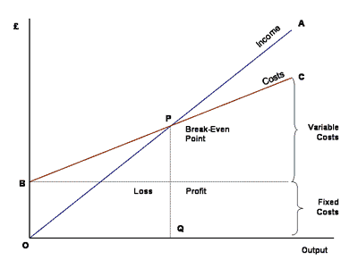
- Graph the cost selling this product on the next page. An example graph is shown to the right.
Your cost line should leave the y-axis at the value of the total fixed cost. On this graph at the right, this is shown at “B”. This line should increase by the total variable cost.
Also include the brackets on the right showing your variable costs and fixed costs. You will add your income line later.
HINT: use a ruler to draw your lines so they are straight - this will help you determine your breakeven point.
$

- How much of your product or service do you need to sell to be profitable based on your graph?
- If your goal was to make $40,000 per year, how much of your product or service would you have to sell per year to have this income. Remember, this is based on net profit (profit after expenses), not gross profit (total profit).
- Is your answer above feasible? Or is it unlikely that you could sell this much in a year. Explain:
- How will your product or service be perceived in comparison to your competitors? What will potential customers perceive that is different AND better about your particular product or service?
- What benefits does your product provide beyond the product itself? This could include performance, social image, trustworthiness, general recognition, or its ability to be substituted by another product (or lack thereof).
- What can you do to make sure that your customers will demonstrate brand loyalty and always choose your product over the competition even if prices change, options are different, or the competition is able to provide additional benefits?

