Agriscience

“Why does Waterford have an Agricultural Sciences Department?”
You might wonder why a high school might have agriculture classes After all, most students do not become farmers or ranchers after high school.
Agricultural Sciences is about the use of science, business, and technology to solve problems and make the world a better place.
Agricultural Sciences students are trained to be the leaders of tomorrow, using their skills to find solutions to many of our most pressing issues, including nutrition, medicine, ecology, and biotechnology.
Ag courses are a proven way to help students raise their test scores and increase their likelihood of college acceptance.
Why Ag? Because it will train you to be a better student, let you learn in a fun environment, and help get you into college!

A real education for the real world.

Wouldn’t it be great if there was a course that would allow students to simply explore the natural world, where they could work in teams to discover solutions to real-world problems in a hands-on environment?
At Waterford Union High School, such a class actually exists! Open to freshmen through seniors, Agriscience is an elective that enables students to explore scientific topics at their own pace in a hands-on, engaging laboratory setting. With a student-centered atmosphere, Agriscience is highly popular among students who have been a part of the course. So why should a student enroll in Agriscience? Because…
71%

of students in the class ranked Agriscience as one of their best courses at WUHS!

- It’s fun! We experiment with real ideas using living plants and animals. This is hands-on learning at its finest! We use real live organisms to learn, including radishes, microorganisms, Tiffany the Cat, live cattle, and more.
- It will help you get better grades! Agriscience is taught by the Waterford’s ACT Science Prep instructor and reinforces concepts universal to all science classes at a pace set by the students. Test taking strategies, writing skills, and classroom success are actively included into the curriculum. This course is also aligned to state and national standards in biology, agriculture, and environmental science. Communications, mathematics, and group work are heavily emphasized.
- You get to discover issues and topics not covered in any other subject! From biofuels to cloning, from genetic engineering to cellular biology, Agriscience is on the cutting edge of science and technology, keeping pace with the latest breakthroughs and advancements. Agriscience is taught by an instructor with real-world scientific experience in medicine, ecology, and biotechnology, and all students leave Agriscience with a strong ability to conduct and assess scientific research.
- WHS Agricultural Sciences has received state and national recognition as a leader in education. Waterford Ag Dept. has state and national recognition as an example of high school instruction at its best. Mr. Kohn was recognized as the 2011 Agriscience Teacher of the Year and is also on the State & National Committee for Agriculture and Natural Resources Academic Standards. In 2012 he was named a Kohl Fellowship Winner (a top honor for teachers in Wisconsin) and in 2013 Kohn was named a national Ag Ed Outstanding Young Educator. In 2014 Kohn was named as one of the Top 40 professionals under 40 in the industry.
Enter a world of discovery right here at Waterford Union High School with Agriscience!
S
o what do students actually do in Agriscience? Beginning with learning how to conduct experiments, Agriscience students design an experiment and explore it for weeks. They learn how the carbon cycle, photosynthesis, and respiration affect their lives and consider the nature of science as it affects society. They work in the greenhouse, conduct field experiments, test ideas in the lab, and discover the meaning of science for their lives. They write scientific papers and learn how to analyze data and graphs. They become scientists in every way while learning real job skills.
How would Agricultural Science Classes Prepare Me for a Career?
As part of Career & Technical Education, Agricultural Science courses exist in part to provide students with preparation for future careers. Agriscience serves as the prerequisite for all of the courses below.
Students with an interest in a medical field would be highly encouraged to take Veterinary Pet Care and Large Animal Veterinary Science. Both courses are largely focused on physiology and medical techniques (such as sutures and injections).
Students with an interest in the environmental science should consider taking Natural Resources – ES.
Due to its design and drafting nature, students with an interest in engineering, architecture, or design should consider Landscape Design.
Students with an interest in science, technology, or research should consider Biotechnology – a research-oriented laboratory class based on renewable energy.
Science credit is also available for some courses, including Home Gardening & Horticulture - ES as well as Natural Resources - ES.

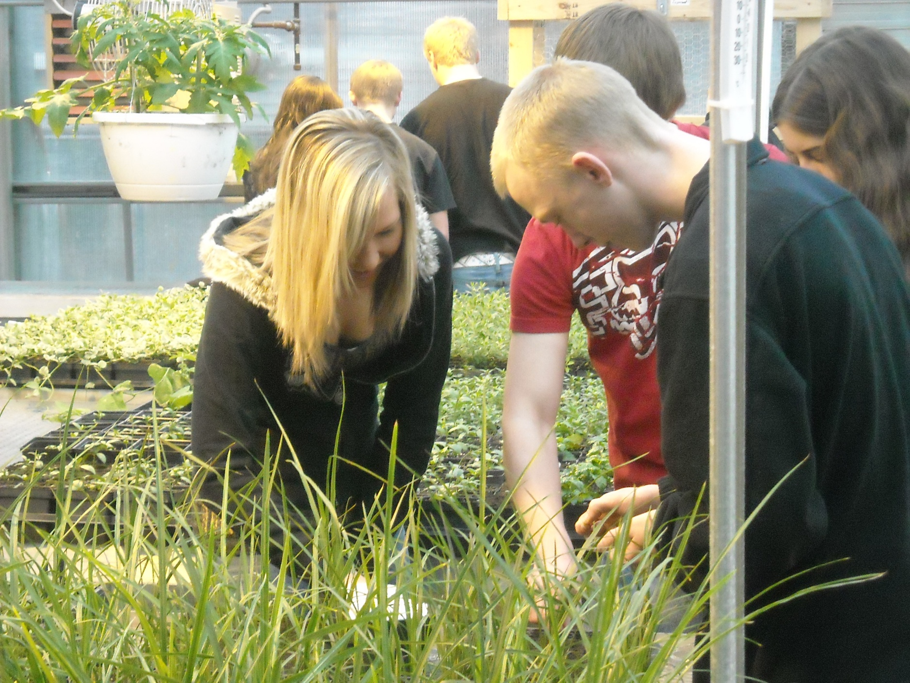
In the second semester, Agriscience students explore the role that DNA plays in our lives. They explore their genetics with animal examples, test the impact of drugs on living organisms, run enzyme and DNA testing for diseases, prove or disprove paternity cases, solve murders using DNA fingerprints, predict the genetic potential of offspring, and debate the ethics of stem cells, cloning, and genetically modified organisms.
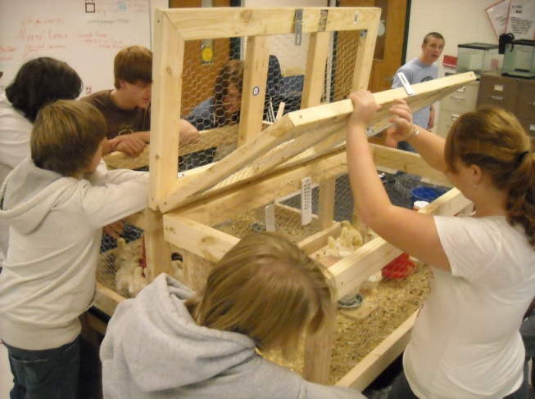
Students are also encouraged to take their research outside the classroom. Agriscience students have won grants worth thousands of dollars to pursue their ideas even further than a typical class period would allow. Recent student-led research projects involve topics including ethanol, the impact of some drugs on cellular biology, biodiesel from waste vegetable oil, drought-resistant crops, climate change, and conservation science.
Simply put, an Agriscience student will be more likely to achieve higher grades, be better prepared for careers, and understand the process of science at a much deeper level.
For more information, contact Mr. Kohn at ckohn@waterforduhs.k12.wi.us or visit wuhsag.weebly.com . You can also call at 262-534-3189 ext. 7309 or visit Rm 209!

