Fall 2013 Agriscience Final Exam by C. Kohn, Waterford WI
Name: Hour Date: Score:
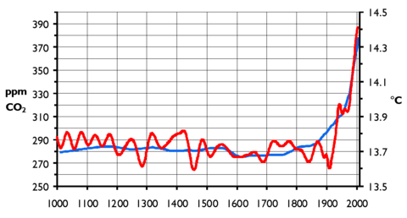
The smoother, straighter line shows carbon dioxide (measured in parts per million, or ppm). The more erratic, wiggly line shows temperature (measured in Cº). The x-axis shows years from 1000 AD to 2000 AD.

- Create a caption for the graph above in the space below.
In this graph, you can see
_
This indicates that
_
_
- What is the carbon cycle?
_
- How is this graph related to the carbon cycle?
_
_
_
- Scientists predict that CO₂ levels would have to be reduced to half of their levels in 2000 to prevent
serious damage from climate change. If this is true, to what levels would CO₂ have to be reduced to?
The graph above is the result of a respiration experiment. A predetermined amount of yeast and water were added to a balloon. Once the yeast had been reactivated, a type of carbohydrate was added. Each balloon contained the same amount of yeast, water, and carbohydrate. This experiment was repeated 3 times per type of carbohydrate.
Type I was table sugar (sucrose – glucose bonded to fructose). Type II was pure glucose. Type III was fruit sugar (fructose). Type IV was potato starch. Type V was whole wheat flour.
Once the carbohydrate was added, the balloon’s circumference was measured at 30 minutes, 60 minutes, 90 minutes, and 120 minutes. The results are shown in the graph and table above. Use this information to answer the following questions. Use this information to answer the following questions.
- What molecule caused the balloons to inflate?
- What does it indicate if one kind of carbohydrate caused the balloon to inflate more than the other kinds of carbohydrates?
- Based on this data, which kind of carbohydrate caused the greatest inflation?
- Create a hypothesis that would explain why this type of carbohydrate would have this kind of impact on cellular respiration:
- Given this data, how do you think the amount and/or availability of hydrogen atoms on wheat flour is different from the amount and/or availability of hydrogen in sucrose?
- Below, defend your answer with evidence and what you know about carbohydrates, respiration, and hydrogen:
- How does this information relate to the production and/or use of ATP?
- How might this information be valuable to a pig farmer?
- How might this information be valuable to a nutritionist?
Use the passage above to answer the following questions:
- How is C4 photosynthesis different from C3 photosynthesis?
- What is a legume?
- What would be the advantage of creating a C4 legume?
- Do you agree with Mr. Gupta? Given that all legumes are C3 plants, would they grow in all conditions? Explain:
A research group is trying to determine how the rate of application of fertilizer affects the amount of corn produced in a field. The researchers tested different application rates of two kinds of nutrients: nitrogen and phosphorus.
When 0 lbs of nitrogen were applied, the average yield of corn was 156 bushels per acre. When 10-20 lbs of nitrogen was applied per acre, the corn yielded an average of 168 bushels per acre. When 30-40 lbs of nitrogen was applied per acre, the corn yielded an average of 177 bushels per acre. When 60 lbs of nitrogen was applied per acre, the corn yielded 175 bushels per acre.
The researchers also tested different rates of phosphate application. When 0 lbs of phosphate was applied, the corn yielded an average of 166 bushels per acre. When 10-20 lbs of phosphate was applied per acre, the corn yielded an average of 172 bushels per acre. When 30-40 lbs of phosphate was applied per acre, the corn yielded an average of 169 bushels per acre. When 60 lbs of phosphate was applied per acre, the corn yielded 171 bushels per acre.
- Create a graph based on the information above on the opposite side of this sheet.
  - Be sure to label all axes and types of data.
  - Be sure to include a caption for this graph. A title is not needed if the graph has a caption.
- In the space below, write a hypothesis that could be applicable to this research experiment.
- In the space below, write a rationale for this hypothesis:
- Based on this research, what would have the most impact on the
productivity of a corn field, a shortage of nitrogen or a shortage of phosphate?
Explain:
- Assume that the error bars for the 30-40 lb. application results and the 60 lb. application results overlapped for both nutrients. What would this indicate about the benefits of applying 60 lbs. compared to applying 30 lbs.

