Drafting Notesheet – Landscape Design by C. Kohn
Name: Hour Date:
Date Assignment is due: Why late? Score: + ✓ -
^{Day of Week} ^{Date} If your project was late, describe why
Directions: Use the accompanying PowerPoint (available online) to complete this sheet. This sheet will be due upon the completion of the PowerPoint in class. These assignments are graded on a +/✓/- scale.
- What is the purpose of drafting?
- Without the ability to draft your ideas on paper, there is no way for a designer to show
- What if you are just a homeowner designing your own personal project? Do you still need drafting?
Explain:
- Without skills and abilities in regards to drafting, there is a minimal likelihood that you’ll be able to
- Summarize the four steps of drafting in the spaces below:
1
2
3
Step 3 also includes:
4
- Summarize what occurs in the program development step:
- During this step, the focus is on
and primarily consists of
- True or false: this step usually includes drawings: Explain:
- What is a “bubble diagram” and how can it help in this stage?
- What happens in the inventory and analysis stage?
- Inventory involves recording the (
involving a such as )
- Site analysis involves the , which could include
- True or false: inventory and analysis usually includes drawings: Explain:
- What will these drawings look like?
- Design development tends to entail
and can be broken into :
- Conceptual Design is where
- True or false: conceptual designs are usually pretty detailed and accurate. Explain:
- Who is meant to see the conceptual design, the designer, the customer, or both?
- The conceptual design can be very ; even with
can suffice in this stage. The key is that the designer uses the conceptual design
to
- Preliminary design is where
- It is as this stage that the designer begins to choose
- It is typically at this stage that the designer makers
- What if the client does not like the presentation made at this stage? What should the designer do?
- Obtaining honest feedback from their client is vital at this stage to
should the client
- True or false: preliminary designs are usually pretty detailed and accurate. Explain:
- The presentation should be and
should include a ( )
- True or false: preliminary designs are detailed enough that the need for text is minimal or nonexistent.
- Construction documentation is the step in which the ideas are finalized into documents that will
- True or false: changes should not occur in the construction documentation stage. Explain:
- The purpose of the documents created during the construction documentation is to provide
- Fill in the blank with the step that is most reflective of that description. Use each of the following once: program development, inventory & analysis, design development, preliminary design, conceptual design, and construction documentation.
A rough design seen only by the designer that is used to stimulate creativity.
This is the phase in which the designer researches the property and owners.
The ideas from the conceptual design become shaped by constraints & themes.
The finalized documents that provide the specifics for the construction of the site.
This can be broken into two steps: conceptual design and preliminary design.
Information is gathered about the physical characteristics of site (soils, views, etc.)
- For each image, record below whether it is for Inventory & Analysis, Bubble Design (Program Development or Conceptual Design), Preliminary Design, or Construction Documentation.
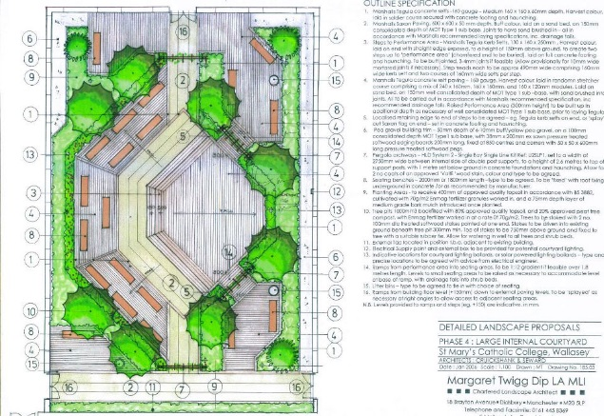
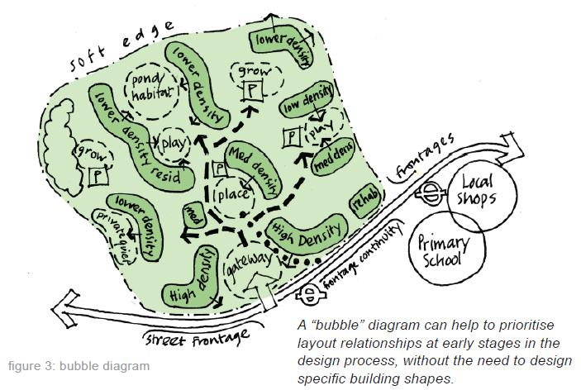
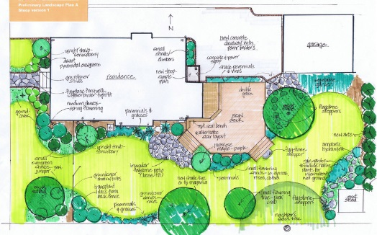
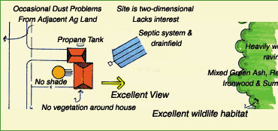

- What is CADD?
- If most modern landscapes are created using CADD, why should you learn manual drafting skills? List 3 reasons:
- Briefly summarize the four main kinds of pencil lead:
HB Soft:
H medium:
2H to medium hard:
4H Hard:
- Summarize the purpose of each tool:
T-square:
Triangle:
Compass:
French Curve:
Template:
Kneaded Eraser:
Erasing Shield:
Drafting Brush:
Scales:
Drafting Tape:
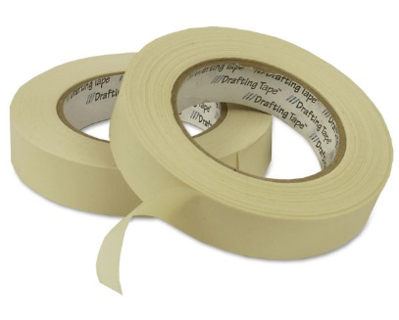
- Identify each of the following by writing its name below the picture of it:
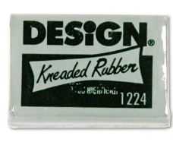
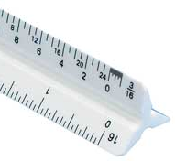
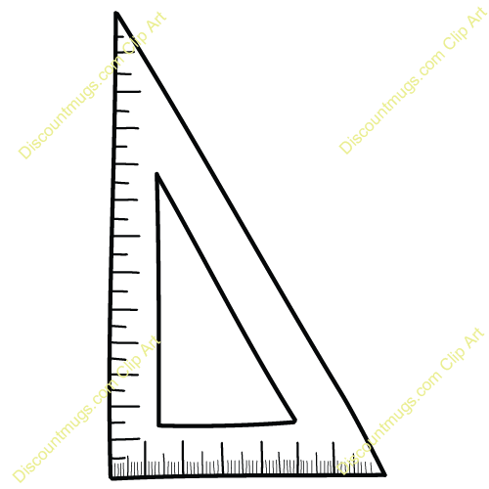
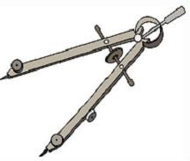
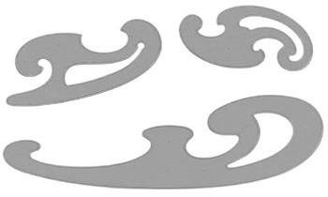
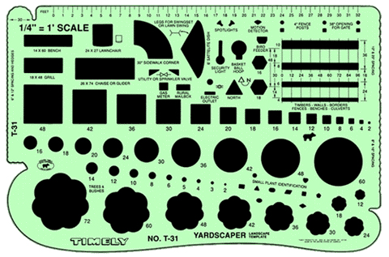
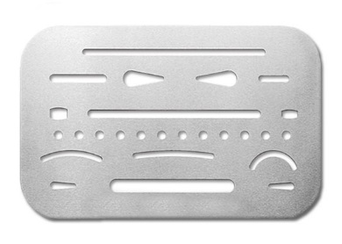
- List and summarize the three keys to creating high quality lines:
1
2
3
- List the six steps of drawing a high quality line:
1
2
3
4
5
6
- True or false: the pencil should always be held at a 90º angle to the paper in all directions.
Explain:
- True or false: when connecting lines, you want to avoid weak corners, so it is important that you have excessive overlap.
Explain:
- The density and weight of a line should be
- Drafted lines should have a as if
- Avoid drawing lines as a series of
- All lines should at the corners.
- When starting a design, it is best to begin with your and then
- Use for the arcs and for the straight lines. Why?
- Finally your lines once you are sure they are and add
- Landscape drawings should include if they will be used in a
- What is a title block?
- This information includes the
- This helps the designer and viewer orient their eyes .
- North indicators are usually just a
- The north indicator should always be near the .
- What does a scale indicator do?
- The scale is expressed as either
- There are three options for the scale:
- Architects’ scales are written as a
- Engineers’ scales are written with
- A metric scale is written with
- Provide an example of each kind of scale. Architect’s:
Engineer’s: Metric:

Unit Wrap-up C. Kohn, Agricultural Sciences - Waterford WI
This page is designed to help raise your grade while enabling you to develop skills you will need for after high
school. You will need to complete every question and blank in order to receive full credit for your notes. Note: if you cannot come up with a strategy to remember a difficult concept on your own, see your instructor for help.
- What is a topic or concept from this unit that you found to be more challenging? Write or describe below:
In the space below, create a mnemonic, rhyme, analogy, or other strategy to help you remember this particular concept:
- What is a 2nd topic or concept from this unit that you found to be more challenging? Write or describe below:
In the space below, create a mnemonic, rhyme, analogy, or other strategy to help you remember this particular concept:
- What is a 3rd topic or concept from this unit that you found to be more challenging? Write or describe below:
In the space below, create a mnemonic, rhyme, analogy, or other strategy to help you remember this particular concept:
- Circle the most appropriate response. You will only be graded on whether or not you completed this section, so be entirely honest with yourself when completing this section.
Circle one: I used my notes outside of class to prepare for the quiz. Definitely – Yes – Sort of - No
Circle one: I took extra notes in the margins for very difficult concepts. Definitely – Yes – Sort of - No
Circle one: I created a personal strategy for at least three difficult items. Definitely – Yes – Sort of - No
Circle one: I was very involved and actively studying during the quiz review. Definitely – Yes – Sort of - No
Circle one: I think I will be satisfied with the quiz grade I received this week. Definitely – Yes – Sort of - No
Circle one: I might need to meet with the instructor outside of class. Definitely – Yes – Sort of - No

