Carbon Molecule Modeling Lab by C. Kohn
Name: Hour Date:
Date Assignment is due: end of class Why late? Score: + ✓ -
^{Day of Week} ^{Date} If your project was late, describe why
Directions: In this lab, you will be using the Play-doh to create the atomic structures of carbon dioxide, water, and a sugar molecule. To do so, you will need to create the following:
- For carbon dioxide (CO₂)
  - Two balls of the same color to represent oxygen atoms
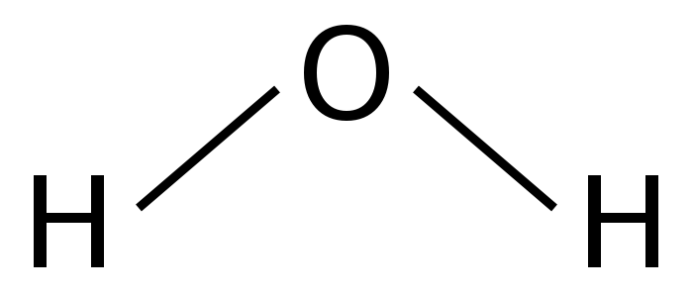
  - One ball of a different color to represent a carbon atom
- For water (H₂O)
  - Two balls of a third color to represent hydrogen atoms
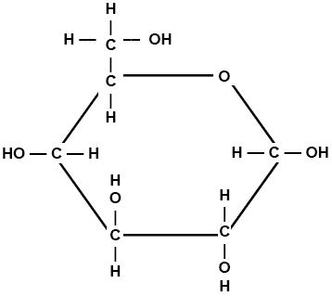
  - One ball of a different color to represent an oxygen atom (use the same color for oxygen as you did for carbon dioxide)
- For a sugar molecule (C₆H₁₂O₆)
  - Using the same color as you used previously for oxygen, create six balls of that color for the 6 oxygen molecules
  - Using the same color as you used previously for carbon, create six balls of that color for the 6 carbon atoms
  - Using the same color as you used previously for hydrogen, create 12 balls of that color for the 12 hydrogen atoms
  - Note: all carbon atoms should have 4 toothpicks attached. All oxygen atoms should have 2 toothpicks attached. All hydrogen atoms should only have one toothpick each.
Using the pictures of each molecule as a guide, create each molecule out of the Play-doh atoms that you created. Use the toothpicks to represent the bonds between each atom in the molecule. Hint: when making a sugar molecule, it is easier if you start by making the 5-carbon/1-oxygen ring and then add the side-chains
When you think you have successfully created both molecules, raise your hand and show your instructor. While you are waiting for their approval and after they give their approval, complete the questions on the back.

Questions:
Each of the following questions below will relate to at least one the molecules that you created for this lab on the opposite page.
- Which form of carbon exists as a gas in the atmosphere? Write the molecules formula and name below.
Molecule Name: carbon dioxide Molecular Formula:
- Which form of carbon exists as a solid? Write the molecules formula and name below.
Molecule Name: Molecular Formula: C₆H₁₂O₆
- What 2 molecules are used to create a sugar molecule? Write their names and formulas below:
1. Molecule Name: Molecular Formula:
2. Molecule Name: Molecular Formula:
- What 2 molecules does sugar become when it is digested or decomposed? Write their names and formulas below:
1. Molecule Name: Molecular Formula:
2. Molecule Name: Molecular Formula:
- If sugar is not decomposed, digested, or burned, what will happen to it?
- In the space below, draw a picture showing how the carbon cycle works. Be sure to include the following: a) carbon dioxide; b) water; c) a plant; d) soil (in which the plant is rooted); e) an herbivore that eats the plant; f) decomposers breaking down the plant; g) arrows showing the absorption or release of carbon dioxide.

Teacher’s Note: having radish seedlings growing in a wet sponge is an excellent way to show that plants only need CO₂ and H₂O and sunlight to create sugars (add some very diluted fertilizer to keep the plants healthy).

