Practice LD Midterm by C. Kohn, Waterford WI
Name: Hour Date:
- The Elements of Design are important to landscaping because…
  - Everyone in the industry has agreed to the kind of landscaping that is best.
  - A landscape needs to meet most of the six principles in order to be functional and appealing.
  - If even one element is misused, a landscape will seem poorly designed and will be unappealing.
  - All of the above.
  - None of the above.
- This is line.
  - The sense that a landscape is three-dimensional and draws your eye into the landscape.
  - The element that guides your eye and guides you where to look.
  - This consists of hue, value, and intensity and helps to emphasize, complement, heighten the effect of, or disguise other aspects of a landscape’s design.
  - The element that refers to the use of cubes, spheres, pyramids, cylinders, cones, etc.
  - This is the visual ‘feel’ of a substance.
- This is form.
  - The sense that a landscape is three-dimensional and draws your eye into the landscape.
  - The element that guides your eye and guides you where to look.
  - This consists of hue, value, and intensity and helps to emphasize, complement, heighten the effect of, or disguise other aspects of a landscape’s design.
  - The element that refers to the use of cubes, spheres, pyramids, cylinders, cones, etc.
  - This is the visual ‘feel’ of a substance.
- This is space.
  - The sense that a landscape is three-dimensional and draws your eye into the landscape.
  - The element that guides your eye and guides you where to look.
  - This consists of hue, value, and intensity and helps to emphasize, complement, heighten the effect of, or disguise other aspects of a landscape’s design.
  - The element that refers to the use of cubes, spheres, pyramids, cylinders, cones, etc.
  - This is the visual ‘feel’ of a substance.
- This is color.
  - The sense that a landscape is three-dimensional and draws your eye into the landscape.
  - The element that guides your eye and guides you where to look.
  - This consists of hue, value, and intensity and helps to emphasize, complement, heighten the effect of, or disguise other aspects of a landscape’s design.
  - The element that refers to the use of cubes, spheres, pyramids, cylinders, cones, etc.
  - This is the visual ‘feel’ of a substance.
- This is texture.
  - The sense that a landscape is three-dimensional and draws your eye into the landscape.
  - The element that guides your eye and guides you where to look.
  - This consists of hue, value, and intensity and helps to emphasize, complement, heighten the effect of, or disguise other aspects of a landscape’s design.
  - The element that refers to the use of cubes, spheres, pyramids, cylinders, cones, etc.
  - This is the visual ‘feel’ of a substance.
- Value is best defined as…
  - The measure of how large a landscape is.
  - The impact that the size of the leaves of vegetation have on its visual feel.
  - The creation of borders as a result of color and contrast.
  - The measure of lightness and darkness of the components of a landscape.
  - None of the above.
- This is used to create contrast in order to highlight focal points and lines in a landscape.
  - Line b. Form c. Space d. Texture e. Value
- Creating spaces using ceilings and walls of vegetation for privacy and seclusion would be an example of effective use of…
  - Line b. Form c. Space d. Texture e. Value
- The component of the landscape that guides your eyes to the focal point by using contrast and color would be…
  - Line b. Form c. Space d. Texture e. Value
- This is the component that guides your eyes and adds boundary and separation to a landscape.
  - Line b. Form c. Space d. Texture e. Value
- This is necessary to highlight a focal point and involves contrasting values that used side by side.
  - Line b. Form c. Space d. Texture e. Value
- This use of this through the inclusion of contrasting leaf sizes can add emphasis, heighten a sense of space, or accentuate intended emotions by the viewer.
  - Line b. Form c. Space d. Texture e. Value
- This makes the design seem intentional and designed instead of disorderly and haphazard through the use of consistency and harmony via three dimensional shapes.
  - Line b. Form c. Space d. Texture e. Value
Use the image at the right to answer the following questions.
- The light statue against the dark hedge is an example of contrasting _______
  - Line b. Form c. Space d. Texture e. Value
- The ‘layering’ effect of the far-away plants and the closer water create a sense of ______
  - Line b. Form c. Space d. Texture e. Value
- The smooth edges of the hedge and the border of the water create the ___ in this scene.
  - Line b. Form c. Space d. Texture e. Value
- The repeated use of square hedges, pyramidal trees, and rectangular water represents…
  - Line b. Form c. Space d. Texture e. Value
- Larger leaves of the tree against the smaller leaves of the hedge represents contrasting…
  - Line b. Form c. Space d. Texture e. Value
- This is what draws your eye to the statue: effective use of….
  - Texture b. Line c. Value d. All of the above e. None of the above
- This is when a component of a landscape is designed so that a viewer’s eyes are drawn to that object before any others.
  - Balance b. Emphasis c. Scale d. Transition
- This is when the visual weight of an object appears equal on all sides.
  - Balance b. Emphasis c. Scale d. Transition
- This is a method of make changes occur gradually in a landscape to make them more appealing to a viewer.
  - Balance b. Emphasis c. Scale d. Transition
- This is a measure of how the elements of a landscape compare to each other in regards to size.
  - Balance b. Emphasis c. Scale d. Transition
- This can be symmetrical or asymmetrical.
  - Balance b. Emphasis c. Scale d. Transition
- This is achieved primarily through contrast but can also be made using lines and color.
  - Balance b. Emphasis c. Scale d. Transition
- If a landscape had a steep vertical wall with no vegetation to soften the vertical angle, this would a problem with…
  - Balance b. Emphasis c. Scale d. Transition
- When utilizing this principle, it is also important to consider the size of objects in regards to people, not just in regards to other objects.
  - Balance b. Emphasis c. Scale d. Transition
- This is the main way in which exits, entries, and usage areas are known without the use of signs.
  - Balance b. Emphasis c. Scale d. Transition
- This is a sense of visual tempo; a visual image feels faster if items in the landscape are placed in closer repetition.
  - Repetition b. Variety c. Unity/Harmony d. Rhythm

- This is the creation of pattern or sequence of elements in a landscape through repeated use of color, form, texture, and other components.
  - Repetition b. Variety c. Unity/Harmony d. Rhythm
- This is the sense that a landscape’s components belong with each other, complement each other, and are a part of a single coherent and well-planned landscape.
  - Repetition b. Variety c. Unity/Harmony d. Rhythm
- This is how dissimilar the elements that are used are from each other.
  - Repetition b. Variety c. Unity/Harmony d. Rhythm
- This is a lack of monotony.
  - Repetition b. Variety c. Unity/Harmony d. Rhythm
- This creates a sense of predictability and calm for a viewer’s brain through a recurring use of color, form, etc.
  - Repetition b. Variety c. Unity/Harmony d. Rhythm
- Too much of this causes monotony.
  - Repetition b. Variety c. Unity/Harmony d. Rhythm
- This is the sense that everything in a landscape ‘goes with each other’.
  - Repetition b. Variety c. Unity/Harmony d. Rhythm
- Look at the image to the right. This is an example of…
  - Symmetrical Balance
  - Asymmetrical Balance
  - Lack of balance
- When is asymmetrical balance an acceptable alternative to symmetrical balance?
  - Asymmetrical balance is usually acceptable, especially if a design does not need to be formal.
  - Asymmetrical balance is never an acceptable alternative.
  - Asymmetrical balance can be an acceptable alternative as long as the two sides are not the same visual weight.
  - Asymmetrical balance should only be used for indoor landscapes.
- This is necessary to create a focal point.
  - Repetition b. Emphasis c. Variety d. Rhythm e. Transition
- A landscape with too much variety is most going to lack enough…
  - Repetition b. Emphasis c. Variety d. Balance e. Transition
- Patterns are mostly an example of…
  - Repetition b. Emphasis c. Variety d. Rhythm e. Transition
- A landscape made of trees of all the same size, type, and age would lack…
  - Repetition b. Emphasis c. Variety d. Rhythm e. Transition
- Which of the following is an accurate summary of Monotony and Disorder?
  - Disorder is always bad and a landscape should maximize its levels of monotony.
  - Monotony is always bad and a landscape should maximize its levels of disorder.
  - Only one should be present in the landscape depending on if a landscape is meant to be formal or informal.
  - A healthy balance should exist between monotony and disorder in any landscape to prevent it from feeling boring or chaotic.
  - None of the above.
- If none of a landscape’s components seemed to belong with each other, a landscape would most be lacking…
  - Balance b. Variety c. Unity/Harmony d. Transition
- Why do objects have color?
  - Every object creates light radiation; the difference in the intensity of light creates different colors.
  - Every object reflects light radiation; the difference in the intensity of light creates different colors.
  - The light reflected by different objects has differently-sized wavelengths; the difference in these wavelengths activates your eyes’ receptors in different ways, and our brains use this to create color.
  - The light reflected by different objects has different intensities; the difference in these intensities activates your eyes’ receptors in different ways, and our brains use this to create color.
  - All of the above.
- Radiation can be best summarized as…
  - Harmful energy.
  - Moving energy.
  - Colored energy.
  - Sound.
- Electromagnetic radiation has two properties. These include:
  - Size of the wavelength and intensity.
  - Size of the wavelength and color.
  - Intensity and Brightness
  - Short or long wavelengths.
  - High frequency or low frequency.
- An incandescent white light bulb and a black light are each 100 watts. Why is the white light bulb brighter?
  - It has a greater intensity than the black light.
  - It has a lower intensity than the black light.
  - Our eyes can detect one bulb but not the other.
  - All of the above.
  - None of the above.
- The cones in our eyes have three versions; these include:
  - High, medium, and low light.
  - Blue, Green, and Red light.
  - Red, Blue, and Yellow light.
  - Infrared, White Light, and Black Light.
- If we have only three kinds of cones, why can we see so many different colors?
  - Colors are the result of whether the rods or the cones are excited in our eyes.
  - Each wavelength of light excites a different combination of cones at a different rate; each color we perceive is due to these different combinations of cone excitation.
  - We have a cone for each kind of color of light.
- This is how light or dark a color is:
  - Hue b. Value c. Intensity
- This is how strong the color appears.
  - Hue b. Value c. Intensity
- This is the actual color we perceive (e.g. green or blue):
  - Hue b. Value c. Intensity
- This is the value that describes a color that has been darkened.
  - Shade b. Tint c. Tone
- This is the value that describes a color that has been changed by the addition of gray color.
  - Shade b. Tint c. Tone
- This is the value that describes a color that has been lightened.
  - Shade b. Tint c. Tone
- What are the primary colors on a color wheel?
  - Red, Blue, & Yellow b. Red, Blue, & Green c. Orange, Green, & Violet d. Violet, Blue, & Green.
- What are the secondary colors on a color wheel?
  - Red, Blue, & Yellow b. Red, Blue, & Green c. Orange, Green, & Violet d. Violet, Blue, & Green.
- These are examples of tertiary color.
  - Violet, Blue, & Green b. Red, Orange, & Yellow c. Red-orange & Blue-green d. None of the above.
- These are examples of warm advancing colors.
  - Violet, Blue, & Green b. Red, Orange, & Yellow c. Red-orange & Blue-green d. None of the above.
- These are examples of cool receding colors.
  - Violet, Blue, & Green b. Red, Orange, & Yellow c. Red-orange & Blue-green d. None of the above.
- These colors are associated with warmth, aggression, excitement, or happiness and make an object look larger.
  - Violet, Blue, & Green b. Red, Orange, & Yellow c. Red-orange & Blue-green d. None of the above.
- These colors are associated with rest, peace, and a soothing atmosphere and can seem depressing if overdone.
  - Violet, Blue, & Green b. Red, Orange, & Yellow c. Red-orange & Blue-green d. None of the above.
- This color grouping involves only different shades, tints, and tones of the same hue.
  - Achromatic Color b. Monochromatic Color c. Analogous Color d. Complementary Color
- This color grouping involves only neutral colors without any hues.
  - Achromatic Color b. Monochromatic Color c. Analogous Color d. Complementary Color
- This color grouping involves using colors opposite from each other on the color wheel.
  - Achromatic Color b. Monochromatic Color c. Analogous Color d. Complementary Color
- This color grouping involves only using colors next to each other on the color wheel.
  - Achromatic Color b. Monochromatic Color c. Analogous Color d. Complementary Color
- This involves using a hue and the two hues on either side of its complementary hue.
  - Triadic Color b. Square Color c. Split-complementary color d. Rectangular Color
- This involves using four colors separated by two different distances on the color wheel.
  - Triadic Color b. Square Color c. Split-complementary color d. Rectangular Color
- This involves using three colors all separated equally from each other on the color wheel.
  - Triadic Color b. Square Color c. Split-complementary color d. Rectangular Color
- This involves using four colors all separated from each other equally on the color wheel.
  - Triadic Color b. Square Color c. Split-complementary color d. Rectangular Color
- This particular color harmony creates a sense of vibrancy.
  - Achromatic color b. Monochromatic color c. Triadic color d. Split-complementary color
- This color harmony is a good choice for beginners because it is difficult to get wrong.
  - Achromatic color b. Monochromatic color c. Triadic color d. Split-complementary color
- This color harmony requires a strong achromatic color such as black or white to prevent monotony.
  - Achromatic color b. Analogous color c. Triadic color d. Split-complementary color
- This color harmony evokes a sense of formality and professionalism.
  - Square color b. Analogous color c. Triadic color d. Split-complementary color
- This color harmony requires careful consideration to make sure the warm and cool colors balance each other.
  - Square color b. Monochromatic color c. Triadic color d. Split-complementary color
- Which of the following is an accurate description of the need for drafting in landscape design?
  - Without skills and abilities in regards to drafting, there is a minimal likelihood that you’ll be able to effectively translate the ideas in your head into a reality.
  - Drafting enables the designer to better plan their projects, avoid problems and pitfalls, and ensure that their design is appropriate for the space in which it will occur.
  - Without the ability to draft your ideas on paper (or using technology), there is no way for a designer to show their customers the ideas they intend to eventually sell to them.
  - All of the above are accurate.
  - None of the above are accurate.
- In this stage, the designer gathers information about the physical characteristics of this site, including property lines, building dimensions, vegetation, topography, soils, views, and other factors.
  - Program development b. Inventory & analysis c. Preliminary design
d. Conceptual design e. Construction Documentation
- The presentation should be realistic, convincing, colorful, and should include a combination of perspectives (bird’s-eye view, cross-section, etc.).
  - Program development b. Inventory & analysis c. Preliminary design
d. Conceptual design e. Construction Documentation
- This is where the ideas are finalized into the documents that will provide the specifics necessary for the construction of the landscape.
  - Program development b. Inventory & analysis c. Preliminary design
d. Conceptual design e. Construction Documentation
- This is the phase in which the designer researches their property and its owners/users, and gathers information from owners and other people who will be affected by the project.
  - Program development b. Inventory & analysis c. Preliminary design
d. Conceptual design e. Construction Documentation
- These designs are usually very rough and are typically only be meant to be seen by the designer as he or she tries to organize their thoughts and stimulate creativity.
  - Program development b. Inventory & analysis c. Preliminary design
d. Conceptual design e. Construction Documentation
- It is at this stage that the designer begins to choose materials, color schemes, and potential uses and benefits of the new design.
  - Program development b. Inventory & analysis c. Preliminary design
d. Conceptual design e. Construction Documentation
- Once this stage is reached, there should be little if any changes made to the documents; any changes should occur prior to this.
  - Program development b. Inventory & analysis c. Preliminary design
d. Conceptual design e. Construction Documentation
- This step can be very loose; even bubbles with written descriptions can suffice in this stage. The key is that the designer uses the conceptual design to narrow their focus for each individual component of this landscape.
  - Program development b. Inventory & analysis c. Preliminary design
d. Conceptual design e. Construction Documentation
- This step involves recording the objective site data (anything involving a number, such as the length and width of the property, the USDA plant hardiness zone, slope, etc.) as well as suggestions that the designer has in regards to the opportunities and limitations of that site based on the inventory.
  - Program development b. Inventory & analysis c. Preliminary design
d. Conceptual design e. Construction Documentation
- The focus of this step is on the facts, attitudes, needs, wants, opportunities, and limitations of this site and primarily consists of discussions with the people who will be most affected by the future design.
  - Program development b. Inventory & analysis c. Preliminary design
d. Conceptual design e. Construction Documentation
- Picture I is an example of…
  - Inventory & Analysis b. Bubble Design c. Preliminary Design d. Construction Documentation
- Picture II is an example of…
  - Inventory & Analysis b. Bubble Design c. Preliminary Design d. Construction Documentation
- Picture III is an example of…
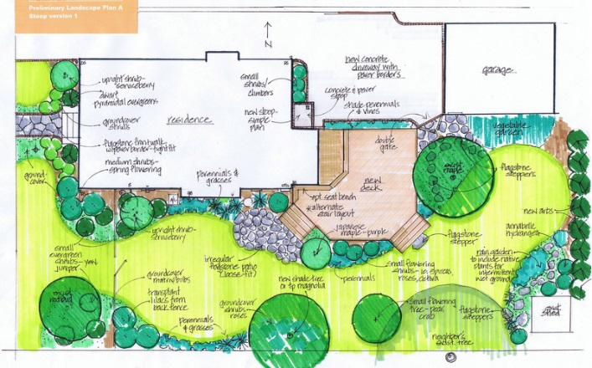
  - Inventory & Analysis b. Bubble Design c. Preliminary Design d. Construction Documentation
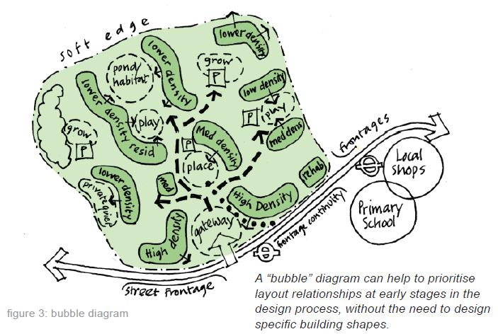
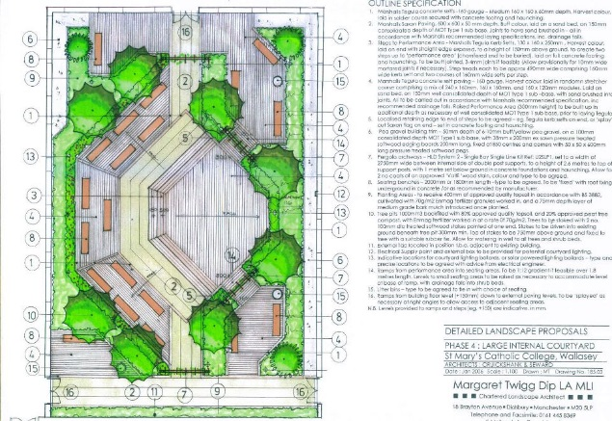
Picture III
Picture II
Picture I
- This kind of pencil is for any lines that need to be light (such as guidelines).
  - HB Soft b. H medium c. 2H to medium hard d. 4H Hard
- This is all purpose lead for a variety of purposes.
  - HB Soft b. H medium c. 2H to medium hard d. 4H Hard
- This is for for wider, darker lines.
  - HB Soft b. H medium c. 2H to medium hard d. 4H Hard
- This is designed for fine, precision work. It is difficult to erase but will not smudge.
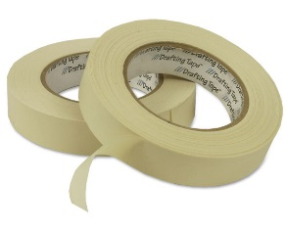
  - HB Soft b. H medium c. 2H to medium hard d. 4H Hard
I
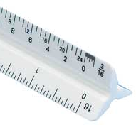
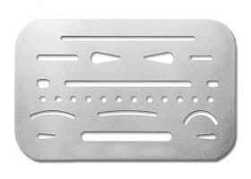
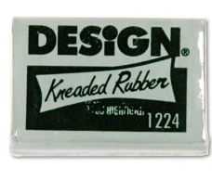
- This is I.
V
IV
III
II
  - Eraser Shield b. Drafting Brush c. Kneaded eraser d. Drafting Tape e. Scale
- This is II.
  - Eraser Shield b. Drafting Brush c. Kneaded eraser d. Drafting Tape e. Scale
- This is III.
  - Eraser Shield b. Drafting Brush c. Kneaded eraser d. Drafting Tape e. Scale
- This is IV.
  - Eraser Shield b. Drafting Brush c. Kneaded eraser d. Drafting Tape e. Scale
- This is V.
  - Eraser Shield b. Drafting Brush c. Kneaded eraser d. Drafting Tape e. Scale
- This is used to remove a specific area of their design in a specific shape without affecting any of the other components.
  - Eraser Shield b. Drafting Brush c. Kneaded eraser d. Drafting Tape e. Scale
- This is used to removing pencil marks without smudging.
  - Eraser Shield b. Drafting Brush c. Kneaded eraser d. Drafting Tape e. Scale
- This is used to dust, debris, and loose graphite without smudging.
  - Eraser Shield b. Drafting Brush c. Kneaded eraser d. Drafting Tape e. Scale
- This prevents shifting of the paper while drawing without ripping the paper.
  - Eraser Shield b. Drafting Brush c. Kneaded eraser d. Drafting Tape e. Scale

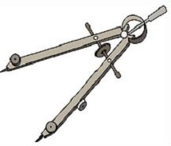
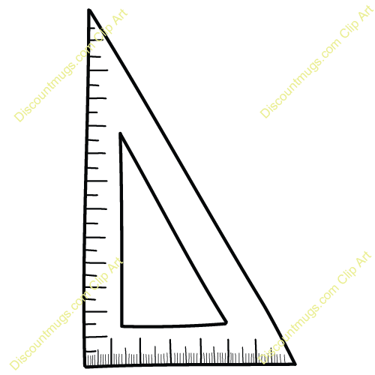
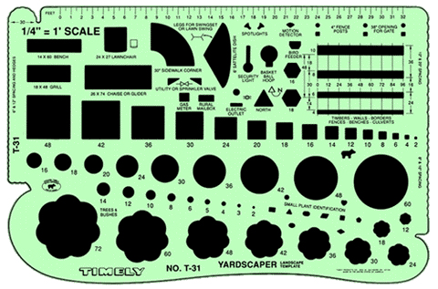
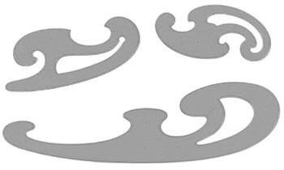
- This is I.
I
V
IV
III
II
  - Compass b. T-square c. French Curve d. Triangle e. Template
- This is II.
  - Compass b. T-square c. French Curve d. Triangle e. Template
- This is III.
  - Compass b. T-square c. French Curve d. Triangle e. Template
- This is IV.
  - Compass b. T-square c. French Curve d. Triangle e. Template
- This is V.
  - Compass b. T-square c. French Curve d. Triangle e. Template
- This helps the designer draw perfectly parallel lines.
  - Compass b. T-square c. French Curve d. Triangle e. Template
- This is used to create perfect circles and arcs.
  - Compass b. T-square c. French Curve d. Triangle e. Template
- This enables the designer to create curves of any kind of curvature as needed.
  - Compass b. T-square c. French Curve d. Triangle e. Template
- This guides the designer in drawing these shapes as needed in their design.
  - Compass b. T-square c. French Curve d. Triangle e. Template
- Which of the following is NOT one of the steps needed for drawing a high quality line?
  - Round the corners by making a few marks on scratch paper while turning the pencil slightly.
  - Breaking off the very tip of a newly sharpened pencil by tapping it gently on scratch paper.
  - Roll the pencil slightly as you draw to ensure that the lead has even contact with the paper.
  - Keep the pencil at a perfect 90º angle to the paper in every direction.
  - None of the above. All of these are part of drawing high quality lines.
- Which of the following is recommended for drawing corners?
  - Make sure you have weak corners so that they look rounded and cleaner.
  - Make sure you have excessive overlap to avoid weak corners.
  - Make sure that your lines touch or have just a slight overlap.
  - Make sure the lines of your corners never touch.
- Which of the following is not a part of the title block?
  - Project name and address
  - The designer and company
  - Scale and north indicator
  - All of these should be in a title block.
- This is an example of what kind of scale? 1” = 20’
  - Architects’ scale b. Engineer’s scale c. Metric scale

