Animal Rights versus Animal Welfare
C. Kohn, Waterford WI, based on “Animal Rights versus Animal Welfare” by Larry S. Katz, Ph.D.
Partner Names:
Hour Date: Why late? Score: + ✓ -
Directions: Use the accompanying reading to complete this sheet. This assignment is graded on a +/✓/- scale.

Pre-reading questions: complete these questions prior to completing the reading.
- What is the difference between animal rights and animal welfare (or are they the same thing)? Summarize your views on this topic in the space below:
- Should animals have the same rights and/or privileges as human beings? Why or why not?
- Are all animals entitled to the same kind of treatment as other animals, or are some animals ‘more deserving’ than others? Why or why not?
- Are all living species (plants, animals, fungi, bacteria, etc.) entitled to the same kind of treatment as other species, or are some species ‘more deserving’ than others? Why or why not?

Post-reading questions: complete these questions after completing the reading.
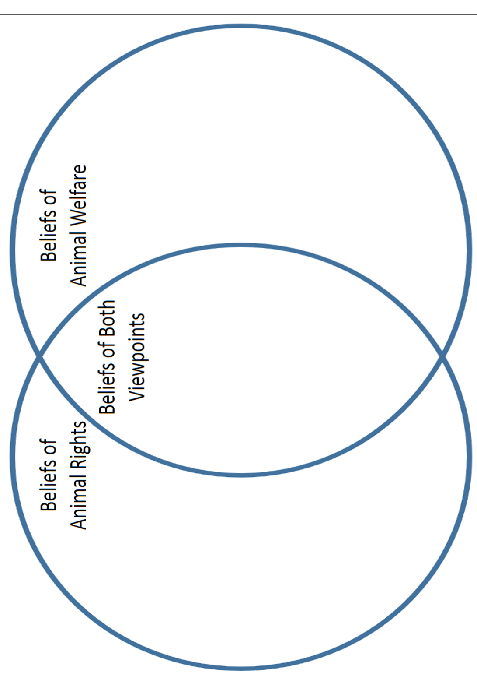
- Complete the Venn Diagram below after completing the reading. Use all of the space that is provided.

- What is the difference between animal rights an animal welfare? Use all of the space provided.
Animal welfare is the belief that
Animal rights is the belief that
- What is your stance on this issue - do you agree more with animal rights or animal welfare? Explain your stance.
- Did you disagree with the author on any of his arguments? Explain how your views differ from the author’s:
- Using the space below, write four belief statements that reflect your views on what the guiding principles should be to help someone to evaluate whether or not an interaction with any kind of animal is humane.
Statement #1: I believe that
Statement #2: I believe that
Statement #3: I believe that
Statement #4: I believe that

