Bacteriology Streaking Lab by C. Kohn, Waterford WI
Partner Names: Hour Date:
Date Assignment is due: Why late? Score: + ✓ -
If your project was late, describe why

Bacteriology Streaking Lab
In this lab you will be working in groups of 2 to use specialized petri dishes to determine if Gram Negative bacteria are present in a sample. To do so, you will need to practice proper microbiological streaking.

Materials – You will need the following (order form at https://ahdc.vet.cornell.edu/docs/LabSuppliesOrderForm.pdf):
- Disinfectant spray and/or rubbing alcohol
- Bunsen burner (optional)
- Disposable gloves

- Inoculating Loop (one loop per group of 2)
- MacConkey Agar Plates (1 plate per group of 2)
- Cotton Swabs (2-4 per group of 2)
- Small sealing plastic bags, e.g. Ziplock bags (2-4 per group of 2)
- A permanent marker (or a pen/pencil and masking tape)
- Sterile tube(s)
- Potential sources of Gram Negative Bacteria (door knobs, sinks, etc).
- An incubator or warm area of your classroom (such as under a sink or by a radiator).

Directions
- With your partner, think of four places around school that you think might have the most harmful bacteria. Write these places in the spaces below (and be specific – tell me exactly where you intend to go):

Instructor approval: Date:
- What do these areas have in common that makes you think they would promote the growth of harmful bacteria? List four characteristics that all of these places have in common:
- The plates we will be using stop the growth of gram positive bacteria and promote the growth of gram negative bacteria. Why would we use these plates if we’re looking for harmful bacteria around school? Answer by describing multiple reasons of why gram negative bacteria are more harmful than gram positive bacteria.
- Have your instructor review the areas you are intending to go to. If your instructor approves and signs off, you may go acquire your samples. Your instructor may request that you only visit a portion of these sites.
- To collect your samples, wear disposable gloves and use the cotton swab and ‘roll’ the swab across the sample.
  - For example, if you were swabbing a door knob, make sure every part of the cotton head of the swab touches the door knob.
  - Place it in a sealing plastic bag (using caution to make sure nothing else touches the end of the swab) and label the bag with where the sample was acquired and when.
- Repeat these steps for three more areas. Bring your labeled/bagged swabs back to your room.
- With your partner, decide which of the four samples you will use. You want to pick the sample that you think will have the greatest growth on a gram-negative petri dish. Be prepared to discuss and defend in class.
Which sample did you choose?
Why did you choose this sample?
- Sanitize your lab bench or work area. You can wipe down the area with an alcohol solution. Spraying Lysol and wiping with a clean paper towel would also work fine.
- Fill a sterile tube halfway with lukewarm water. Dip and swish your swab in the water for 20 seconds. Return your swab to its plastic bag. Cap your sterile tube.
- See your instructor to acquire your MacConkey Agar Plate. This is a petri dish that only allows gram negative bacteria to grow. You will also need to acquire an inoculation loop. Be sure the loop DOES NOT come in contact with anything – it needs to remain sterile.
- If using a non-disposable inoculating loop, sterilize by running it through a flame. If using a plastic disposable loop, dip it in rubbing alcohol and wipe it dry with a sterile paper towel.
- Dip your sterilized loop into the water in which you swished your cotton swab.
  - Lift the cover of your petri dish at an angle so that the end furthest from you is open.
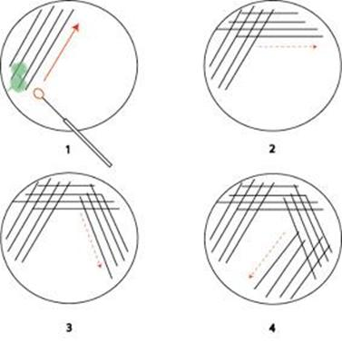
  - Using the loop, spread it carefully across the surface of the nutrient medium in a single line as shown in the image to the right (1).
  - Using the same loop, make three more lines as shown to the right in #1.

- Re-sterilize your loop.
  - Turn your dish slightly.
  - Use your loop to “draw” four more lines (as shown in #2).
  - DO NOT re-dip your loop – you are pulling the loop across the lines you previously “drew” with your loop.

- Re-sterilize your loop. Turn your dish slightly again. Draw four more lines as shown in #3.
- Re-sterilize your loop. Turn your dish slightly again. Draw four more lines as shown in #4.
Source: http://www.marine.csiro.au/microalgae/methods/support%20or%20original%20files/microa3.jpg
- Close your dish and label it with permanent marker (or masking tape and pen or pencil).
  - Mark your dish with your class’s hour, date, and last names.
- Put your petri dish upside down into your incubator.
  - If the dish is upside down, it is less likely to be contaminated by environmental bacteria in the air (the bacteria cannot “fall upwards”).
- Allow your dishes to incubate at least 24 hours.
Note: more time will be needed if you don’t have an incubator.
- As best as you can, draw what you see
- Do you think your sample contained harmful bacteria?
Explain:

