Biodiesel From New Veg. Oil Lab C. Kohn, Waterford WI
Name: Hour Date: Group #
Date Assignment is due: Friday in class Why late? Score: + ✓ -
^{Day of Week} ^{Date} If your project was late, describe why
Objective: in this lab, you will be creating biodiesel from new vegetable oil (NVO) using a transesterification reaction involving methanol and potassium hydroxide (KOH).
Safety: this is a potentially dangerous lab experiment! Methanol is very flammable – keep away from flames and sparks and avoid inhaling fumes. Methanol can be hazardous and will be easily absorbed through the skin – avoid contact at all times and do not remove gloves, eyewear, or aprons at any point while performing the lab.
Potassium hydroxide (KOH) will cause chemical burns if inappropriately handled. NEVER remove gloves or goggles when handling.
Mixing KOH with methanol will produce fumes. Perform only in a well-ventilated area. If you feel faint or dizzy, immediately leave the lab and go into the classroom.
DO NOT wear sandals, flip flops, or other open toed shoes. Spills can be hazardous on exposed skin. If you do spill KOH, methanol, or methoxide onto exposed skin, immediately flush with copious amounts of water.
It is VERY important that all materials are safely stored or disposed as instructed. Do NOT leave potentially hazardous chemicals in a location where they may cause later harm or injury. YOU ARE RESPONSIBLE FOR PREVENTING ANY AND ALL PROBLEMS. SAFETY SHOULD NOT HAPPEN BY ACCIDENT!
Never attempt any of these procedures without the supervision of a trained adult. This work should not be performed at home. If you are interested in further experience, speak with your instructor to schedule time at school for additional opportunities.
Lab Overview:
Day 1: Transesterification – new vegetable oil (NVO) heated to 55º C will be treated with methoxide (KOH and methanol). After 45-60 minutes of stirring and heat, the mixture will be allowed to cool and settle overnight.
Day 2: Separation and washing – biodiesel and glycerine will be poured into a separatory funnel. The glycerine will settle to the bottom of the funnel and will be drained. The biodiesel will be washed three times using pure water. The water will be drained as the biodiesel rises to the top. The biodiesel will be allowed to dry overnight.
Day 3: Collection – the biodiesel will be moved into clean mason jars for storage until later testing.

Day 1: Transesterification of the oil (you will need gloves, goggles, and aprons for this entire portion).
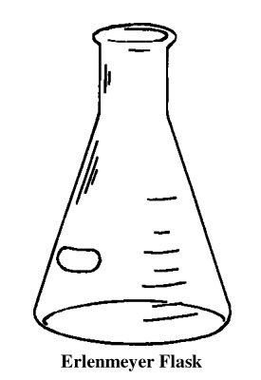
- Pour 200 ml of new vegetable oil into a clean beaker (500 ml). Heat to 55º C and stir using the magnetic stir bar.
- While the oil is heating, measure 40 ml of methanol and pour into a clean Erlenmeyer flask. Stopper the flask.
- Using the scales at your stations and the paper holders, measure 1.3 g of potassium hydroxide (KOH).
  - It takes 6.5 g per liter of new vegetable oil to cause a complete reaction. Because we are working with 200 ml instead of 1000 ml, we will divide 6.5 by 5 to get 1.3 g.
- After checking to ensure that the room exhaust fans are running, add your 1.3 g KOH to your flask of methanol and quickly stopper the flask (do this away from your face).
- Swirl your flask until all of the KOH dissolves (it will take some time; be persistent with your swirling).
  - CAUTION: this solution is extremely caustic and produces toxic fumes. Keep your flask sealed until you are ready to add your solution to your oil. Once the solution is in the heated oil, its danger is reduced by the transesterification reaction.
- When the oil is between 55-57º C, quickly but carefully pour your 40 ml of methoxide into the oil. Re-cap your flask. Continue stirring – stirring should be vigorous but not so fast that it forms a vortex.
- Keep your reaction between 55-57º C; shoot for 56º C. Allow your mixture to stay at this temperature for 45-60 minutes. Keep the solution mixing using the magnetic stir bar.
- After 45-60 minutes, turn off your heat source and stop the mixing. Allow the mixture to cool and settle overnight (or at least 2 hours).
- Rinse your flasks in a well ventilated area. Wash with soap, water, and a bottle brush. Rinse well and hang on the drying rack.

Day 2: Separation and washing (you will need gloves, goggles, and aprons for this entire portion).
- If your reaction was performed correctly, you should now see a dark layer of glycerine on the bottom of the flask with the clearish yellow biodiesel on top.
- Carefully pour your light yellow biodiesel into a separatory funnel (NOTE: make sure it is closed before your pour!). Try to not transfer any of the dark glycerine at the bottom. Dispose of the glycerine as instructed.
Figure 1 A Separatory Funnel
- Add 50 ml of fresh water to the separatory funnel with your biodiesel.
- Gently swirl the funnel to mix the diesel and water. Allow the mixture to settle (this may take a few minutes). After the water has settled to the bottom, drain into a collection jar under the funnel. Stop draining when all of the water has been removed.
- Add 50 ml of fresh water again and repeat the two steps above. You should notice the wash water getting clearer each time and that it should separate more quickly from the biodiesel each time.
- Add 50 ml of fresh water for a third time and drain when it settles to the bottom.
- Allow your wash water to stand in the well-ventilated lab for a day to allow the excess methanol to evaporate.
- Allow your biodiesel to dry open overnight in the separatory funnel.
- After ensuring that no glycerine remains in your beaker, rinse your beaker in a well ventilated area (glycerine will clog drains – be sure none remains before you rinse!). Wash your beaker with soap, water, and a bottle brush. Rinse well and hang on the drying rack.

Day 3: Collection (you will need gloves, goggles, and aprons for this entire portion).
- Remove any remaining impurities in your biodiesel by draining them from the separatory funnel.
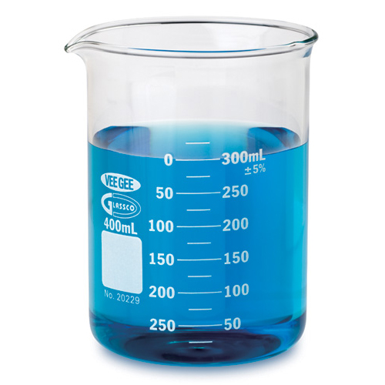
- Remove your waste collection jar and dispose of your waste as instructed.
Figure 2 A beaker
- Place a clean dry mason under your separatory funnel and slowly transfer your biodiesel into your jar. Seal your jar.
- Carefully wash your separatory funnel and collection jar with soap and water and hang on the drying rack. Acquire your instructor’s initials HERE after you have completed this step.
- Label your jar of biodiesel using a wax pencil with your group names and date. Place your jar in the location provided by your instructor.

Why the washing?
You might wonder why we rinsed our biodiesel with water. You might have seen the biodiesel turn cloudy when the water was added. This was caused by water molecules clinging to impurities in the biodiesel. As the water settles, it takes most of the impurities with it. The hazier the biodiesel, the more impurities it has. One measure of biodiesel quality is its level of clarity. This is also an indication of how “dry” the biodiesel is – i.e. if haziness is present in the biodiesel, it is an indication that water remains in the fuel. This water can impair the performance of the biodiesel when combusted in an engine.

