Biodiesel From Waste Veg. Oil Lab C. Kohn, Waterford WI
Name: Hour Date:
Date Assignment is due: Why late? Score: + ✓ -
^{Day of Week} ^{Date} If your project was late, describe why
Objective: in this lab, you will a be creating biodiesel from waste vegetable oil (WVO) using titration to determine the amount of reagent needed and a transesterification reaction involving methanol and potassium hydroxide (KOH).
Safety: this is a potentially dangerous lab experiment! Methanol is very flammable – keep away from flames and sparks and avoid inhaling fumes. Methanol can be hazardous and will be easily absorbed through the skin – avoid contact at all times and do not remove gloves, eyewear, or aprons at any point while performing the lab.
Potassium hydroxide (KOH) will cause chemical burns if inappropriately handled. NEVER remove gloves or goggles when handling.
Mixing KOH with methanol will produce fumes. Perform only in a well-ventilated area. If you feel faint or dizzy, immediately leave the lab and go into the classroom.
DO NOT wear sandals, flip flops, or other open toed shoes. Spills can be hazardous on exposed skin. If you do spill KOH, methanol, or methoxide onto exposed skin, immediately flush with copious amounts of water.
It is VERY important that all materials are safely stored or disposed as instructed. Do NOT leave potentially hazardous chemicals in a location where they may cause later harm or injury. YOU ARE RESPONSIBLE FOR PREVENTING ANY AND ALL PROBLEMS. SAFETY SHOULD NOT HAPPEN BY ACCIDENT!
Never attempt any of these procedures without the supervision of a trained adult. This work should not be performed at home. If you are interested in further experience, speak with your instructor to schedule time at school for additional opportunities.
Lab Overview:
Day 1: Filtration and Titration of oil (to determine KOH needed). Because Free Fatty Acids (FFAs) remain in the oil as a result of its use for cooking, extra KOH will be needed to neutralize these FFAs. Titration tells us how much KOH is needed.
Day 2: Transesterification – new vegetable oil (NVO) heated to 55º C will be treated with methoxide (KOH and methanol). After 45-60 minutes of stirring and heat, the mixture will be allowed to cool and settle overnight.
Day 3: Separation and washing – biodiesel and glycerine will be poured into a separatory funnel. The glycerine will settle to the bottom of the funnel and will be drained. The biodiesel will be washed three times using pure water. The water will be drained as the biodiesel rises to the top. The biodiesel will be allowed to dry overnight.
Day 4: Collection – the biodiesel will be moved into clean mason jars for storage until later testing.

Day 1: Titration of the oil (gloves, goggles, and aprons are needed for this portion).
- Measure 200 ml of waste vegetable oil and pour into a clean, dry 400 ml beaker.
- Filter the oil by pouring it into another container through cheesecloth to strain out any large impurities.
- Return the filtered oil to the beaker. Clean out the second container using soap and water and leave to dry.
- Fill your burette with 0.1% KOH solution. Note the initial volume of your KOH here
We have KOH in our burette.
- Measure 10 ml of methanol and pour into a small container.
- Measure 1 ml of waste oil heated to 55º C. Add this oil to the methanol in the small container. Swirl to dissolve the oil into the methanol.
- Add 2 drops of phenolphthalein to the oil/methanol solution. Gently swirl the oil/methanol/phenolphthalein to evenly distribute all components of the solution.
- Slowly add the 0.1% KOH solution to your oil/methanol solution drop by drop, swirling the solution each time a drop is added. Continue to add the KOH solution to your oil/methanol solution in a drop by drop manner until the mixture holds its pink color for 10-15 seconds.
  - If your solution holds the pink color permanently, you have added too much KOH. (If this happens, start again with Step 7.)
- Note the FINAL volume of your KOH here
We have KOH remaining in our burette.
- Subtract the initial volume of your KOH solution in the burette from your final volume. Record below.
We used ml of KOH.
- The ml of KOH used equals the grams of KOH needed per 1000 ml of oil to neutralize the Free Fatty Acids (FFAs) remaining in the used oil from cooking. Divide this number by 5 to determine the g of KOH needed per 200 ml.
We need g of extra KOH per 1000 ml of waste oil. This would be g KOH extra per 200
ml of waste oil. This means that we need 1.3 g + g KOH = g total KOH per 200 ml of waste oil.
- Turn off your heaters and cover your oil. Be sure to clean up all messes around your lab area.
- Dump your 0.1% KOH solution from your burettes into a sink with running water. Rinse your burettes and dry.
Day 2: Transesterification of the oil (you will need gloves, goggles, and aprons for this entire portion).
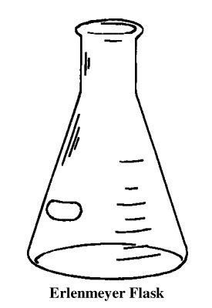
- Heat 200 ml of your waste oil to 55º C and stir using the magnetic stir bar.
- While the oil is heating, measure 40 ml of methanol and pour into a clean Erlenmeyer flask. Stopper the flask.
- Using the scales at your stations and the paper holders, measure 1.3 g of potassium hydroxide (KOH) plus what you calculated in #13 yesterday.
  - It takes 1.3 g per 200 ml of new vegetable oil to cause a complete reaction. Because we are working with waste oil, we will need to add additional KOH to completely react the extra FFAs in the oil due to its use in frying. Add 1.3 to your calculated KOH from your titration for your total amount.
- After checking to ensure that the room exhaust fans are running, add your calculated KOH amount to your flask of methanol and quickly stopper the flask (do this away from your face).
- Swirl your flask until all of the KOH dissolves (it will take some time; be persistent with your swirling).
  - CAUTION: this solution is extremely caustic and produces toxic fumes. Keep your flask sealed until you are ready to add your solution to your oil. Once the solution is in the heated oil, its danger is reduced by the transesterification reaction.
- When the oil is between 55-57º C, quickly but carefully pour your 40 ml of methoxide into the oil. Re-cap your flask. Continue stirring – stirring should be vigorous but not so fast that it forms a vortex.
- Keep your reaction between 55-57º C; shoot for 56º C. Allow your mixture to stay at this temperature for 45-60 minutes. Keep the solution mixing using the magnetic stir bar.
- After 45-60 minutes, turn off your heat source and stop the mixing. Allow the mixture to cool and settle overnight (or at least 2 hours).
- Rinse your flasks in a well ventilated area. Wash with soap, water, and a bottle brush. Rinse well and hang on the drying rack.

Day 3: Separation and washing (you will need gloves, goggles, and aprons for this entire portion).
- If your reaction was performed correctly, you should now see a dark layer of glycerine on the bottom of the flask with the clear-ish yellow biodiesel on top.
- Carefully pour your light yellow biodiesel into a separatory funnel (NOTE: make sure it is closed before your pour!). Try to not transfer any of the dark glycerine at the bottom. Dispose of the glycerine as instructed.
- Add 50 ml of fresh water to the separatory funnel with your biodiesel.
- Gently swirl the funnel to mix the diesel and water. Allow the mixture to settle (this may take a few minutes). After the water has settled to the bottom, drain into a collection jar under the funnel. Stop draining when all of the water has been removed.
- Add 50 ml of fresh water again and repeat the two steps above. You should notice the wash water getting clearer each time and that it should separate more quickly from the biodiesel each time.
- Add 50 ml of fresh water for a third time and drain when it settles to the bottom.
- Allow your wash water to stand in the well-ventilated lab for a day to allow the excess methanol to evaporate.
Figure 1 A Separatory Funnel
- Allow your biodiesel to dry open overnight in the separatory funnel.
- After ensuring that no glycerine remains in your beaker, rinse your beaker in a well ventilated area (glycerine will clog drains – be sure none remains before you rinse!). Wash your beaker with soap, water, and a bottle brush. Rinse well and hang on the drying rack.

Day 4: Collection (you will need gloves, goggles, and aprons for this entire portion).
- Remove any remaining impurities in your biodiesel by draining them from the separatory funnel.
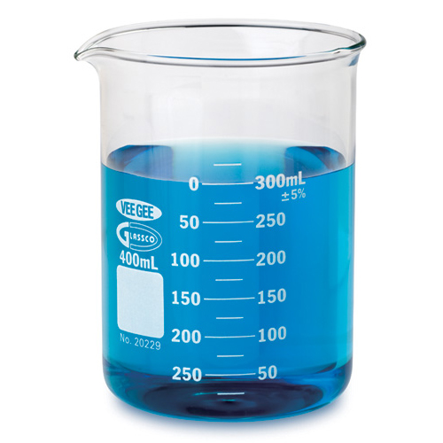
- Remove your waste collection jar and dispose of your waste as instructed.
Figure 2 A beaker
- Place a clean dry mason under your separatory funnel and slowly transfer your biodiesel into your jar. Seal your jar.
- Carefully wash your separatory funnel and collection jar with soap and water and hang on the drying rack. Acquire your instructor’s initials HERE after you have completed this step.
- Label your jar of biodiesel using a wax pencil with your group names and date. Place your jar in the location provided by your instructor.
- Compare your biodiesel from waste vegetable oil to your biodiesel from the new vegetable oil from the previous lab. Note any differences. Hypothesize whether there will be a difference in performance between the two fuels.

0.1% KOH = 1 g KOH dissolved in 1000 ml of water
Phenolphthalein is an indicator solution that changes color in response to changes in pH

