Enzymes & Bioprospecting Notesheet C. Kohn, Waterford WI
Name: Hour Date:
Date Assignment is due: Why late? Score: + ✓ -
^{Day of Week} ^{Date} If your project was late, describe why
Directions: Use the accompanying PowerPoint (available online) to complete this sheet. This sheet will be due upon the completion of the PowerPoint in class. These assignments are graded on a +/✓/- scale.
- Life is
- What is anabolism?
- What is catabolism?
- What is an example of anabolism?
- What is an example of catabolism?
- True or false: most chemical reactions occur under widely varying conditions without the input of energy.
- The majority of require
and often involves and
in order to .
- What is a reactant?
- What is a product?
- What is activation energy?
- What are enzymes?
- Why are enzymes needed by living organisms?
- Without enzymes, the reactions needed for life
- Enzymes are , or chemicals that
- Enzymes and other kinds of catalysts lower
that is
and for
without
- What is a substrate?
- True or false: a substrate is just another term for the reactant in an enzymatic reaction.
- How are substrates in an enzymatic reaction like a car going up a mountain?
- What do enzymes do in this mountain analogy?
- Enzymes are , or
that are formed through
of
- What is macromolecule?
- What are six examples of functions of proteins in an organism?
- Proteins are often the of an organism.
- Briefly summarize how a protein is made:
Note: include the following in your answer above: transcription, translations, amino acids, shape, and function.
- How does a protein obtain its shape?
- Why is the shape of a protein important?
- Why is the shape of a protein especially important in the case of an enzyme?
- What is the active site of an enzyme?
- True or false: almost all of the work of an enzyme occurs at the active site.
- How does the shape of the active site regulate and limit which molecules are affected by an enzyme?
- How does temperature affect the function of an enzyme?
- True or false: the higher the temperature, the more effective the protein. Explain:
- What does it mean if a protein is denatured?
- Why is a denatured protein ineffective?
- How does pH affect an enzyme?
- How does the concentration of a substrate affect an enzyme’s function?
- How is lactose a good example of how an enzyme works?
- In the case of lactose, what is the enzyme? What is the substrate?
What is/are the products?
- If someone is lactose intolerant, what is wrong with them?
- What are the symptoms of lactose intolerance and what causes these symptoms?
- Cellulose is a polymer, which is
- Cellulase is
- Cellulose has a dense made from chains of
- Why does cellulose have to be converted into glucose? Why not just ferment the cellulose?
- How does the fact that cellulose has a crystalline structure make it especially hard to break down?
- True or false: without cellulase, you cannot break down cellulose. Explain:
- If we can break down cellulose using materials other than cellulase, why are scientists seeking better sources of
cellulase?
- Not only does the hydrolysis of cellulose into glucose represent the
of cellulosic biofuel production, but it can often be the
step in this process.
- Finding
is necessary to make cellulosic ethanol a
potential fuel source.
- True or false: one enzyme, cellulase, is necessary to convert cellulose into glucose. Explain:
- Briefly summarize the function and role of each of the following kinds of cellulase enzymes:
****
Endoglucanase:
Substrate acted upon by endoglucanase:
Product created by endoglucanase:
****
Exoglucanase:
Substrate acted upon by exoglucanase:
Product created by exoglucanase:
****
Beta-glucosidases:
Substrate acted upon by Beta-glucosidases:
Product created by Beta-glucosidases:
- What is cellobiose?
- What is a monomer?
- Why is exoglucanase dependent on the action endoglucanase?
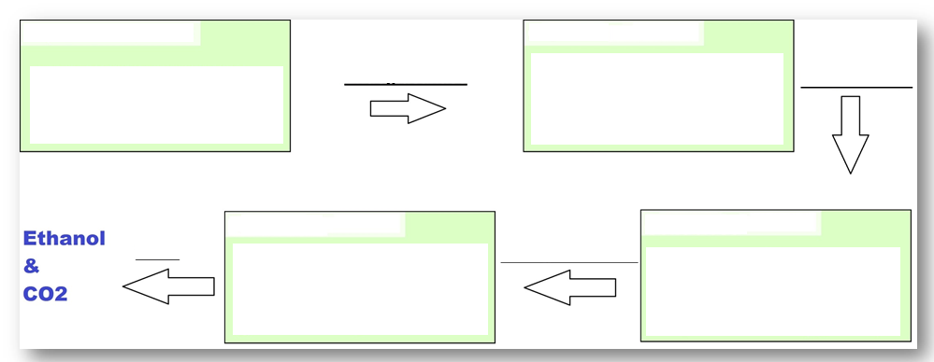
- Fill in each blank in the image below. Include a sketch of each substrate in each stage of this process:
- Crystalline cellulose is converted into
by . Single-stranded cellulose is converted into
by
Cellobiose is converted into by
Glucose is converted into by .
- Briefly summarize how the understanding of cellulase enzymes came about as a result of T reesei.
- How has research of T reesei changed since the original research of the 1950s?
- What is bioprospecting?
- These products can include
- Why is bioprospecting vital to the future of cellulosic ethanol?
- Briefly provide examples of how bioprospecting was applied to each of the following:
Medicine:
Engineering:
Agriculture:
- Summarize the relationship between leaf cutter ants and their fungus in your own words:
- What are three potential discoveries that these ants, their fungus, and their environment might provide?
Hint: what does the fungus do? What happens in the ants’ dumps? How is the ant’s use of antibiotics uniquely valuable?
1
2
3
- How does someone start the process of bioprospecting? How would a scientist even know where to begin to look for compounds, species, or substances that might be undiscovered and uniquely valuable to humans?
- What two factors are most important in an environment when hypothesizing whether or not it would contain beneficial organisms and/or compounds?
- Briefly summarize the five steps of bioprospecting:
1
2
3
4
5
- Once a valuable species or molecular compound has been found, what are three options for making this product available in mass quantities for human use?
1
2
3

>

Unit Wrap-up C. Kohn, Agricultural Sciences - Waterford WI
This page is designed to help raise your grade while enabling you to develop skills you will need for after high
school. You will need to complete every question and blank in order to receive full credit for your notes. Note: if you cannot come up with a strategy to remember a difficult concept on your own, see your instructor for help.
- What is a topic or concept from this unit that you found to be more challenging? Write or describe below:
In the space below, create a mnemonic, rhyme, analogy, or other strategy to help you remember this particular concept:
- What is a 2nd topic or concept from this unit that you found to be more challenging? Write or describe below:
In the space below, create a mnemonic, rhyme, analogy, or other strategy to help you remember this particular concept:
- What is a 3rd topic or concept from this unit that you found to be more challenging? Write or describe below:
In the space below, create a mnemonic, rhyme, analogy, or other strategy to help you remember this particular concept:
- Circle the most appropriate response. You will only be graded on whether or not you completed this section.
Circle one: I used my notes outside of class to prepare for the quiz. Definitely – Yes – Sort of - No
Circle one: I took extra notes in the margins for very difficult concepts. Definitely – Yes – Sort of - No
Circle one: I created a personal strategy for at least three difficult items. Definitely – Yes – Sort of - No
Circle one: I was very involved and actively studying during the quiz review. Definitely – Yes – Sort of - No
Circle one: I think I will be satisfied with the quiz grade I received this week. Definitely – Yes – Sort of - No
Circle one: I might need to meet with the instructor outside of class. Definitely – Yes – Sort of - No

