Carbon Cycle Interactive Activity by C. Kohn, Agricultural Sciences
Group Names (first/last):
Hour Date: Why late? Score: + ✓ -
If your project was late, describe why
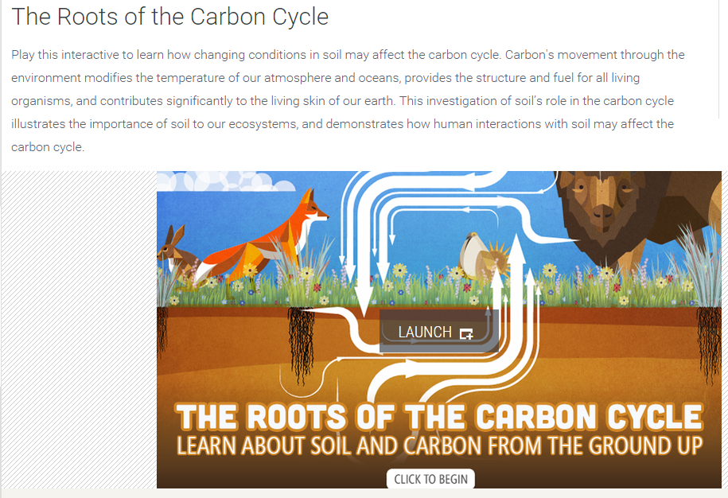
Instructions: using an internet search engine (such as Google), type the following: “PBS Roots of the Carbon Cycle”. Hit ENTER. Select the first link that comes up (it should be “The Roots of the Carbon Cycle - PBS LearningMedia”). It should look like the image on the right
Scroll down and click “Launch.”
Use this program to answer the questions below. Click “NEXT” to move through the program.
Complete this assignment in teams of 2-4. Each question should be answered by a different person and each person should do an equal number of questions. Write your initials next to your answer after completing a question.
- Where is there more organic carbon, in the soil or in the atmosphere?
- Why should we care about how carbon molecules move between the soil and our atmosphere?
Because it is related to how
- As plants grow, they absorb from the atmosphere, storing organic carbon as
- When plant roots and leaves enter the soil and break down, some of the carbon
- When animals defecate or die, organic carbon from their bodies also
- What happens when microorganisms in the soil decompose that plant and animal matter?
These microorganisms release
- What determines how fast organic matter decomposes in the soil?
- What is soil humus?
- How does soil structure affect plants in microbes in the soil?
- The moisture content of the soil indicates
- Soil temperature affects the activity of
and the rate of
In the next section, you will be engineering the soil in different ways using this program. Describe the kind of environment that is created using biomes (e.g. deserts, prairies, forest, rainforests, etc.).
- What kind of environment results from unstable, moist, and hot conditions? Summarize what you get when you choose these options:
These conditions create a type of environment.
- What kind of environment results from stable, moist, and hot conditions? Summarize what you get below:
These conditions create a type of environment.
- What kind of environment results from stable, wet, and hot conditions? Summarize what you get below:
These conditions create a type of environment.
- What kind of environment results from stable, wet, and warm conditions? Summarize what you get below:
These conditions create a type of environment.
- What kind of environment results from stable, dry, and warm conditions? Summarize what you get below:
These conditions create a type of environment.
- What kind of environment results from stable, dry, and hot conditions? Summarize what you get below:
These conditions create a type of environment.

