The Carbon Cycle Notesheet by C. Kohn
Name: Hour Date:
Date Assignment is due: After weekly quiz Why late? Score: + ✓ -
^{Day of Week} ^{Date} If your project was late, describe why
Units
1. Radish Races
2. Lab Safety
3. Carbon Cycle
4. Science Writing
5. Cell Biology
6. Cell Respiration
7. Photosynthesis
8. Research Statistics
9. C3/C4 Plants
10. Final Experimental Project
11. FFA & Science
12. Parli. Pro.

Weekly Schedule

Monday: Topic Intro Discussion

Tuesday: Notes

Wednesday: Lab

Thursday: Review & Quiz

Friday: Finish Radish Races Lab
- Create four questions about this topic:
A.
B.
C.
D.
- How do plants affect the amount of carbon dioxide in the air?
- What is the difference between an organic molecule and an inorganic molecule?
- When you burn a log, what happens to its mass? Where does it go?
- An oak tree weighs many tons. Where did this weight mostly come from?

Notes C. Kohn, Agricultural Sciences - Waterford WI
Directions: use the accompanying PowerPoint (available online) to complete the questions below. These assignments are graded on a + ✓- scale
- The carbon cycle is a term for the process in which
- For example, plants absorb from the and convert it into
- When plants are consumed or decomposed, the plant matter is converted into
- During photosynthesis, plants assemble organic versions of carbon molecules (including
) using
- This process of assembling organic molecules of is powered by
- When the plant begins to (such as in autumn), soil organisms break down the
back into &
- In the carbon cycle, the carbon atoms always stays – it is neither
nor . Carbon can only change what it is
- In the atmosphere, we typically see carbon molecules as . This is the
version of carbon (it is not part of something ).
- Organic versions of carbon molecules include: ,
and
- Cellulose is most commonly found in a plant’s
(Hint: look at the picture on the side of this slide showing glucose and cellulose molecules)
- True or false: you can’t change the amount of carbon that exists. Explain:
- Photosynthesis the amount of in the air.
- ,
and increase the amount of carbon dioxide in the air.
- In order to make crops more , an
Has to create plants with a greater ability to into
_ .
- Normally, the carbon cycle keeps itself
  - Inorganic carbon molecules are used by plants to create
  - Organic forms of carbon molecules convert back into when they are consumed or decomposed
- Today, however, the carbon cycle is not . The levels of atmospheric carbon
have risen to the highest levels in recent geological history at an
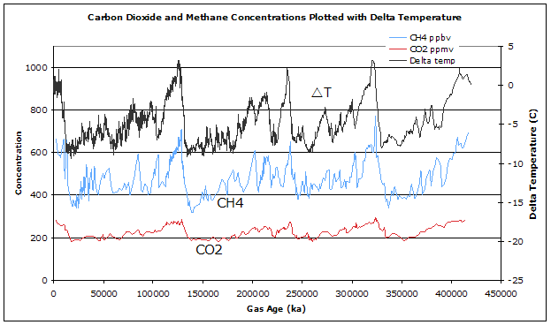
- On the graph below, draw a horizontal line showing where atmospheric CO₂ levels are today.
- Why does it matter how high CO₂ is? Why do we think this is a problem?

- How is CO₂ in the atmosphere sort of like a winter coat?

- What is Climate Change?
- Describe the four ways in which atmospheric carbon dioxide could be reduced:

- Which of these do you think would work the best? Explain:
- How might a farmer reduce the amount of CO₂ that is put into the atmosphere? Propose an idea below:
I think that a farmer could reduce the amount of CO₂ that goes into the atmosphere by….
_
_
I think this would work because
_
_
- What do you think the average person should do to reduce carbon dioxide levels in the atmosphere?
I think that the average person could reduce the amount of CO₂ that goes into the atmosphere by….
_
_

Unit Wrap-up C. Kohn, Agricultural Sciences - Waterford WI
- Write the 3 topics that you most need to review before the quiz:
1_
2_
3_
- Create 3 high-level questions related to this material
(These questions could be something you still don’t know or questions that reflect understanding that you have now that you did not have before.)
1_
2_
3_
- List 6 vocabulary words that you did not know before or have not used very often prior to this unit:
1_ 2 3
4 5 6
- In the spaces below, fully write three strategies that will help you to remember specific vocabulary words or topics from this unit. NOTE: A strategy is not an activity such as reviewing your notes, studying hard, etc. A strategy is a mnemonic, rhyme, analogy, or other brain-based device that is specific to one item from the unit.
1._
2._
3._
- Circle the most appropriate response. You will only be graded on whether or not you completed this section, so be entirely honest with yourself when completing this section.
Circle one: I used my notes outside of class to prepare for the quiz. Definitely – Yes – Sort of - No
Circle one: I took extra notes in the margins for very difficult concepts. Definitely – Yes – Sort of - No
Circle one: I created a personal strategy for at least three difficult items. Definitely – Yes – Sort of - No
Circle one: I was very involved and actively studying during the quiz review. Definitely – Yes – Sort of - No
Circle one: I think I will be satisfied with the quiz grade I received this week. Definitely – Yes – Sort of - No

