Carbon Pools and Exchanges by C. Kohn, Waterford WI. Based on the Poker Chip Model of Carbon Pools and Fluxes by the Great Lakes Bioenergy Research Center (glbrc.org/education/classroom-materials).
Group Names: Hour
Date: Date Assignment is due: Why late? Score: + ✓ -
If your project was late, describe why
Overview: Students create a scaled 3-D visual of carbon pools and net fluxes between pools with human influences.

Directions:
- Acquire a “Carbon Pools & Exchanges” diagram as well as some scrap paper.
- Use scrap paper to create columns that visually show the amount of carbon found in each carbon pool on the diagram,
  - To do this, first cut and measure lengths of paper to correspond to the amount of carbon in each pool by converting from Gt C (gigatons of carbon, or one billion metric tons) to centimeters so that every 100 gigatons is 1 centimeter.
  - To calculate this, divide each Gt C value by 100 to get the size in centimeters of each length of paper. For example, 3500 Gt C would equal 35 centimeters, and 750 Gt C would be 7.5 cm.
  - When you’ve cut each piece of paper to size (or taped pieces of paper together to reach the appropriate size), roll each length of paper to create a column, secure the roll with tape, and secure this paper column to the corresponding location on the diagram with tape at the base.
- Repeat Step 2 for the fluxes.
- Answer the accompanying questions below and be prepared for a class discussion on this issue.

Questions:
- Where is most of the carbon on earth stored?
- Where is most of the movement of carbon occurring?
Hint: which flux was the greatest?
- What biological process is most likely accounting for flux a?
Why does this make sense?
- What biological process is most likely accounting for flux b?
Why does this make sense?
- What is the primary cause of flux i?
- How much carbon is entering the atmosphere? How much is leaving the atmosphere?
- How many gigatons of carbon does the atmosphere gain per year?
- Which is greater – the amount of carbon absorbed by the upper ocean or the amount released?
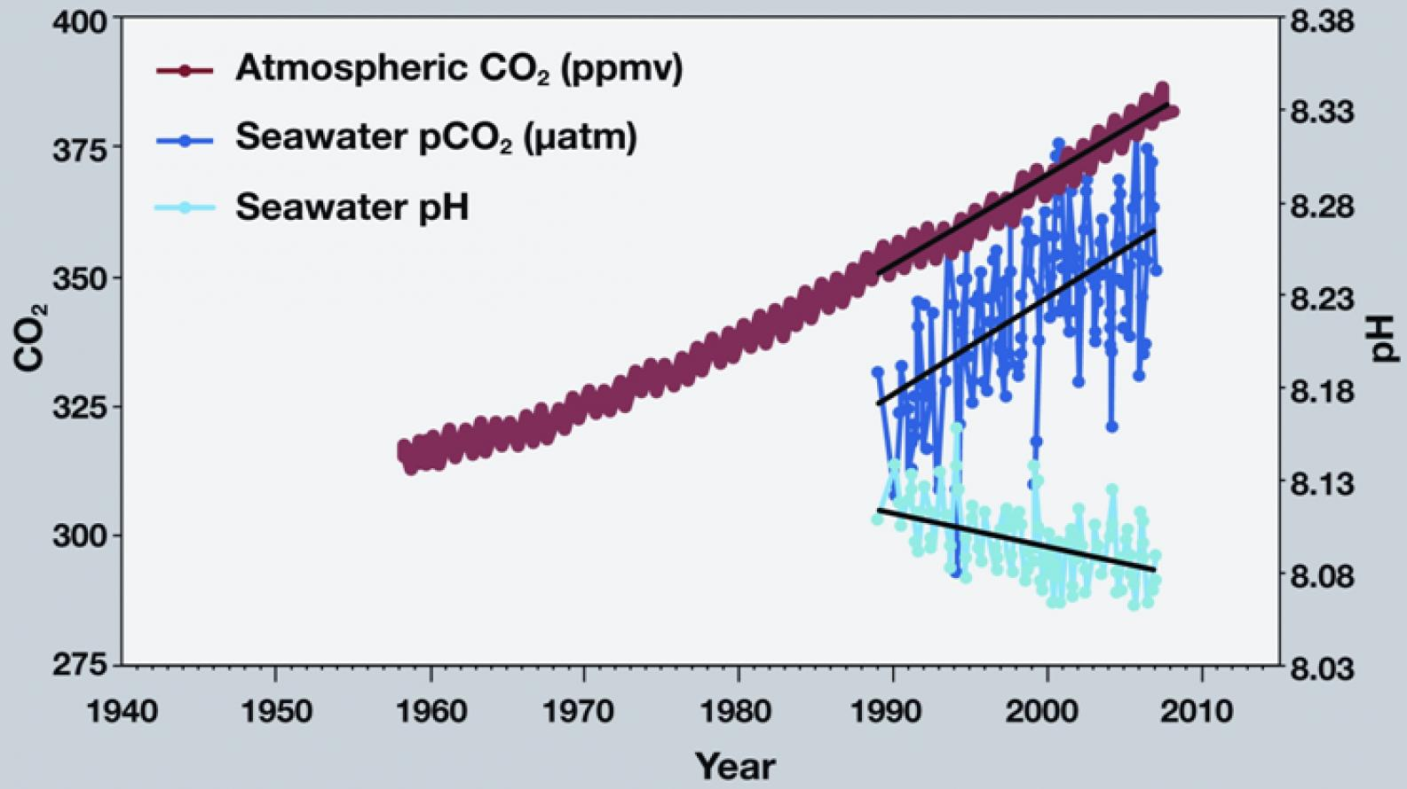
Source: ocean.si.edu
Use this graph to answer the questions below.
- What is happening to atmospheric CO₂? It is… decreasing increasing (circle one).
- What is happening to seawater CO₂? It is… decreasing increasing (circle one).
- What is happening to seawater pH? It is… decreasing increasing (circle one).
- If seawater pH is decreasing, that means it is become more… acidic basic (circle one)
“For eons, the world’s oceans have been sucking carbon dioxide out of the atmosphere and releasing it again in a steady inhale and exhale. The ocean takes up carbon dioxide through photosynthesis by plant-like organisms (phytoplankton), as well as by simple chemistry: carbon dioxide dissolves in water. It reacts with seawater, creating carbonic acid. Carbonic acid releases hydrogen ions, which combine with carbonate in seawater to form bicarbonate, a form of carbon that doesn’t escape the ocean easily.
This absorption has a price: these reactions lower the water’s pH, meaning it’s more acidic. And the ocean has its limits. As temperatures rise, carbon dioxide leaks out of the ocean like a glass of root beer going flat on a warm day. The warmer the surface water becomes, the harder it is for winds to mix the surface layers with the deeper layers. The ocean settles into layers, or stratifies. Without an infusion of fresh carbonate-rich water from below, the surface water saturates with carbon dioxide. The stagnant water also supports fewer phytoplankton, and carbon dioxide uptake from photosynthesis slows. In short, stratification cuts down the amount of carbon the ocean can take up.”
Taken from: The Ocean’s Carbon Balance, by Holli Riebeek, June 30, 2008.
- Based on the reading on the previous page, what problems do excess carbon levels in the atmosphere create for the ocean? Summarize three problems:
- Warmer temperatures result in a reduced ability of ocean water to hold gases like CO₂. Given that the ocean has the largest pool of carbon and given that global temperatures continue to increase, why are the oceans especially concerning when it comes to issues like climate change?
- If the use of carbon-emitting fuels (like fossil fuels) were replaced by carbon-neutral fuels, what impact would this have on global carbon pools and fluxes?
- Fossil fuels are currently less expensive and are more energy-dense than biofuels and other forms of alternative energy. Based on what you know, would you recommend long-term use of fossil fuels in the near- or distant-future? Explain:

