Climate Change Notesheet C. Kohn, Waterford WI
Name: Hour Date:
Date Assignment is due: Why late? Score: + ✓ -
^{Day of Week} ^{Date} If your project was late, describe why
NR-ES Units
1. Lab Safety
2. Sustainability
3. Biodiversity
4. Habitats
5. Invasive Spec.
6. Quadrat Meas.
7. Pollution
8. Water Testing
9. Midterms
10. Wildlife Mgmt
11. Habitat Mgmt
12. TOC
13. Climate Chg
14. Survival
Weekly Schedule: See Board and record
Mon
Tues
Wed
Thurs
Fri
1. What is climate change? Create a complete definition in your own words below.

2. What is the main concern about climate change? What problems could it cause?

3. What is your personal stance on climate change? Is it a legitimate threat to ecosystems and biodiversity?
4. Why might someone choose to adopt a stance different from yours? What evidence do they have to support this?

Page through this notesheet. Then answer the questions below:
Circle one: I need to review my notes & practice before the quiz. Definitely – Yes – Sort of - No
Circle one: I have never seen or heard of some of these concepts. Definitely – Yes – Sort of - No
Circle one: This may be a challenging unit for me personally. Definitely – Yes – Sort of - No
Circle one: I may need extra strategies for some topics/vocab. Definitely – Yes – Sort of - No

Directions: Use the accompanying PowerPoint (available online) to complete this sheet. This sheet will be due upon the completion of the PowerPoint in class. These assignments are graded on a +/✓/- scale.

- Define climate:
- How is climate different from weather?
- Define Global Warming:
- What is the primary cause of global warming?
- Define Climate Change:

- How is Climate Change different from Global Warming?
- How is climate change expected to affect precipitation?
- Explain why climate change is expected to increase the frequency of droughts AND flooding:
- How much has the Earth’s average temperature changed in the past 100 years?
How does this compare to the previous fastest rate of change?
- How much has sea ice declined by since 1970?
- We know that that would normally occur over
_ are now occurring
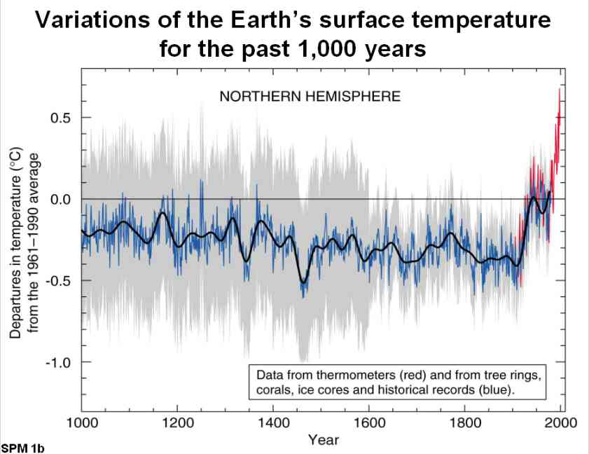
- Draw the graph showing the variations of the earth’s surface temperature for the past 1000 years below.
- To the left of this graph, explain what this indicates.
- We know that warmest winters on record have occurred since
- All have occurred since .
- Evidence from
_ correlate with each other.
- All indicate the same message -
- We know that the Earth is and we know it is
- What is the primary cause of climate change today?
- Define greenhouse gases:
- Examples include:
- How do greenhouse gases warm the surface of the Earth?
- How are greenhouse gases like fur coats?
- What is Vostok?
- How do the gases trapped in bubbles that are trapped in ice help us to determine whether today’s changes are normal or abnormal?
- Vostok evidence shows that for , CO₂
- Today at we know that
- Besides greenhouse gases, what else do scientists measure in these ice bubbles?
What is this?
What does this tell scientists?
How does it tell them this?
- In the last 150 years, CO₂ has increased and methane has increased
- Why have greenhouse gases increased since the start of the Industrial Revolution?
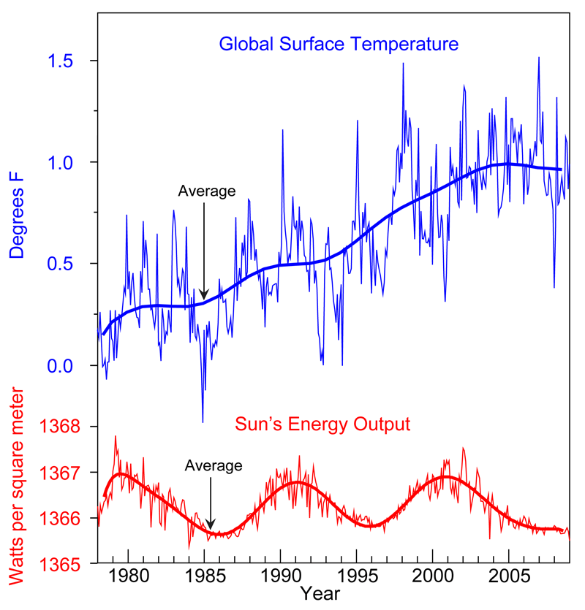
- How do we know this warming trend is not because of the sun?
- In the space to the right, draw the graph showing
both the changes to the Earth’s surface temperature,
and the fluctuation of the Sun’s energy output.

- What are the Milankovitch Cycles?
- Describe the three ways in which the Earth’s orbit can change AND how long each cycle lasts:
1
2
3
- How do we know the Miilankovitch Cycles are not responsible for the changes to the Earth’s climate?
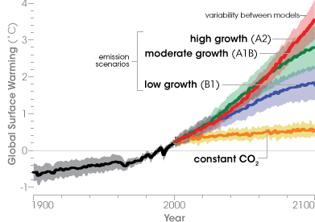
- In the space below, sketch the graph showing the temperature predictions for 2100. Label this graph.
- As greenhouse gas levels increase,
- Northern areas will likely
- Southern areas
- Heavy that once occurred
are projected to
raising the risk of
- For each º F increase in , there is a projected
- How will snowfall change?
How will this affect temperatures?
- Heatwaves like those of 1995 will occur how often by 2100?
- Heavy and severe are projected to occur
- Why are crops expected to do worse (not better) in a future with high CO₂?

- Agriculture depends on
- Wetter conditions in spring
- More frequent will place added
- As insects are able to ,
are expected to
- Why is the faster maturation of crops in the future going to be a bad thing?
- List two reasons why sea levels are rising:

- As oceans warm, they are also becoming more . Why is this a problem?
- Because the oceans contain
this could
- Describe how the thermohaline currents work:
- Why is climate change expected to put the thermohaline currents at risk?
- What would be the problem if the thermohaline currents stopped flowing?
- How will climate change affect terrestrial habitats?
- Warmer springs have led to
- Northeastern birds are returning on average than they did in the 20th century.
- In California,
- Changes to can lead to
- Species with specific will face
as
- How is the border between tundra and boreal forests changing as a result of climate change?
How does this affect species like caribou, arctic foxes, and snowy owls?
- Why are cold-water species such as trout especially at risk because of climate change?
- Explain how the Prairie Pothole region may be approaching a threshold, or tipping point, because of climate change:
- Because carbon dioxide stays for nearly
, and because
the Earth will
- This would occur even
- Current estimates predict
- Global greenhouse gas emissions would have to be reduced by from the levels
they had in by in order to
- In the space below, list and describe 6 things you can personally do to combat climate change.
What you can do: How it will help:
What you can do: How it will help:
What you can do: How it will help:
What you can do: How it will help:
What you can do: How it will help:
What you can do: How it will help:

Unit Wrap-up C. Kohn, Agricultural Sciences - Waterford WI
- Write the 3 topics that you most need to review before the quiz:
1_
2_
3_
- Create 3 high-level questions related to this material
(These questions could be something you still don’t know or questions that reflect understanding that you have now that you did not have before.)
1_
2_
3_
- List 6 vocabulary words that you did not know before or have not used very often prior to this unit:
1_ 2 3
4 5 6
- In the spaces below, fully write three strategies that will help you to remember specific vocabulary words or topics from this unit. NOTE: A strategy is not an activity such as reviewing your notes, studying hard, etc. A strategy is a mnemonic, rhyme, analogy, or other brain-based device that is specific to one item from the unit.
1._
2._
3._
- Circle the most appropriate response. You will only be graded on whether or not you completed this section, so be entirely honest with yourself when completing this section.
Circle one: I used my notes outside of class to prepare for the quiz. Definitely – Yes – Sort of - No
Circle one: I took extra notes in the margins for very difficult concepts. Definitely – Yes – Sort of - No
Circle one: I created a personal strategy for at least three difficult items. Definitely – Yes – Sort of - No
Circle one: I was very involved and actively studying during the quiz review. Definitely – Yes – Sort of - No
Circle one: I think I will be satisfied with the quiz grade I received this week. Definitely – Yes – Sort of - No

