Co-Dominance, Incomplete Dominance,
and Epistasis Worksheet by C Kohn, WUHS
Partner Names: Hour Date
Date Due: end of class Why late? Score: + ✓ -
Directions: In your groups of 2, complete the worksheet below. Each question should be answered by a different partner (i.e. you should not answer multiple questions in a row). Initial by the questions you complete.
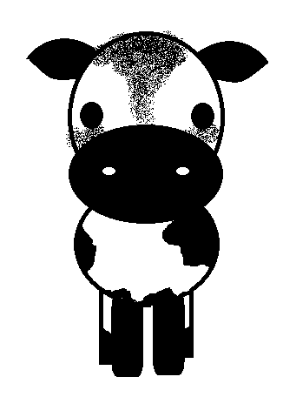
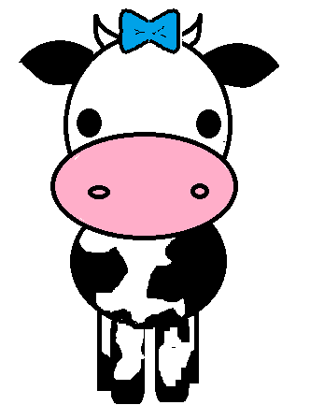
- Brandy the Bull has no horns (polled). Polled or hornless is dominant to having horns. We don’t know if he is homozyous dominant (HH) or heterozygous (Hh). To test this, Mr. Kohn mates Brandy the Bull with a horned cow. For a cow to be horned, it has to be homozyous recessive (hh).
Complete the Punnett Squares above for each possible genotype for Brandy. Then answer the questions below.
  - If Brandy is homozygous dominant, what would be the possible genotypes:
  - If Brandy is heterozygous, what would be the possible genotypes:
  - If Brandy is homozygous dominant, what would be the possible phenotypes:
  - If Brandy is heterozygous, what would be the possible phenotypes:
- Jack is heterozygous for Type A blood. Jill is heterozygous for Type B blood. Neither Jack nor Jill are Type AB. Create a Punnett Square below showing their possible childrens’ blood types.
Complete the Punnett square for bloody type. Then answer the questions below.
  - What possible blood types could their children have?
  - Which genotype could receive any kind of blood?
  - Which genotype could give blood to anyone?
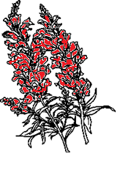
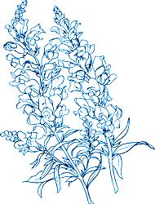
- Spotted flowers are an example of co-dominance. A red snapdragon flower (RR) is paired with a white snapdragon (WW). What will their offspring look like if both red and white are dominant traits?
The offspring of a red and white snapdragon will be
because
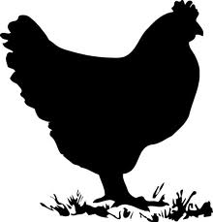
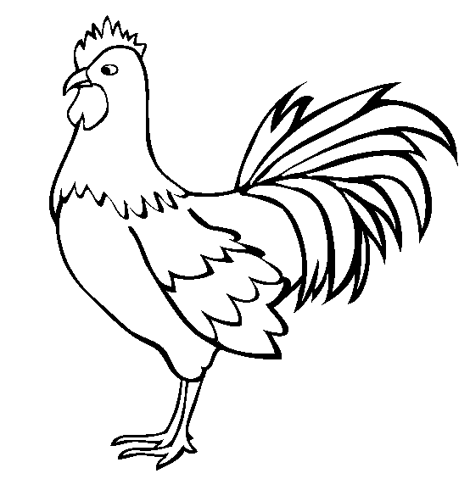
- Human hair curliness is a good example of incomplete dominance. Straight hair is recessive to curly hair. However, someone who is heterozygous for hair curliness will have wavy hair that is kind of curly but kind of straight.
If a couple, both with wavy hair, have children, what possible genotypes and phenotypes would they have? Show in the Punnett Square and then explain.
- A white rooster is crossed with a black hen. The rooster is homozygous, and so is the hen.
If the black and white colors are incompletely dominant, what color(s) will the chicks be?
Explain below and show with a Punnett Square.
If on the other hand the black and white colors are co-dominant, what color(s) will the chicks be? Explain below and show with a Punnett Square.
In the space below, draw what the chicks’ feathers would look like for incomplete dominance on the left and what they would look like for co-dominance in this case on the right.
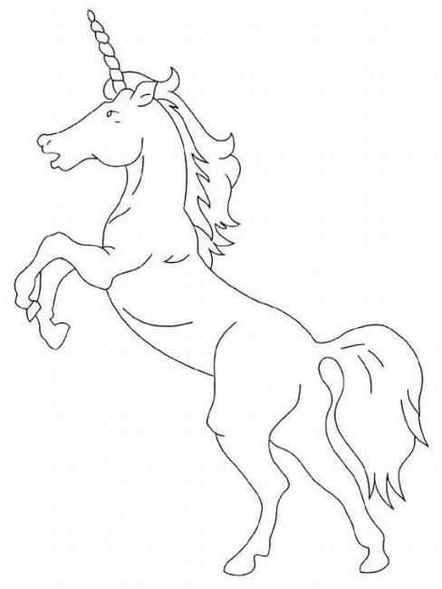
- It is a little known ‘fact’ that unicorns demonstrate epistasis for their horn presence and color. The presence of a unicorn’s horn is recessive (hh), while no horn (polled) is dominant (HH or Hh). The color of the horn can be either white (dominant – WW or Ww) or black (recessive - ww). If the horn is not present, the genes for color are not expressed. Use this information to complete the questions below.
First, write a definition for epistasis:
Two unicorns mate. One unicorn has a white horn and has genotype hhWw (has horns and the horn is white). The other unicorn has the genotype Hhww (it has genes for a black horn, but no horn). What is the likelihood that they will have…
  - A colt with a white horn? /16
  - A colt with a black horn? /16
  - A colt with no horn? /16
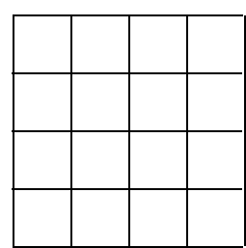
Note: your numbers for A, B, and C should add up to 16!
Complete the dihybrid Punnett Square below to answer the questions above.
Could a unicorn colt with no horn have offspring with a horn? Explain.
Could a unicorn colt with a horn have offspring with no horn? Explain.

