DNA Worksheet by C Kohn
Partner names: Hour
Date Assignment is due: Why late? Score: + ✓ -
^{Day of Week} ^{Date} If your project was late, describe why
Directions: Use your notes and your partner to complete this sheet. The younger partner should complete the odd questions and the older partner should complete the even questions. You should both work together on each question to create the answer.
- Draw DNA below:
- Label each of the following parts: Nitrogenous bases Sugar Molecule Phosphate
- Which parts of DNA actually code for proteins?
Which parts of DNA form the “backbone” of DNA?
- Draw transcription below:
- Label each of the following parts: Helicase Polymerase DNA mRNA
- Which base is A always found with? Which base is G always found with?
Why? (there are two reasons)
_
- In what direction is DNA read?
  - What does this mean?
_
Hint: What does 5’ and 3’ refer to?

- How does RNA differ from DNA? There are two key ways:
1.
2.
- Describe the role of each of the following:
mRNA:
rRNA:
tRNA:
- Draw translation below:
- Label each of the following parts: mRNA Ribosome tRNA amino acids
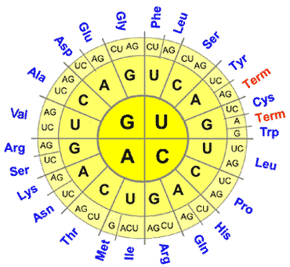
- What is a codon?
- What would GAG code for?
What would CCC code for?
What would UAC code for?
What would GGU code for?
What would ACU code for?
What would UAG code for?
- What is the difference between transcription and translation?
_ `
_ `

