Invasive Species Lab
Name: Hour Date:
Date Assignment is due: Why late? Score: + ✓ -
^{Day of Week} ^{Date} If your project was late, describe why
Overview: in this lab, you will be determining the impact of invasive species on the school’s forest ecosystem. Using the Invasive Species of WI Handout (see http://bit.ly/wi-invasives), you will identify how often each species occurs along a transect line in order to determine the overall impact and spread of invasive species in our school’s forest ecosystem.
Materials Needed: this form; Invasive Species of WI handout; tape measure; pen or pencil; outdoor-appropriate clothing
Directions: In your assigned teams of 2, you will find the transect area assigned to you and follow the steps below:
- Once you have found your transect area, familiarize yourself with the kinds of species you will be looking for.
  - Look carefully at your ID handout – some species may look very similar to each other.
  - Try to determine key identifying aspects of each species – i.e. what are the key traits that would help you to determine without a doubt that you are looking at that particular species?
- Using a tape measure (or by pacing), move 5 meters in from the outside edge of the forest ecosystem. Using the attached chart, record how many of each invasive species are within arm’s reach at that particular point.
  - You may want to have one person identifying and one person recording.
  - Be careful when moving! Use caution so that you do not step on native plants or create a greater disturbance – this could allow more invasives to attack this ecosystem!
- Repeat this step every 5 meters until you reach 75 meters.
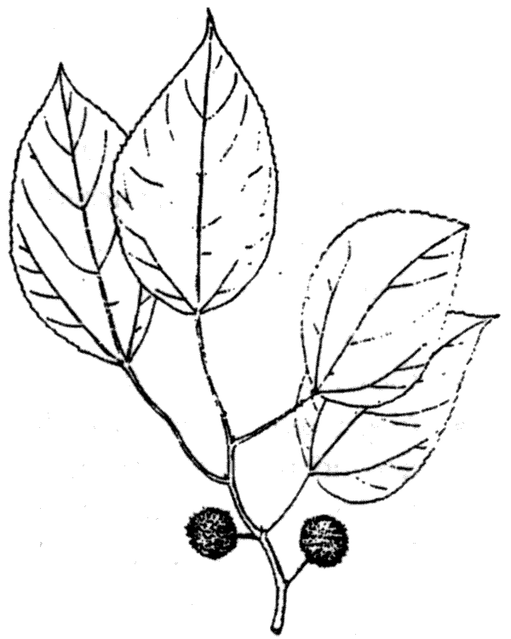
- Report back to your start location at the end of the hour or when your instructor calls time.
- Collect your data as a class and use the whole-class data to answer the questions on the last page.

Transect Survey Data Form: Group Name (e.g. 2A, 5B, etc.) Study Location: School Environmental Center
Partner Names: Date:
Record the number of times each species was within arm’s reach at each 5-meter interval.
Species / Site# | 5m | 10m | 15m | 20m | 25m | 30m | 35m | 40m | 45m | 50m | 55m | 60m | 65m | 70m | 75m | Total Times Found
Black Locust
Common Buckthorn
Tree-of-heaven
Autumn Olive
Eurasion Bush Honeysuckle
Glossy Buckthorn
Japanese Barberry
Multiflora Rose
Black Swallow-wort
Oriental Bittersweet
Bird's-foot trefoil
Musk/Plumeless Thistle
Canada Thistle
Common and cut-leaved teasel
Crown vetch
Dame's Rocket
European marsh thistle
Garlic Mustard
Japanese hedgeparsley
Japanese knotweed
Leafy/Cypress Spurge
Poison Hemlock
Purple Loosestrife
Queen Anne's-lace
Spotted Knapweed
Tansy
Wild Parsnip
White & Yellow Sweet Clover
Narrow-leaf Cattail
Phragmites (common reed)
Reed Canary Grass
Smooth Brome

Questions – complete after all the class’s data has been compiled.
- What was the most prevalent invasive species in your transect?
- Why do you think this species was more prevalent than the others? Why would this species be more successful at invading than others? Hypothesize three advantages this species had in your area over other invasive species:
1.
2.
3.
- What was the most prevalent invasive species in this ecosystem overall?
- What are 3 factors that enable this species to spread like it has? List AND DESCRIBE in detail below:
1.
2.
3.
- On a scale of 1-5, with 1 being “no problem whatsoever” and 5 being “worst possible outcome”, how would you rank the prevalence of invasive species in this ecosystem?
Ranking: Why did you choose this ranking? Explain in detail:
_
_
- What should be done to fix this problem?
How would you implement this plan?
_
_
Why is this action needed?
_
_

