Practice Agriscience Final Exam C. Kohn, Waterford WI

Name: Hour Date: Score:

1. Which of the following best describes how modern cattle were created?
   1. Different breeds of cattle resulted from the different environments of Europe, where specific kinds of cattle emerged through natural selection.
   2. Breeds of cattle began as widely-varying animals but eventually were bred so that all cows became black and white and excellent at producing milk.
   3. Cattle used to be completely dependent on people but were changed so that they could exist in natural environments without human interference.
   4. All modern breeds of cattle originated from the auroch, a much larger and more ferocious animal that was selected for productive traits by only breeding individuals who expressed those traits.
   5. All of the above are true.
2. Improvements to species that occur through domestication…
   1. Usually result in the loss of other valuable traits.
   2. Develop by breeding only individuals who express those traits.
   3. Are the result of the proteins created through transcription and translation of specific genes.
   4. All of the above.
   5. None of the above.
3. What two factors are most responsible for the emergence of different breeds of domesticated animals in early human civilizations?
   1. Isolation and an understanding of Mendelian genetics
   2. An understanding of Mendelian genetics and different needs and environments of different locations
   3. Different needs and environments of different locations and isolation of those same places
   4. None of the above are responsible for the emergence of different breeds
4. Which of the following describes the Holstein breed?
   1. Large, rugged cattle that tolerate rough terrain.
   2. Excellent grazers that turn low quality pasture into high quality milk.
   3. Produces the greatest volume of milk.
   4. Produces the milk highest in butterfat.
   5. Dual purpose for both meat and milk.
5. Which of the following describes the Jersey breed?
   1. Large, rugged cattle that tolerate rough terrain.
   2. Excellent grazers that turn low quality pasture into high quality milk.
   3. Produces the greatest volume of milk.
   4. Produces the milk highest in butterfat.
   5. Dual purpose for both meat and milk.
6. Which of the following describes the Brown Swiss breed?
   1. Large, rugged cattle that tolerate rough terrain.
   2. Excellent grazers that turn low quality pasture into high quality milk.
   3. Produces the greatest volume of milk.
   4. Produces the milk highest in butterfat.
   5. Dual purpose for both meat and milk.
7. Which of the following describes the Ayrshire & Guernsey breeds?
   1. Large, rugged cattle that tolerate rough terrain.
   2. Excellent grazers that turn low quality pasture into high quality milk.
   3. Produces the greatest volume of milk.
   4. Produces the milk highest in butterfat.
   5. Dual purpose for both meat and milk.
8. Which of the following describes the Milking Shorthorn breed?
   1. Large, rugged cattle that tolerate rough terrain.
   2. Excellent grazers that turn low quality pasture into high quality milk.
   3. Produces the greatest volume of milk.
   4. Produces the milk highest in butterfat.
   5. Dual purpose for both meat and milk.
9. This is the main purpose of a breed association:
   1. To make better cattle through genetic modification in a laboratory.
   2. To provide genetic data on breeding animals to produce better offspring.
   3. To merge different breeds to develop hybrid vigor.
   4. All of the above.
   5. None of the above.
10. This method of genetic change is the result of random occurrences that randomly enable one trait to become more prevalent than another.
    1. Mutation b. Random Drift c. Selection d. Crossbreeding e. Selection AND Crossbreeding
11. This method of genetic change is responsible for hybrid vigor.
    1. Mutation b. Random Drift c. Selection d. Crossbreeding e. Selection AND Crossbreeding
12. This method of genetic change occurs when one individual is more likely to reproduce than another because it possesses traits that are advantageous to its survival and/or are beneficial for human needs.
    1. Mutation b. Random Drift c. Selection d. Crossbreeding e. Selection AND Crossbreeding
13. This method of genetic change occurs randomly and results in the DNA of a species changing in a negative, positive, or neutral manner.
    1. Mutation b. Random Drift c. Selection d. Crossbreeding e. Selection AND Crossbreeding
14. An agriculturalist can directly control this kind of genetic change.
    1. Mutation b. Random Drift c. Selection d. Crossbreeding e. Selection AND Crossbreeding
15. This is the term for a trait that has a small amount of outcomes that can be predicted with a Punnett square.
    1. Continuous traits b. Discontinuous traits c. Both d. Neither
16. This is the term for traits that are affected by multiple genes and are not predictable using a Punnett square.
    1. Continuous traits b. Discontinuous traits c. Both d. Neither
17. This kind of trait is usually grouped into categories and shown on a histogram.
    1. Continuous traits b. Discontinuous traits c. Both d. Neither
18. The further from the center an outcome is on a histogram, the likely it is to occur.
    1. More b. Less c. Neither
19. This is the term for an outcome that would be found on the edges of a histogram.
    1. Bell curve b. Heritability c. Environmental Variance d. Outlier e. Correlation
20. This is the term for how much a trait is affected by factors that are not genetically based.
    1. Bell curve b. Heritability c. Environmental Variance d. Outlier e. Correlation
21. This is the term for how much the variation in a trait is affected by genetic factors.
    1. Bell curve b. Heritability c. Environmental Variance d. Outlier e. Correlation
22. This is the term for when selection for one trait affects another unrelated trait.
    1. Bell curve b. Heritability c. Environmental Variance d. Outlier e. Correlation
23. Milk yield has a heritability of 0.25. This means that…
    1. It is almost entirely unaffected by genetics.
    2. It has some genetic basis but also is affected by environmental factors.
    3. It is highly impacted by genetics.
24. Milk protein and fat each has a heritability of 0.5. This means that…
    1. It is almost entirely unaffected by genetics.
    2. It has some genetic basis but also is affected by environmental factors.
    3. It is highly impacted by genetics.
25. Calving ease has a heritability of 0.05. This means that…
    1. It is almost entirely unaffected by genetics.
    2. It has some genetic basis but also is affected by environmental factors.
    3. It is highly impacted by genetics.
26. The higher the heritability the ___________ a trait is affected by a choice of bulls
    1. Less b. More
27. Which of the following WOULD NOT increase the rate of genetic change for a species.
    1. Record keeping that records the strength of each animal for each trait.
    2. Breeding an animal as soon as it is ready.
    3. Breeding animals that have little variation in genetic traits.
    4. Keeping as many animals as possible each year for breeding.
    5. None of the above; all of these would help increase the rate of genetic change.
28. Milk volume and milk quality are negatively correlated. This means…
    1. The more milk a cow produces, the better it will be.
    2. The more milk a cow produces, the lower its quality will be.
    3. The volume of milk production is unrelated to the quality of the milk.
29. According to Galton’s Law, the best cow in the world would most likely have a daughter who…
    1. Would also be the best cow in the world.
    2. Would be the worst cow in the world.
    3. Would be a good cow but would not be as good as her mother was.
    4. Would have a completely unpredictable performance; we would be unable to tell if she would be a good cow or a poor performer.
30. This is the process in which a producer can directly add the semen of a bull to a cow without the bull being present.
    1. Sire Summary b. Predicted Transmitting Ability c. Standard Transmitting Ability d. Art. Insemination
31. This is an estimate of how well a bull will pass on improvements to genetic traits to its offspring.
    1. Sire Summary b. Predicted Transmitting Ability c. Standard Transmitting Ability d. Art. Insemination
32. This is determined by standard deviation of the bull’s PTA and ranks a bull compared to all other bulls from -3-3.
    1. Sire Summary b. Predicted Transmitting Ability c. Standard Transmitting Ability d. Art. Insemination
33. This is a report that summarizes the genetic quality of available bulls for every measured trait.
    1. Sire Summary b. Predicted Transmitting Ability c. Standard Transmitting Ability d. Art. Insemination
34. Which bull would be the best choice for improving the milk fat percentage of your herd’s cows?
    1. R-E-W Buckeye ET b. Pursuit September Storm ET
35. Which bull would be the best choice for improving the milk protein percentage of your herd’s cows?
    1. R-E-W Buckeye ET b. Pursuit September Storm ET
36. Biotechnology…
    1. is a recently developed science in which genes from one species are added to another.
    2. is the process of changing living species or a biological process to benefit human activity.
    3. is a field of research that is currently illegal in the US
    4. All of the above
37. The ultimate goal of biotechnology is to…
    1. Allow nature to create beneficial traits in species in an unobstructed manner.
    2. Modify the genomes of living species so that they are more valuable for human purposes.
    3. Change the traits of living species without regard for whether or not they are beneficial.
    4. Eliminate species that are not valuable to human beings.
38. The use of biotechnology to develop medicines would be an example of…
    1. Green Biotechnology b. White Biotechnology c. Red Biotechnology
39. The use of biotechnology to protect the environment would be an example of…
    1. Green Biotechnology b. White Biotechnology c. Red Biotechnology
40. The use of biotechnology to make an industrial process more efficient or productive would be an example of…
    1. Green Biotechnology b. White Biotechnology c. Red Biotechnology
41. The use of biotechnology to improve agricultural yields would be an example of…
    1. Green Biotechnology b. White Biotechnology c. Red Biotechnology
42. The entire set of genes of an organism is known as its…
    1. Chromosome b. Genome c. Trichrome d. Nucleus
43. This is the process in which a species is changed through intentional and controlled mating of specific individuals over long periods of time.
    1. Gene splicing b. Brewing/Fermentation c. Artificial Selection d. Artificial Insemination
44. This is the process in which the semen of one individual is artificially introduced into the reproductive tract of another individual.
    1. Gene splicing b. Brewing/Fermentation c. Artificial Selection d. Artificial Insemination
45. This is the process in which artificially-selected microorganisms are used to convert food from one form to another to make more valuable or useful products.
    1. Gene splicing b. Brewing/Fermentation c. Artificial Selection d. Artificial Insemination
46. This is the process in which a gene from one species is added the genome of another species.
    1. Gene splicing b. Brewing/Fermentation c. Artificial Selection d. Artificial Insemination
47. _______ are a form of biotechnology that uses a weakened form of a disease.
    1. Stem Cells b. Cloning c. Vaccines d. Genomics e. Protein Purification
48. _______ is the science of reading an individual’s DNA.
    1. Stem Cells b. Cloning c. Vaccines d. Genomics e. Protein Purification
49. ___________ is the process of creating an individual with an identical set of genes to another individual.
    1. Stem Cells b. Cloning c. Vaccines d. Genomics e. Protein Purification
50. ____________ are a form of biotechnology that could develop replacement organs and tissues for injured or diseased individuals
    1. Stem Cells b. Cloning c. Vaccines d. Genomics e. Protein Purification
51. ____________ is the form of biotechnology that allows scientists to analyze the amino acid and DNA sequences of specific traits or products.
    1. Stem Cells b. Cloning c. Vaccines d. Genomics e. Protein Purification
52. Microbial Synthetic Biology is the science in which…
    1. The genes of one organism are added to another.
    2. Genes from one species are deleted to improve their performance.
    3. An entirely new, previously nonexistent species is created by scientists in a laboratory.
    4. A new strain of DNA, SNA is added to existing species.
    5. All of the above.
53. Which of the following is NOT an example of biotechnology?
    1. Bt Corn b. Cheese c. Dolly the Sheep d. Antibiotics e. All of these are biotechnology
54. To sequence DNA, we would typically use
    1. Red blood cells b. White blood cells c. Skin cells d. Plasma
55. The first step of isolating DNA is to centrifuge your blood, meaning we…
    1. Shake it vigorously
    2. Heat it quickly
    3. Spin it rapidly
    4. Insert it into bacteria
56. In order to access the nuclei inside of the cells, we must _____ the cells with a detergent
    1. Boil b. Freeze c. Stir d. Lyse
57. Nuclei can be separated from the rest of the cell contents using…
    1. Lysing agent b. Heat c. Enzymes d. Centrifugation
58. To separate DNA from the rest of the contents of the nucleus, we would use…
    1. Water b. Alcohol c. Heat d. Centrifugation
59. To read DNA letter by letter, we would use the ___________ Method
    1. Sanger b. Sequencer c. Separator d. Babcock
60. To break DNA into more manageable chunks, we would use a ….
    1. Acid b. Base c. E. coli bacteria d. Restriction Enzyme
61. To copy the same piece of DNA many times, we would use a ….
    1. Acid b. Base c. E. coli bacteria d. Restriction Enzyme
62. To denature DNA means to…
    1. Multiply it b. Separate it into individual strands c. Cut it into pieces d. Purify it
63. A primer does which of the following?
    1. Tells helicase where to open the DNA
    2. Indicates where to add bases
    3. Adds bases to the single stranded DNA
    4. Stops the addition of bases in random places and dyes the strand
64. Polymerase does which of the following?
    1. Tells helicase where to open the DNA
    2. Indicates where to add bases
    3. Adds bases to the single stranded DNA
    4. Stops the addition of bases in random places and dyes the strand
65. A ddNTP does which of the following?
    1. Tells helicase where to open the DNA
    2. Indicates where to add bases
    3. Adds bases to the single stranded DNA
    4. Stops the addition of bases in random places and dyes the strand
66. How is a ddNTP different from a normal base?
    1. It is dyed
    2. It stops the addition of any other bases
    3. It indicates the last letter added in any sequence
    4. All of the above
67. Why do we put the replicated DNA fragments into an electrified gel?
    1. This purifies the DNA
    2. This colors the DNA so we can read it
    3. This separates the DNA chunks from longest to shortest so that they can be read
    4. All of the above
68. How does a computer know how to read DNA?
    1. The last base added colors the entire stretch of DNA; a laser excites the ddNTP to determine this color
    2. A computer can see each DNA chunk and read it letter by letter
    3. The computer can convert the molecular structure of each base into a color
    4. The DNA uses E. coli bacteria to read the DNA
69. An intron is…
    1. A section of DNA that codes for a protein
    2. A section of DNA that codes for nothing
    3. A tool used to separate useful DNA from useless DNA
    4. A tool that determines whether or not DNA has an Open Reading Frame
70. An exon is…
    1. A section of DNA that codes for a protein
    2. A section of DNA that codes for nothing
    3. A tool used to separate useful DNA from useless DNA
    4. A tool that determines whether or not DNA has an Open Reading Frame
71. Which of the following would have an Open Reading Frame?
    1. An intron b. An exon c. A polymerase d. A ddNTP
72. An Open Reading Frame can be identified by a lack of ______ between the beginning and end of the gene.
    1. ddNTPs b. Proteins c. Stop commands d. Introns
73. The Human Genome Project has made it possible for us to…
    1. Read every letter of the human genome
    2. Identify the causes of thousands of genetic diseases
    3. Create tests to check any individual for their risk of over a thousand diseases
    4. All of the above
74. Genetic engineering is the process in which…
    1. The genome of an organism is changed through natural selection.
    2. The genome of an organism is changed through artificial selection.
    3. The genome of a species is modified by adding or removing a gene.
    4. All of the above.
75. This is the technique where a naturally-occurring gene is replaced by mutated gene.
    1. Recombinant DNA b. Gene Knockout c. Gene Knockin
76. This is the technique where a functional gene is removed from a genome.
    1. Recombinant DNA b. Gene Knockout c. Gene Knockin
77. This is the technique where a new gene is added to a genome where it did not exist before.
    1. Recombinant DNA b. Gene Knockout c. Gene Knockin
78. Genetic engineering is used to produce insulin; prior to this, treatments for diabetes came from…
    1. Synthetically-produced medicine from a laboratory.
    2. The pancreas of cows or pigs (often resulting in an immune response by the patient).
    3. Plant-based compounds.
    4. None of the above; prior to genetic engineering there were no treatments for diabetes.
79. How was genetic engineering used to develop treatments for diabetes?
    1. The gene for human insulin was inserted into the genome of diabetes patients.
    2. The gene for human insulin was inserted into cow and pig genomes and taken from their pancreas.
    3. The gene for human insulin was replaced by the gene for cow or pig insulin so that it wouldn’t be damaged.
    4. The gene for human insulin was inserted into E. coli bacteria so that this microbe could produce an identical version of human insulin.
80. What is a sticky end?
    1. When a primer is added to DNA so that polymerase creates copies of it.
    2. When DNA Ligase makes DNA stick to genomes.
    3. When DNA is cut so that a single-stranded portion juts out.
    4. When DNA is cut into pieces so that they reassemble into a new genome.
81. How do sticky ends make recombinant DNA possible?
    1. The sticky ends help polymerase know what bases to add to the genome.
    2. By cutting up the genome into sticky ends, we ensure that new genes will form.
    3. If both the inserted gene and the genome are cut with the same restriction enzyme, the inserted gene will have the complementary bases on its sticky ends for the bases on the sticky end of the genome.

*Use the cut DNA sequence below to answer the following question*

1. 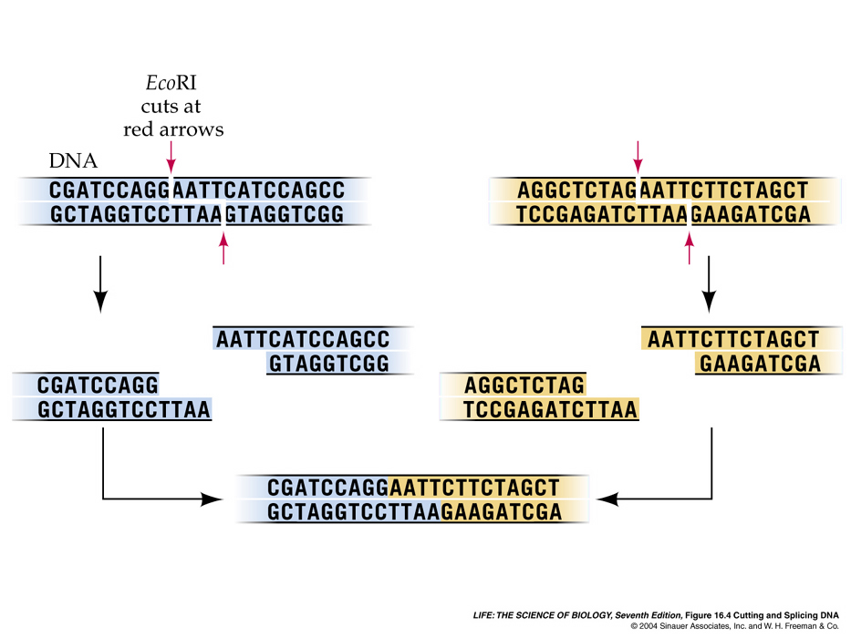A gene inserted into this genome would to begin with what sequence (*i.e. what bases do the x’s below have to be in order for this gene to be inserted into this genome*)?
   1. TTAA
   2. AATT
   3. CGAT
   4. GCTA

X X X X

1. What is the purpose of DNA Ligase?
   1. It prevents mutations from occurring.
   2. It ensure that the inserted gene does not ‘fall out’ of the genome.
   3. It ensures that sticky ends are “sticky”.
   4. It reduces the likelihood that a recombinant genome will have extra genes.
2. What is Bt corn?
   1. A type of corn that produces its own insecticide because of an inserted gene for toxin production
   2. A type of corn that is organically produced and cannot be sprayed with insecticides
   3. Any kind of corn that is genetically modified
   4. Corn that is especially vulnerable to the corn pest, *Bacillus thuringiensis*
3. How does Bt corn prevent being attacked by insects?
   1. It kills all insects that touch it
   2. When an insect ingests it, it breaks down its intestinal tract
   3. It prevents insects from reproducing
   4. It does not prevent insect attacks
4. Which of the following is TRUE about Bt Corn and monarchs
   1. Bt corn has been shown to cause significant harm to monarch butterflies
   2. An early strain of Bt corn did initially cause harm to monarchs, but is not used anymore
   3. Bt corn has never had any impact on monarch butterflies
5. Golden Rice is rice that is genetically modified to produce its own ____________
   1. Vitamin A b. Vitamin B c. β-carotene
6. What organism was used to introduce the genes for this compound into Golden Rice?
   1. *Bacillus thuringiensis b.* Taq polymerase c. *E. coli d. Agrobacterium*
7. The most common method for producing a transgenic animal is…
   1. Use of *Agrobacterium* to naturally insert a removed gene into a new genome.
   2. Use of restriction enzymes and sticky ends to modify animal genomes.
   3. Gene transfer by DNA Microinjection
   4. Stem Cell-based Cloning
8. To produce a transgenic animal via microinjection, the gene to be added must be inserted into…
   1. The nucleus of an unfertilized egg.
   2. The pronucleus of a sperm cell.
   3. The extracted DNA of the animal.
   4. An animal’s skin cell.
9. A knockout mouse is a mouse that…
   1. Has received a mutated or changed gene in place of one of its normal genes.
   2. Has had a gene added to its genome via genetic engineering.
   3. Has lost a functional gene as a result of genetic engineering.
   4. All of the above.
10. How are embryonic stem cells used in creating a knockout mouse?
    1. A faulty gene is inserted into the stem cell and replaces the regular gene to inactivate it.
    2. Because stem cells can become any kind of tissue, the stem cells are used to grow artificial mice.
    3. The embryonic stem cells are inserted into the adult mouse’s body and change its function.
11. A knockin mouse is a mouse that…
    1. Has received a mutated or changed gene in place of one of its normal genes.
    2. Has had a gene added to its genome via genetic engineering.
    3. Has lost a functional gene as a result of genetic engineering.
    4. All of the above.
12. What is a chimera?
    1. The breed of mouse used to study knockout genes.
    2. An organism that has two genomes; some cells have one genome and other cells have the other genome.
    3. The term for any organism that is created by genetic engineering.
    4. A mouse made from a fertilized embryo.
13. If you wanted to create an organism that produced an additional protein needed for a human disease, which of the following would work best?
    1. Recombinant DNA b. Gene Knockout c. Gene Knockin
14. If you wanted to determine the impact of a faulty gene on normal body function, which would work best?
    1. Recombinant DNA b. Gene Knockout c. Gene Knockin
15. If you wanted to understand the specific function of a particular gene, which would work best?
    1. Recombinant DNA b. Gene Knockout c. Gene Knockin
16. If we were unsure whether or not a specific mutation was the cause of a kind of cancer, what method could confirm whether or not this was the case?
    1. Recombinant DNA b. Gene Knockout c. Gene Knockin
17. This is a technique in which a specific protein is found using an antigen and antibody which cause a color change if the protein is present.
    1. Genomics b. PCR c. Gel Electrophoresis d. Southern Blotting e. ELISA
18. This is a technique in which DNA that was cut using a restriction enzyme is pulled through a gel which creates a banding pattern.
    1. Genomics b. PCR c. Gel Electrophoresis d. Southern Blotting e. ELISA
19. This is a procedure that involves amplifying small amounts of DNA to create millions of copies of a particular DNA sequence for analysis or testing.
    1. Genomics b. PCR c. Gel Electrophoresis d. Southern Blotting e. ELISA
20. This is a technique in which DNA fragments in an electrophoresis gel are transferred to a membrane to check for a specific gene sequence using a marker with a complementary sequence for that specific gene.
    1. Genomics b. PCR c. Gel Electrophoresis d. Southern Blotting e. ELISA
21. This involves reading the entire genome of an organism using a technique such as the Sanger Method.
    1. Genomics b. PCR c. Gel Electrophoresis d. Southern Blotting e. ELISA
22. This is what is used to open DNA to make copies during PCR.
    1. Helicase b. Polymerase c. Heat d. Primer e. All of the above
23. Primers are necessary for PCR because…
    1. They tell polymerase where to begin copying.
    2. They ensure that the DNA that is copied is the target sequence we need.
    3. Polymerase couldn’t copy DNA without a primer.
    4. All of the above.
    5. None of the above.
24. Why is a thermal cycler needed for PCR?
    1. It is what copies the DNA strand over and over.
    2. It provides the heat needed to denature the DNA.
    3. It provides the starting point for polymerase to begin copying.
    4. All of the above.
    5. None of the above.
25. What is Taq polymerase?
    1. The protein that makes copies of DNA.
    2. The protein that indicates where the copying of DNA should begin.
    3. The protein that separates double-stranded DNA.
    4. All of the above.
26. Why is Taq polymerase used for PCR?
    1. Regular polymerase can’t make copies of anything but human DNA.
    2. Taq polymerase can withstand the heat needed for PCR to function.
    3. Regular polymerase cannot make copies fast enough.
    4. All of the above.
    5. None of the above.
27. What would happen if a restriction enzyme was not used prior to gel electrophoresis?
    1. The DNA would not copy enough times to be visible.
    2. The DNA would remain double-stranded and PCR could not occur.
    3. The DNA would not form the bands needed for gel electrophoresis; it would stay in one clump.
    4. All of the above.
    5. None of the above.
28. Why do different individuals have different banding patterns when their DNA is cut and run through gel electrophoresis?
    1. Because everyone’s exons are different, they will result in different patterns on the gel.
    2. Because no two people have the same number of microsatellites (or STRs) across all the sites that are tested to create a genetic fingerprint (unless they are twins or clones).
    3. Because everyone’s introns are so similar, researchers focus on the genes for proteins, which vary widely.
    4. 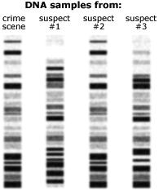Because of mutations in an individual’s genome, which occur regularly.
29. Look at the DNA fingerprint to the right. Based on this  
    evidence, we can conclude that…
    1. Suspect 1 committed the crime.
    2. Suspect 2 committed the crime.
    3. Suspect 3 committed the crime.
    4. Suspect 2 was at the scene of the crime.
    5. Suspect 3 was at the scene of the crime.
30. 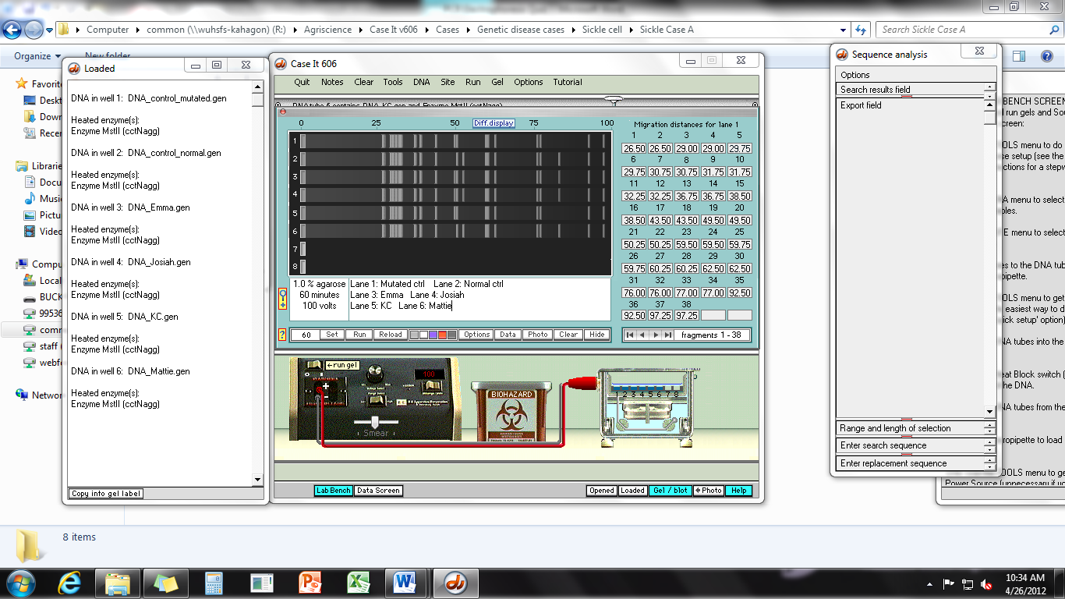Based on the electrophoresis   
    gel to the right, we can conclude   
    that _____ has the disease.
    1. Emma
    2. Josiah
    3. KC
    4. Mattie

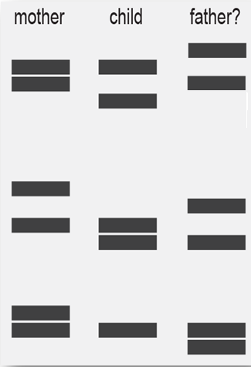

1. Based on the gel to the right…
   1. This is not the father.
   2. This must be the father.
   3. This could possibly be the father;   
      more data is needed to tell.
2. Southern Blotting differs from PCR-Electrophoresis in that…
   1. Southern Blotting does not involve a gel.
   2. Southern Blotting does not require amplification of the DNA.
   3. Southern Blotting follows PCR and requires a membrane  
      (to absorb the DNA) and a probe (to indicate if a gene is present).
   4. Southern Blotting is like PCR and uses some of the same steps but is   
      used to find infectious disease, not whether or not a gene is present.
   5. Southern Blotting is used for plant DNA. PCR Electrophoresis is used   
      for animal DNA.
3. For which of the following would Southern Blotting NOT be effective?
   1. To determine if a person has a genetic mutation for a disease.
   2. To determine if a transgenic crop successfully received the new gene.
   3. To determine if a cow carries a specific gene linked to higher productivity.
   4. To determine if a person carries a genetic disease (and is heterozygous for that gene).
   5. None of the above; Southern Blotting could be used to determine all of these things.

*Use the results from a Southern Blot to the right to answer the following questions.*

1. In this example, we are testing for recessive genetic disease. The mother (Megan) is _______ for this disease.
   1. 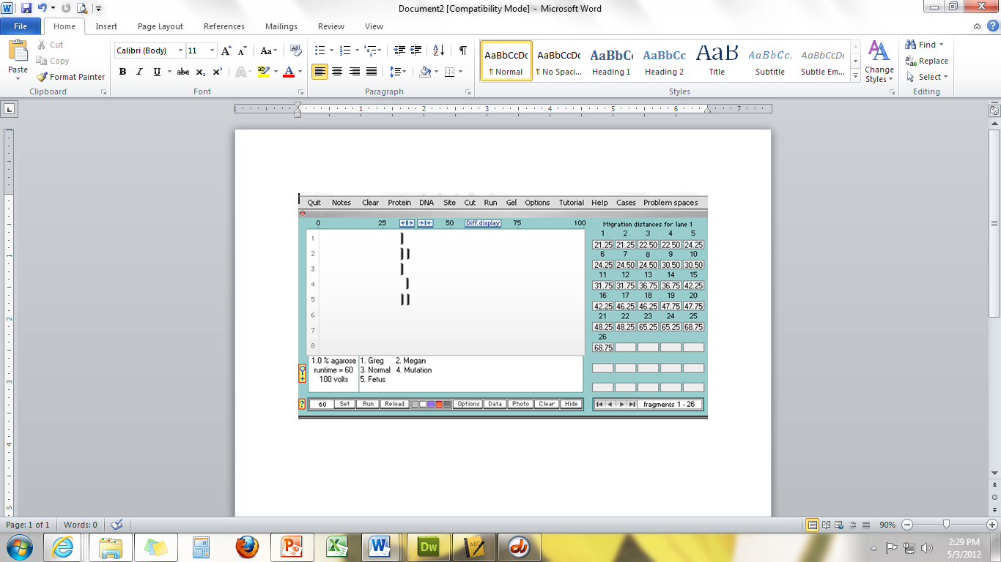Heterozygous b. Homozygous Recessive c. Homozygous Dominant d. None of the above
2. The father (Greg) is _______ for this disease.
   1. Heterozygous b. Homozygous Recessive c. Homozygous Dominant d. None of the above
3. The fetus is _______ for this disease.
   1. Heterozygous b. Homozygous Recessive c. Homozygous Dominant d. None of the above
4. The unborn fetus _____________________
   1. Does not have the disease and does not carry it
   2. Carries the disease but does not have it
   3. Has the disease and carries it
   4. None of the above
5. ELISA is a test that only works for ___________ disease.
   1. Infectious b. Incurable c. Genetic d. Curable
6. ELISA works by detecting ______________
   1. Genes b. Polymerases c. Proteins d. White blood cells
7. ___________ is the protein produced by the disease while __________ is the protein that recognizes the disease.
   1. Antibody, Antigen
   2. Antigen, Antibody
   3. Gene, Enzyme
   4. Enzyme, Gene
8. If an individual has had a disease, their blood will always contain _________ specific to that disease
   1. Antigens b. Antibodies c. All of the above
9. If a disease is present in a blood sample, the well of the ELISA plate containing that sample will _______
   1. Grow viral particles b. Not change c. Move the furthest d. Change color
10. The severity of a disease can be determined through the ELISA test by …
    1. Measuring how much the color changes
    2. How much the bands of DNA move
    3. Whether or not the probe binds a gene
    4. All of the above
11. A woman named Katrice contracted HIV from her boyfriend in high school who was an active drug user. She was not aware of her infection until after she was married and had a child. In this test, you can see blood samples from Katrice, her husband (*father*) and her daughter Liddy at both 3 months and 6 months of age. You can also see a negative (lane 6) and a positive control (lane 1). Who is HIV positive?
    1. The father and Liddy (infant)
    2. Katrice and her husband (the father)
    3. Katrice and Liddy (infant)
    4. Katrice only
    5. 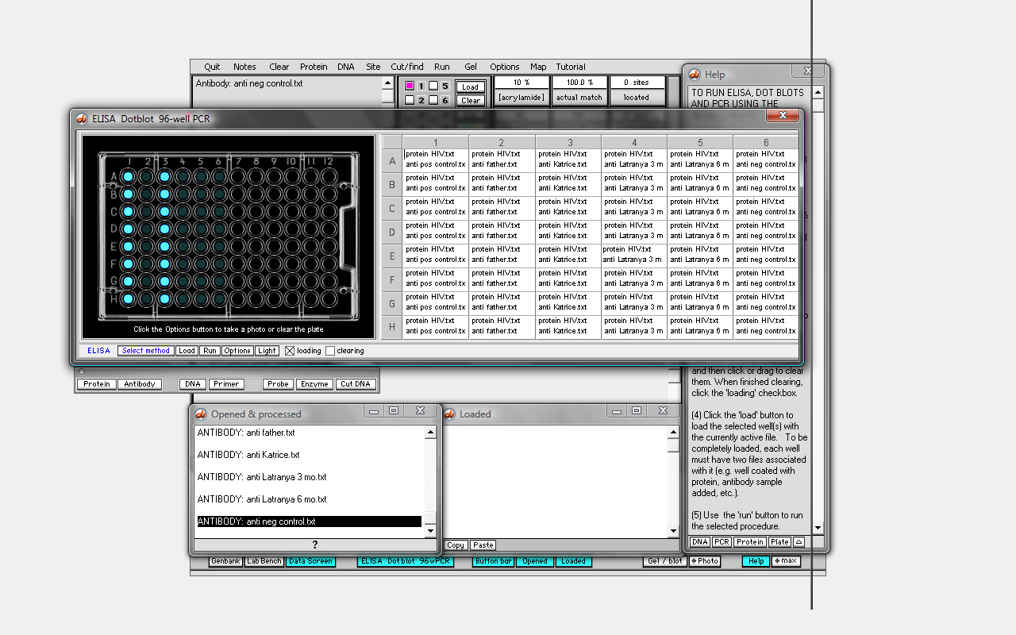None of the above

Column 1: HIV Positive Control

Column 2: Father’s blood

Column 3: Katrice’s blood

Column 4: Liddy’s blood at 3 months old

Column 5: Liddy’s blood at 6 months old

Column 6: Negative Control

1. A zygote is….
   1. A sperm or egg cell
   2. An enucleated egg
   3. A fertilized egg cell
   4. A modified cell
2. Hans Spemann worked on which experiment? He…
   1. Tied a fertilized salamander zygote in half with a hair and created two identical salamander embryos
   2. Removed the nucleus of a frog zygote and inserted into an unfertilized frog egg cell
   3. Took the nucleus from a frog intestinal cell and inserted it into an unfertilized egg cell
   4. Took the nucleus from the mammary cell and inserted into an enucleated egg cell
3. In their experiment Briggs and King…
   1. Tied a fertilized salamander zygote in half with a hair and created two identical salamander embryos
   2. Removed the nucleus of a frog zygote and inserted into an unfertilized frog egg cell
   3. Took the nucleus from a frog intestinal cell and inserted it into an unfertilized egg cell
   4. Took the nucleus from the mammary cell and inserted into an enucleated egg cell
4. John Gurdon worked on which experiment? He…
   1. Tied a fertilized salamander zygote in half with a hair and created two identical salamander embryos
   2. Removed the nucleus of a frog zygote and inserted into an unfertilized frog egg cell
   3. Took the nucleus from a frog intestinal cell and inserted it into an unfertilized egg cell
   4. Took the nucleus from the mammary cell and inserted into an enucleated egg cell
5. The scientists who worked on Dolly the Sheep did which of the following? They…
   1. Tied a fertilized salamander zygote in half with a hair and created two identical salamander embryos
   2. Removed the nucleus of a frog zygote and inserted into an unfertilized frog egg cell
   3. Took the nucleus from a frog intestinal cell and inserted it into an unfertilized egg cell
   4. Took the nucleus from the mammary cell and inserted into an enucleated egg cell
6. Why was the re-nucleated sheep egg cell jolted with electricity after inserting the nucleus of a mammary cell?
   1. To induce it to start dividing
   2. To seal the membrane shut after it was broken to insert the nucleus
   3. To raise the temperature to body temp
   4. Because electricity is cool
7. How many attempts did it take to create Dolly?
   1. 1 b. 10 c. 120 d. 277
8. Which of the following problems did Dolly have?
   1. Enlarged organs b. Obesity c. Arthritis d. All of the above
9. How did the telomeres of Dolly compare to those of other sheep’s cells?
   1. Her telomeres were longer
   2. Her telomeres were shorter
   3. Her telomeres were the same size
   4. She did not have any telomeres
10. How does the length of telomeres relate to the age of a cell?
    1. The older the cell, the shorter the telomeres
    2. The older the cell, the longer the telomeres
    3. The older the cell, the wider the telomeres
    4. The size of telomeres does not relate to the age of the cell
11. Telomeres are most like…
    1. A lock and a key
    2. The color of a T-shirt
    3. The opening of a soda can
    4. The plastic caps on shoelaces
12. Is it scientifically accurate to argue that a cloned animal will look and behave like its original?
    1. No – not all DNA is found in the nucleus; some is also in the mitochondria and some traits are affected by the environment more than by DNA
    2. Yes - if two organisms have the same DNA, they will look and behave the same
    3. No – no two organisms can ever have the same genes
    4. Yes – to clone means to make an exact copy
13. Why did the first cloned cat, CC, have different colored fur than her original, Rainbow?
    1. In the process of cloning, sometimes the genes are changed
    2. CC’s mitochondrial DNA was different than rainbows
    3. The color of fur in cats is decided randomly based on which X-chromosome is expressed; because CC came from a cell that already “chose” an X-chromosome, she had only one color – black (instead of black and orange)
    4. CC was not actually a clone of Rainbow – she just had some of her genes.
14. A stem cell is…
    1. A cell taken from the inner cell mass of an embryo that can become any kind of cell type in the body.
    2. A cell taken from your intestines that can become any kind of tissue in the body.
    3. A kind of cell that can only become other kinds of similar cells.
    4. Any kind of undifferentiated cell that can divide and form new cells.
15. Examples of undifferentiated cells include…
    1. Embryonic stem cell.
    2. Muscle cell.
    3. Nerve cell.
    4. Epithelial cell.
16. Tissue-specific stem cells…
    1. Are also known as adult stem cells.
    2. Are found in your own body right now.
    3. Are used to replace the tissue in your body as it wears out.
    4. All of the above.
17. Pluripotent stem cells…
    1. Always come from embryos.
    2. Can become any kind of cell in the body.
    3. Are widespread in your body right now.
    4. All of the above.
18. Your intestinal lining wears away every 4 days. The new tissue to replace comes from…
    1. Pluripotent stem cells.
    2. Induced pluripotent stem cells.
    3. Tissue-specific stem cells.
    4. All of the above.
19. Hemapoietic stem cells are the source of…
    1. Bone cells, cartilage, fat cells, and tendons.
    2. Neurons as well as two kinds of cells that support nerves in the brain and spinal cord.
    3. All kinds of blood cells, including red blood cells and white blood cells.
    4. The protective outer layer of your skin as well as hair follicles.
20. Neural stem cells are the source of…
    1. Bone cells, cartilage, fat cells, and tendons.
    2. Neurons as well as two kinds of cells that support nerves in the brain and spinal cord.
    3. All kinds of blood cells, including red blood cells and white blood cells.
    4. The protective outer layer of your skin as well as hair follicles.
21. Epidermal stem cells are the source of…
    1. Bone cells, cartilage, fat cells, and tendons.
    2. Neurons as well as two kinds of cells that support nerves in the brain and spinal cord.
    3. All kinds of blood cells, including red blood cells and white blood cells.
    4. The protective outer layer of your skin as well as hair follicles.
22. Mesenchymal stem cells are the source of…
    1. Bone cells, cartilage, fat cells, and tendons.
    2. Neurons as well as two kinds of cells that support nerves in the brain and spinal cord.
    3. All kinds of blood cells, including red blood cells and white blood cells.
    4. The protective outer layer of your skin as well as hair follicles.
23. Tissue-specific stem cells are multipotent. This means that…
    1. They can become any kind of tissue in the body.
    2. They are found in embryos.
    3. They can only become the cell types present in the tissue they originate.
    4. They were created from genetically-altered mature cells.
24. How are tissue-specific stem cells used to treat leukemia?
    1. These stem cells are used to re-grow the skeleton, which is replaced bone-by-bone.
    2. These stem cells are used to reproduce the patient’s blood, which is then transfused into their body.
    3. These stem cells are mutated so that they grow excessively fast in an uncontrolled manner.
    4. The damaged stem cells in the bone marrow are replaced by healthy donor stem cells.
25. A pluripotent stem cell is one that…
    1. Can become any kind of cell type in the body.
    2. Can only become a limited number of kinds of tissue in the body.
    3. Is found in your body right now.
    4. All of the above.
26. Where to embryonic stem cells come from?
    1. From eggs fertilized in a laboratory that were created for the purposes of research.
    2. From abortion clinics.
    3. From blastocysts leftover from in vitro fertility treatments.
    4. All of the above.
27. A blastocyst is…
    1. An unfertilized egg.
    2. A newly fertilized egg.
    3. A 5-7 day old fertilized egg that has an inner cell mass.
    4. The source of tissue-specific stem cells.
28. The early embryo is composed of three germ layers. The endoderm layer becomes…
    1. Skin and nerve cells b. Soft tissues like the pancreas and liver c. Muscle, blood, and bone.
29. The ectoderm layer becomes…
    1. Skin and nerve cells b. Soft tissues like the pancreas and liver c. Muscle, blood, and bone.
30. The mesoderm layer becomes…
    1. Skin and nerve cells b. Soft tissues like the pancreas and liver c. Muscle, blood, and bone.
31. In order for a stem cell to be pluripotent, it must….
    1. Be present in your body right now.
    2. Be able to become all three germ layers (endoderm, ectoderm, and mesoderm).
    3. Be taken from an embryo.
    4. All of the above.
32. Induced pluripotent stem cells are different from embryonic stem cells in what way?
    1. Embryonic stem cells are pluripotent.
    2. Induced pluripotent stem cells are pluripotent.
    3. Induced pluripotent stem cells are created from mature cells, not an embryo.
    4. Embryonic stem cells are created from mature cells, not an embryo.
33. Why not use tissue-specific stem cells for research instead of pluripotent stem cells?
    1. Tissue-specific stem cells can only become limited kinds of tissue.
    2. Tissue-specific stem cells cannot be used for research on embryonic growth and development.
    3. Tissue-specific stem cells can only grow for limited periods of time.
    4. Tissue-specific stem cells are less valuable for creating pure tissue for drug testing.
    5. All of the above.