Protein Folding C. Kohn, Waterford WI
Name: Hour Date:
Date Assignment is due: Why late? Score: + ✓ -
^{Day of Week} ^{Date} If your project was late, describe why
Units
1. Mendelian Genetics
2. FFA
3. DNA
4. Proteins
5. Ag Genetics
6. Biotechnology
7. Genomics
8. PCR
9. Southern Blotting
10. Cloning
11. Stem Cells
Weekly Schedule: See Board and record
Mon
Tues
Wed
Thurs
Fri
What is a protein?
What is a protein made out of?
How does a protein work?
How does a protein know what job to do?
How is a protein created?
What would happen if a protein were created wrong?

What is a mutation?
How do mutations affect proteins?
Circle one: I have learned some of this material in previous classes. Definitely – Yes – Sort of - No
Circle one: I need to review my notes & practice before the quiz. Definitely – Yes – Sort of - No
Circle one: I have never seen or heard of some of these concepts. Definitely – Yes – Sort of - No
Circle one: This may be a challenging unit for me personally. Definitely – Yes – Sort of - No

Directions: Use the accompanying PowerPoint (http://bit.ly/protein-ppt) to complete this sheet. This sheet will be due upon the completion of the PowerPoint in class. These assignments are graded on a +/√/- scale.
- DNA is copied by in a direction
- mRNA is read in groups of ( ) by a
- Each codon codes for a specific
- Each amino acid is delivered by a
- A string of amino acids creates a and peptides join to form a
- The shape of a protein comes from its and this shape determines its
.
- Proteins are made from amino acids
- Each amino acid has a set of that helps to create the shape of the protein
  - List some examples of these:
- What are three ways in which you can identify the amino acid Asparagine?
- Do amino acids stay in a straight chain after they are assembled?
- What three kinds of charge can an amino acid have?
- How does the charge of an amino acid change the way they line up?
  - Amino acids with a similar charge will
  - Amino acids with opposite charges will
- What is hydrophobicity?
- Hydrophobic amino acids will
- Hydrophilic amino acids will
- In the picture below, label with amino acids are hydrophobic and which are hydrophilic
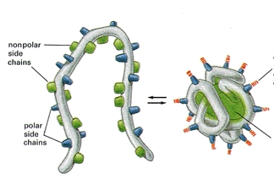
- What is a cysteine?
- Why are cysteines different from other amino acids?
- What is the bond called between two cysteine molecules?

- In the picture below, circle the cysteine bond
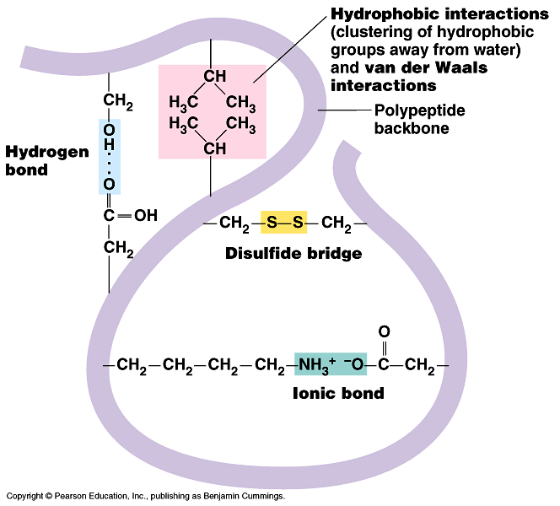
- In the space below, draw an α helix
- In the space below, draw a β sheet
- Describe each of the following levels of protein organization
Primary
Secondary
Tertiary
Quaternary
- Define mutation:
- The effect of a mutation is usually , but it can also be
or even have no
- Mutations are responsible for
- How do mutations relate to evolution and improvements made through artificial selection in agriculture?
_
_
- List and describe the four kinds of mutations:
1
2
3
4
- How can a mutation change an organism (particularly a frameshift mutation)?
- How does a frameshift mutation change a protein at each level?
Primary
Secondary
Tertiary
Quaternary

Unit Wrap-up C. Kohn, Agricultural Sciences - Waterford WI
This page is designed to help raise your grade while enabling you to develop skills you will need for after high
school. You will need to complete every question and blank in order to receive full credit for your notes. Note: if you cannot come up with a strategy to remember a difficult concept on your own, see your instructor for help.
- What is a topic or concept from this unit that you found to be more challenging? Write or describe below:
In the space below, create a mnemonic, rhyme, analogy, or other strategy to help you remember this particular concept:
- What is a 2nd topic or concept from this unit that you found to be more challenging? Write or describe below:
In the space below, create a mnemonic, rhyme, analogy, or other strategy to help you remember this particular concept:
- What is a 3rd topic or concept from this unit that you found to be more challenging? Write or describe below:
In the space below, create a mnemonic, rhyme, analogy, or other strategy to help you remember this particular concept:
- Circle the most appropriate response. You will only be graded on whether or not you completed this section, so be entirely honest with yourself when completing this section.
Circle one: I used my notes outside of class to prepare for the quiz. Definitely – Yes – Sort of - No
Circle one: I took extra notes in the margins for very difficult concepts. Definitely – Yes – Sort of - No
Circle one: I created a personal strategy for at least three difficult items. Definitely – Yes – Sort of - No
Circle one: I was very involved and actively studying during the quiz review. Definitely – Yes – Sort of - No
Circle one: I think I will be satisfied with the quiz grade I received this week. Definitely – Yes – Sort of - No
Circle one: I might need to meet with the instructor outside of class. Definitely – Yes – Sort of - No

