Proteins Notesheet by C Kohn
Name: Hour Date:
Date Assignment is due: Why late? Score: + ✓ -
^{Day of Week} ^{Date} If your project was late, describe why
Directions: Use the accompanying PowerPoint (visit wuhsag.weebly.com) to complete this sheet. This sheet will be due prior to taking the quiz. These assignments are graded on a +/✓/- scale.
- Describe what you currently know about proteins. Include as least three facts about proteins that you know from your own personal experience:

- At the level, proteins are
- Proteins are what do
- If you eliminated from your body, proteins would comprise % of your weight.
- Describe 8 different roles that proteins can play in an organism using 1-3 word descriptions:
- While there are over different proteins in your body alone, all proteins are similar in that
- The type of protein that is created at any given moment is dependent on
- The in which amino acids are assembled to make a protein is determined by your
- True of false – your body cannot make a protein unless you have a DNA with instructions for that protein.
- True or false – your body currently has all the ingredients necessary to make proteins found in plants or bacteria.
Explain:
- Why are some people unable to digest the lactose sugar in dairy foods? Explain using the following terms: 1) gene; 2) amino acids; 3) protein; 4) lactase
- True or false: if we add a gene for a glowing protein to the DNA of a pig, that pig would be able to make the glowing protein.
- A protein is made as a result of and in the cell.
- Summarize what happens during transcription:
- Summarize what happens during translation:
- How does tRNA know which amino acid to bring to the ribosome? tRNA has an
that matches each of .
- True or false: there is only one codon for every amino acid. Explain:
- True or false: there is only one amino acid for every codon. Explain:
- _________ is called the “ ”. It indicates where
- ______, , and are all called “ ”. Like a
at the end of a sentence tells you where to stop reading, stop codons tell a ribosome where to
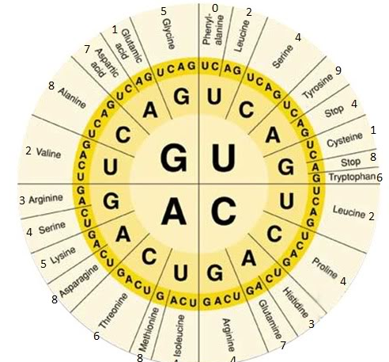
- The different kinds of codons make up the . What is the genetic code?
- Use the chart at the right to answer the following questions:
GCU code for
AUU code for
CCA code for
UCA code for
CGG code for
The codon for tryptophan is: _______
The codon for methionine is: _______
The codon for aspartic acid is
________ and
- This keeps amino acids linked to each other after they’re delivered by tRNA:
- The chain of amino acids that will become a protein is called a
- True or False: a protein is always made of multiple polypeptides. Explain:
- A protein is a macromolecule that is usually made from a of multiple
- List and describe the three parts of an amino acid:
- Which of these parts is relatively the same among all amino acids?
- Which of these parts is varies and determines the properties of the amino acid?
- A chain of amino acids must into a specific before the can
become .
- Several key properties of each amino acid are necessary to change a
into a with a specific
What are four of these properties? ,
, and
- What will happen if two similarly charged amino acids are near each other?
What will happen if two oppositely charged amino acids are near each other?
- In the space below, draw what happens to a polypeptide before and after two oppositely charged amino acids interact:
- Much of the of a protein comes from moving towards
or away from other because of .
- How does a hydrophilic amino acid differ from a hydrophobic amino acid?
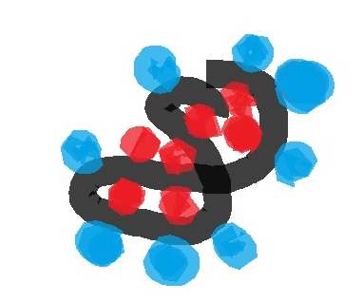
- Because our bodies (and our cells) are mostly made of , hydrophillic amino acids will
move to the of a polypeptide chain. Hydrophobic amino acids will try to
- For the image at the right, draw X’s in the hydrophobic amino acids
- Which amino acids are attracted to themselves?
- A bond between these amino acids is called a
- Disulfide bonds are very and provide a lot of to the protein structure.
- What is a hydrogen bond?
- The (__) atoms on amino acids will be drawn towards (__) atoms on other amino acids.
- What is a covalent bond?
- True or false: hydrogen bonds are covalent bonds.
- The attraction between these hydrogen and oxygen atoms will cause the chain of amino acids to
- The combination of these 4 factors (
) are what ultimately influence the
of a chain of .
- The of the polypeptide chains are what determine the final shape of each
, and this shape determines the of the protein.
- The four levels of organization in a protein are called the
and Structures.
- The primary structure of protein organization refers to
- What could happen to the protein if you changed just one of the amino acids in the polypeptide?
- The secondary structure of protein organization refers to
- What are the two main shapes? And
- Draw an alpha-helix and a beta-pleated sheet in the space below:
- What factors determine whether a group of amino acids will form an alpha helix or a beta pleated sheet?
- The tertiary structure of protein organization is
. In other words, it is the final combination of
- The quaternary structure of protein organization is
that results from
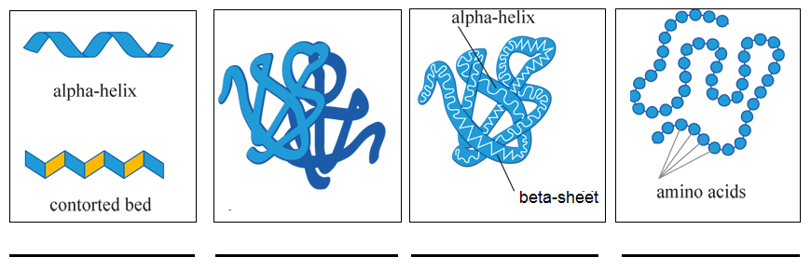
- Beneath each box, list whether it represents the primary, secondary, tertiary, or quaternary structure.

- Posttranslational processing refers to
- What is protein splicing?
- Besides protein splicing, what is another type of posttranslational process?

Unit Wrap-up C. Kohn, Agricultural Sciences - Waterford WI
This page is designed to help raise your grade while enabling you to develop skills you will need for after high
school. You will need to complete every question and blank in order to receive full credit for your notes. Note: if you cannot come up with a strategy to remember a difficult concept on your own, see your instructor for help.
- What is a topic or concept from this unit that you found to be more challenging? Write or describe below:
In the space below, create a mnemonic, rhyme, analogy, or other strategy to help you remember this particular concept:
- What is a 2nd topic or concept from this unit that you found to be more challenging? Write or describe below:
In the space below, create a mnemonic, rhyme, analogy, or other strategy to help you remember this particular concept:
- What is a 3rd topic or concept from this unit that you found to be more challenging? Write or describe below:
In the space below, create a mnemonic, rhyme, analogy, or other strategy to help you remember this particular concept:
- Circle the most appropriate response. You will only be graded on whether or not you completed this section, so be entirely honest with yourself when completing this section.
Circle one: I used my notes outside of class to prepare for the quiz. Definitely – Yes – Sort of - No
Circle one: I took extra notes in the margins for very difficult concepts. Definitely – Yes – Sort of - No
Circle one: I created a personal strategy for at least three difficult items. Definitely – Yes – Sort of - No
Circle one: I was very involved and actively studying during the quiz review. Definitely – Yes – Sort of - No
Circle one: I think I will be satisfied with the quiz grade I received this week. Definitely – Yes – Sort of - No
Circle one: I might need to meet with the instructor outside of class. Definitely – Yes – Sort of - No

