Reproductive Hormones Notesheet C. Kohn, Waterford WI

Name: Hour Date:

Date Assignment is due: Why late? Score: + ✓ -  
 Day of Week Date If your project was late, describe why**Directions**: Use the accompanying PowerPoint (*available online*) to complete this sheet. This sheet will be due upon the completion of the PowerPoint in class. These assignments are graded on a +/✓/- scale.

1. What is the estrous cycle?
2. In cattle the estrous cycle lasts
3. How is “estrous” different from “estrus”
4. What are hormones?
5. What is an endocrine gland?
6. What is a target tissue?
7. Is the endocrine gland a specific organ? Explain:
8. Is the target tissue a specific organ? Explain:
9. True or false: an organ could be both an endocrine gland and a target tissue. Explain:
10. What is the endocrine system?
11. Why does the body have two signaling systems?
12. How are like hormones and target tissues like a lock and key?
13. What are six functions that hormones regulate in animal bodies?
14. What is the difference between an endocrine hormone and a paracrine hormone?
15. Complete   
    the table:
16. What is estradiol?
17. What is the primary job of estradiol?
18. These physiological changes include the in the   
      
    of the (which helps propel towards the ),   
      
    induced production into the for lubrication and to flush out   
      
    bacteria, and and in the vulva.
19. What are five signs of estrus induced by estradiol?
20. Estradiol also causes the release of .
21. What is the primary purpose of GnRH?
22. FSH stimulates the and of a   
      
     in which
23. What would happen if FSH was not released?
24. How can FSH be used in reproductive therapy?
25. LH is necessary for
26. Upon the release of an egg, LH enables
27. What is the corpus luteum?
28. What would happen if LH was not released?
29. From where is progesterone released?
30. Progesterone prevents   
      
    and prevents   
      
    by regulating
31. In addition to this, what other major roles does progesterone play?
32. From where is PGF2α released?
33. PGF2α causes and stops
34. Why is this necessary?
35. What if the cow is pregnant?
36. In the spaces below, explain five ways in which hormone levels change over the estrous cycle:
37. Summarize the key occurrences that occur in each of the following stages:   
      
    Estrus:   
      
       
      
       
      
       
      
    Metestrus:   
      
       
      
       
      
    Diestrus:   
      
       
      
       
      
    Proestrus:
38. For each stage of the estrous cycle, explain the most noteworthy changes to hormone levels that occur:   
      
    Estrus:   
      
    Metestrus:   
      
    Diestrus:   
      
    Proestrus:
39. 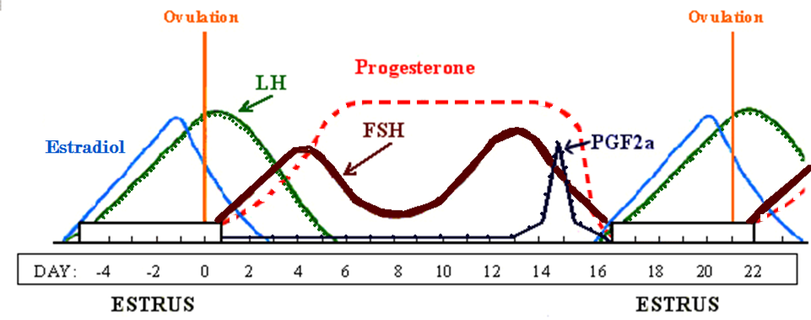Draw & label the hormone fluctuations in the space below. Begin by drawing the lines for ovulation as a guide.

*Summarize the purpose, function, and mechanism of each of the following common reproductive therapies:*

1. **Lutalyse**: Purpose:   
     
   How it works:   
     
      
     
      
     
   Other important info:
2. **Ovsynch**: Purpose:   
     
   How it works:   
     
      
     
      
     
   Other important info:
3. **CIDR**: Purpose:   
     
   How it works:   
     
      
     
      
     
   Other important info:
4. **MGA**: Purpose:   
     
   How it works:   
     
      
     
      
     
   Other important info:
5. In the space below, complete the self-evaluation. Circle which most applies to you at this moment.

* I understand how hormones work. Definitely Kind of Not Really
* I understand endocrine glands and target tissues. Definitely Kind of Not Really
* I understand why two signaling systems are needed. Definitely Kind of Not Really
* I understand what estradiol does in the estrous cycle. Definitely Kind of Not Really
* I understand what GnRH does in the estrous cycle. Definitely Kind of Not Really
* I understand what LH does in the estrous cycle. Definitely Kind of Not Really
* I understand what FSH does in the estrous cycle. Definitely Kind of Not Really
* I understand what progesterone does in the estrous cycle. Definitely Kind of Not Really
* I understand what PGF2α does in the estrous cycle. Definitely Kind of Not Really
* I understand what occurs during estrus. Definitely Kind of Not Really
* I understand what occurs during estrus. Definitely Kind of Not Really
* I understand what occurs during metestrus. Definitely Kind of Not Really
* I understand what occurs during diestrus. Definitely Kind of Not Really
* I understand what occurs during proestrus. Definitely Kind of Not Really
* I can identify hormones based on their peak levels in the cycle. Definitely Kind of Not Really
* I understand the purpose and mechanism of Lutalyse. Definitely Kind of Not Really
* I understand the purpose and mechanism of Ovsynch. Definitely Kind of Not Really
* I understand the purpose and mechanism of CIDR. Definitely Kind of Not Really
* I understand the purpose and mechanism of MGA Definitely Kind of Not Really

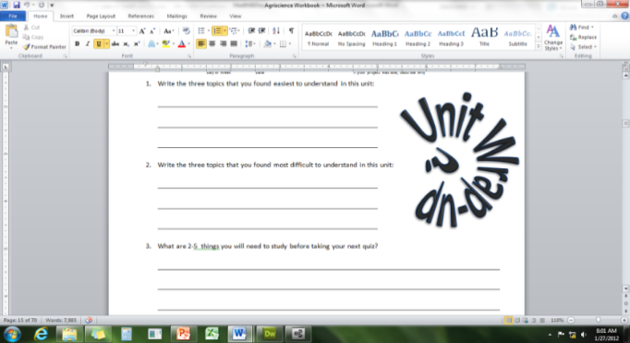Unit Wrap-up C. Kohn, Agricultural Sciences - Waterford WI

This page is designed to help raise your grade while enabling you to develop skills you will need for after high   
school. You will need to complete every question and blank in order to receive full credit for your notes. Note: if you cannot come up with a strategy to remember a difficult concept on your own, see your instructor for help.

1. What is a topic or concept from this unit that you found to be more challenging? Write or describe below:  
     
      
     
   In the space below, create a mnemonic, rhyme, analogy, or other strategy to help you remember this particular concept:
2. What is a 2nd topic or concept from this unit that you found to be more challenging? Write or describe below:  
     
      
     
   In the space below, create a mnemonic, rhyme, analogy, or other strategy to help you remember this particular concept:
3. What is a 3rd topic or concept from this unit that you found to be more challenging? Write or describe below:  
     
      
     
   In the space below, create a mnemonic, rhyme, analogy, or other strategy to help you remember this particular concept:
4. Circle the most appropriate response. You will only be graded on whether or not you completed this section.

Circle one: *I used my notes outside of class to prepare for the quiz.* Definitely – Yes – Sort of - No

Circle one: *I took extra notes in the margins for very difficult concepts.* Definitely – Yes – Sort of - No

Circle one: *I created a personal strategy for at least three difficult items.* Definitely – Yes – Sort of - No

Circle one: *I was very involved and actively studying during the quiz review.* Definitely – Yes – Sort of - No

Circle one: *I think I will be satisfied with the quiz grade I received this week.* Definitely – Yes – Sort of - No

Circle one: *I might need to meet with the instructor outside of class.* Definitely – Yes – Sort of - No