Ruminant Physiology Notesheet by C Kohn
Name: Hour Date:
Date Assignment is due: Thursday Why late? Score: + ✓ -
^{Day of Week} ^{Date} If your project was late, describe why

Unit Preview
Weekly Schedule: See Board and record
Mon
Tues
Wed
Thurs
Fri
- What does it mean that a cow ‘chews her cud’?

- How can a cow eat grass if humans cannot?
- Write a basic definition for “ruminant”.
- In the space below, describe four different kinds of digestive tracts found in animals.
Circle one: I have learned some of this material in previous classes. Definitely – Yes – Sort of - No
Circle one: I need to review my notes & practice before the quiz. Definitely – Yes – Sort of - No
Circle one: I have never seen or heard of some of these concepts. Definitely – Yes – Sort of - No
Circle one: This may be a challenging unit for me personally. Definitely – Yes – Sort of - No

Directions: use the accompanying PowerPoint (http://bit.ly/ruminant-physiology) to complete the questions below. This sheet will be due upon the completion of the PowerPoint in class. These assignments are graded on a +/√/- scale.
- In nature, all must be able to the
from which their are built and in which to their cells.
- Plants, because of , can acquire all of their needs
from the and through sugar production.
- Why can’t animals do this?
- List and describe the four classes of animals (in regards to digestive e strategies):
_
_
_
_
- What molecule in plants makes the unique adaptations of ruminants necessary?
- Define cellulose:
_
- What are the four chambers of a ruminant’s stomach?
_
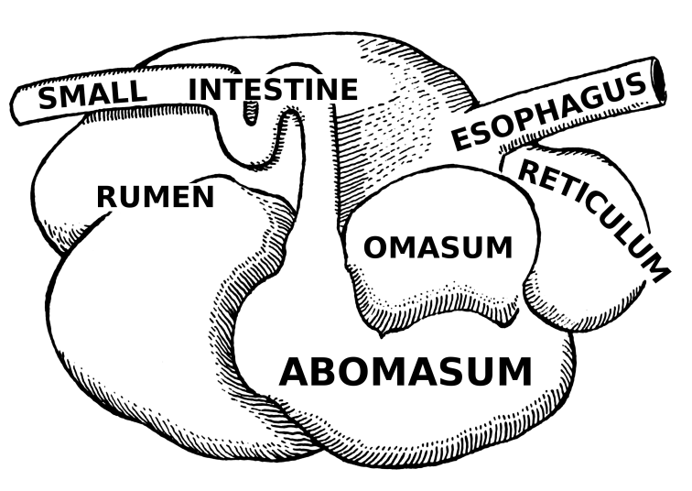
- Correctly label each structure below:
- Which of the stomach chambers is the first to receive food after it is ingested?
- The rumen is a sort of
- Inside, microbes live in an where
_ , , and are all closely
- Fermented feed is either by the itself or is
moved further along the for more
and downstream
- Ruminants are designed to consume ( ,
or )
- An adult cow will also produce liters of per day to help digest the consumed forage.
- What are the two functions of saliva in ruminant digestion?
_
_
- Is the passage of feed through the rumen fast or slow? Why?
_
- As is broken , it will sink to the where
it can move on to the next of the cow’s .
- What function do rumenal contractions provide?
_
- How often do rumen contractions occur?
- When are they most frequent?
- List and describe the two types of rumen contractions:
1_
2_
- How do contractions provide for proper digestion?
_
- What happens to contractions if a ruminant is sick or injured?
- What occurs when a cow chews her cud?
_
- What is a cow’s cud?
- How does a cow get the bolus of the cud into her mouth?
_
- What else must a cow do when chewing her cud?
- What will happen if a cow cannot release the buildup of gas?
_
- What makes of possible is the diverse
population of that inhabit this structure.
- How do microbes in the rumen interact and support each other?
_
- What enzyme is necessary for microbes to break down the forage?

- Ruminant microbes provide what four services to a cow?
1_
2_
3_
4_
- Almost all feed ingested by the cow is actually used to feed
- The cow itself gets the from the microbes after they the forage.
- Fermentation occurs under (w/o ) conditions
- What would happen if the microbes in the rumen were exposed to oxygen?
_
- The freed when is broken apart become
fermented into , or .
- What provides the majority of the energy used by the herbivore?
- The is a tough, lower portion of the and is
considered the chamber of a cow’s stomach.
- The reticulum objects and prevents them from
causing further downstream of the .
- It has a tough, structure that is
.
- After day-old forage is fermented in the rumen, it moves on to the third chamber, the
- The omasum resembles
- The rumen will inject a mixture of partially
and into this structure.
- Its main job is of
- The folds digested to maximize .
- The of a cow is the chamber and the “true”
- It acts much like secreting
- What makes the abomasum of the cow unique compared to human stomachs?
_
  - How does it handle this?
- VFAs are absorbed by the walls of the .
- Why is this necessary?
- Besides lowered absorption of energy, what else would happen if VFAs were not absorbed by the rumen walls?
_
_
- What are papillae?
- After the abomasum, the plant matter will enter the
- What two things break down the plant matter in the small intestine?
- Any unabsorbed will be digested and absorbed here.
- From this structure
- Following the small intestine and absorption into the blood stream, any remaining plant matter will pass into the
_
- The large intestine is the site of
- It is also where excess is reabsorbed

- Why is it so important to reabsorb water in the large intestine?
_
- What are the four key advantages of being a ruminant?
_
_
_
_
- What is the main disadvantage of being a ruminant?
_
_
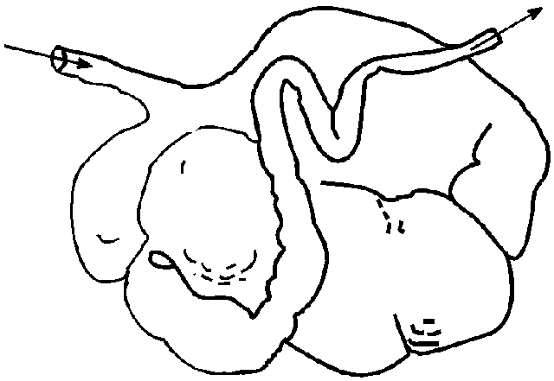
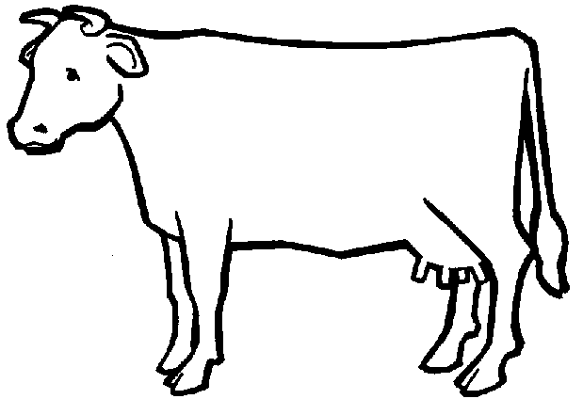
- Draw a label the path of food through a ruminant. Be sure to include the following structures:
Mouth Esophagus Rumen Reticulum Omasum Abomasum Small Intestine
Large Intestine

Unit Wrap-up C. Kohn, Agricultural Sciences - Waterford WI
This page is designed to help raise your grade while enabling you to develop skills you will need for after high
school. You will need to complete every question and blank in order to receive full credit for your notes. Note: if you cannot come up with a strategy to remember a difficult concept on your own, see your instructor for help.
- What is a topic or concept from this unit that you found to be more challenging? Write or describe below:
In the space below, create a mnemonic, rhyme, analogy, or other strategy to help you remember this particular concept:
- What is a 2nd topic or concept from this unit that you found to be more challenging? Write or describe below:
In the space below, create a mnemonic, rhyme, analogy, or other strategy to help you remember this particular concept:
- What is a 3rd topic or concept from this unit that you found to be more challenging? Write or describe below:
In the space below, create a mnemonic, rhyme, analogy, or other strategy to help you remember this particular concept:
- Circle the most appropriate response. You will only be graded on whether or not you completed this section, so be entirely honest with yourself when completing this section.
Circle one: I used my notes outside of class to prepare for the quiz. Definitely – Yes – Sort of - No
Circle one: I took extra notes in the margins for very difficult concepts. Definitely – Yes – Sort of - No
Circle one: I created a personal strategy for at least three difficult items. Definitely – Yes – Sort of - No
Circle one: I was very involved and actively studying during the quiz review. Definitely – Yes – Sort of - No
Circle one: I think I will be satisfied with the quiz grade I received this week. Definitely – Yes – Sort of - No
Circle one: My instructor is cool & I want to pay dues to be in their fan club. Definitely – Yes – Sort of - No

