Syringes Lab C. Kohn, Waterford, WI
Partner Names: Hour Date:
Date Assignment is due: Why late? Score: + ✓ -
^{Day of Week} ^{Date} If your project was late, describe why
Objective: to gain background and technical skills regarding syringes and veterinary injections.
Overview: administration of a drug or vaccine is a routine component of herd health management for cattle. While medications can be given orally (by mouth) or topically (on top of the skin), very often a medication requires the use of a syringe. Syringes can be used to inject the medication intramuscularly (into the muscle), subcutaneously (under the skin), intravenously (into a vein), or intradermally (between the layers of the skin).
Injecting medication usually involves a small amount of risk. If a needle is used multiple times, it can spread some diseases. Dirty, bent, broken, burred, or dull needles can increase the risk of an infection, as can improper sanitation prior to the injection. Injury to either the animal or the person administering the drug can also occur if the animal is not properly restrained.
Finally, an intramuscular injection will create site blemishes at the site of injection. These blemishes will leave permanent marks in the muscle where the injection occurred. Because this can reduce the appeal of the meat and cause a negative impression for a consumer, intramuscular injections should never be used at a site where a cut of meat may be used in the future. For this reason, the neck, shoulder, and tail head are ideal sites for injection in all cattle (even dairy cattle). With proper preparation and technique, most risk can be reduced as much as possible.
The use of injectable medicines should be used only when necessary and at the appropriate time. For example, many injectable drugs have a withholding time; this is the amount of time needed between injection and slaughter of the animal (or sale of the milk) in order for the drug to be completely eliminated from the animal’s body so that it is not present in the food consumed by a person. Furthermore, the effectiveness of many injectable medications is dependent on the age of animal.
Accurate records should be kept on all animals every time it receives any kind of injection. It is very important not only for the health of the animal (both now and in the future), but also to keep track of when the withdrawal time will be reached. The dosage of the medication given to the animal depends on the instructions on the label. Never give more than 10 cc’s of a drug in one location. If more than 10 cc’s of a drug is needed, spread the drug over multiple sites using equal portions (e.g. if 20 cc’s is needed, spread the injections over three equal doses at three separate sites).
How to administer a drug depends entirely on the drug’s label and the advice of the veterinarian. Always follow the instructions on the label of a drug unless advised otherwise by a veterinarian. While a veterinarian can prescribe directions that differ from the label’s instructions (this is called extra-label use), a non-licensed practitioner cannot decide this on their own (this is called off-label use). It is unlawful to administer any injectable product in any amount or in any way other than how it is directed on the label (unless directed to do so by a veterinarian).

The needle of a syringe that is used depends on how the drug is administered. The gauge of a needle is the measure of the diameter of a needle. The larger the number of the gauge, the smaller the needle. Use the largest gauge-size needle (thinnest) that the medication will pass through and that will not bend or break during the injection. For intramuscular injections in cattle over 500 lbs., this usually means a 16- or 18- gauge needle that is 1.5 inches long, and 18- or 20- gauge for livestock under 500 lbs. For subcutaneous injections, the needle should be less than 1 inch. Never use a needle that is bent, broken, or in any way defective. While multiple animals are often injected with the same needle to save time and money, never inject more than 10 animals with the same needle.
Questions
- Syringes are necessary for the administration of many vaccines and antibiotics. In the space below, briefly describe the purpose and use of both types of treatments:
Vaccine:
Antibiotics:
- Between vaccines and antibiotics, which would become less effective if it was overused?
Explain:
- There is always a risk that comes with using a needle and syringe to administer a treatment. Using information from the previous page, explain all the ways in which this risk can be minimized:
- What problem is associated with intramuscular injections?
Why is this a problem?
How should intramuscular injections be administered in order to avoid this problem?
- What is a withholding time?
Why is this important to consider before administering an injection?
- If a drug requires a dosage of 18 cc’s, how should it be administered so that the animal is not harmed?
- If a veterinarian provides you with instructions that differ from the drug label, is this ok?
What is this called? What is it called if you have instructions
from a source other than a veterinarian or drug label? Is this ok?
- The the number of the gauge, the the needle.
- If you were administering an intramuscular injection to a 500 lb. steer, you would use a gauge needle.
- If you were administering an intramuscular injection to a 200 lb. pig, you would use a gauge needle.
- For subcutaneous injections, the needle should be less than . For intramuscular
injections, the needle should be .
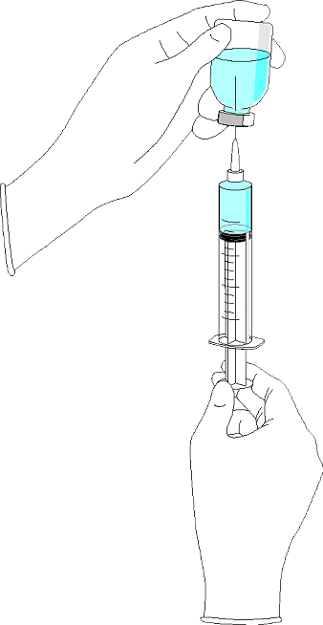
Procedure
Materials needed: 1 orange; 1 16-, 18-, or 20- gauge needle and syringe; dyed sterile veterinary saline solution (instructors – dye the saline solution by injecting colored food dye prior to the lab), paper towels; rubbing alcohol.

Step 1: Obtain all materials. Sanitize the surface of your orange, the top of the bottle, and your needle using alcohol and a paper towel.

Step 2: Pull the plunger back to 1 cc (or the amount your instructor states). Push the needle through the rubber top of the bottle of saline solution.

Step 3: Turn the bottle of saline solution upside down. Push the plunger of the syringe all the way in (you are injecting air into the bottle so you should see bubbles of air moving through the liquid).

Step 4: Slowly pull back on the plunger to move 2 cc’s of saline into the syringe.

Step 5: Keeping the needle in the bottle, thump the air bubbles to the top of the syringe.

Step 6: Push the air bubbles and 1 cc of saline back into the bottle.

Step 7: Complete each of the following types of injections on the following page (repeat steps 1-6 prior to each injection)

Subcutaneous: fold the skin with your thumb and finger to make a skin "tent". Insert the needle through one side of the tent at an angle of 30 to 45 degrees relative to the surface of the body. If it isn’t possible to make a "tent", slide the needle under the skin at an angle of about 30 degrees from parallel to the skin surface and inject. The fluid should form a slight ‘bubble’ under the skin but should not be in the skin itself.

Intramuscular: quickly inject the needle directly into the fruit of the orange and slowly inject the saline. The needle should be perpendicular to the skin. The fluid should not be visible.

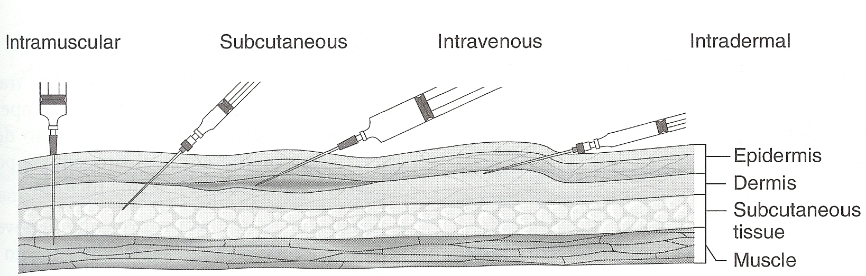
Intradermal: insert the needle at a very low angle (almost parallel to the skin). Inject and watch to make sure the colored saline solution stays within the skin. The skin should form a ‘bruise’ visible on the surface.

NOTE: when giving these injections, a professional would normally aspirate before injecting. This means they would pull back on the plunger to make sure they are not in a vein or artery. If this were the case, blood would enter the syringe and the practitioner would know to try a different location. Because we are using oranges, this is not possible.

