Vaccines & Antibiotics Notesheet C. Kohn, Waterford WI
Name: Hour Date:
Date Assignment is due: Why late? Score: + ✓ -
^{Day of Week} ^{Date} If your project was late, describe why
Directions: Use the accompanying PowerPoint (available online) to complete this sheet. This sheet will be due upon the completion of the PowerPoint in class. These assignments are graded on a +/✓/- scale.
- What is homeostasis?
- Because an animal’s body must maintain a
infections by pathogens are an .
- , which serve as the
of the body, help to ensure a .
- The blood and lymph combine with to protect the body
from in order to maintain .
- The immune system is composed of
that protect the body from and from its own
- The immune system has of to protect the body.
- A pathogen seeks to , , and
utilize the body to
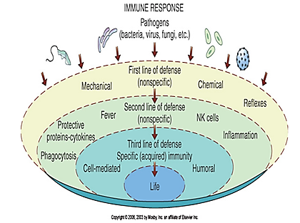
- Fill in the blanks below:
(Abbreviate if needed)

- The immune system recognizes which
- Cells that are (including and ) are
by the immune system.
- True or false: the immune system only attacks cells that are not a part of the body Explain:
- What is the immune system’s first line of defense? . This refers to
- Summarize the three kinds of nonspecific immunity:
Mechanical:
Physical:
Chemical:
- If a pathogen is not by forms of
an animal’s body can employ forms of
that are only used during a as a line of defense.
- These include
- What is phagocytosis?
- What is inflammation?
This enables
- What is pyrexia? . How does this eliminate a bacterial pathogen?
- Protective proteins include which
and limit and
, which are
and .
- What are NK cells?
- What is specific immunity?
- What is an antibody?
- What is an antigen?
- What is antigen short for?
- Antibodies and antigens physically
- What happens if an antibody fits on an antigen?
- If an animal has antibodies for antigens from a pathogen, what does this indicate?
- Summarize the difference between genetic specific immunity and acquired specific immunity:
- What is active acquired immunity?
Shorten by summarizing the slide’s info in your own words.
- What is passive acquired immunity?
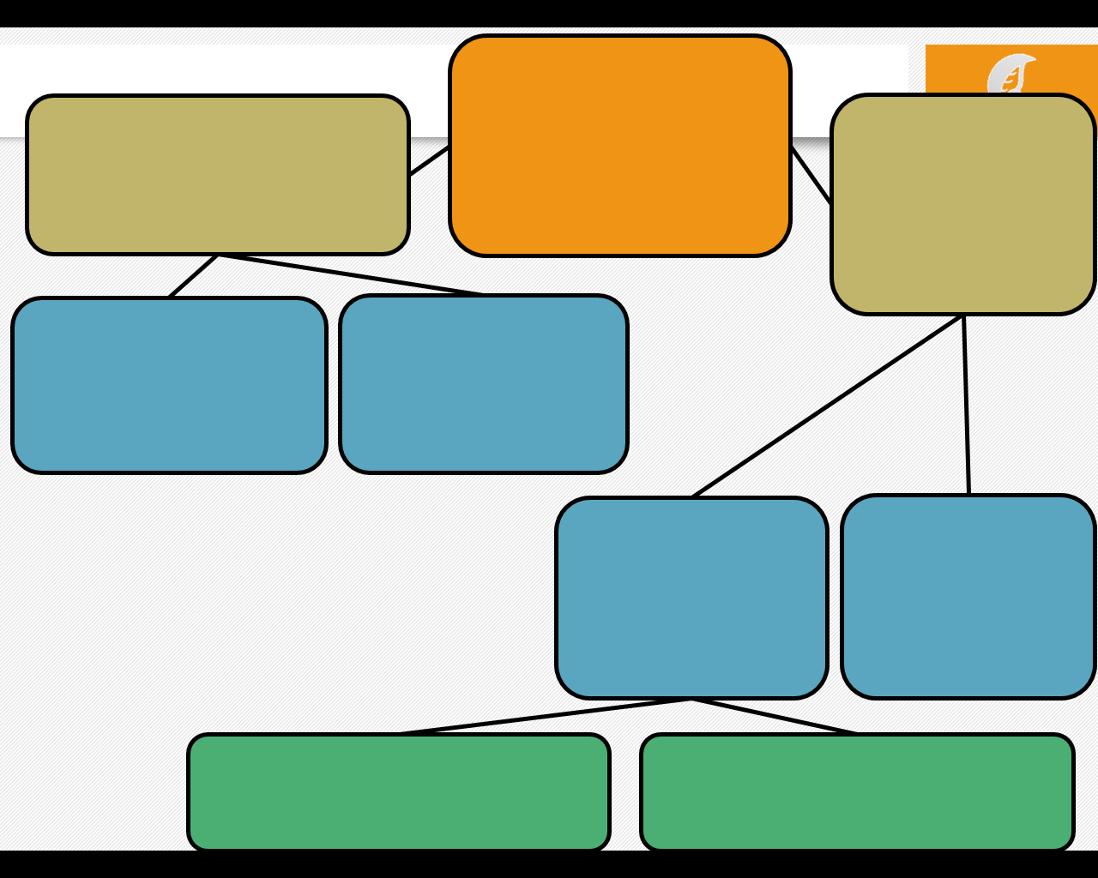
- Show the relationship between all of the versions of immunity by filling in the bubbles below with the correct terms:
- What is a vaccine?
- A vaccine consists of in a format that does not
enable but does enable
to the disease.
- The immune system of the vaccinated animal will
and the moment it is able to gain access to the body.
- This either or, at
minimum, keeps the disease
- List AND summarize the four kinds of vaccinations.
1
2
3
4
- What is colostrum?
Why is it important?
- Because a young animal has due to its
(meaning less to fight disease) and because are
generally more , farms depend on
to prevent the
- How is leptospirosis an example of why vaccinations are important for adult livestock as well?
- Vaccinations are part of an for all production animal operations.
- Healthier animals grow
A health management plan ensures that .
- A health management plan for a farm should include
in which a veterinarian is ,
and can make
- Herd health management should also include a herd health plan that includes
- A farm’s health management plan should also address , including
how
and how
- Finally, a farm should develop an
in the event
- Responsible use of should be part of a farm’s health management plan.
- What are antibiotics?
- What are examples of antibiotics?
- While vaccines are used to , antibiotics are primarily used for
that have . Antibiotics are primarily for
Vaccines have no impact on .
- Summarize the three purposes of antibiotic use on farms. Shorten by writing in your own words:
- The of antibiotics is related to the of antibiotics.
- What is antibiotic resistance?
- List AND summarize the four ways in which antibiotics can destroy bacteria:
- List AND summarize the five ways in which antibiotics can be overcome by bacteria:
- Antibiotic resistance can be (natural) or .
- What is inherent resistance?
- What is acquired resistance?
- Very rarely, acquired resistance will occur because of
that provides a bacterium with an that makes it
to an . This is very . More often, acquired resistance is due to
of from that already has
to an antibiotic.
- What is horizontal gene transfer?
- Unlike , whose remain in
almost all circumstance after conception, bacteria can their
frequently by exchanging .
- What are plasmids?
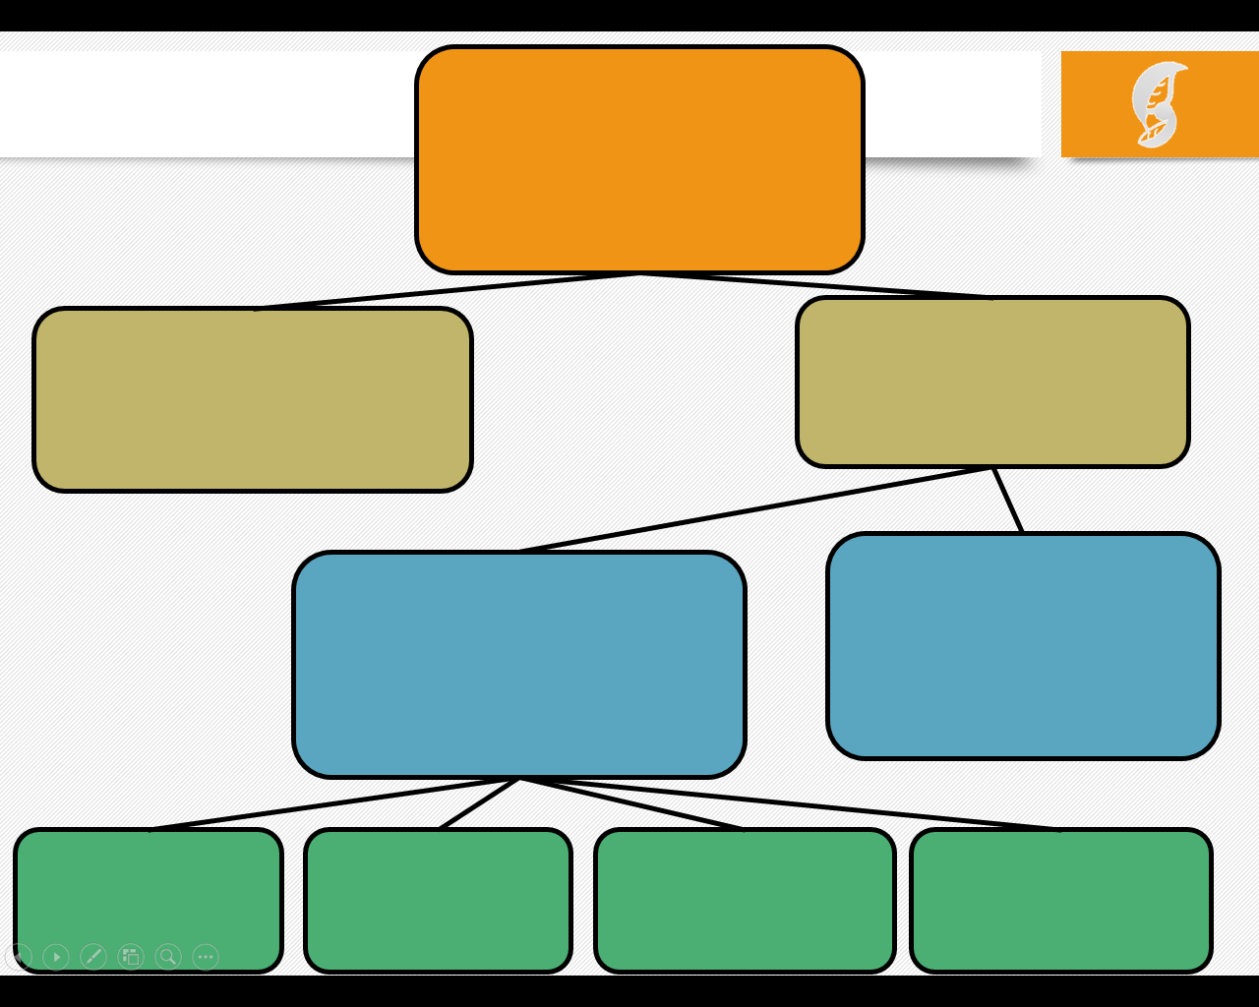
- Summarize the four ways in which horizontal gene transfer can occur:
Conjugation:
Transformation:
Transduction:
Transposons:
- Complete the blanks below
with the appropriate terms.
Abbreviate if needed:

- In your own words, Summarize five practices on farms that would reduce antibiotic resistance:
- What is the difference between off-label use and extra-label use?
- Summarize the five items that, at minimum, should be included in an animal’s treatment records:
- What is the most important reason to keep accurate animal medication records?
- What is a withdrawal time?
- Where can this be found?
- What if the drug was prescribed in an extra-label manner?
- If a pig was treated at 9 am on a , and the drug has a 5-day withdrawal time, that pig could not
be sold for slaughter until

Unit Wrap-up C. Kohn, Agricultural Sciences - Waterford WI
This page is designed to help raise your grade while enabling you to develop skills you will need for after high
school. You will need to complete every question and blank in order to receive full credit for your notes. Note: if you cannot come up with a strategy to remember a difficult concept on your own, see your instructor for help.
- What is a topic or concept from this unit that you found to be more challenging? Write or describe below:
In the space below, create a mnemonic, rhyme, analogy, or other strategy to help you remember this particular concept:
- What is a 2nd topic or concept from this unit that you found to be more challenging? Write or describe below:
In the space below, create a mnemonic, rhyme, analogy, or other strategy to help you remember this particular concept:
- What is a 3rd topic or concept from this unit that you found to be more challenging? Write or describe below:
In the space below, create a mnemonic, rhyme, analogy, or other strategy to help you remember this particular concept:
- Circle the most appropriate response. You will only be graded on whether or not you completed this section.
Circle one: I used my notes outside of class to prepare for the quiz. Definitely – Yes – Sort of - No
Circle one: I took extra notes in the margins for very difficult concepts. Definitely – Yes – Sort of - No
Circle one: I created a personal strategy for at least three difficult items. Definitely – Yes – Sort of - No
Circle one: I was very involved and actively studying during the quiz review. Definitely – Yes – Sort of - No
Circle one: I think I will be satisfied with the quiz grade I received this week. Definitely – Yes – Sort of - No
Circle one: I might need to meet with the instructor outside of class. Definitely – Yes – Sort of - No

