Water Pollution – The Pineville Pond by C. Kohn
Group Names (first/last):
Date: Date Due: end of class Why late? Score: + ✓ -
As a UW-Extension ecologist, you’ve been asked to examine the Pineville Pond, a county nature center’s pond. In previous years, the Pineville Pond was a hotspot for local fishermen. In both winter and summer, the pond was well stocked with panfish including bluegills, sunfish, and perch. Lately, the pond’s fishing quality has declined dramatically, and the county supervisor has asked you to investigate this problem.

Directions: In teams of 4, complete each question after reading the accompanying section. For each question, a different person should complete the answer. Please initial your answer after finishing. The remaining three members in your group should all help to create the answer you are writing, as well as monitor the time and summarize everyone’s ideas. After each question, switch roles.

In this activity, you will be addressing two key questions:
1. What factors affect the ability of aquatic ecosystems to support life?
2. What has caused the reduction of the Pineville Pond gamefish population?
Pineville Pond activity 1
The Pineville Pond is actually a lake that is 20 square miles large. It’s maximum depth is 40 feet, and its average depth is 10 feet. The Pineville Pond routinely freezes over each winter, while in summer, it’s temperature ranges from 75º F to 50º F depending on the depth and location on the pond. The Pineville Pond is part of a the Sedi River drainage basin which includes the Pineville Natural Area, a 7000 acre natural preserve, the town of Pineville (population 5000), and a strong dairying presence in the north, with farms ranging from 25 to 750 cows. The largest of these farms is Greenville Dairy.
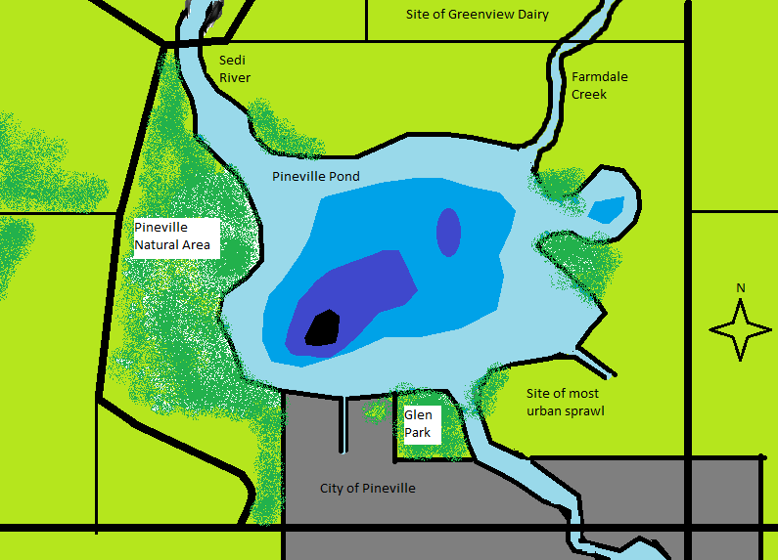
The shores of Pineville Pond are dotted with houses and cabins everywhere but the Pineville Natural Area and Glen Park (a small city park on the south shore). The Sedi River flows into Pineville Pond from the north, and leaves the pond to the south through the city of Pineville. Farmdale Creek also flows into Pineville Pond, with various other drainage ditches. The deepest portion of Pineville Pond is the southwest portion of the lake at 40 feet, while the lake is shallowest in the southeast portion. This is also the location of a large amount of urban sprawl, with new homes occupying what was formerly farmland.
- If you were a fish, in what part of the lake would you choose to live and why?

- What major differences do you notice between the different parts of this lake?

- What effect do you think the city has on the quality of the lake water?
- What effect do you think that agriculture has on the quality of the lake water?
- What part of this lake do you think has the poorest quality water? Why?
- What part of this lake do you think has the highest quality water? Why?

Pineville Pond activity 2
Your first task in determining the cause of problems in this lake is to check the macroinvertebrate populations in different parts of the lake. Using the chart on the next page, predict what types of macroinvertebrates you would find in each portion of the lake.
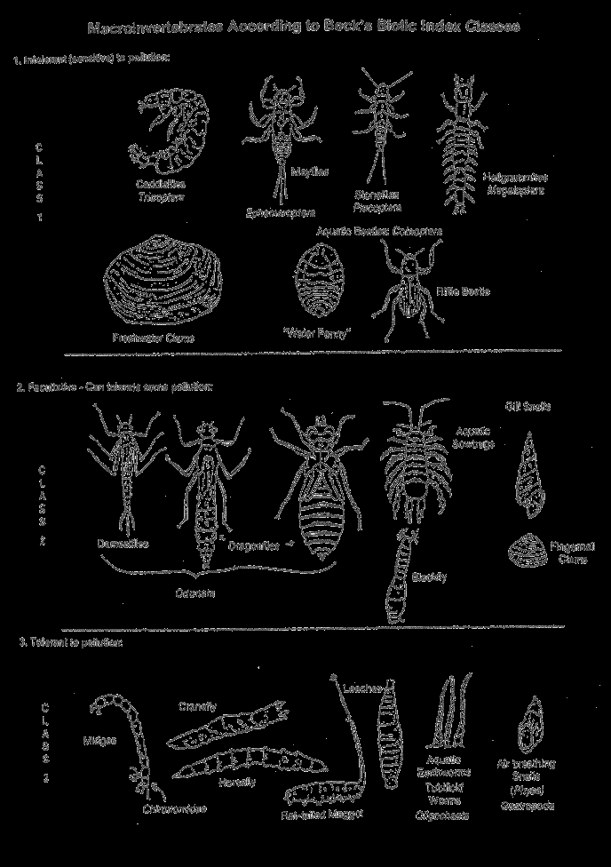
- List THREE species of macroinvertebrates that you think would be most prevalent in the northeastern portion of the lake. Then explain why you chose these three and explain what their presence indicates about the potential quality of this water.

- List THREE species of macroinvertebrates that you think would be most prevalent in the northwestern portion of the lake. Then explain why you chose these three and explain what their presence indicates about the potential quality of this water.

- List THREE species of macroinvertebrates that you think would be most prevalent in the southeastern portion of the lake. Then explain why you chose these three and explain what their presence indicates about the potential quality of this water.

- List THREE species of macroinvertebrates that you think would be most prevalent in the southwestern portion of the lake. Then explain why you chose these three and explain what their presence indicates about the potential quality of this water.

Pineville Pond activity 3 After testing the macroinvertebrates in multiple portions of the pond, you find that Class I macroinvertebrates (intolerant to pollution) are lowest in the eastern half of the lake, while they are highest in the western half of the lake.
- What do these results indicate about the quality of the water on the east side vs. the west side? How do you know?

You decide to test the water for nutrient levels. You suspect that nutrients are being added to the water through runoff after each period of rain or other precipitation. You decide to check nutrient levels in all four seasons (winter, spring, summer, and fall). You find that nutrient levels are higher from Farmdale creek in spring and fall, while they are higher from the drainage ditch in the southeastern portion of the lake in summer.
- What would most likely explain the high nutrient levels from Farmdale Creek in spring and fall?

- What would most likely explain the high nutrient levels from the southeastern drainage ditch in summer?

Pineville Pond activity 4 After tracing the source of the nutrients up Farmdale creek, you notice they are highest a mile before Greenview Dairy. You decide to question farmers in the area regarding their manure disposal methods. Three farms are in the area where the high nutrient levels begin: Greenview (750 cows), the Huntts (200 cows), and John Johanns (25 cows). While Greenview and Hunts use manure injection (the manure is kept in a tank or lagoon until it is injected directly into the soil) in fall and spring, Johanns uses a manure spreader and spreads manure daily.
- Which method do you think contributes the greatest to nutrient runoff? Why?

- Why would runoff be higher in spring and fall?

Pineville Pond activity 5 After feeling confident you have found a source of the problem north of the lake, you turn your attention to the southeast drainage ditch.

- What do you think is the main cause of the problem in this location?

- Why would runoff be higher here in the summer? Explain

- Would this be an example of point or non-point pollution? Explain

Pineville Pond activity 6 After analyzing your results, you are asked to submit a summary of your recommendations for cleaning up Pineville Pond and improving the gamefish conditions once again. You decide that the most effective way to improve the pond would be to reduce the phosphorus and nitrogen levels in this body of water. You suggest a phosphorus-fertilizer ban for yards and a nutrient management permit requirement for agriculturalists in this watershed.
- Why would reducing phosphorus levels help the quality of the water? Include a description of what eutrophication is and its impact on fish in your answer.

- How would these actions help improve the number of fish in this body of water? Explain.

