Bioprospecting Student Procedure
Name: Hour Date:
Date Assignment is due: end of the week Why late? Score: + ✓ -
^{Day of Week} ^{Date} If your project was late, describe why

Lab Summary
In this lab, students will bioprospect for microorganisms that can break down a cellulose sample (filter paper). Students will use a sterile method to collect their sample from the environment, prepare a growth media solution using a standard fertilizer, and prepare test tubes with the media and filter paper. After adding their bioprospected sample, they will make daily observations and record if and when their cellulose filter paper is degraded by their bioprospected sample. Because the cellulosic filter paper is the only source of digestible energy in the test tube (the media solution only provides inorganic minerals), only microorganisms that can digest cellulose will survive in the test tube.

Objectives
By the end of this lab, students will be able to
- Define bioprospecting and provide examples of products created through bioprospecting.
- Define the following: biofuel, feedstock, cellulase, and hydrolysis.
- Describe what must be done to cellulose in order to change it into something that can be converted into a biofuel through fermentation.
- Explain and defend the reasons for using cellulose as a feedstock for ethanol.
- Explain how bioprospecting is important to developing renewable sources of fuel
- Demonstrate the proper technique for acquiring a sterile sample of a microbial population
- Demonstrate the proper procedure for setting up a sterile sample of cellulose paper in a test tube.
- Properly mix a media solution to enable microbial growth in a test tube.
- Properly inoculate a test tube with a microbial population.
- Make observations on and record the effective of different inoculated microbial populations.
- Predict, test, analyze, and justify the effectiveness of different microbial populations at producing useful enzymes for use in processing cellulosic feedstocks for fermentation into ethanol.
Ag, Food, and Natural Resources National Standards:
- BS.02.05.06.a. Explain reasons for detecting microbes and identify sources of microbes.
- BS.03.03.08.c. Creation of biofuels from biomass.
- BS.03.03.09.c. Biotechnology processes & molecule synthesis.
- ESS.01.01.01.a. Explain the importance of unbiased sampling and collect samples.
- ESS.01.01.01.c. Analyze/interpret results of samples.
- BS.02.05.06.c. Design and perform an assay to detect a target microorganism in food, water or the environment.

Standards
This activity is aligned to the following standards
AAAS Project 2061:
- 1B The Nature of Science: Scientific Inquiry
- 3C The Issues in Technology
- 5D Interdependence of Life
- 12C Manipulation and Observation
- 12D Communication Skills

Media Solution Recipes
The media solution is necessary to provide non-energy related nutrients for microbial cell growth. This media mainly provides three key nutrients essential for any cell growth – nitrogen, phosphorus, and potassium. Note that these nutrients by themselves cannot be used as energy – they only provide the raw materials for building a cell. The only source of energy in the test tube is the cellulose in the filter paper. Microbes that cannot break down cellulose will die. Miracle Grow Media Recipe: (developed by Craig Kohn, 2011 – GLBRC) – add 20 g of 20:20:20 Miracle Grow to 1 liter of tap water (pure water is not recommended because it has fewer minerals which can aid microbial growth). This solution will settle if not agitated, so be sure to swirl and re-suspend before adding samples. 20:20:20 Miracle Grow contains 20% Nitrogen, 20% Phosphorus, and 20% Potassium. Other formulations of Miracle Grow will have different concentrations of these nutrients and are therefore not recommended. Other brand names of 20:20:20 fertilizer should work equally well assuming that they have no organic ingredients. If a fertilizer does have organic ingredients, it cannot be used because it will provide a source of energy outside of the cellulose, preventing the test from providing accurate results.

Bioprospecting Student Procedure

Set-up
- In groups of 4, acquire each of the following:
  - 4 test tubes and caps (aluminum foil or parafilm can be used in lieu of caps)
  - 25 ml of minimal media solution
  - 4 pieces of filter paper cut into 1x10 cm strips and marked with Sharpie marker at 1 cm increments
  - Labels or masking tape and pen
  - Protective gear – gloves, aprons, goggles
- Sterilize your work area and hands.
- Add one strip of 1x10 cm filter paper to each tube
- Using a pipette or eyedropper, add 5 ml of minimal media solution to each tube.
  - Be careful not to hit the filter paper when adding the media solution.
- Using a sterilized glass rod, pipette, or other sterile object, push the filter paper flat against the side of the tube. Raise or lower the filter paper so that it is straight and not folded over itself.
  - If the filter paper strip is not flat against the side of the tube, it may fall into the solution and skew the results.
- Securely cap the test tube and add a label. On the label, write your group name and date. Leave room so that you can later write contents of the test tube.
- Place your group’s test tubes in the space designated by your instructor.

Bioprospecting
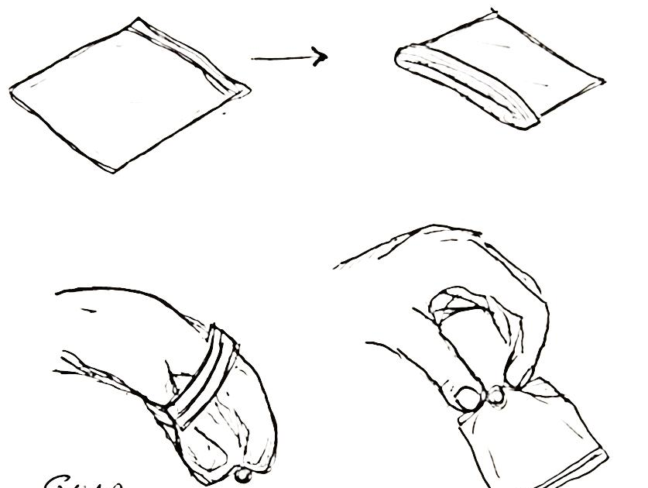
- In your group of 4, acquire the following: 4 plastic sealable sandwich bags
- To collect your samples…
  - Invert the bag so that the outside is on the inside (i.e. so that the bag is inside out)
  - Reach your hand inside the bag and grab the sample through the bag
  - Re-invert the bag so that the sample is inside the bag.
    - Your hands should never actually come in contact with the sample.
  - Seal the bag and date and label it.
  - Collect four samples and bring them to the classroom.

Inoculation of Samples
- As a group, acquire the following: your samples; your test tubes (that you prepared earlier).
  - Check to make sure the filter paper is still flat against the tube; if it is not, use a glass rod or other sterile long object to re-flatten it against the side of the test tube.
- As a group, select two of the samples that you wish to add to your test tubes. Select your two samples on the basis of which ones you think will have the most cellulose-degrading activity.
  - Be prepared to defend your choice of samples using logic and your observations of the sample.
- With a gloved hand, acquire a pea-sized amount of one of the samples you chose from its bag.
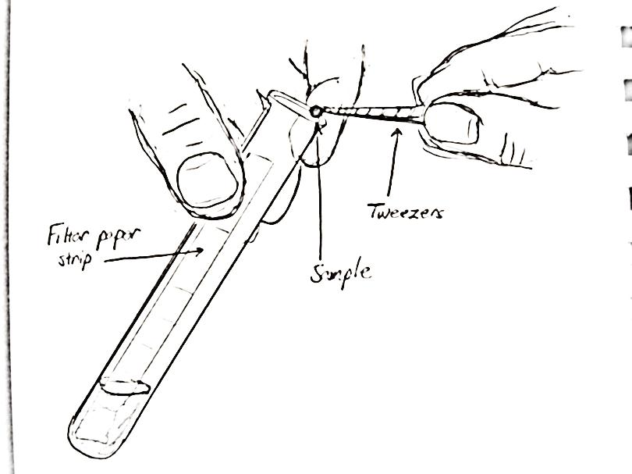
- Take one of the test tubes you prepared; slightly tip it so that the filter paper is on top.
  - With a tweezers (or a gloved hand if needed) add your pea-sized sample so that it does not hit the sides or the filter paper.
  - Take great care not to hit the filter paper when adding; this could skew the results.
  - If you do hit the side of the tube, use a sterile glass rod or similar object to push it all the way down to the media solution.
- Cap the tube and add the substance added to the label.
- Repeat this once more for the same sample in a second test tube.
- Repeat this for the second sample using the remaining two tubes that you prepared.
- When you have inoculated all four tubes, make sure they are labeled correctly with the substance and place in a lab shaker as specific by your instructor.
- Check your tubes periodically (if not daily) for any signs of growth and cellulose degradation.
  - If you tubes have the same consistency and cloudiness as the day you added the sample, you likely do not have a sample that can degrade cellulose.
  - If you see any increased cloudiness, yellowing or definite color change on the filter paper strip (ignoring the color change caused by the color of the sample itself), or microbial growth on the filter paper, you have possible cellulose degradation.
  - If you observe any ripping, tearing, or dissolving of the filter paper, you have definite cellulose-degradation, an indication of cellulase activity.
- Record each observation on the accompanying table and write or draw your visual observations for each tube (see attached table to record observations). When the experiment is finished, complete the attached questions.
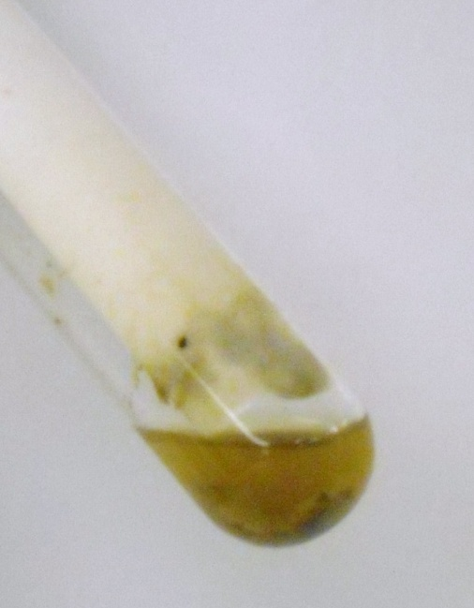
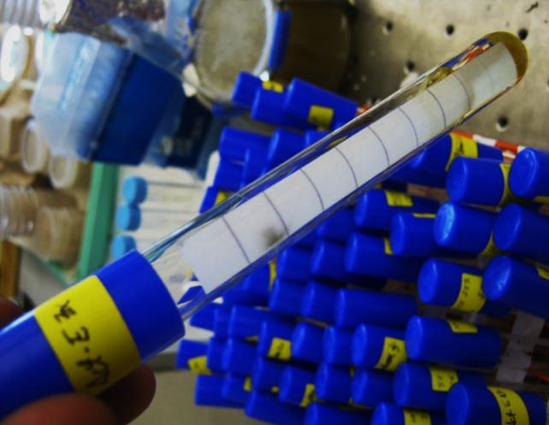
Figure 1 (left) Properly inoculated sample after 6 days of growth. Some growth has occurred in the media and the paper has a noticeable yellowed line indicating possible growth.
Figure 2 (Right): the dissolved and ripped filter paper after a week of growth.

Bioprospecting Lab by C. Kohn
Name: Hour Date:
Date Assignment is due: Why late? Score: + ✓ -
^{Day of Week} ^{Date} If your project was late, describe why

Lab Summary (complete before the lab is started):
- How will you know if your bioprospected samples are effective in producing the cellulase enzyme? How will your test tubes change if your samples are effective?
- If your samples are not effective at producing cellulase or at breaking down cellulose, how will you be able to tell?
- Why did you choose each of your two samples? What made you think they would have the most cellulase activity? For each sample, describe it and defend your choice with an explanation.
  - First sample: Why chosen:
  - Second sample: Why chosen:
- Could a microbe that does not produce cellulase survive in these test tubes? Why?
- What role did the liquid media solution play? Why was it necessary?
- What differences do you think you will see between your control and your test tubes with your bioprospected samples? Explain:
I hypothesize that we will see the following differences:
- Provide a rationale for all hypotheses made above: I think these hypotheses will be proven correct because…

Table 1: Filter Paper Test Tube Results (complete after the lab is started)
 | Test Tube 1 | Test Tube 2 | Test Tube 3 | Test Tube 4
Description of Sample
Observations – circle which description best fits each sample for that day.
Date: | No Growth  Possible Growth  Definite Growth | No Growth  Possible Growth  Definite Growth | No Growth  Possible Growth  Definite Growth | No Growth  Possible Growth  Definite Growth
Observations
(you may write a description or draw it)
Date: | No Growth  Possible Growth  Definite Growth | No Growth  Possible Growth  Definite Growth | No Growth  Possible Growth  Definite Growth | No Growth  Possible Growth  Definite Growth
Observations
(you may write a description or draw it)
Date: | No Growth  Possible Growth  Definite Growth | No Growth  Possible Growth  Definite Growth | No Growth  Possible Growth  Definite Growth | No Growth  Possible Growth  Definite Growth
Observations
(you may write a description or draw it)
Date: | No Growth  Possible Growth  Definite Growth | No Growth  Possible Growth  Definite Growth | No Growth  Possible Growth  Definite Growth | No Growth  Possible Growth  Definite Growth
Observations
(you may write a description or draw it)

“No Growth” = sample remains largely clear and mostly unchanged. Little or no indication of microbial growth.
“Possible Growth” = media solution is cloudier than when the sample was added. Visible color change has occurred on the filter paper (often with a clear line on the paper). Signs of microbial growth and reproduction are observable.
“Definite Growth” = the filter paper has ripped, torn, or dissolved

Table 2: Filter Paper Test Tube Results (second page if needed)
 | Test Tube 1 | Test Tube 2 | Test Tube 3 | Test Tube 4
Description of Sample
Observations – circle which description best fits each sample for that day.
Date: | No Growth  Possible Growth  Definite Growth | No Growth  Possible Growth  Definite Growth | No Growth  Possible Growth  Definite Growth | No Growth  Possible Growth  Definite Growth
Observations
(you may write a description or draw it)
Date: | No Growth  Possible Growth  Definite Growth | No Growth  Possible Growth  Definite Growth | No Growth  Possible Growth  Definite Growth | No Growth  Possible Growth  Definite Growth
Observations
(you may write a description or draw it)
Date: | No Growth  Possible Growth  Definite Growth | No Growth  Possible Growth  Definite Growth | No Growth  Possible Growth  Definite Growth | No Growth  Possible Growth  Definite Growth
Observations
(you may write a description or draw it)
Date: | No Growth  Possible Growth  Definite Growth | No Growth  Possible Growth  Definite Growth | No Growth  Possible Growth  Definite Growth | No Growth  Possible Growth  Definite Growth
Observations
(you may write a description or draw it)

“No Growth” = sample remains largely clear and mostly unchanged. Little or no indication of microbial growth.
“Possible Growth” = media solution is cloudier than when the sample was added. Visible color change has occurred on the filter paper (often with a clear line on the paper). Signs of microbial growth and reproduction are observable.
“Definite Growth” = the filter paper has ripped, torn, or dissolved

Lab Summary (complete after the lab is completed):
- Why did you choose each of your two samples? What made you think they would have the most cellulase activity? For each sample, describe it and defend your choice with an explanation.
  - First sample: Why chosen:
  - Second sample: Why chosen:
- For each sample, describe how it changed from the first day of incubation to your final day of results:
  - Test Tube 1:
  - Test Tube 2:
  - Test Tube 3:
  - Test Tube 4:
- Which tubes showed evidence of cellulase?
- What evidence is there that there was cellulase-activity in these tubes?
- Rate yourself on your understanding of the following (1 = little understanding; 5 = complete understanding):
How bioprospecting affects the science and production of biofuels: 1 - 2 - 3 - 4 - 5
How to test microbial populations for the production of cellulase: 1 - 2 - 3 - 4 - 5
Why cellulase is needed to produce biofuels from cellulosic feedstocks: 1 - 2 - 3 - 4 - 5
How cellulose is turned into simpler, easier-to-ferment molecules: 1 - 2 - 3 - 4 - 5

