Elements of Design Notesheet by C. Kohn, Waterford WI
Name: Hour Date:
Date Assignment is due: Why late? Score: + ✓ -
^{Day of Week} ^{Date} If your project was late, describe why
Directions: Use the accompanying PowerPoint (available online) to complete this sheet. This is graded on a + ✓- scale.
- The elements of design are
to that .
- It is easy to spot poor designs because
- The elements of design are that must
- If a design has 5 of the 6 elements used successfully, how would that landscape be perceived?
Why?
- Is this just a landscaping thing? Explain:
- List and briefly summarize the six elements of design:
- List and describe two additional elements that are a part of landscape design:
- What is Line?
- What does it mean that line “tells your eyes where to look”?
- A poor design will seem - it will be
- A strong design will have
- How are landscapes like cartoon characters?
- Describe three ways in which line can be created in a landscape and explain how:
1
2
3
- Line is used effectively when it is used to
(a.k.a. the )
emphasize
and highlight
- How should line be used in a landscape if it contains a statue or monument?
- How should line be used if the landscape is made of distinct parts?
- If a landscape contained naturally-existing lines, do you still need to include man-made lines? Explain:
- What is Form?
- What are examples of Form?
- Draw these examples below:
- How does a person’s brain use Form?
- A good designer will use form to
- Why does form matter?
- The same kinds of form, ,
- Good landscapers use form in order to
- Our brains . Good landscapes
- What is Space?
- Draw what this means below:
- A landscape that lacks depth will
- A well-designed landscape will
- How can this be accomplished?
- What are three ways in which a sense of space can be created?
- Color helps to
- Describe the three properties of color:
Hue:
Value:
Intensity:
- What is texture?
- How does the texture of a palm tree differ from that of a lawn of grass?
- Draw a rough-textured plant, a smooth textured plant, and a medium-textured plant below:
- What are four functions that texture can be used for?
- What is Value?
- Value can affect the of other
including
- Value is necessary to create or
- Draw what Value means below:
- What is an example of contrast?
- Contrast is created when
- Contrast is necessary to create , to
,
to
and provide
- Contrast is necessary to
- Without the combination of contrasting value and bold lines,
- Summarize five ways in which a landscape that misuses the Elements would be affected in the space below:

- Below is the White House. Explain how the surround landscape properly uses each element:
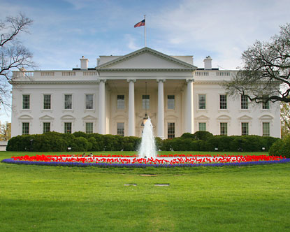
Line:
Form:
Space:
Color:
Note – the flowers around the fountain are red and blue.
Texture:
Value:

Unit Wrap-up C. Kohn, Agricultural Sciences - Waterford WI
This page is designed to help raise your grade while enabling you to develop skills you will need for after high
school. You will need to complete every question and blank in order to receive full credit for your notes. Note: if you cannot come up with a strategy to remember a difficult concept on your own, see your instructor for help.
- What is a topic or concept from this unit that you found to be more challenging? Write or describe below:
In the space below, create a mnemonic, rhyme, analogy, or other strategy to help you remember this particular concept:
- What is a 2nd topic or concept from this unit that you found to be more challenging? Write or describe below:
In the space below, create a mnemonic, rhyme, analogy, or other strategy to help you remember this particular concept:
- What is a 3rd topic or concept from this unit that you found to be more challenging? Write or describe below:
In the space below, create a mnemonic, rhyme, analogy, or other strategy to help you remember this particular concept:
- Circle the most appropriate response. You will only be graded on whether or not you completed this section, so be entirely honest with yourself when completing this section.
Circle one: I used my notes outside of class to prepare for the quiz. Definitely – Yes – Sort of - No
Circle one: I took extra notes in the margins for very difficult concepts. Definitely – Yes – Sort of - No
Circle one: I created a personal strategy for at least three difficult items. Definitely – Yes – Sort of - No
Circle one: I was very involved and actively studying during the quiz review. Definitely – Yes – Sort of - No
Circle one: I think I will be satisfied with the quiz grade I received this week. Definitely – Yes – Sort of - No
Circle one: I might need to meet with the instructor outside of class. Definitely – Yes – Sort of - No

