Marketing Research Worksheet by C. Kohn, Waterford WI
Partner Names: Hour Date:
Date Assignment is due: Why late? Score: + ✓ -
If your project was late, describe why
Directions: Work with your assigned partner to complete this worksheet. When one person is writing, the other should help them determine what to write. Switch roles after each question. Please initial after each question you write.
+ = all space is completely used w/ legible answers. ✓= expectations were met but not exceeded. - = redo assignment
Background: you are starting a student business in which you will sell eggs from backyard chickens in central Madison, WI – population 250,000. You spent $500 to build and furnish a chicken coop (your fixed cost). You purchase 15 baby chicks for $30 (variable cost), which been producing an average of 6 eggs per week per hen since they were 6 months old. You spend an average of $90 per month on feed, bedding, electricity, etc. for all chickens (variable costs). The store you buy from is trendy and only sells certified-organic supplies; you could potentially find cheaper supplies, but you might also lose any savings from higher shipping costs and time. Your local supermarket sells standard eggs for $1.25 a dozen; organic eggs sell for $2.50 a dozen. A blogger claims their backyard eggs sell for $5 per dozen. You can expect your chickens to have a productive lifespan of 36 months, and lay eggs reliably for 30 months. You do not have a rooster but you could potentially acquire one for under $10. Use this information to answer the questions below.

- Summarize five separate ways in which marketing research could help you make a profit from selling these eggs. Use your notes if needed.
1.
2.
3.
4.
5.
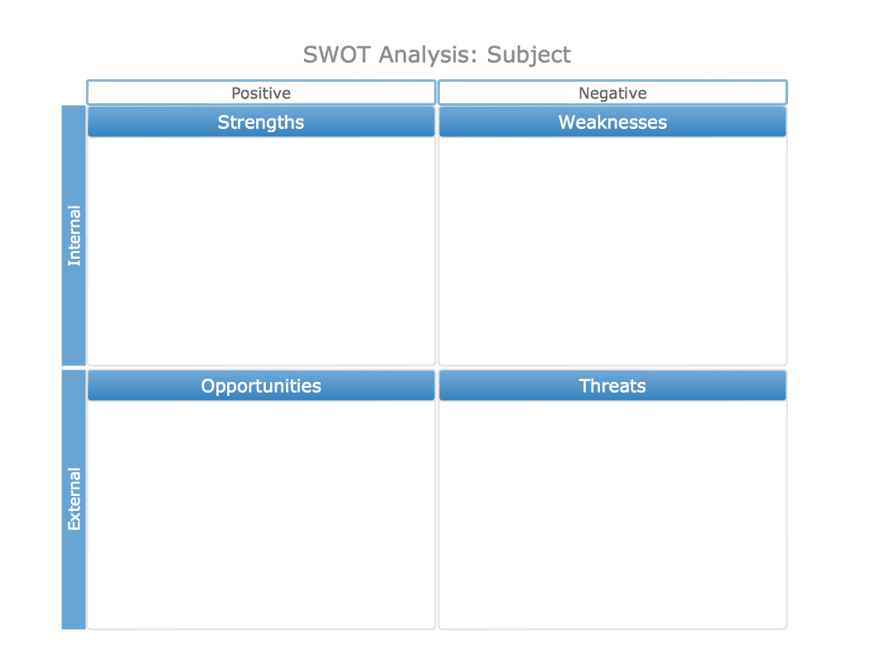
- Perform a SWOT Analysis in the area below.
- How will you utilize your product’s strengths most effectively?
- How do you fix or negate the weaknesses of your product?
- How will you capitalize on the opportunities that exist to sell your product?
- How will you prevent or negate the threats to the sales of your product?
- In the space below, describe 3 kinds of people who would be most likely to buy your eggs.
Type One – General Description:
Specifics (geographics, demographics, psychographics, behavioral, benefits sought):
Type Two – General Description:
Specifics (geographics, demographics, psychographics, behavioral, benefits sought):
Type Three – General Description:
Specifics (geographics, demographics, psychographics, behavioral, benefits sought):
- Of the three types you described above, which do you think is most likely to purchase from you?
Type: . Why is this group more likely to buy from you than any other?
- Answer the following: Is this specific group… (NOTE: do not use this group unless you know it is ‘YES' for all).
  - Measurable and specific – are you able to tell who is a part of this segment and who is not?
Explain:
  - Able to be reached by your available methods of communication? Explain:
  - Relatively steady, stable, and unchanging? Explain:
  - Sizeable enough to be profitable? Explain:
  - Able to participate - do customers must have the money and willingness to buy the good or service offered?
Explain:
- What are the Unique Selling Points (or Points of Differentiation) for your product that are specific and appealing to this particular market segment? Consider product quality, convenience, customer values, cost, service, etc. What can you provide with your product bundle that no one else can to these people to the same extent?
USP 1:
USP 2:
USP 3:
USP 4:
- Why is your product better for this group than all other similar products? Explain by comparing your product to each of the following. Note: this is based on what your target market would believe about your product; this might not be the same as what you think about your product (the customer’s opinion is more important than your own in this case).
Standard eggs from the grocery store:
Organic eggs from the grocery store:
Eggs from another backyard chicken operation:
Note: you may have to make some general assumptions about other backyard chicken operations.
- Write a position statement in the space below. The standard formula for a position statement is:
For [describe target market], the [product] is the [unique selling point(s)] because [reason why your product is the best for this group].
E.g. For World Wide Web users who enjoy books, Amazon.com is a retail bookseller that provides instant access to over 1.1 million books. Unlike traditional book retailers, Amazon.com provides a combination of extraordinary convenience, low prices, and comprehensive selection.
For our
^{Describe your target market}
backyard eggs are
- Are your potential customers aware of you? Not yet . How does this affect your communication
with this target market?

- How many people total do you estimate would buy your eggs on a weekly basis? Explain:
Be realistic! This is only something you’ll do on the side when you’re not in class – you have limited time & resources!
- Who is your top competitor?
How will you position your product to make it seem like the better choice for this specific group of people?

- What will you need to do or offer to keep your market segment from going to the competition?

- What are your top priorities for reaching and acquiring the business of your targeted market segment? What do you MOST need to do to prevent your target market from buying from your competition instead of you?
1
2
3
4
- Describe your positioning strategy in the space below. How will you acquire a sizeable portion of your target market from your competition in order to make your operation profitable enough to be worthwhile?
- What are your total fixed costs (see the first page)? $
This is what you had to spend before you could have any chickens at all.
- What are your variable unit costs (see the first page)? $ /chicken/lifespan
How much does it cost per chicken to buy and support each bird? Assume each bird will be kept for 36 months.
Show your work:
- What are your total variable costs for all 15 chickens? $ (multiply your answer above by 15)
- How many eggs will ONE chicken produce in its lifetime if they lay an average of six eggs
per week for 30 months? Assume there are four weeks in a month. Show your work below. eggs
Mathematically, this would be #months x #weeks/month x #eggs per week = #eggs/lifetime/chicken
- How many dozen eggs is this? dozen eggs/chicken. ^{(Divide by 12)}
- For what price do you intend to sell a dozen (12) eggs? $ per dozen eggs.
- How much money will ONE chicken produce in its lifetime at this price? $ /per chicken.
- What would be your GROSS income (income before subtracting expenses) for all 15 chickens? $
Show your work:
- What would be your NET income (income after subtracting expenses) for all 15 chickens $
Don’t forget to subtract both the total variable costs and the total fixed cost!
Show your work:
- If there are roughly 154 weeks in the lives of these chickens, what is your average net income per week?
$ made per week. Show your work:
- If you had to hire someone to work an average of 3.5 hours per week at $7 per hour, would you still be profitable? For this, assume that you have to pay for 34 months of labor, which equates to roughly 146 weeks.
Are you still profitable? Show your math:
HINT: subtract this total value from your net income.
- If a rogue raccoon attacked and killed five of your chickens immediately after you put them in the coop, would
you still be profitable?
Show your work:
Should your price be raised to reflect this possibility? Explain:

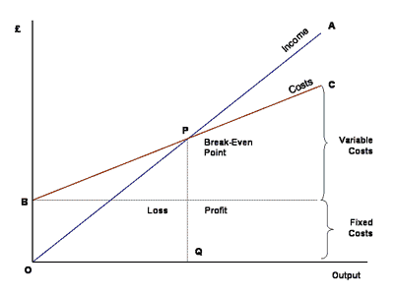
- In the space below, graph the cost of raising these chickens. An example graph is shown to the right. Your cost line should leave the y-axis at the value of the total fixed cost of raising your chickens. On this graph, this is shown at “B”. This line should increase by the total variable cost.
Also include the brackets on the right showing your variable costs and fixed costs. You will add your income line later. HINT: use a ruler to draw your lines so they are straight - this will help you determine your breakeven point. You will need to use ACTUAL values – don’t just draw lines; you need to plot out the points in order to answer the questions below..
$

- How many chickens do you need to breakeven?
- Do you think it is reasonable that you could sell the eggs of all 15 chickens on a weekly basis, or do you think you would struggle to find enough people in Madison to buy your product at the price you are offering? Explain:
- Do you think this would be easier or harder than getting a part-time job?

