Mendelian Genetics – Agriscience by C Kohn
Name: Hour Date:
Date Assignment is due: Why late? Score: + ✓ -
^{Day of Week} ^{Date} If your project was late, describe why

Unit Preview
Weekly Schedule: See Board and record
Mon
Tues
Wed
Thurs
Fri
- What is a Punnett square? What does it do?

- If a black bull and a red cow have a calf, would it be black or red? How would you know?
- What is the difference between a dominant and a recessive gene?
- Define “Genetics” in your own words below:
Page through this notesheet. Then answer the questions below:
Circle one: I need to review my notes & practice before the quiz. Definitely – Yes – Sort of - No
Circle one: I have never seen or heard of some of these concepts. Definitely – Yes – Sort of - No
Circle one: This may be a challenging unit for me personally. Definitely – Yes – Sort of - No
Circle one: I may need extra strategies for some topics/vocab. Definitely – Yes – Sort of - No

Directions: Use the accompanying PowerPoint (http://bit.ly/punnett-ppt) to complete this sheet. This sheet will be due upon the completion of the PowerPoint in class. These assignments are graded on a +/√/- scale.
- Define genetics in your own words:
- Define allele in your own words:
- Define recessive in your own words:
- Define dominant in your own words:
- Define homozygous dominant in your own words:
- Define homozygous recessive in your own words:
- Define heterozygous in your own words:
- Define genotype in your own words:
- Define phenotype in your own words:
- What is Mr. Kohn’s phenotype for eye color?
- What is Mr. Kohn’s genotype for eye color?
- Define Punnett Square in your own words:
- In the space below, show the FIVE steps and the Punnett Squares you would use to determine the genotypes and phenotypes of the Octopus family shown here.
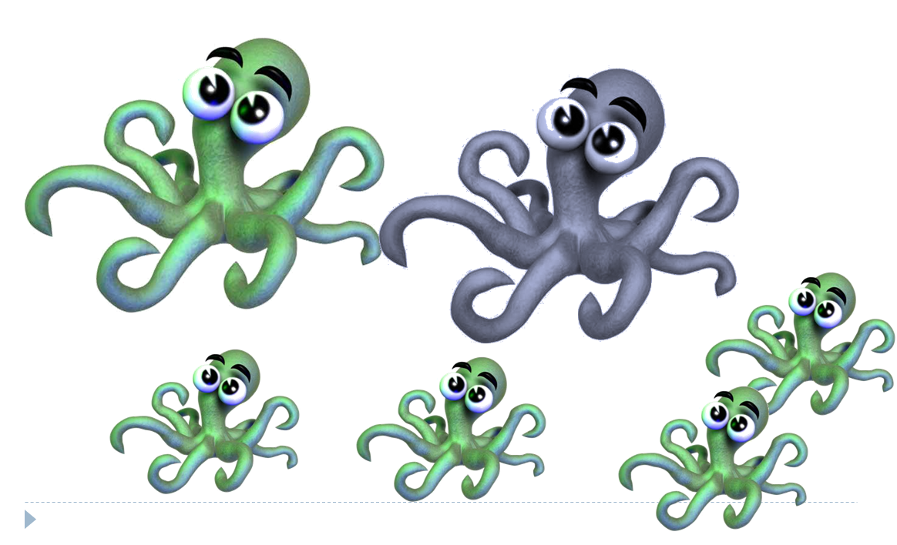
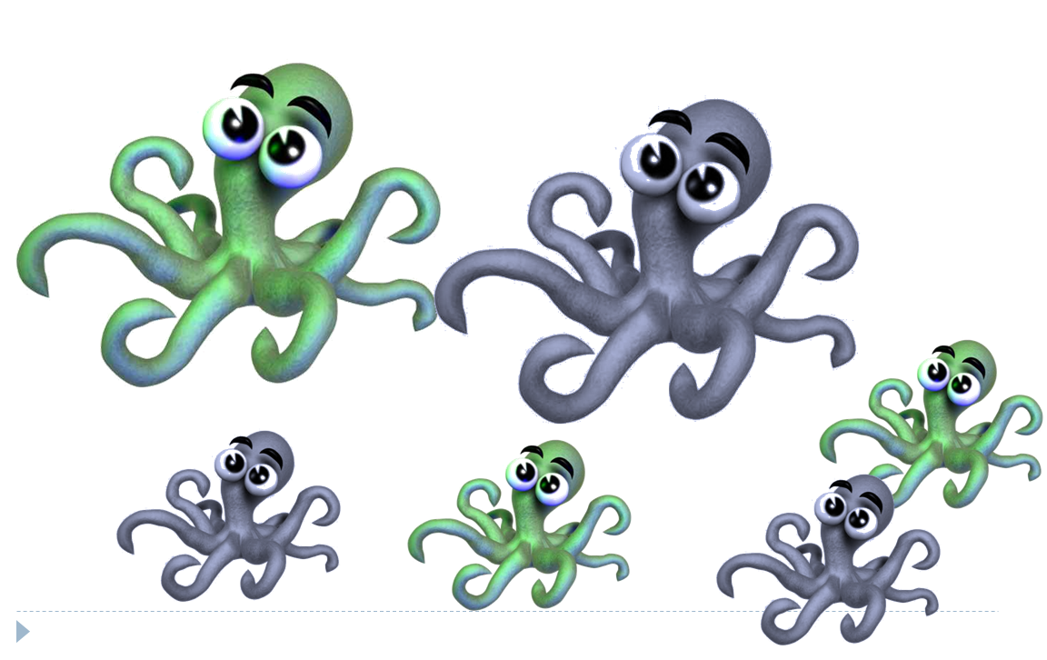
- In the space below, show the FIVE steps and the Punnett Squares you would use to determine the genotypes phenotypes of the Octopus family shown here.
- Write the six possible genotype combinations below:

- Complete the six possible genotype combinations in the Punnet squares below:

- For the following ratios of phenotypes, explain what the genotype(s) of the parents has to be:
- 3:1
- 2:2
- 4:0 (all dominant phenotypes)
- 0:4 (all recessive phenotypes

Unit Wrap-up C. Kohn, Agricultural Sciences - Waterford WI
This page is designed to help raise your grade while enabling you to develop skills you will need for after high
school. You will need to complete every question and blank in order to receive full credit for your notes. Note: if you cannot come up with a strategy to remember a difficult concept on your own, see your instructor for help.
- What is a topic or concept from this unit that you found to be more challenging? Write or describe below:
In the space below, create a mnemonic, rhyme, analogy, or other strategy to help you remember this particular concept:
- What is a 2nd topic or concept from this unit that you found to be more challenging? Write or describe below:
In the space below, create a mnemonic, rhyme, analogy, or other strategy to help you remember this particular concept:
- What is a 3rd topic or concept from this unit that you found to be more challenging? Write or describe below:
In the space below, create a mnemonic, rhyme, analogy, or other strategy to help you remember this particular concept:
- Circle the most appropriate response. You will only be graded on whether or not you completed this section, so be entirely honest with yourself when completing this section.
Circle one: I used my notes outside of class to prepare for the quiz. Definitely – Yes – Sort of - No
Circle one: I took extra notes in the margins for very difficult concepts. Definitely – Yes – Sort of - No
Circle one: I created a personal strategy for at least three difficult items. Definitely – Yes – Sort of - No
Circle one: I was very involved and actively studying during the quiz review. Definitely – Yes – Sort of - No
Circle one: I think I will be satisfied with the quiz grade I received this week. Definitely – Yes – Sort of - No
Circle one: I might need to meet with the instructor outside of class. Definitely – Yes – Sort of - No

