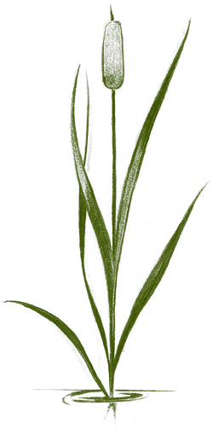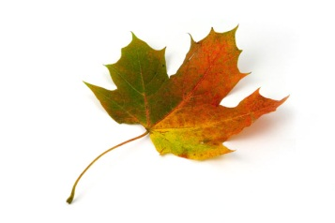** Natural Resources**

*Environmental Science Meets Everyday Solutions.*

***“Why does Waterford have an Agricultural Sciences Department?”***

*You might wonder why a high school might have agriculture classes After all, most students do not become farmers or ranchers after high school.*

*Agricultural Sciences is about the use of science, business, ecology, and technology to solve problems and make the world a better place.*

*Agricultural Sciences students are trained to be the leaders of tomorrow, using their skills to find solutions to many of our most important issues including nutrition, medicine, ecology, and biotechnology.*

*Ag courses are a proven way to help students raise their test scores and increase their likelihood of college acceptance.*

*Why Ag? Because it will train you to be a better student, let you learn in a fun environment, and help get you into college!*

Do you love the outdoors? Do you want to help protect the environment? Are you into hunting or fishing? If so, then there is a class just for you!

**Natural Resources – E.S.** is a class open to freshmen through seniors. Natural Resources is a science elective that enables students to explore the natural world and discover how to best protect it from the greatest threats to the environment. Students who enroll in Natural Resources learn the mechanics that make ecosystems function. So why should a student enroll in Natural Resources? Because…

- **It’s Outside!** Many of our weekly labs take place outside where you can apply classroom lessons to real-world situations. This is hands-on learning at its finest! From the Environmental Center on campus to the Fox River, our laboratory is Mother Nature.

- **Learn about the things you care about!** **Earn science credit** while discussing things that matter to you. Wildlife, habitats, hunting, fishing, and nature are at the forefront in this class. Gain real world skills and science credit in a class about the things you enjoy and are passionate about.  
  
- **It will help you get better grades!** Natural Resources is taught by the Waterford’s ACT Science Prep instructor and reinforces concepts fundamental to biology. Test taking strategies, writing skills, and classroom success are actively included into the curriculum. This course is also aligned to state and national standards in biology, agriculture, and environmental science. Communications, mathematics, graphing, and group work are also heavily emphasized.

- **You will become an expert in the most important issues of today!** From extinctions of living species to pollution, from climate change to invasive species, Natural Resources covers the latest and greatest topics in science. With an actual environmental researcher for a teacher, you will leave this class an expert.

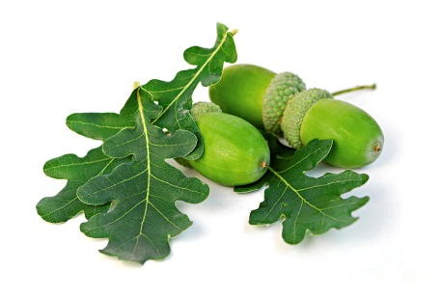- **WHS Agricultural Sciences has received state and national recognition as a leader in education.** Waterford Ag Dept. has state and national recognition as an example of high school instruction at its best. Mr. Kohn was recognized as the 2011 Agriscience Teacher of the Year and is also on the State & National Committee for Agriculture and Natural Resources Academic Standards. In 2012 he was named a Kohl Fellowship Winner (a top honor for teachers in Wisconsin) and in 2013 Kohn was named a national Ag Ed Outstanding Young Educator. In 2014 Kohn was named as one of the Top 40 professionals under 40 in the industry.

***Change the world while exploring nature!***

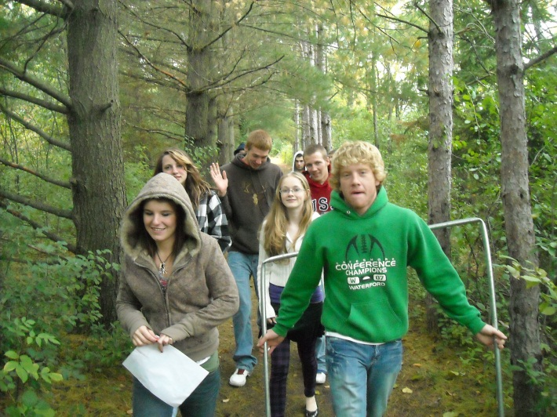So what do students actually do in Natural Resources? The class begins by looking at biodiversity and extinctions. Students learn how species go extinct as well as the value that biodiversity creates for our lives. Students assess biodiversity levels in different kinds of habitats on the school’s campus, including the Environmental Center forest in multiple outdoor lab experiments.

***What other classes could I take in the Agriculture Sciences Department?***

*Students who want to maximize their performance in* ***science*** *and on the* ***ACT*** *in a fun atmosphere with lots of hands-on labs and live animals and plants should take Agriscience.*

*Students with an interest in a* ***medical field*** *would be highly encouraged to take Veterinary Pet Care and Large Animal Veterinary Science. Both courses are largely focused on physiology and medical techniques (such as sutures and injections).*

*Due to its design and drafting nature, students with an interest in* ***engineering, architecture,*** *or* ***design*** *should consider Landscape Design.*

*Students with an interest in* ***science, technology,*** *or* ***research*** *should consider Biotechnology – a research-oriented laboratory class based on renewable energy.*

***Science credit*** *is also available for some courses, including Home Gardening & Horticulture - ES as well as Natural Resources - ES.*



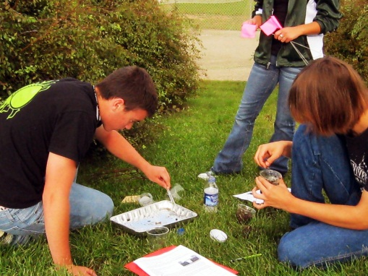Next, students examine the four main causes of extinction: habitat loss, invasive species, overharvesting, and pollution. Students begin by assessing the habitat value of the Environmental Center forest, spending weeks collecting and analyzing data on the plant and animal species in this ecosystem.

In October, students will investigate the impact of invasive species such as Emerald Ash Borer, Garlic Mustard, and Asian Carp. Students will test for the presence of these species and assess their impact on biodiversity using real ecological measurements.

By November, students focus on fish and wildlife by examining the impacts of pollution on hunting and fishing. Students will test the Fox River to determine the impact of pollution on game fish and collect samples to analyze the health of this aquatic ecosystem.

In time for hunting, students will examine practices in population ecology and game management to determine how to best preserve and manage Wisconsin’s legendary whitetail deer population.

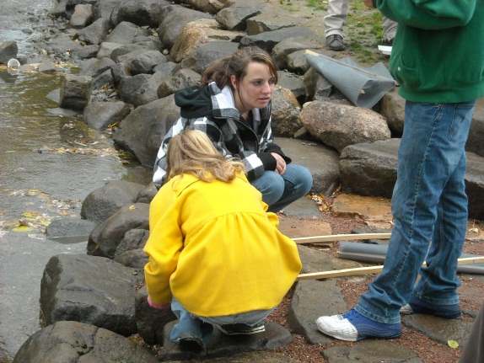In December students examine air pollution and its effects on climate and weather. Students will examine the ice conditions on the world’s most studied lake, Lake Mendota in Madison. They will analyze the same 450,000 years of data from Antarctica that real scientists use to determine how the planet is changing over time.

Students conclude the semester with a unit on survival strategies, ensuring that if they are ever lost in the wilderness, they can survive and return safe and sound.

For more information, contact Mr. Kohn at [ckohn@waterforduhs.k12.wi.us](mailto:ckohn@waterforduhs.k12.wi.us) or visit [www.wuhsag.weebly.com](http://www.wuhsag.weebly.com). You can also call at 262-534-3189 x 7309 or visit Rm 209!