Agriscience Final Exam C. Kohn, Agricultural Sciences - Waterford WI

Name: Hour Date: Score:

A researcher is interested in testing the impact of adrenaline on radishes. She is not certain if adrenaline will affect the radish rate of growth or final average height. She suspects that adrenaline may increase the final average height of the radishes because of its effects on animal bodies. Use this background information to answer the questions below.

1. Which of the following would be her **Research Question**?
   1. I predict that adding adrenaline to my soil will make my radishes grow taller
   2. I think this will happen because adrenaline makes animal hearts pump faster; it might help plants circulate nutrients more quickly in the same way blood is circulated more quickly in the body.
   3. I wondered if adding adrenaline to my soil would make my radishes grow taller.
   4. Adrenaline is a chemical found in animal bodies that increases the heart rate.
2. Which of the following would be her **Hypothesis**?
   1. I predict that adding adrenaline to my soil will make my radishes grow taller
   2. I think this will happen because adrenaline makes animal hearts pump faster; it might help plants circulate nutrients more quickly in the same way blood is circulated more quickly in the body.
   3. I wondered if adding adrenaline to my soil would make my radishes grow taller.
   4. Adrenaline is a chemical found in animal bodies that increases the heart rate.
3. Which of the following would be her **Rationale**?
   1. I predict that adding adrenaline to my soil will make my radishes grow taller
   2. I think this will happen because adrenaline makes animal hearts pump faster; it might help plants circulate nutrients more quickly in the same way blood is circulated more quickly in the body.
   3. I wondered if adding adrenaline to my soil would make my radishes grow taller.
   4. Adrenaline is a chemical found in animal bodies that increases the heart rate.
4. Which of the following would be her **Independent Variable**?
   1. The height of the radishes
   2. The addition of adrenaline to the soil
   3. The plants/soil that have no adrenaline added to them
   4. The plants/soil that were given extra fertilizer AND received adrenaline.
5. Which of the following would be her **Dependent Variable**?
   1. The height of the radishes
   2. The addition of adrenaline to the soil
   3. The plants/soil that have no adrenaline added to them
   4. The plants/soil that were given extra fertilizer AND received adrenaline.
6. Which of the following would be her **Control**?
   1. The height of the radishes
   2. The addition of adrenaline to the soil
   3. The plants/soil that have no adrenaline added to them
   4. The plants/soil that were given extra fertilizer AND received adrenaline.
7. Which of the following is **never** ok to have in an experiment?
   1. Two or more rationales (two or more reasons for making her hypothesis)
   2. Two or more dependent variables (two or more things to measure)
   3. Two or more independent variables (two or more things to change)
   4. Two or more people
8. When listing the **Materials** for an experiment, she should include…
   1. Only the items that will affect the outcome of the experiment
   2. Everything used in the experiment
   3. Only the items not used in the control
   4. Only the items that are a part of the independent variable
9. If you have a good **Methods section**, which of the following would be true?
   1. A person could probably do her experiment if they read her methods, but only if they saw her conduct the experiment as well.
   2. Only she and her group could do the experiment; this way no one steals her work.
   3. The experiment would have similar results no matter who did the experiment so long as they followed the instructions in the Methods section.
   4. Enough detail is provided for someone to understand her experiment, but not so much that they could steal it
10. If she changed more than one thing in your experiment, what would most likely happen?
    1. She would have a more valuable experiment.
    2. There would be no way to determine which change was responsible for the data.
    3. She would see more results compared to if she only changed one thing.
    4. Her experiment would be more likely to work.
11. Plants acquire most of the carbon molecules they need from…
    1. The air b. The soil c. The water d. None of the above
12. When a human or animal consumes food, the carbon in that food is most likely to be converted into which of the following elements?
    1. Oxygen b. Hydrogen c. Nitrogen d. None of the above; the carbon will remain carbon
13. Which of the following consumes carbon dioxide (CO2)?
    1. Plants b. Animals c. Decomposers d. All of the above
14. When a log is burned in a fire it seems like it loses weight; what actually happens to its physical mass?
    1. It disappears
    2. It is released into the air as CO2 and H2O
    3. It becomes energy
    4. The log does not change weight or size
15. From where does a log primarily obtain its physical mass when it is growing as a tree (not including water weight)?
    1. From the soil b. From the sunlight c. From the air d. From the seed
16. The Carbon Cycle is best defined as the process in which…
    1. Carbon molecules change from inorganic forms to organic forms and back
    2. Carbon atoms are changed into other elements, including oxygen and hydrogen
    3. Carbon molecules are consumed and regenerated from other elements such as oxygen, hydrogen, and nitrogen
    4. Carbon atoms are continually created from the sun’s energy by living organisms
17. Organisms such as fungi and microbes that are decomposers will affect the carbon cycle by…
    1. Consuming carbon, reducing the total amount of carbon that exists in the cycle
    2. Releasing CO2 into the atmosphere, increasing atmospheric levels of carbon
    3. Creating carbon from other atomic elements (such as oxygen)
    4. None of the above; decomposers do not affect the carbon cycle
18. Photosynthesizing plants affect the carbon cycle by…
    1. Creating more carbon atoms
    2. Reducing the amount of carbon in the soil, reducing soil fertility
    3. Absorbing CO2 from the atmosphere, lowering atmospheric levels of carbon
    4. None of the above; plants to do not affect the carbon cycle
19. Animals affect the carbon cycle by…
    1. Creating more carbon atoms through cell division
    2. Releasing CO2 into the atmosphere, increasing atmospheric levels of carbon
    3. Consuming carbon, reducing the total amount of carbon that exists in the cycle

*\*\*Use the image below to answer these questions. 1 is a plant; 2 is a respiring animal; 3 is the air; 4 is under the soil\*\**

1. 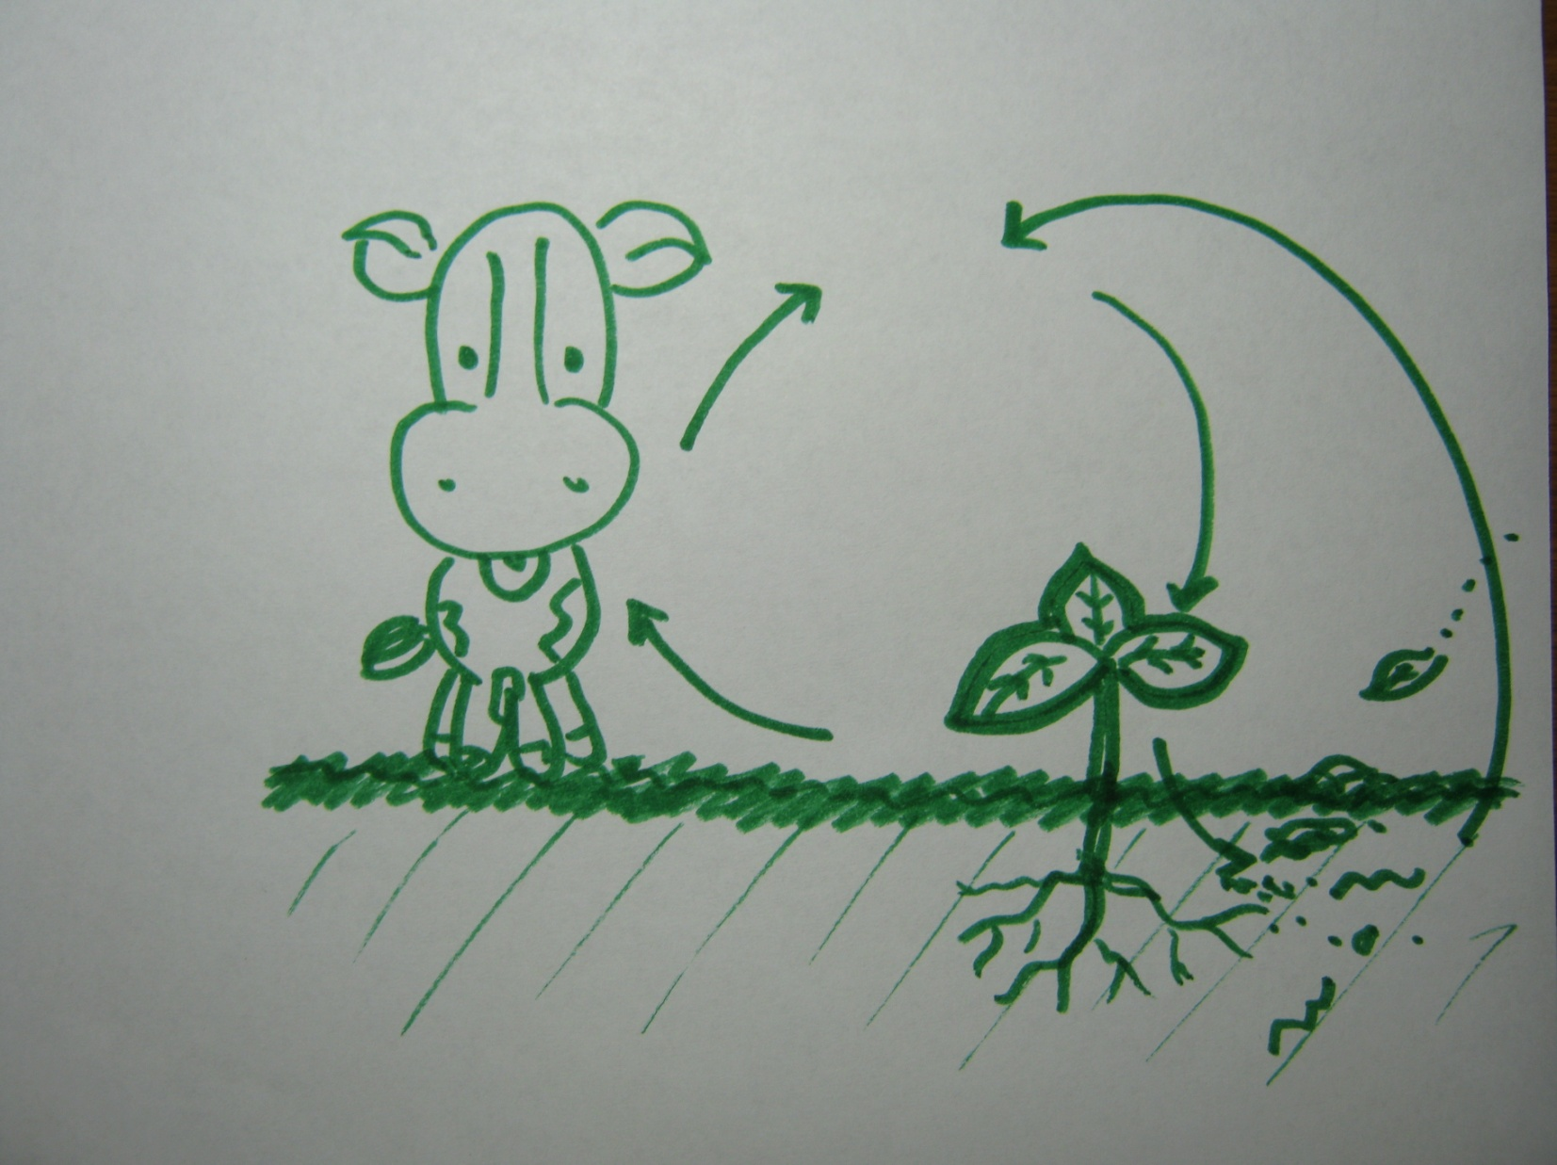Look at “1”. What process is occurring here and only here?
   1. Photosynthesis b. Respiration c. Decomposition d. Burning
2. At “1”, what is occurring?
   1. Sugars are being made from oxygen.

3

* 1. Sugars are broken down into hydrogen.
  2. Water and carbon dioxide are being made into sugar.

2

1

* 1. Sugars are being broken down into carbon dioxide and water.

1. Look at “2”. What process is occurring here?

4

* 1. Photosynthesis
  2. Respiration
  3. Decomposition
  4. Burning

1. At “2”, what is occurring?
   1. Sugars are being made from oxygen.
   2. Sugars are broken down into hydrogen.
   3. Water and carbon dioxide are being made into sugar.
   4. Sugars are being broken down into carbon dioxide and water.
2. What form of carbon are we most likely to find at “3”?
   1. C6H12O6 b. CO2c.Living Tissue
3. Look at “4”. What process is occurring here and only here (in the soil)?
   1. Photosynthesis b. Burning c. Decomposition
4. How does the carbon cycle affect our lives?
   1. All of our food depends on the crops that use the carbon cycle to make food.
   2. An imbalance in the carbon cycle can cause serious weather changes.
   3. We depend on plants to convert inorganic carbon molecules into organic carbon molecules in order for us to acquire the carbon we need for our body.
   4. All of the above.
5. Which of the following is NOT a requirement for something to be alive.
   1. It must have a cell with a membrane that allows for homeostasis
   2. It must have genetic material that it can pass on
   3. It must have organelles
   4. It must use energy to grow and change
6. The smallest indivisible unit of matter is the…
   1. Electron b. Atom c. Molecule d. Cell
7. The smallest unit of life is the…
   1. Electron b. Atom c. Molecule d. Cell
8. A group of atoms bonded together is a…
   1. Electron b. Atom c. Molecule d. Cell
9. Opposite charges of atoms ______ while similar charges __________
   1. Attract; Attract b. Repel; Repel c. Repel; Attract d. Attract; Repel
10. This atomic particle has a negative charge
    1. Proton b. Neutron c. Electron d. Nucleus
11. An example of a macromolecule is…
    1. Water b. CO2 c. a cell d. a protein
12. This organelle houses and protects DNA
    1. Nucleus b. Mitochondria c. Membrane d. Ribosomes e. Cytosol
13. This organelle produces proteins in the cell
    1. Nucleus b. Mitochondria c. Membrane d. Ribosomes e. Cytosol
14. This organelle produces ATP
    1. Nucleus b. Mitochondria c. Membrane d. Ribosomes e. Cytosol
15. This organelle is the outer lining and protects the inside of the cell
    1. Nucleus b. Mitochondria c. Membrane d. Ribosomes e. Cytosol
16. A group of cells all performing the same function is known as…
    1. An organ b. Tissue c. A system d. ATP Synthase
17. A group of different kinds of tissue with coordinated action and a main function is…
    1. An organ b. Tissue c. A system d. ATP Synthase
18. A group of organs all performing the same function is known as…
    1. An organ b. Tissue c. A system d. ATP Synthase
19. The energy of all living cells is…
    1. ATP b. ADP c. Glucose d. ATP Synthase
20. The uncharged version of this molecule is…
    1. ATP b. ADP c. Glucose d. ATP Synthase
21. The structure that produces the energy molecule of a cell is…
    1. ATP b. ADP c. Glucose d. ATP Synthase
22. ATP Synthase is primarily found in…
    1. The nucleus b. The membrane c. The ribosome d. The mitochondria
23. ATP Synthase is like …
    1. A battery b. A train c. A tiny wheel d. A mousetrap
24. What turns the ATP Synthase wheel?
    1. Water b. Oxygen c. Hydrogen d. ATP
25. From where does a cell acquire the substance that turns ATP Synthase?
    1. Water from the food we eat
    2. Oxygen from the air
    3. Hydrogen from carbohydrates and fat
    4. Carbon from the food we eat
26. How is ADP reformed back into ATP?
    1. A third phosphate turns ATP Synthase, adding hydrogen to ATP
    2. A third phosphate turns ADP Synthase, adding hydrogen to ADP
    3. ATP Synthase adds a third phosphate to ADP
    4. The cellular membrane move hydrogen back and forth, creating an electrical charge
27. What removes the leftover hydrogen from the mitochondria after ATP is created by ATP Synthase?
    1. Water from the food we eat
    2. Oxygen from the air
    3. Hydrogen from carbohydrates and fat
    4. Carbon from the food we eat
28. What are the waste products that are breathed out after ATP production by ATP Synthase?
    1. CO2 and H­2O b. CO2 and hydrogen c. CO2 and oxygen d. H­2O and carbon
29. 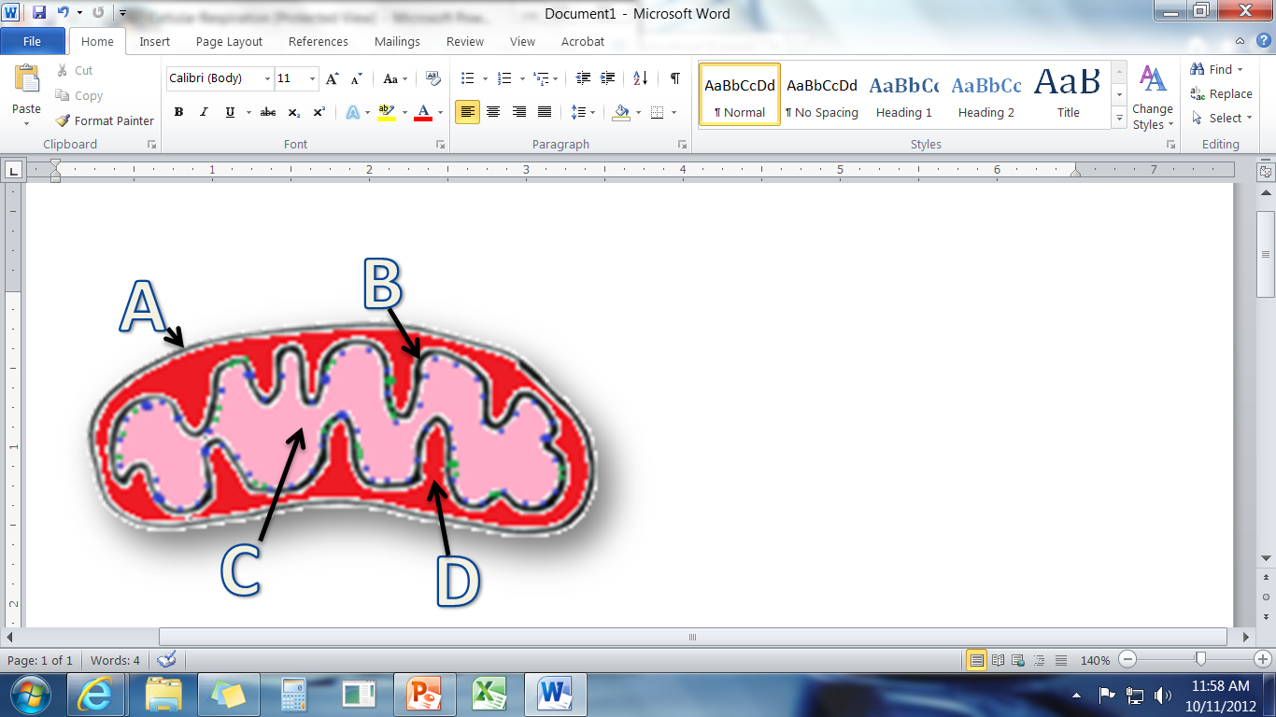This is the intermembrane space.
    1. b. c. d.

**A**

**D**

1. This is the matrix.
   1. b. c. d.
2. This is the inner membrane.
   1. b. c. d.
3. This is the outer membrane.
   1. b. c. d.

**C**

**B**

1. This is where we would find ATP Synthase
   1. b. c. d.
2. This is where hydrogen is stored before it powers ATP Synthase
   1. b. c. d.
3. This is where pyruvate is broken down completely and where its hydrogen atoms are removed.
   1. b. c. d.
4. This process creates ATP from ADP and Pi
   1. Substrate-level phosphorylation b. Oxidative Phosphorylation c. Both A & B d. None of the above
5. This process uses pyruvate and an enzyme in the cytosol to create ATP
   1. Substrate-level phosphorylation b. Oxidative Phosphorylation c. Both A & B d. None of the above
6. This process uses hydrogen to turn ATP Synthase to make ATP
   1. Substrate-level phosphorylation b. Oxidative Phosphorylation c. Both A & B d. None of the above
7. This process creates ATP from the energy of the sun.
   1. Substrate-level phosphorylation b. Oxidative Phosphorylation c. Both A & B d. None of the above
8. This is what the cell absorbs in order to acquire most of its hydrogen.
   1. Pyruvate b. Glucose c. NAD+/FAD+ d. Electron Transport System
9. This enzyme moves hydrogen to the inner membrane.
   1. Pyruvate b. Glucose c. NAD+/FAD+ d. Electron Transport System
10. This is half of a sugar molecule
    1. Pyruvate b. Glucose c. NAD+/FAD+ d. Electron Transport System
11. This is the set of pumps that move hydrogen into the intermembrane space from the matrix
    1. Pyruvate b. Glucose c. NAD+/FAD+ d. Electron Transport System
12. Which of the following would increase ATP production?
    1. Decreasing the number of ATP Synthase in the mitochondria
    2. Increasing the concentration of hydrogen in the matrix
    3. Increasing the concentration of hydrogen in the intermembrane space
    4. Allowing hydrogen to bypass the ATP Synthase
13. Cellular respiration is the process in which…
    1. Oxygen is turned into ATP, making ADP
    2. ATP is produced by ATP Synthase as it is turned by hydrogen
    3. Hydrogen is turned into ATP from ADP
    4. ATP is converted into ADP and Pi­
14. The simplest carbohydrate is…
    1. Starch b. Fiber c. Cellulose d. Glucose
15. Before a carbohydrate can be absorbed by the blood and cells, it must be broken down into…
    1. Glucose b. ATP c. ADP d. Hydrogen
16. The first step of respiration is Glycolysis. In this process…
    1. Hydrogen turns ATP Synthase, powering the production of ATP
    2. A pyruvate molecule is completely broken down, and FAD+ and NAD+ remove hydrogen.
    3. Sugar is split into two pyruvates; some ATP is made by substrate-level phosphorylation.
    4. Electron-powered protein pumps move hydrogen into the intermembrane space.
17. In the TCA Cycle…
    1. Hydrogen turns ATP Synthase, powering the production of ATP
    2. A pyruvate molecule is completely broken down, and FAD+ and NAD+ remove hydrogen.
    3. Sugar is split into two pyruvates; some ATP is made by substrate-level phosphorylation.
    4. Electron-powered protein pumps move hydrogen into the intermembrane space.
18. In the Electron Transport System, …
    1. Hydrogen turns ATP Synthase, powering the production of ATP
    2. A pyruvate molecule is completely broken down, and FAD+ and NAD+ remove hydrogen.
    3. Sugar is split into two pyruvates; some ATP is made by substrate-level phosphorylation.
    4. Electron-powered protein pumps move hydrogen into the intermembrane space.
19. In Oxidative Phosphorylation…
    1. Hydrogen turns ATP Synthase, powering the production of ATP
    2. A pyruvate molecule is completely broken down, and FAD+ and NAD+ remove hydrogen.
    3. Sugar is split into two pyruvates; some ATP is made by substrate-level phosphorylation.
    4. Electron-powered protein pumps move hydrogen into the intermembrane space.
20. This is a measurement of variability only.
    1. Mean b. Standard Deviation c. Standard Error d. Error Bars
21. This is a measurement of accuracy of data that included variability and sample size.
    1. Mean b. Standard Deviation c. Standard Error d. Error Bars
22. This is the average of the data
    1. Mean b. Standard Deviation c. Standard Error d. Error Bars
23. This visually shows the margin of error.
    1. Mean b. Standard Deviation c. Standard Error d. Error Bars
24. When it comes to data & accuracy, we want ______ variability and a _______ population size.
    1. Maximum Maximum
    2. Maximum Minimum
    3. Minimum Minimum
    4. Minimum Maximum
25. The _____ our data varies, the more reliable it is.
    1. Less b. More
26. The _____ data we have, the more reliable it is.
    1. Less b. More

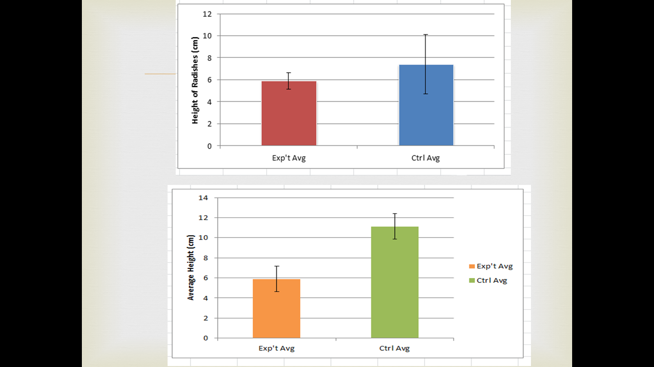Two graphs are shown below. Use these graphs to answer the following questions.

1. In which graph are the two sets of data statistically different from each other?
   1. Left b. Right
2. In which graph do the error bars overlap?
   1. Left b. Right
3. In which graph will the control always be greater than the experimental average?
   1. Left b. Right

**Addition of Adrenaline Solution Increases the   
Final Average Height of Radishes Compared to Control.**

W. Wolverine, 6th Hour Agriscience

Waterford Union High School, Waterford, WI

**Introduction: (1)** The rate at which crops grow can affect the profitability of that crop (Fermer, 2013). The faster crop grows, the more profitable a crop is for a farmer (Crop, et. al, 2012). **(2)** I wondered if adding diluted adrenaline would increase the final average height of my treated radishes after two weeks of growth. **(3)** I predicted that radishes treated with adrenaline would be taller after two weeks. **(4)** I thought this would be the case because of the effects that adrenaline has on the human body. **(5)** To test this hypothesis, I treated radish seedlings with 1 mg of adrenaline diluted in 2 liters of water on a daily basis. The control received only untreated tap water. After 2 weeks of growth, measured the heights of each radish and calculated the average of the experimental group and the control.

1. What is **Independent Variable** in this experiment?
   1. Radishes b. The addition of adrenaline c. The final average height d. The profitability of the radishes
2. What is the **Dependent Variable** is this experiment?
   1. Radishes b. The addition of adrenaline c. The final average height d. The profitability of the radishes
3. Which sentence contains the **Hypothesis**?
   1. 1 b. 2 c. 3 d. 4 e. 5
4. Which sentence contains the **Research Question**?
   1. 1 b. 2 c. 3 d. 4 e. 5
5. Which sentence contains the **Rationale**?
   1. 1 b. 2 c. 3 d. 4 e. 5
6. Which sentence contains the **Background Information**?
   1. 1 b. 2 c. 3 d. 4 e. 5
7. In what section would they include a graph of this data?
   1. Introduction b. Methods c. Results d. Discussion
8. In what section should they discuss the meaning of this data in relationship to the hypothesis?
   1. Introduction b. Methods c. Results d. Discussion
9. In what section would they find detailed steps for how we conducted this experiment?
   1. Introduction b. Methods c. Results d. Discussion
10. The sources of the facts in this introduction are cited in parentheses. Because of this…
    1. We don’t need a bibliography
    2. We also need to cite these sources in the bibliography
    3. We need a bibliography, but only for sources not cited in parentheses.
11. Which of the following is the correct way to site a source when using parentheses?
    1. (Date, Author) b. (Title, Date) c. (Author, Date) d. (Title, Author)
12. This is absorbed by a plant during photosynthesis.
    1. water b. carbon dioxide c. oxygen d. both water & carbon dioxide e. none of the above
13. This is released by a plant during photosynthesis.
    1. water b. carbon dioxide c. oxygen d. both water & carbon dioxide e. none of the above
14. Plant cells are similar to animal cells except that…
    1. Plant cells do not have mitochondria.
    2. Animal cells do not have a chloroplast or cell wall.
    3. Plant cells produce ATP in their chloroplasts instead of mitochondria.
    4. All of the above.
    5. None of the above.
15. This is the part of the chloroplast where hydrogen is stored.
    1. Thylakoids b. Stroma c. All of the above d. None of the above
16. This is the part of the chloroplast where glucose is produced.
    1. Thylakoids b. Stroma c. All of the above d. None of the above
17. This is the part of the chloroplast where we’d find ATP Synthase.
    1. Thylakoids b. Stroma c. All of the above d. None of the above
18. This is the part of the chloroplast where we’d find chlorophyll.
    1. Thylakoids b. Stroma c. All of the above d. None of the above
19. This is where the light reaction takes place.
    1. Thylakoids b. Stroma c. All of the above d. None of the above
20. This is where the Calvin Cycle takes place
    1. Thylakoids b. Stroma c. All of the above d. None of the above
21. This structure is what is most similar to the intermembrane space of the mitochondria.
    1. Thylakoids b. Stroma c. All of the above d. None of the above
22. This is what is used to split a water molecule.
    1. Hydrogen b. Photon light energy c. Oxygen d. ATP e. NADP+
23. This is what turns ATP Synthase in the chloroplasts.
    1. Hydrogen b. Photon light energy c. Oxygen d. ATP e. NADP+
24. This is what is released as a waste product when water molecules are split in the chloroplast.
    1. Hydrogen b. Photon light energy c. Oxygen d. ATP e. NADP+
25. This is most similar to NAD+ and FAD+ in cellular respiration.
    1. Hydrogen b. Photon light energy c. Oxygen d. ATP e. NADP+
26. This is what directly powers the assembly of a glucose molecule.
    1. Hydrogen b. Photon light energy c. Oxygen d. ATP e. NADP+
27. This is what moves hydrogen so that it can be added to a glucose molecule.
    1. Hydrogen b. Photon light energy c. Oxygen d. ATP e. NADP+
28. This is a waste product of photosynthesis and is released during this process.
    1. Hydrogen b. Photon light energy c. Oxygen d. ATP e. NADP+
29. This is what occurs during the light reaction.
    1. The energy from oxygen is used to assemble a glucose molecule.
    2. A glucose molecule is assembled from CO2 and from hydrogen using the energy of ATP.
    3. A water molecule is split and the hydrogen is used to power ATP production.
    4. Hydrogen from glucose is used to produce ATP.
    5. None of the above.
30. The ATP produced in the chloroplasts is used…
    1. To power all cellular activity in plants.
    2. To power the assembly of glucose in the chloroplasts.
    3. To power break-down of water.
    4. To power the ATP Synthase in the thylakoids.
31. This is what occurs during the Calvin Cycle.
    1. The energy from oxygen is used to assemble a glucose molecule.
    2. A glucose molecule is assembled from CO2 and from hydrogen using the energy of ATP.
    3. A water molecule is split and the hydrogen is used to power ATP production.
    4. Hydrogen from glucose is used to produce ATP.
    5. None of the above.
32. What is the purpose of RuBP?
    1. RuBP is used to split a water molecule so that its hydrogen can be used to produce ATP.
    2. RuBP is the source of energy needed to power the Calvin Cycle.
    3. RuBP is used to make all molecules that are produced in the plant cell.
    4. RuBP takes on the carbon molecule from CO2 so that it can be used to make two G3P’s.
    5. None of the above.
33. What is the purpose of G3P?
    1. G3P is used to split a water molecule so that its hydrogen can be used to produce ATP.
    2. G3P is the source of energy needed to power the Calvin Cycle.
    3. G3P is used to make all molecules that are produced in the plant cell.
    4. G3P takes on the carbon molecule from CO2 so that it can be used to make two RuBP’s.
    5. None of the above.
34. Which of the following accurately describes the steps of the Calvin Cycle?
    1. Sugar is broken down into pyruvate. The hydrogen is removed and used to power ATP production in the thylakoids.
    2. G3P binds to carbon (from CO2) to make a six-carbon molecule. This molecule is split into two RuBP molecules. One re-forms G3P. The other is used to make sugar.
    3. RuBP binds to carbon (from CO2) to make a six-carbon molecule. This molecule is split into two G3P molecules. One re-forms RuBP. The other is used to make sugar.
    4. Water is spit by photon energy. The hydrogen is stored in thylakoids and powers ATP production.
35. Photophosphorylation is similar to phosphorylation in cellular respiration except that…
    1. Photophosphorylation does not involve ATP.
    2. Photophosphorylation is powered by the energy of photons.
    3. Photophosphorylation involves oxygen.
    4. None of the above.
36. This is why plants need sunlight.
    1. It provides a source of hydrogen to turn ATP Synthase.
    2. It is used to split a water molecule to acquire hydrogen.
    3. It is a part of every ATP molecule (among other reasons).
    4. It is needed so that the cells can acquire the oxygen needed for cellular respiration.
37. This is why plants need fertilizer w/ phosphorus.
    1. It provides a source of hydrogen to turn ATP Synthase.
    2. It is used to split a water molecule to acquire hydrogen.
    3. It is a part of every ATP molecule (among other reasons).
    4. It is needed so that the cells can acquire the oxygen needed for cellular respiration.
38. This is why plants need well-aerated soil.
    1. It provides a source of hydrogen to turn ATP Synthase.
    2. It is used to split a water molecule to acquire hydrogen.
    3. It is a part of every ATP molecule (among other reasons).
    4. It is needed so that the cells can acquire the oxygen needed for cellular respiration.
39. This is why plants need water.
    1. It provides a source of hydrogen to turn ATP Synthase.
    2. It is used to split a water molecule to acquire hydrogen.
    3. It is a part of every ATP molecule (among other reasons).
    4. It is needed so that the cells can acquire the oxygen needed for cellular respiration.
40. This part of the plant is where most absorption of carbon dioxide occurs.
    1. Roots b. Stem c. Leaves d. All of the above e. None of the above
41. This is where most of the water absorption occurs.
    1. Roots b. Stem c. Leaves d. All of the above e. None of the above
42. This is where we would find most of the plant’s xylem and phloem.
    1. Roots b. Stem c. Leaves d. All of the above e. None of the above
43. This is where most of a plant’s photosynthesis takes place.
    1. Roots b. Stem c. Leaves d. All of the above e. None of the above
44. This is where we would find most of the plant’s stomata.
    1. Roots b. Stem c. Leaves d. All of the above e. None of the above
45. This structure has hairs to increase absorption of water.
    1. Roots b. Stem c. Leaves d. All of the above e. None of the above
46. This enables a plant to stay upright.
    1. Absorption of water into the plant’s cells due to solutes.
    2. Lignin proteins in the cell walls.
    3. Turgor pressure.
    4. All of the above.
    5. None of the above.
47. This is the kind of cell the moves water up from the roots to a plant’s leaves.
    1. Lignin b. Phloem c. Stomata d. Xylem e. Lenticels
48. This is the kind of cell that can open or close to regulate water loss and CO­2 absorption.
    1. Lignin b. Phloem c. Stomata d. Xylem e. Lenticels
49. This is the kind of structure on woody plants that helps get oxygen to internal tissue.
    1. Lignin b. Phloem c. Stomata d. Xylem e. Lenticels
50. This is the kind of protein found in the cell walls of woody plants to help them stay upright.
    1. Lignin b. Phloem c. Stomata d. Xylem e. Lenticels
51. This is the kind of cell that moves sugars down to the stem and root cells from the leaves.
    1. Lignin b. Phloem c. Stomata d. Xylem e. Lenticels
52. What happens to a C3 plant when CO2 concentrations in its cells get too low?
    1. The plant will use malic acid as a source of carbon for the Calvin Cycle.
    2. The plant will use sugar as a source of hydrogen instead of water.
    3. The Rubisco inside the plant will bind to oxygen instead of carbon, interrupting the Calvin Cycle.
    4. All of the above.
53. Rubisco is…
    1. The substance that moves hydrogen to the stroma from the thylakoids.
    2. The substance that adds carbon to RuBP
    3. The substance that coverts G3P into glucose.
    4. All of the above.
54. This kind of plant has nodules in its roots with special bacteria that are able to convert unusable nitrogen in the air into the biologically-useful ammonia that a plant or other living things can use.
    1. C3 b. C4 c. CAM d. Legumes e. All of the above
55. In this kind of plant, the stomata close in hot and dry weather, cutting off the supply of CO2 and slowing or stopping photosynthesis.
    1. C3 b. C4 c. CAM d. Legumes e. All of the above
56. This kind of plant only opens its stomata at night; the CO2 it absorbs at night is converted into malic acid in order to supply a source of carbon for the Calvin Cycle during the day.
    1. C3 b. C4 c. CAM d. Legumes e. All of the above
57. In this kind of plant, if the stomata are closed, the plant can rely on its own supply of carbon in the form of malic acid. This plant will open its stomata during the day.
    1. C3 b. C4 c. CAM d. Legumes e. All of the above
58. This kind of plant includes wheat, rice, and oats.
    1. C3 b. C4 c. CAM d. Legumes e. All of the above
59. This kind of plant includes corn and sugar cane.
    1. C3 b. C4 c. CAM d. Legumes e. All of the above
60. This kind of plant includes cacti and pineapples.
    1. C3 b. C4 c. CAM d. Legumes e. All of the above
61. This kind of plant includes soybeans, alfalfa, and peas.
    1. C3 b. C4 c. CAM d. Legumes e. All of the above
62. This is the process in which nitrogen from the air is converted into biologically-useful nitrogen.
    1. The Calvin Cycle b. The Light Reaction c. Nitrogen Fixation d. Nitrogen
63. If a farmer plants a crop that can perform nitrogen fixation, this means that…
    1. Nitrogen will be converted into ammonia by the crop.
    2. The soil will gain nitrogen when the crop decomposes in the field.
    3. The plant should not need additional nitrogen fertilizer.
    4. All of the above.