Spring 2015 Agriscience Essay Midterm Exam by C. Kohn
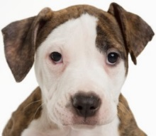
Name: Hour Date: Score: + ✓ -
- A puppy is born with a mutation in one of its copies of the gene for the protein that it uses to break down starch. This mutation consists of a single base that was deleted near the beginning of the gene. Explain how this mutation would change each of the following:
Transcription of the mutated gene:
Translation of this gene:
Shape of the protein:
Function of the protein:
- It is not mentioned whether or not this puppy’s mutation for the starch-digesting protein is dominant, recessive, or incompletely dominant. For each of these, explain how each type of dominance would affect the phenotype of this dog. Assume the puppy is heterozygous for this mutation (one gene is mutated, and one is normal).
Mutation is Dominant:
Mutation is Recessive:
Mutation is Incompletely Dominant:
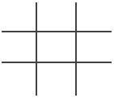
- This puppy is heterozygous for the mutation to the protein for digesting starch. Assume that when this puppy is older, it mates with another dog that is homozygous for the normal gene. What would be the most likely phenotype(s) of the puppies of these two dogs for each of the following possible types of dominance for this mutated gene? Complete the Punnett squares and reference them in your answers. Assume that in each case, there are 8 puppies born.
Most likely ratio of phenotypes of the puppies if the mutation is dominant:
Most likely ratio of phenotypes of the puppies if the mutation is recessive:
Most likely ratio of phenotypes of the puppies if the mutation is incompletely dominant:
- This puppy’s mutation is a deletion mutation that occurs near the beginning of the gene. Explain how the impact of this mutation would be different if the mutation were…
A substitution mutation instead of a deletion mutation:
An insertion mutation instead of a deletion mutation:
At the end of the gene instead of near the beginning:

