Pipe Cleaner Protein Modeling C. Kohn, Waterford WI
Partner Names: Hour Date:
Date Assignment is due: Why late? Score: + ✓ -
^{Day of Week} ^{Date} If your project was late, describe why
The function of a protein is determined by its shape, and the shape of the protein is determined by its amino acids. Because proteins are smaller than microscopic, we would have a pretty hard time doing a hands-on lab on this topic. However, we can explore proteins in an indirect way through modeling.
Many aspects of science are explored with models – the scientific method itself is about modeling complex ideas into simpler formats so that we can better understand them. Scientific models may also help us to do things that would otherwise be impossible.
A model is a substitute for the actual thing we are studying, but it is also similar to what it represents. It tends to follow the same rules as the actual object, and it provides us with a simpler idea of a more complex process so that we can better understand it.
In this case, you will be using pipe cleaners, beads, and cut up straws to model how proteins fold, and how mutations affect the shape of proteins. Each group of 2 students will be responsible for completing their own sheet and protein. You should split up the work evenly between you and your partner.
There are 3 important properties of amino acids that affect protein folding:
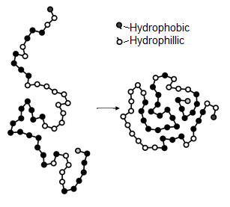
- Hydrophobicity – hydrophobic (water hating) amino acids will always try to get to the inside of a protein while hydrophilic (water loving) amino acids will try to move as far outside of the protein as they can.
- Charge – amino acids can have one of three charges – positive, negative, or neutral. Like opposite sides of a magnet, positively and negatively charged amino acids try to move toward each other; similarly-charged amino acids will repel each other.
- Cysteine Bonds –Cysteine amino acids will move toward each other and form bonds whenever they can.

To create your protein, you will need to following the steps below:
- Begin by transcribing your strand of DNA into mRNA. The first two codons have been started for you.
DNA Strand (the second side of this strand has been omitted for easier reading)
3’ TAC-TTA-CGA-TGG-TAC-ACG-CAA-TCT-ATA-CTC-AAA-TAT-AGG-ACC-TTG-ACG-TCG-AAT-CTC-CAC-TGT-ACC-TTG-AAC-CTG-ACT 5’

mRNA Strand (remember that C’s become G’s, T’s become A’s, G’s become C’s, and A’s become U’s):
5’-AUG-AAU-
- Next, transcribe the mRNA sequence into an amino acid sequence based on what each codon codes for.
Amino Acid Sequence
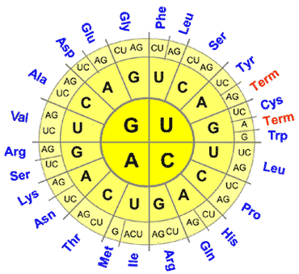
MET-ASN-
- Third, determine the color of bead (or beads) that should represent each amino acid above. Use the information below as well as the chart of amino acid properties.
Hydrophobicity – yellow beads will represent hydrophobic amino acids; purple beads are hydrophilic amino acids.
Charge – blue beads are amino acids with a positive charge and red beads will be the negatively charged amino acids.
Cysteine bonds – use green to represent the amino acids cysteine.
Some amino acids may have multiple beads! For example, Arginine is both positively charged (blue) and hydrophilic (purple).
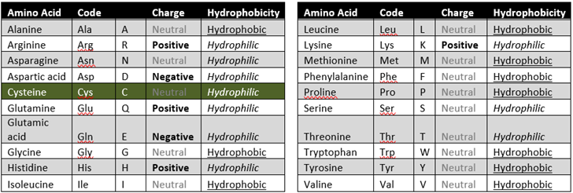

- Once you have determined the order of amino acids and the order of colored beads that you will need, you can begin assembling your protein.
  - Your first amino acid (methionine) should be represented by a yellow bead (because methionine is neutral and hydrophobic). Take a yellow bead and add it to the end of a pipe cleaner. Wrap the pipe cleaner around this yellow bead so that it cannot slip off.
  - Once you have added and secured your first yellow bead, add a cut up straw to separate this first bead from your next amino acid bead. This straw will represent a peptide bond.
  - If you have an amino acid that has two beads, make sure that these two beads are together. Do not separate the two beads with a straw if they both represent the same amino acid.
  - Continue adding your beads and cut-up straws until every amino acid in your sequence is represented. If you fill up your pipe cleaner, attach a second pipe cleaner.
- Finally, you will need to fold your protein using the guidelines below.
  - Start by moving your purple hydrophilic amino acids to the outside and your yellow hydrophobic amino acids to the inside.
  - Then connect your opposite charges (red and blue amino acids) by wrapping them around each other.
  - Next, connect your green cysteine amino acids (wrap them around each other using the pipe cleaner).
- Your finished protein should have an ‘outer shell’ of hydrophilic and charged amino acids with an inner center of hydrophobic amino acids, with opposite charges connected to each other, and with cysteines connected to each other in pairs.
  - When finished, your protein should resemble the one in the image below.
- When finished, submit your completed protein with your names attached to it (using masking tape or whatever your instructor provides for you) to the location that you instructor has provided.
