Animal Welfare & Society Notes (Cornell Method)
C. Kohn, Waterford WI
Name: Hour Date:
Date Assignment is due: Why late? Score: + ✓ -
^{Day of Week} ^{Date} If your project was late, describe why
Directions: Use the Cornell Method to take notes on the Temple Grandin Reading, “Animal Welfare and Society Concerns Finding the Missing Link”. Follow the instructions provided below. This is graded on a +/✓/- scale.
Using the Cornell Method: The Cornell method of notetaking involves dividing your paper into 3 sections. The main section is the Notes Column. This is where you record the main ideas and concepts using your own words. On the left is the Recall Column; this is where you list the main ideas, key concepts, and important facts. The bottom section is the Summary Section. This is where you create a short summary of what you just read using your own words.
This approach offers several advantages. It results in more organized notes. It allows you to quickly and identify key words and key concepts from a complex reading. A graphic (left) and an example (right) are provided in the space below to help you understand what your work should look like.
Be sure to only use the space provided. This is an extremely dense article with a lot of information. You will not be tested on every detail but you will need to have a general understanding of the arguments of the author. Focus on key points.
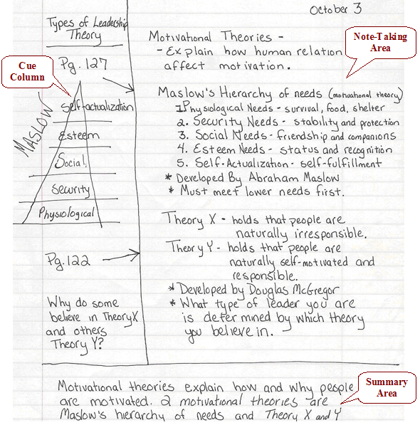
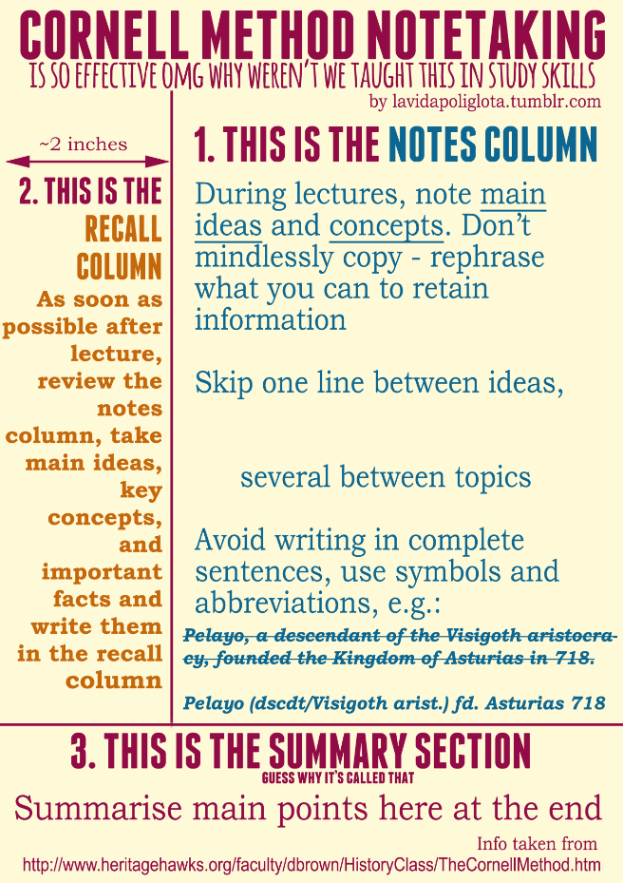

Cornell Notes for Part 1. Introduction.

Cornell Notes for Part 2. Two types of animal welfare issues.

Cornell Notes for Part 3. How do animal welfare issues affect different segments of the meat industry?

Cornell Notes for Part 4. Welfare issues on the farm for all species.

Cornell Notes for Part 5. Monitoring farm and transport problems at slaughter, and 6. Biological system overload may be the big future welfare problem

Cornell Notes for Part 7. How has the industry responded to consumer concerns?

In the space below, summarize what you think are five of the most important arguments made by the author in this reading:
1.
2.
3.
4.
5.
Do you agree or disagree with the author (or are you a little of both)? Summarize your sentiments on this issue in the space below:

