Bioprospecting Molecule Modeling Lab by C. Kohn
Group Names (F&L):
Hour Date Assignment is due: end of class Why late? Score: + ✓ -
If your project was late, describe why
Objective: create the molecular structures of crystalline cellulose, an individual cellulose polymer strand, cellobiose, glucose, and ethanol in order to show the different molecular structures that occur as cellulose is converted to ethanol.
Materials: Play-Doh, toothpicks, plain white paper.
Directions: In this lab, you will be using the Play-doh to create the atomic structures of crystalline cellulose, an individual cellulose polymer strand, cellobiose, glucose, and ethanol. To do so, you will need to…
- Decide which partner will be responsible for creating each molecule.
- Consult your notes and/or a search engine to determine how you will make each type of molecule.
- Work as a team to create the molecules shown (you may decide whether or not you need toothpicks and what color(s) to use).
- Once you have created each type of molecule, label them using a plain white sheet of paper. Physically place the Play-doh molecule above its written name.
- In between molecule, draw an arrow and write the name of the enzyme or organism that converts the substrate into the product above or below that arrow. (For example, you would write “endoglucanase” above the arrow between crystalline cellulose and the individual cellulose strand).
- When you think you have successfully created both molecules, raise your hand and show your instructor. While you are waiting for approval and after receiving approval, complete the questions below and on the back.
  - Each question should be completed by a different partner.
- At the end of class, you may be asked to present your models or discuss the questions – prepare for this by discussing the questions with your team while working or after you have all finished.
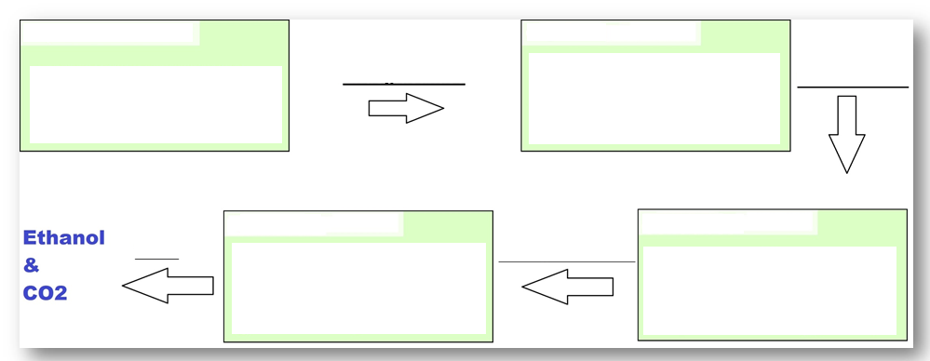
Review: complete the chart below.

Review: read, then answer the questions below

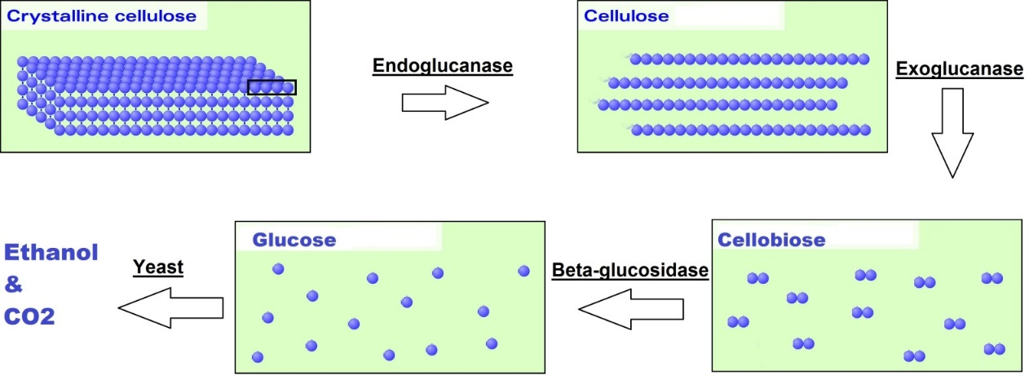
To produce ethanol from cellulosic feedstock, cellulase enzymes must be used to break down the cellulose polymer into its glucose monomers. Multiple cellulase enzymes are needed for this process; these enzymes include endoglucanses, exoglucanases, and beta-glucosidases. Crystalline cellulose is converted by the endoglucanase enzyme into a single strand of cellulose. Single-stranded cellulose is converted by exoglucanase into cellobiose. Cellobiose is converted by beta-glucosidase into glucose. Glucose is fermented by yeast into ethanol.

Questions:
- What converts crystalline cellulose into an individual cellulose polymer strand?
- What converts an individual cellulose polymer strand into cellobiose?
- What converts cellobiose into glucose?
- What converts glucose into ethanol and CO₂?
- How is crystalline cellulose different from an individual cellulose strand?
- How is an individual cellulose strand different from cellobiose?
- How is cellobiose different from glucose?

- How could bioprospecting improve our ability to produce ethanol from cellulosic crops?

