Case-It! Instructions
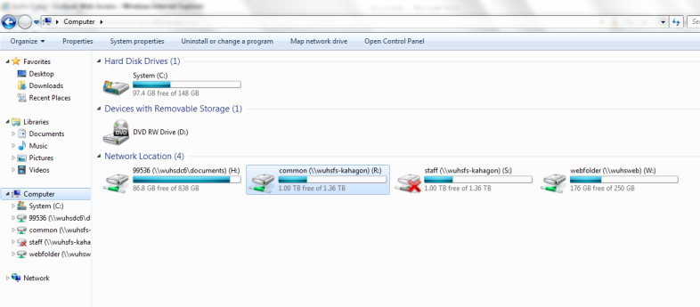
Overview: Case-It! is a simulation created by the University of Michigan and the University of Wisconsin-River Falls. The purpose of Case-It is to simulate, as closely as possible, how genetic tests such as PCR Electrophoresis and ELISA are performed by enabling students to conduct the tests themselves. In this first experiment, you will be practicing with a murder trial. You will have to match the genetic fingerprints of DNA samples found at the scene of the crime with the genetic fingerprints of suspects in the case to make a determination of who is most likely guilty.
Directions:
- On your computer, click on My Computer.
  - Open the Common (R:) Drive
  - Open the “Agriscience” Folder
  - Open “Case It”
  - Open “Case It v606”
  - Double Click “Case It 606”
- A window should open.
  - Click “Click here to begin”
  - Click “Click to Continue”
  - Click “Lab Bench” in the
lower left of the screen.
  - Your screen should
now look like this
  - On the tools menu (top of screen)
select “Setup” and
select “Quick Setup”

- On the top menu bar, select “DNA” and
then “Select DNA samples”
  - Select “Cases”
  - Select “Forensics”
  - Select “Murder Case A”
    - Then select “DNA blood spot 1.gen”
    - Hold SHIFT and simultaneously select “DNA victim.gen”
    - Click Open
- Now you will need to acquire your restriction enzyme. To do this, click
“Site” on the upper menu bar.
  - Select “Open up to 4 enzyme tubes”
  - Select “Open enzyme file for DNA digest”
  - Scroll down and select “Enzyme HindIII”
*Note – your sample of DNA already has primers, polymerase, and bases for PCR. You only need to add the restriction enzyme.
- You should now have six tubes on your lab bench: 5 DNA and 1 Enzyme (HindIII)
- To open your tubes, double click them. Pick up your micropipette (on the top shelf; the blue thing on the right).
  - Click on the micropipette and hold.
  - Dip the pipette into the box of pipette tips (center shelf on the right).
  - You will need to add enzyme to each of the 5
DNA samples.
    - To do this, dip the micropipette w/ tip into the tube of enzyme.
    - Click the plunger to such up enzyme
    - Lower the micropipette into DNA 1 and click the plunger to release.
    - Dip your tip into the biohazard bin.
  - You will need to repeat these steps (starting with a new pipette tip each time) for all 5 DNA samples.
- After you have added enzyme to all 5 tubes, close each tube (by double-clicking them). Click and drag each DNA tube into the heat block (the box on the center shelf, left-hand side)
  - Click the “Power” switch on the upper left of the heat block to “High”
  - Click on “Click to Remove Tubes”
  - Your DNA has now been processed; the enzymes have cut your DNA anywhere it saw the sequence AAGCTT. Polymerase, primers, and bases (previously added to the sample) enabled your single sample of DNA to be multiplied billions of times (for the sake of convenience, the program doesn’t make us wait the hours it would take in a lab).
  - Your processed DNA samples can now be added to an electrophoresis gel.
- Dip your micropipette in the pipette tip box to get a new green tip.
  - Double-click your DNA tubes to open them
  - Dip your micropipette into DNA 1 and suck up a sample of DNA by clicking the plunger
  - Lower your micropipette into Well one of the gel (bottom shelf, lower right) until the yellow box appears that says “Click Plunger”. Click it to add the DNA to that well of the gel.
  - Discard your micropipette tip in the Biohazard bin and continue these steps for all 5 samples of processed DNA until all 5 wells of the gel have been loaded.
- When all 5 wells have been loaded with all 5 DNA samples, click “run gel” on the power source in the lower left.
- A blue screen should appear showing your gel from above. You will notice the ‘chunks’ of DNA spreading across the gel from the negative side to the positive side with the current.
  - In reality, this would never occur this fast. Again, the program speeds up the process for us for the sake of convenience.
- In the center of your screen will be various dyes. Choose one to make your DNA fragments more visible.
- On the left-hand side of your screen, a window should show the following information:
    - DNA tube #1: Blood spot 1
    - DNA tube #2: Blood spot 2
    - DNA tube #3: DNA Suspect 1
    - DNA tube #4: DNA Suspect 2
    - DNA tube #5: Victim.
  - Match the banding patterns in Lanes 1 and 2 to the DNA from the suspects and victims to determine where the blood came from and who our most likely suspect is in this murder trial.

Case-It Questions By C. Kohn, Agricultural Sciences, Waterford WI
Name: Hour Date:
Date Assignment is due: Same Day Why late? Score:
^{Day of Week} ^{Date} If your project was late, describe why
- What caused the different numbers of DNA fragments to occur in each sample? I.e. what was responsible for cutting DNA into multiple pieces?
- Why were the different chunks differently sized? i.e. what made some chunks larger than others?
- What lanes’ DNA samples matched? Who had blood found at the scene of the crime?
- Who do you think was most likely responsible for this murder? Why?
- If a person’s blood was found at the scene of the crime, does this mean that they were guilty of that crime? Explain:
- What other hypotheses might explain why their blood was found at the murder scene?

