DNA Notesheet by C Kohn
Name: Hour Date:
Date Assignment is due: Why late? Score: + ✓ -
^{Day of Week} ^{Date} If your project was late, describe why
Directions: Use the accompanying PowerPoint (visit wuhsag.weebly.com) to complete this sheet. This sheet will be due prior to taking the quiz. These assignments are graded on a +/✓/- scale.
- There are millions of different species. What is responsible for the differences in visible traits that we see among different species, and what is responsible for the differences that we see among individuals within a species? In your answer, be sure to include the following: 1) nucleic acids, and 2) proteins.
- What are the two kinds of nucleic acids? and .
- Almost all living species use to
needed to
- If DNA is used to store genetic information in most species, what is RNA used for? List the 3 main roles of RNA:
- A protein cannot be assembled by a cell unless
- The differences we see among different kinds of species is due to the fact that each species has
- T or F – the visible traits of a species are the result of DNA, not protein. Explain:
- What is a protein?
- Fill in the text of the images below:
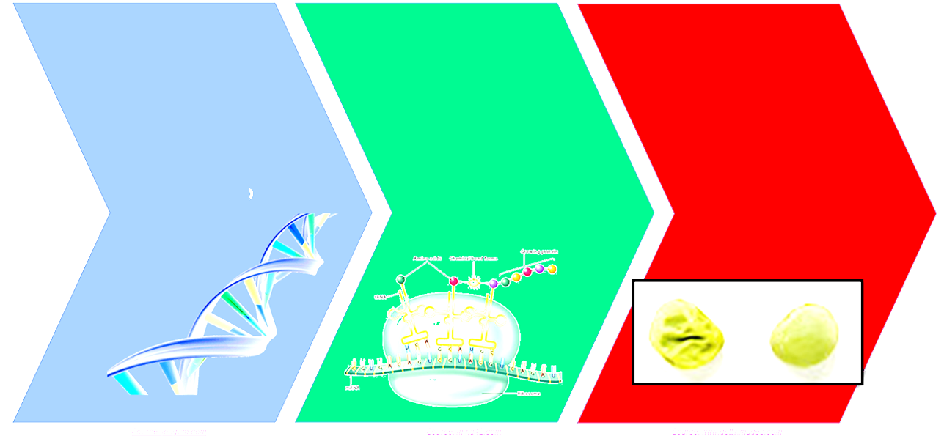
- Why do some people have blue eyes and other people have brown eyes? Explain using the following terms: 1) Protein; 2) Protein Structure; 3) Gene
- What is a gene? that
- Draw a gene in the space to the right:
- In order to have a trait, an organism must have a that is used to create the
responsible for that particular trait.
- What is a genotype?
- What is a phenotype?
- DNA and RNA are . What is a polymer?
- The molecule that repeats over and over in DNA is a . What is a nucleotide?
- What three things is a nucleotide made from?
- Draw a nucleotide in the space to the right:
- What molecule actually stores the information found in DNA?
- List the nitrogenous bases found in DNA:
- List the nitrogenous bases found in RNA:
- The only difference between the bases found in DNA and those in RNA is
- Your notes compare a notebook to the structure of DNA and RNA. In the space below, compare which parts of a notebook are similar to which parts in DNA.
Spiral of the Notebook: is most similar to this structure in DNA: Why?
Paper of the Notebook: is most similar to this structure in DNA: Why?
Writing of the Notebook: is most similar to this structure in DNA: Why?
- If the sugar and phosphate of DNA don’t encode any information, why are they found in DNA?
- Because of both and ,
___ is always bonded to ___ and ___ is always bonded to ___.
- What would happen if an A bonded to a G?
- What would happen if a C bonded to a T?
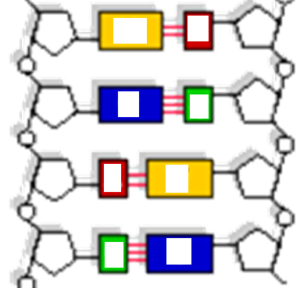
- Besides size, how do bonding sites on the nitrogenous bases help to ensure that A is always with T (or G with C)?
- A and T have _____ bonding sites.
C and G have _____ bonding sites.
____ and ____ are the biggest bases.
____ and ____ are the smallest bases.
- In the image at the right, use both size and the
amount of bonding sites (lines between bases
to figure out which letters should go in which
bases. Then fill in those letters appropriately.
(Your letters again are A, T, G, and C).
- To replicate DNA, a cell simply
to make
- What is polymerase?
- For the section of single stranded DNA here, fill in the bases of the other side: A T C G C A T T A G G
_ _ _ _ _ _ _ _ _ _ _
- Where does polymerase get the nucleotides to fill in the other side of single stranded DNA?
- What is helicase?
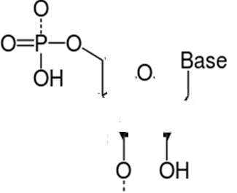
- How does polymerase know which way is “forward”?
- In the space to the right, draw the sugar molecule of a nucleotide.
Then, number the carbon atoms from 1 to 5

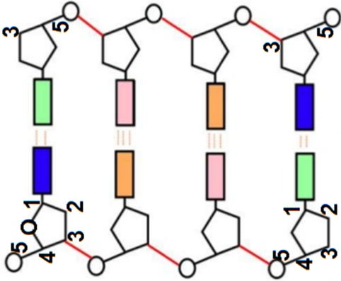
- For the image to the right , draw arrows to show the direction that polymerase would move on each side.
(Note: your arrows should point right or left; you should draw 2 arrows – one for each side).
- If the left side is of a strand of DNA is read from the bottom up, the right side will be read
from the .
- What is a chromosome?
- Why is DNA packaged into chromosomes?
- What is a mutation?
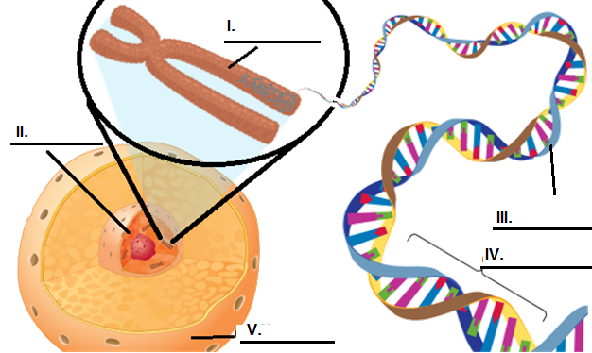
- What is a nucleus?
- Label each of the items in the image
- T or F – DNA is the same thing
as a chromosome.
Explain:
- T or F – DNA is the same thing as a gene. . Explain:
- The process of making a functional protein using the information stored in DNA begins with 2 steps:
and
- Transcription is
- Translation is
- Fill in all of the boxes in the image shown here:
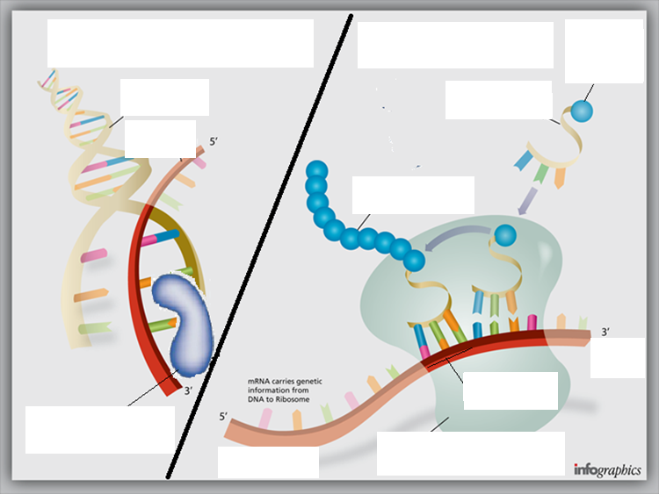
- What is a transcript?
- Transcription begins when
- This RNA copy of DNA is called
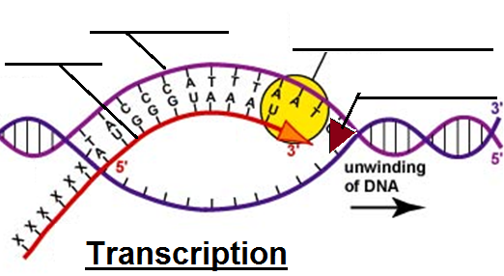
- What creates the mRNA copy of DNA?
- Label each of the following in the blanks
- As it moves along the section of DNA,
RNA Polymerase adds the
for every that it encounters.
- if polymerase encounters a G, it will add a _______ to the mRNA. If it encounters a C, it will add a _____ to
mRNA. If it encounters a T, it will add an _____ to mRNA. If it encounters an A, it will add a ______ to mRNA.
- For the strand of DNA below, create the mRNA copy strand than would be made from it.
DNA: 5’ TAC-TTA-CGA-TGG-TAC-ACG-TGT-ACC-TTG-AAC-CTG-ACT 3’
mRNA: __’ _____ _____ ______ _____ _____ ______ _____ _____ ______ ______ _____ ______ __’
- Translation begins when
and goes into the (the )
- In the , the mRNA copy makes contact with a structure called
- What is a ribosome?
- What is a ribosome made from?
- T or F – cells usually have 1-5 ribosomes. Explain:
- The ribosome reads one at a time. What is a codon?
- The moves through the like a
. As each codon enters the ribosome, another kind of
. This kind of RNA is called
- What is tRNA?
- Each codon (or ) codes for a specific
- Each codon will tell that ribosome what
- The order of the in a strand of directly corresponds to the order of
in the .
- T or F – there is only one kind of tRNA. Explain:
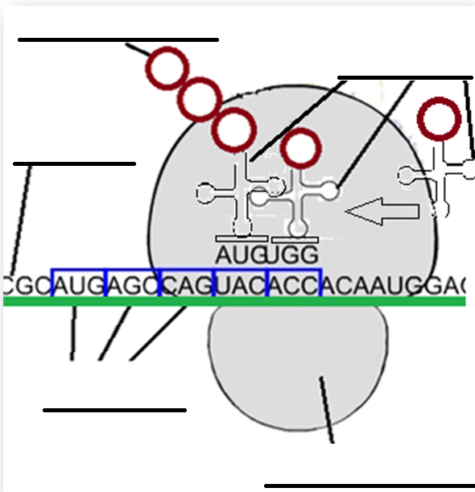
- Label each blank in the image shown right
- How does the right tRNA with the specific amino acid
needed find the appropriate codon on mRNA? Explain
using the term anticodon.
- The will enter the in a - -
fashion until the entire has moved through the
- For each that enters the ribosome, the appropriate
will be delivered by .
- As each amino acid is delivered by tRNA, it will be added to a
that will eventually become the .
- In the space below, draw or write a summary of how a protein is made. Be sure to include each of the following: 1) DNA; 2) Gene; 3) mRNA; 4) Transcription & Translation; 5) Polymerase; 6) Helicase; 7) Cytosol; 8) Ribosome; 9) Codon; 10) tRNA; 11) Amino Acid; 11) Anticodon. If drawn, please label these items. If written, please underline.

Unit Wrap-up C. Kohn, Agricultural Sciences - Waterford WI
This page is designed to help raise your grade while enabling you to develop skills you will need for after high
school. You will need to complete every question and blank in order to receive full credit for your notes. Note: if you cannot come up with a strategy to remember a difficult concept on your own, see your instructor for help.
- What is a topic or concept from this unit that you found to be more challenging? Write or describe below:
In the space below, create a mnemonic, rhyme, analogy, or other strategy to help you remember this particular concept:
- What is a 2nd topic or concept from this unit that you found to be more challenging? Write or describe below:
In the space below, create a mnemonic, rhyme, analogy, or other strategy to help you remember this particular concept:
- What is a 3rd topic or concept from this unit that you found to be more challenging? Write or describe below:
In the space below, create a mnemonic, rhyme, analogy, or other strategy to help you remember this particular concept:
- Circle the most appropriate response. You will only be graded on whether or not you completed this section, so be entirely honest with yourself when completing this section.
Circle one: I used my notes outside of class to prepare for the quiz. Definitely – Yes – Sort of - No
Circle one: I took extra notes in the margins for very difficult concepts. Definitely – Yes – Sort of - No
Circle one: I created a personal strategy for at least three difficult items. Definitely – Yes – Sort of - No
Circle one: I was very involved and actively studying during the quiz review. Definitely – Yes – Sort of - No
Circle one: I think I will be satisfied with the quiz grade I received this week. Definitely – Yes – Sort of - No
Circle one: I might need to meet with the instructor outside of class. Definitely – Yes – Sort of - No

