Fall 2015-16 Agriscience Cumulative Test by C. Kohn, Waterford WI
Name(s): Hour Date: Score:
Background: a plant is placed inside of a sealed bell jar (right). The jar and plant are placed in a
sunny location. Assume that the soil is moist and there are enough nutrients in the soil. Use this
information to answer the questions below.
- Can this plant survive for extended periods in this jar? YES NO _{(circle one)}
Explain your answer:
- In the space below, explain why each of the following is necessary to this plant in the jar above and how it will be acquired/produced:
Oxygen – Why it is necessary to a plant:
How it will be produced/acquired:
Water – Why it is necessary to a plant:
How it will be produced/acquired:
CO₂ – Why it is necessary to a plant:
How it will be produced/acquired:
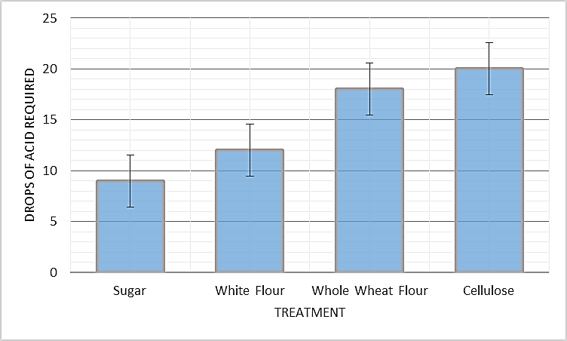
Background: a respiration experiment is conducted using a Waterford Fermenter. Yeast are added to the fermentation chamber with water and a type of carbohydrate. CO₂ from respiration is released through an air lock containing a KOH solution. As the CO₂ moves through the KOH, it forms carbonic acid, which lowers the pH of the solution. After 15 minutes, the experiment is stopped. A pH color indicator is then added to the KOH which turns it bright pink. A strong acid is added drop by drop, lowering the pH even further until the color changes to clear (indicating that the solution has a neutral pH). The fewer drops of acid required for a color change, the more CO₂ that was produced. The average results from each carbohydrate are shown above. Use this to answer the questions below.
- Which carbohydrate produces the greatest amount of CO₂?
- Why would this carbohydrate result in more CO₂ production than all of the others?
Hint: describe its molecular structure in your answer.
- What are the small lines found at the top center of each bar in the bar graph above?
- What do these lines indicate?
- From this graph, which of the following can be interpreted? Circle the correct answer.
  - Cellulose required significantly more drops of acid than whole wheat flour.
  - Whole wheat flour required significantly more drops of acid than white flour.
  - White flour required significantly more drops of acid than sugar.
  - All of the above
- If the mitochondria of the yeast had a genetic mutation that resulted in a ‘leaky’ inner membrane, allowing hydrogen to escape into the matrix without going through ATP Synthase, what would most likely happen to CO₂ production? In the blank below, write “more” or “less” and then explain.
I hypothesize that CO₂ would be produced because
Background: a group of scientists have developed a genetically engineered plant that can create a new type of simple carbohydrate called “synthase”. This carbohydrate is similar to glucose except that it has the molecular formula C₇H₁₅O₆.
When scientists test the effects of this sugar on cellular respiration using yeast, they find that while the CO₂ released increases slightly, the ATP produced increases even more. While respiration of one glucose molecule yields 6 molecules of CO₂ and 36 molecules of ATP, respiration of one synthose molecule yields 7 molecules of CO₂ and 45 ATP molecules.
Use this information to answer the questions below.
- Why would more CO₂ per molecule be produced from synthose than from glucose?
Hint: look at how many carbon atoms are on each molecule.
- Why would more ATP per molecule be produced from synthose than from glucose?
Hint: look at how many hydrogen atoms are on each molecule.
- These scientists are claiming that they have developed this plant to fight climate change. If this plant were grown throughout the world on a large-scale basis, would this increase or decrease atmospheric levels of carbon dioxide over time? In the blank below, write “increase” or “decrease” and then explain.
I hypothesize that widespread use of the plants that produce synthose sugars would
atmospheric levels of CO₂ because
- Scientists find that in order for this plant to survive, they also had to genetically modify it to produce more chlorophyll and more Rubisco. Explain what each does and why more is needed to make synthose.
Chlorophyll – What it does:
Why more is needed:
Rubisco – What it does:
Why more is needed:

Directions: Read the following abstract from the Journal of Experimental Biology and then answer the accompanying questions.
Abstract - Ever since the discovery of C4 photosynthesis in the mid-1960s, plant biologists have envisioned the introduction of C4 photosynthesis into C3 crops such as rice and soybeans. Recent advances in genomics capabilities, and new evolutionary and developmental studies indicate that C4 engineering will be feasible in the next few decades. -Taken from Exploiting the engine of C4 photosynthesis by Rowan F. Sage, and Xin-Guang Zhu, published in the peer-reviewed Journal of Experimental Botany, Vol. 62, No. 9, pp. 2989–3000, 2011.
- How does a C4 plant differ from a C3 plant?
- What would be the advantage of converting a C3 plant into a C4 plant?
- What is a legume?
- What would be the advantage of creating a C4 legume?
- Is this abstract most likely from a credible source? Explain how you know:
Hint: include the term “peer reviewed” in your answer.
A research group is trying to determine how the rate of application of fertilizer affects the amount of corn produced in a field. The researchers tested different application rates of two kinds of nutrients: nitrogen and phosphorus.
When 0 lbs of nitrogen were applied, the average yield of corn was 156 bushels per acre. When 10-20 lbs of nitrogen was applied per acre, the corn yielded an average of 168 bushels per acre. When 30-40 lbs of nitrogen was applied per acre, the corn yielded an average of 177 bushels per acre. When 60 lbs of nitrogen was applied per acre, the corn yielded 175 bushels per acre.
The researchers also tested different rates of phosphate application. When 0 lbs of phosphate was applied, the corn yielded an average of 166 bushels per acre. When 10-20 lbs of phosphate was applied per acre, the corn yielded an average of 172 bushels per acre. When 30-40 lbs of phosphate was applied per acre, the corn yielded an average of 169 bushels per acre. When 60 lbs of phosphate was applied per acre, the corn yielded 171 bushels per acre.
- Create a graph based on the information above on the opposite side of this sheet.
  - Be sure to label all axes and types of data.
  - Be sure to include a caption for this graph. A title is not needed if the graph has a caption.
- In the space below, write a hypothesis that could be applicable to this research experiment.
- In the space below, write a rationale for this hypothesis:
- Based on this research, what would have the most impact on the
productivity of a corn field, a shortage of nitrogen or a shortage of phosphate?
Explain:
- Assume that the error bars for the 30-40 lb. application results and the 60 lb. application results overlapped for both nutrients. What would this indicate about the benefits of applying 60 lbs. compared to applying 30 lbs.

