Genetic Testing Worksheet by C. Kohn, Waterford WI
Partner Names: Hour Date:
Date Assignment is due: Why late? Score: + ✓ -
If your project was late, describe why
+ = exceeded expectations. ✓= expectations were met but not exceeded. - = redo assignment
Directions: use your notes and work with your assigned partner to complete this worksheet. Each partner should do half of the questions (one partner should do the evens, the other should do the odds). The partner not writing the answer should create the answer that is written down. The partner who writes should rely on their other partner to help create the answer.
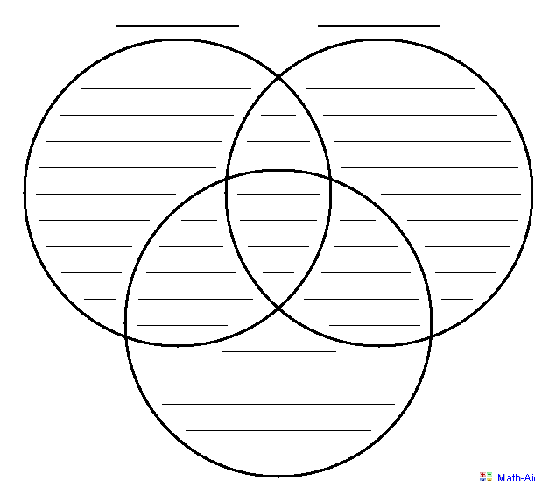
- Using the Venn Diagram below, summarize the basic characteristics of each test. The areas that overlap should include the characteristics common to both tests. The center should include characteristics common to all 3.
ELISA
PCR-Electrophoresis Southern Blotting
- Summarize the role of each of the following in PCR:
  - DNA:
  - Heat:
  - Primer:
  - Taq Polymerase:
  - Thermal Cycler:
- Summarize how PCR works. Include the five terms you described above:
- Summarize the role of each of the following in Electrophoresis:
  - Restriction Enzyme:
  - Gel:
  - Electricity:
  - STRs (or microsatellites):
  - Banding Pattern:
- Based on PCR Electrophoresis, how would we know if a suspect was at the scene of a crime? Be sure to include the following: crime scene DNA sample; suspect’s DNA sample; banding patterns; STRs

- Based on PCR Electrophoresis, how would we know if a patient has a genetic disease? Be sure to include the following in your answer: patient DNA; healthy sample; diseased sample.
- Can Southern Blotting be performed without performing PCR-Electrophoresis? Explain:
- What does Southern Blotting do that PCR-Electrophoresis cannot?
Summarize how it does this:
- Summarize the role of each of the following in Southern Blotting:
  - PCR-Electrophoresis:
  - Membrane:
  - Probe:
  - Bioluminescence:
- Create three hypothetical scenarios in which Southern Blotting would be necessary to make a determination:
Hint: Southern Blotting is needed anytime we need to quickly determine the presence of a specific gene.
- If Southern Blotting can be used to detect a genetic disease, why is ELISA needed? What can ELISA do that Southern Blotting cannot? (Be sure to address BOTH questions in your answer below):
- Summarize the role of each of the following in ELISA:
  - Antigens:
  - Antibodies:
  - Dyed Antibodies or Antigens:
  - 96-well plate:
  - Color Change:
- You are a doctor and a patient has come to you to determine if they have Lyme disease. Explain to this patient how you will confirm they have Lyme disease using ELISA by explaining how the ELISA test works in terms they could understand.

