Marketing Research Worksheet by C. Kohn, Waterford WI
Partner Names: Hour Date:
Date Assignment is due: Why late? Score: + ✓ -
If your project was late, describe why
Directions: Work with your assigned partner to complete this worksheet. When one person is writing, the other should help them determine what to write. Switch roles after each question. Please initial after each question you write.
+ = all space is completely used w/ legible answers. ✓= expectations were met but not exceeded. - = redo assignment
Background: you are starting a student business in which you will sell eggs from backyard chickens in central Madison, WI – population 250,000. Your parents purchase two dozen baby chicks for you at $30, of which 17 survive to 20 months old and have been producing an average of 6 eggs per week per hen since they were 6 months old. You spent $315 to build and furnish a chicken coop, and you spend an average of $70 per month on feed, bedding, etc. for all 17 chickens. The store you buy from is trendy and only sells certified-organic supplies; you could potentially find cheaper supplies, but you might also lose any savings from higher shipping costs and time. Your local supermarket sells standard eggs for $1.25 a dozen; organic eggs sell for $2.50 a dozen. You can expect your chickens to be productive for another 14 months before their production begins to decline. You do not have a rooster but you could potentially acquire one for under $10.

Use this information to answer the questions below.

- Summarize five separate ways in which marketing research could help you make a profit from selling these eggs.
1.
2.
3.
4.
5.
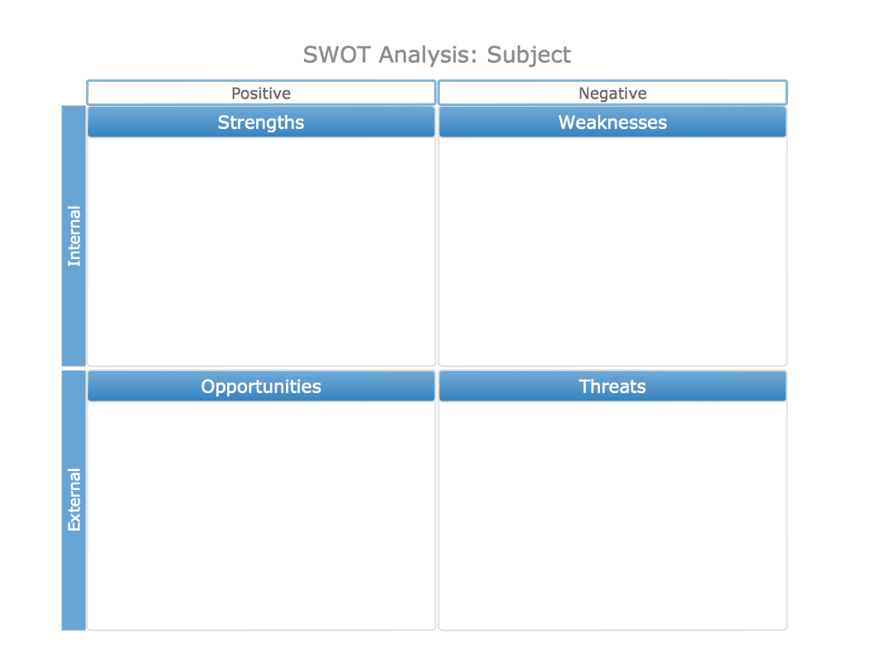
- Perform a SWOT Analysis in the area below.
- How will you utilize your product’s strengths most effectively?
- How do you fix or negate the weaknesses of your product?

- How will you capitalize on the opportunities that exist to sell your product?
- How will you prevent or negate the threats to the sales of your product?
- In the space below, describe four kinds of people who would be most likely to buy your eggs.
Type One – General Description:
Specifics (geographics, demographics, psychographics, behavioral, benefits sought):
Type Two – General Description:
Specifics (geographics, demographics, psychographics, behavioral, benefits sought):
Type Three – General Description:
Specifics (geographics, demographics, psychographics, behavioral, benefits sought):
Type Four – General Description:
Specifics (geographics, demographics, psychographics, behavioral, benefits sought):
- Of the four types you described on the previous page, which do you think is most likely to purchase from you?
Type: . Why is this group more likely to buy from you than any other?
- Answer the following: Is this specific group… (NOTE: do not use this group unless you know it is ‘YES' for all).
  - Measurable and specific – are you able to tell who is a part of this segment and who is not?
Explain:
  - Able to be reached by your available methods of communication? Explain:
  - Relatively steady, stable, and unchanging? Explain:
  - Sizeable enough to be profitable? Explain:
  - Able to participate - do customers must have the money and willingness to buy the good or service offered?
Explain:
- What are the Unique Selling Points (or Points of Differentiation) for your product that are specific and appealing to this particular market segment? Consider product quality, convenience, customer values, cost, service, etc. What can you provide with your product bundle that no one else can to the same extent?
USP 1:
USP 2:
USP 3:
USP 4:
- Why is your product better for this group than all other similar products? Explain by comparing your product to each of the following. Note: this is based on what your target market would believe about your product; this might not be the same as what you think about your product (the customer’s opinion is more important than your own in this case).
Standard eggs from the grocery store:
Organic eggs from the grocery store:
Eggs from another backyard chicken operation:
Note: you make have to make some general assumptions about other backyard chicken operations.
A fourth competitor (describe that competitor):
Why yours is better for your target market:
A fifth competitor (describe that competitor):
Why yours is better for your target market:
- Write a position statement in the space below. The standard formula for a position statement is:
For [describe target market], the [product] is the [unique selling point(s)] because [reason why your product is the best for this group].
E.g. For World Wide Web users who enjoy books, Amazon.com is a retail bookseller that provides instant access to over 1.1 million books. Unlike traditional book retailers, Amazon.com provides a combination of extraordinary convenience, low prices, and comprehensive selection.
For our
backyard eggs are
Answer the following questions below to develop your position strategy:
- Are your potential customers aware of you? If so, to what extent?

How does this affect your future communication with this target market?

- What percent of this market segment is reasonable for you to acquire? % Explain:

- Who is your top competitor?
How will you position your product to make it seem like the better choice for this specific group of people?

- What will you need to do or offer to keep your market segment from going to the competition?

- What are your top priorities for reaching and acquiring the business of your targeted market segment?
1
2
3
4

- Describe your positioning strategy in the space below. How will you acquire a sizeable portion of your target market in order to make your operation profitable?
- What are your total fixed costs (see the first page)? $
This is what you had to spend before you could have any chickens at all. Do not include the cost of the chickens themselves – they were a gift.
- What are your variable unit cost (see the first page)? $ /chicken/month
Hint: if it costs $70 per month to care for 17 chickens, what would be the variable cost for one chicken per month? Ignore fixed costs. Ignore the initial cost of the chickens – they were a gift from your parents.
What is the total variable monthly cost for 17 chickens? $ /per month for 17 hens
Note – multiply your variable unit cost per month for 1 chicken by 17 to determine this.
What is the total variable cost for 17 chickens for a lifespan of 34 months? $ /17 chickens
Note – multiply your total variable monthly cost for 17 chickens by 34 to determine this.
What is the total variable cost for 1 chicken for a lifespan of 34 months? $ /chicken
Note – divide your total variable cost for by 17 to determine this.
- Assume your chickens have a lifespan of 34 months. What would be the total cost of raising these 17 chickens to the end of their productive life? Show your work below.
17 chickens cost $ /month x months + $ = $
The cost of all 17 chickens per month ^{No. of months} ^{Total Fixed Cost} ^{Total cost of 17 hens}

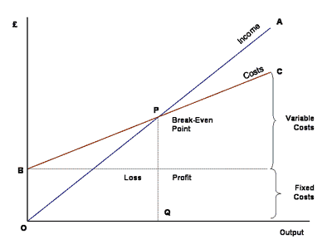
- In the space below, graph the cost of raising these chickens. An example graph is shown to the right.
Your cost line should leave the y-axis at the value of the total fixed cost of raising your chickens. On this graph, this is shown at “B”. This line should increase by the total variable cost.
Also include the brackets on the right showing your variable costs and fixed costs. You will add your income line later.

$
$
- At what price do you intend to sell your eggs for? $ /dozen
- If a chicken produces 6 eggs a week on average, and has 28 months of production, $
assume it will produce 672 eggs, or 56 dozen eggs. How much income will each
chicken produce for you over 28 months?
- How much income will your 17 chickens produce for you over all 28 months of production? $
- Using this information, create an income line on your graph on page 8. Your line starts at 0 on the y-axis.
- Does your line have a breakeven point (Q)?
If so, how many chickens are needed at this price to breakeven?
If not, at what price per dozen would you break even with 17 chickens?
- Make a final decision – at what price will you sell your eggs for? $ /dozen
- Justify your price – why would your target market be willing to pay for this? Is it cheaper than store-bought eggs? If not, how will you justify the extra cost? How does your choice of price make your eggs marketable?
- What would be your net profit at this price? $ Show your math below.
Net profit is your profit after all expenses have been subtracted.

What is your profit per month on average? $ /per month
Divide your net profit by 34 months
- If you had to hire someone to work an average of 3.5 hours per week at $7 per hour, would you still be profitable? For this, assume that you have to pay for 34 months of labor, which equates to roughly 146 weeks.
Are you still profitable? Show your math:
- Should this be considered when determining your pricing? Explain:
Hint: should you assume you would work for free? Could you make more money with a different job?
- Given your answer above, do you think your price is… Too low? Too high? Just right?
- If a rogue raccoon attacked and killed five of your chickens, would you still be profitable?
Should your price be higher to reflect this possibility? Explain:

