Navigation Notesheet C. Kohn, Waterford WI
Name: Hour Date:
Date Assignment is due: Why late? Score: + ✓ -
^{Day of Week} ^{Date} If your project was late, describe why
Directions: Use the accompanying PowerPoint (available online) to complete this sheet. This sheet will be due upon the completion of the PowerPoint in class. These assignments are graded on a +/✓/- scale.

- What is the Leave No Trace ethic?
- What are the seven principles of Leave No Trace?
- How does navigation and the use of maps and compasses related to Leave No Trace? List 2 ways:
Define each of the following:
- Course:
- Legs:
- Bearing:
- Course Bearing:
- Heading:
- Aren’t course bearing and heading the same thing? Explain:
- On a compass, which cardinal directions would be represented by each of the following degrees:
0º 90º 180 º 270 º 45 º
- When looking at a map, what is the first thing you should look at?
Why?
- What is the difference between latitude and longitude?
- Latitude and longitude are measured in . The equator is at º. The degrees of
latitude as you
- What is 0º for longitude? As you get further away from this
point, what happens to the degrees of longitude?
- What is the latitude and longitude of Washington DC?
- What is the latitude and longitude of Waterford WI?
- Washington DC is at 38°54'19" N, 77°02'14" W. Write out the location of DC in degrees, minutes, and seconds.
Washington is located at
- Why does Waterford have a larger latitude and longitude than DC?
- Where is the latitude listed on a map? Longitude?
- What is UTM? A system that
- UTM divides the earth into
- What is easting and northing?
- What is the ZEN method? ; where is Waterford
Union HS based on ZEN?
- Which is better, UTM or latitude/longitude? Why?
- What is the scale on a map?
- If a scale on a map is listed as 1:10,000, what would this mean?
- On a map with a scale of 1:63360, one inch would equal inches in real life. How many feet
would this be? One inch on the map would be feet in the actual terrain.
- How can you use the scale on a map to measure distances between two objects? Explain:
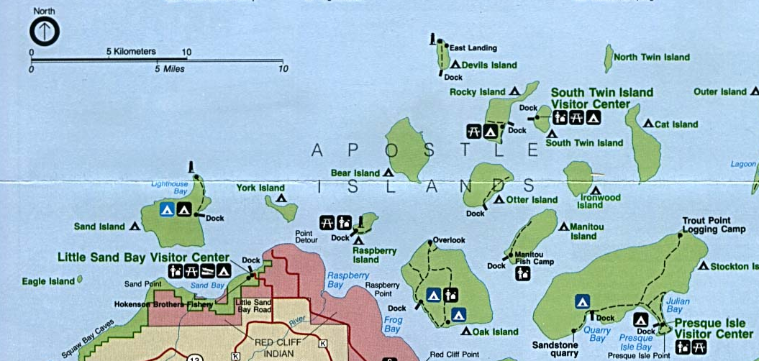
- How far is the lighthouse on Sand Island from the lighthouse on Devils Island? miles or km
If you can kayak 4 mph at the fastest, could you make it to your campsite on Devils Island from Little Sand Bay if the sun sets in 2 hours?
How far is the campsite on Rocky Island from the campsite on Cat Island? miles or km
- A topographic map shows
- How does a topographic map do this?
- What are contour lines?
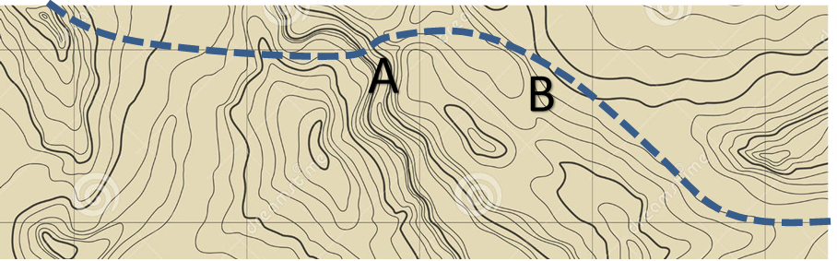
- What does it mean if contour lines are close together?
What does it mean if contour lines are far apart?
What does it mean if contour lines make a V-shape?
- In the map above, would the trail (represented by the dotted line) be steeper at A or B?
How do you know?
- In the map above, draw a dark arrow where we would find a deep ravine or valley.
- In the map above, draw a big dark dot where we would find a peak of a mountain.
- In the map above, draw a dark diamond where we would find a flat plain or plateau.
- In the map above, fill in the space between the contour lines that represent the lowest section on this map.

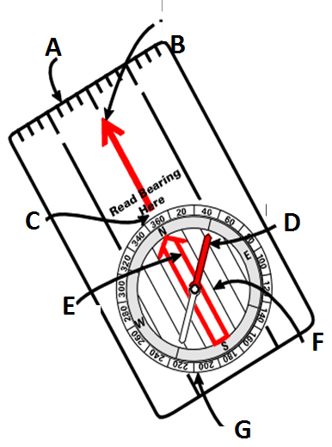
- For each of the following, list what part of the compass that arrow is pointing to. Then describe the purpose of that part of the compass.
A. Item:
Purpose:
B. Item:
Purpose:
C. Item:
Purpose:
D. Item:
Purpose:
E. Item:
Purpose:
F. Item:
Purpose:
G. Item:
Purpose:

- Summarize how to find a course bearing with a compass: Begin by holding the compass
to the , away from
The arrow should always point from your
towards .
To put Red Fred in the Shed, turn the of your until the
Read the (the as determined by where the
).
your regularly to make sure your reach your target.
- Summarize how to determine a course bearing with a map and compass:
- What is declination?
. What is the declination for Wisconsin?
What is the declination for California? . Why is there a difference?
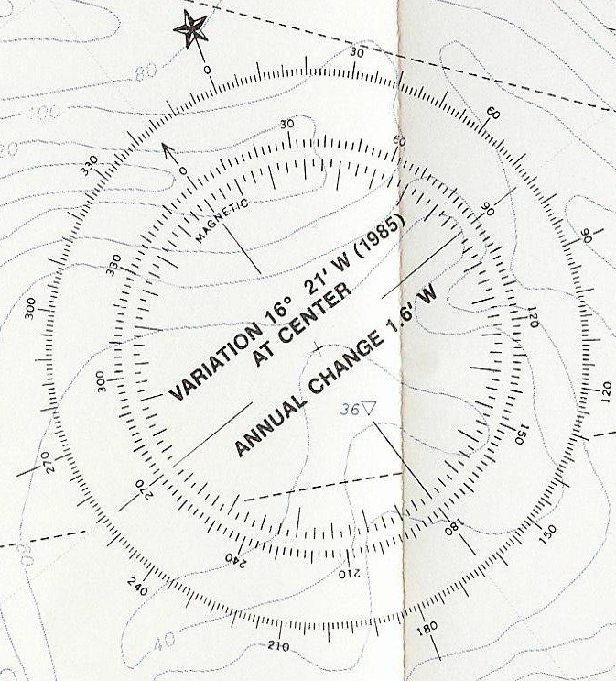
- In regards to declination, why is it necessary to buy new maps every few years?
- Use the declination compass rose at the right.
If your compass tells you that your course
bearing is 90º, what is your actual heading? º
If your compass tells you that your course
bearing is 180º, what is your actual heading? º
If your compass tells you that your course
bearing is 270º, what is your actual heading? º
- Aiming off is a technique in which you deliberately
- When is this technique helpful?
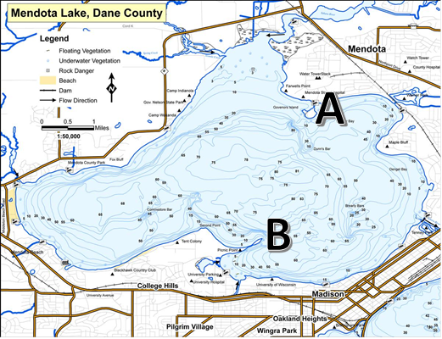
- You are kayaking on Lake Mendota. You
leave from Governor’s Island (A) and are
traveling to Picnic Point (B). As you are
moving across the water, a thick fog
rolls in. In the space below, describe how
you would use aiming off to avoid missing
the narrow peninsula in the fog.
- What could be the problem if you don’t aim off in the previous example?
- By how much should you change your course if aiming off?
Why?
What is necessary in order to successfully aim off?
- What is a handrail?
- What is a backstop?
- What is a triangulation?

Unit Wrap-up C. Kohn, Agricultural Sciences - Waterford WI
This page is designed to help raise your grade while enabling you to develop skills you will need for after high
school. You will need to complete every question and blank in order to receive full credit for your notes. Note: if you cannot come up with a strategy to remember a difficult concept on your own, see your instructor for help.
- What is a topic or concept from this unit that you found to be more challenging? Write or describe below:
In the space below, create a mnemonic, rhyme, analogy, or other strategy to help you remember this particular concept:
- What is a 2nd topic or concept from this unit that you found to be more challenging? Write or describe below:
In the space below, create a mnemonic, rhyme, analogy, or other strategy to help you remember this particular concept:
- What is a 3rd topic or concept from this unit that you found to be more challenging? Write or describe below:
In the space below, create a mnemonic, rhyme, analogy, or other strategy to help you remember this particular concept:
- Circle the most appropriate response. You will only be graded on whether or not you completed this section.
Circle one: I used my notes outside of class to prepare for the quiz. Definitely – Yes – Sort of - No
Circle one: I took extra notes in the margins for very difficult concepts. Definitely – Yes – Sort of - No
Circle one: I created a personal strategy for at least three difficult items. Definitely – Yes – Sort of - No
Circle one: I might need to meet with the instructor outside of class. Definitely – Yes – Sort of - No

