Pet Emergency Flyers by C. Kohn
Name: Hour Date:
Date Assignment is due: Why late? Score: + ✓ -
^{Day of Week} ^{Date} If your project was late, describe why

Directions
Using a clean sheet of paper, each student will create 3 flyers that detail how to save an animal during an emergency. Use your previous notes and worksheets to guide you. Your posters should include:
- A title (e.g. What To Do If Your Dog Swallows A Poison)
- Pictures (hand-drawn or printed from the internet)
- Written instructions (e.g. Step 1: _ _ _ _ _ _)
- Explanations – don’t assume your reader knows; explain everything!
- Your name (e.g. By Wally Wolverine)
Completed posters should be stapled together and turned into the Hand-In Drawer by the end of the hour. An example is included on the opposite side.

You may choose from any of the pet emergencies below:
- Car accidents
- Poisoning
- Choking
- Electrocution and burns
- Heat stroke
- Injured or bloody paws

Your posters will be graded on the following:
- Completeness – did you include all the information necessary for the reader to address this particular injury?
- Neatness – is your poster colorful, attractive, and visually appealing?
- Professionalism – is your poster free of spelling and grammar errors? Is it consistent and well arranged?
- Effort – did you use all the time available to you, or did you rush to finish quickly? Did you cut corners or did you include and do everything that is reasonably expected of you?

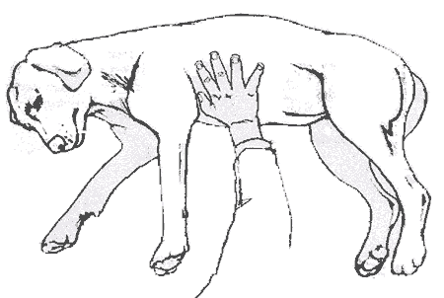
Next, check the animal’s ABCs:
- A – check that the airway is clear.
- B – look, listen, and feel for their breathing.
- C – feel for their heartbeat and check to make sure their gums are pink. Do CPR or rescue breathing if needed.
Third, check to see if you can hear air moving through the wound. If you can, then you may have punctured a lung. Clean the wound. Then use a gauze pad or cloth covered in Vaseline or antibiotic ointment to seal the wound so that the lung does not collapse.
Pet Emergencies: Chest Injuries
By Wally Wolverine, 1st Hour Veterinary Pet Care
Last, treat all other injuries and bandage all other wounds. Call your veterinarian to let them know you are coming. Cover your dog in a blanket to prevent shock and immediately drive to your veterinarian.
First, make sure the scene is safe. Be sure that you can safely examine your pet.
A chest injury can be a scary situation for both the pet and the owner. If your pet has a chest wound, use the following steps to keep your animal safe and alive.

