Physical Exams Notesheet by C Kohn, Agricultural Sciences - WUHS
Name: Hour Date:
Date Assignment is due: Thursday before quiz Why late? Score: + ✓ -
^{Day of Week} ^{Date} If your project was late, describe why
Directions: Use the accompanying PowerPoint (http://bit.ly/cattle-phys-exams) to complete this sheet. This sheet will be due upon the completion of the PowerPoint in class. These assignments are graded on a +/√/- scale.
- Define physical exam:
- Physical exams should follow a consistent – in most cases, every
examination should follow .
- If you find a suspicious symptom, should you stop the exam? Explain:
- What is the first step of any physical exam?
- What are the 8 questions that should be asked during any physical exam of cattle?
1
2
3
4
5
6
7
8
- What should you do after you ask these 8 questions:
- What are the 7 things you should assess in the head and neck of a cow?
1
2
3
4
5
6
7
- How can a cow’s ears be used to assess its health?
- How can a cow’s eyes be used to assess its health?
- How can a cow’s nose be used to assess its health?
- How can a cow’s mouth be used to assess its health?
- What is a capillary?
- What is the capillary refill time test?
- How do you perform and measure the CRT test?
- How can a cow’s jaw be used to assess its health?
- How can a cow’s neck be used to assess its health?
- What are the lymph nodes?
- How do you perform the pinch test to check for dehydration?
  - How would you know if a cow is dehydrated?
- State what the following symptoms mean:
  - Cold ears
  - Sunken eyes
  - Swollen jaw (bottle jaw)
  - Swollen lymph nodes
  - Nasal discharge
  - Chewing her cud
- What two things do you examine on the left hand side?
- How do you check the heart on a cow?
- What should be the heart rate of a cow?
- What do you check for when you assess the quality of a heart rate?
- What is a heart murmur?
- How do you check respiration on a cow?
- What should be the repiration rate of a cow?
- What do you check for when you assess the quality of a respiration?
- What is a dyspnea?
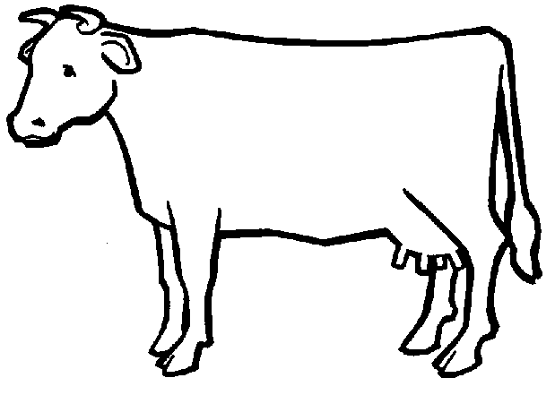
- On the cow below, show where the heart and lungs would be and draw a line from the word to where it exists:
Heart
Lungs
- Explain what the following symptoms mean:
High heart rate:
Heart Murmurs:
Raspy breathing:
- What two things do you check on the left abdomen?
- What is the rumen?
- How do you measure rumen contractions?
How many should occur per minute?
- What do rumen contractions sound like?
- What is the abomasum?
- Why do we need to check the abomasum (what can happen to it)?
- How can you detect if a cow has a displaced abomasum?
- What will a twisted stomach sound like through a stethoscope?
- In the picture below, draw where we would find the rumen and the abomasum. Then draw lines from the word to that structure:
Rumen
. Abomasum
- What are three things you check in the udder?
1
2
3
- What is mastitis?
- Why is mastitis a major concern?
- What are five symptoms of mastitis?
- If you suspect mastitis, what should you do?
- What do you check for in the rear of the cow?
- To take an animal’s temperature, you need a
- Before inserting the rectal thermometer, what do you need to do?
- How do you insert the thermometer?
- What should the temp be? At what temp does a fever begin?
- What are ketones?
- What must occur for ketone levels to rise?
- What is ketosis?
- What problem can be caused by ketosis?
- How do you test for ketosis?
- How do you stimulate urination?
- What four things should you check for when examining the rear feet and legs?
1
2
3
4
- Manure is one of the most of an animal.
- List AND explain the four things you should look for when examining manure?
1
2
3
4
- Explain what the following 8 symptoms would mean:
Brown, frosting like manure
Runny manure
Watery manure
Sour-smelling manure
Slimy manure
Too little manure
Black/red streaks in manure
Too stiff of manure
- What three things do we check/perform on the right side of a cow?
- How do you check for a right displaced abomasum on a cow?
- A Right DA is much more
- How do you check a digestive obstruction on the right side of a cow?
- If you hear a ping around the hip bone, what does that indicate?
- If you hear a ping on the right side of the hip, this indicates a…
- What are the withers?
- How do you perform a withers pinch?
- How do you know if a cow has a problem after performing a withers pinch?
- What is a dorsiflex?
- On the cow below, state what you would check on each of the following:
Head
1
2
3
4
5
6
7
Left Chest
1
2
3
4
Left Abdomen:
1
2
Udder
1

Rear
1
2
3
4
Right Side
1
2
3

A cow has a severe case of mastitis. Describe how the symptoms of each of the following areas would change?
Head:
Chest:
Abdomen:
Udder:
Rear:
Right Side:

Unit Wrap-up C. Kohn, Agricultural Sciences - Waterford WI
This page is designed to help raise your grade while enabling you to develop skills you will need for after high
school. You will need to complete every question and blank in order to receive full credit for your notes. Note: if you cannot come up with a strategy to remember a difficult concept on your own, see your instructor for help.
- What is a topic or concept from this unit that you found to be more challenging? Write or describe below:
In the space below, create a mnemonic, rhyme, analogy, or other strategy to help you remember this particular concept:
- What is a 2nd topic or concept from this unit that you found to be more challenging? Write or describe below:
In the space below, create a mnemonic, rhyme, analogy, or other strategy to help you remember this particular concept:
- What is a 3rd topic or concept from this unit that you found to be more challenging? Write or describe below:
In the space below, create a mnemonic, rhyme, analogy, or other strategy to help you remember this particular concept:
- Circle the most appropriate response. You will only be graded on whether or not you completed this section, so be entirely honest with yourself when completing this section.
Circle one: I used my notes outside of class to prepare for the quiz. Definitely – Yes – Sort of - No
Circle one: I took extra notes in the margins for very difficult concepts. Definitely – Yes – Sort of - No
Circle one: I created a personal strategy for at least three difficult items. Definitely – Yes – Sort of - No
Circle one: I was very involved and actively studying during the quiz review. Definitely – Yes – Sort of - No
Circle one: I think I will be satisfied with the quiz grade I received this week. Definitely – Yes – Sort of - No
Circle one: I might need to meet with the instructor outside of class. Definitely – Yes – Sort of - No

