Agriscience Practice Midterm by C Kohn
Name: Hour Date: Score: /48
- This gene, if the animal has it, is always expressed even if the animal has other versions of the same gene.
  - Dominant b. Recessive c. Both
- This gene, if the animal has it, is only expressed if the animal has no other version of the same gene.
  - Dominant b. Recessive c. Both
- An animal that has both recessive alleles would be described as…
  - Heterozygous b. Homozygous Dominant c. Homozygous Recessive

- An animal that has both dominant alleles would be described as…
  - Heterozygous b. Homozygous Dominant c. Homozygous Recessive

- An animal that has a recessive allele and a dominant allele would be described as…
  - Heterozygous b. Homozygous Dominant c. Homozygous Recessive

- An organism that expresses a recessive phenotype must be…
  - Heterozygous b. Homozygous Dominant c. Homozygous Recessive

- A genotype is…
  - The physical appearance of an organism that is the result of its genes.
  - The combination of genes in an organism.
  - When one gene affects the expression of another gene.
  - The term for a version of a gene
- An allele is…
  - The physical appearance of an organism that is the result of its genes.
  - The combination of genes in an organism.
  - When one gene affects the expression of another gene.
  - The term for a version of a gene
- A phenotype is…
  - The physical appearance of an organism that is the result of its genes.
  - The combination of genes in an organism.
  - When one gene affects the expression of another gene.
  - The term for a version of a gene

- If all of the offspring of a couple are the recessive phenotype, the parents must have which genotype combination?
  - AA x AA b. Aa x Aa c. Aa x aa d. aa x aa
- If 3/4s of the offspring have the dominant phenotype and ¼ have the recessive phenotype, the parent combination is most likely…
  - AA x AA b. Aa x Aa c. Aa x aa d. aa x aa
- If the offspring are half dominant, half recessive phenotypes, the parent combination is most likely…
  - AA x AA b. Aa x Aa c. Aa x aa d. aa x aa
- If all of the offspring are homozygous dominant, the parent combination must be…
  - AA x AA b. Aa x Aa c. Aa x aa d. aa x aa
- In Holstein cows, black is dominant and red is recessive. A bull and a cow (both heterozygous for color) have 3 calves. All of them are black. What are the odds that their fourth calf will be red?
  - 0% b. 25% c. 50% d. 100%
- Which of the following is the correct Punnett square for the picture shown below?
  - Left b. Right c. You are unable to tell from this picture

A red bull, Foster, escapes from a farm and impregnates several cows. The offspring of the cows are all born the same day and get mixed up. On top of this, a calf bought at an auction gets mixed in with the new calves.
Mr. Kohn is called to sort out the mess. However,
his trusty Corolla breaks down on the way and he
calls you to take his place. As he is explaining this
to you over the phone, his battery starts to die.
The last thing you hear before his phone dies is…
“red is recessive, and horns are recessive”
There is only one combination of cows and
calves that will work given this piece of
knowledge.
Show your work below!
Berry Cherry Darlene
Foster
- Who is Berry’s calf (show work below)?
  - Unos b. Diane c. Tracy d. Quincy
Unos
- Who is Cherry’s calf (show work below)?
Quincy
  - Unos b. Diane c. Tracy d. Quincy
- Who is Darlene’s calf (show work below)?
Tracy
  - Unos b. Diane c. Tracy d. Quincy
Diane
- Which calf was bought at an auction (Hint: which calf could not have come from any of the three combinations of Foster the Bull and one of the three cows?)
  - Unos b. Diane c. Tracy d. Quincy

- If two different traits are both equally expressed in an organism, those traits would be considered…
  - Co-dominant b. Incompletely Dominant c. Polygene d. Epistasis e. Pleiotropy
- If one gene prevents another gene from being expressed, this is called…
  - Co-dominant b. Incompletely Dominant c. Polygene d. Epistasis e. Pleiotropy
- If two different traits sort of blend, so that neither is fully present in the phenotype, those traits would be called…
  - Co-dominant b. Incompletely Dominant c. Polygene d. Epistasis e. Pleiotropy
- When one gene influences multiple unrelated traits, this is known as…
  - Co-dominant b. Incompletely Dominant c. Polygene d. Epistasis e. Pleiotropy
- When a group of genes work together to influence a single trait, this is known as…
  - Co-dominant b. Incompletely Dominant c. Polygene d. Epistasis e. Pleiotropy
- The color Roan is an example of…
  - Co-Dominance b. Incomplete Dominance c. Epistasis d. Recessive Alleles
- This blood type is the universal donor.
  - A b. B c. AB d. O
- This blood type is the universal recipient.
  - A b. B c. AB d. O
- This is the dominant blood type.
  - A b. B c. AB d. All of the above e. None of the above
- Brandy the Steer has a black parent and a white parent. He is black and white. This makes his coat a ___ trait.
  - Recessive b. Dominant c. Co-Dominant d. Incompletely Dominant e. None of the above
- The Punnett square here shows a red parent horse and a white parent having a red and white (roan) baby. This is an example of …
  - Co-Dominance b. Incomplete Dominance c. Epistasis d. Recessive Alleles
- Two parents are AB for blood type. Their child is type O.
Could this child be their own child?
  - Yes - they could both carry the recessive O blood type
  - No – neither have O genes to pass on
  - Yes – if neither passed on an A or a B gene
  - No – only Type O-parents can have Type O children.

- This is an example of a polygene.
  - The genes for horn length are not expressed because the animal also has polled genes.
  - The presence of the ‘frizzle’ gene in chickens also causes fewer eggs to be laid.
  - The color of a person’s skin is determined by six genes. The more dominant genes, the darker the skin.
- This is an example of a pleiotropy.
  - The genes for horn length are not expressed because the animal also has polled genes.
  - The presence of the ‘frizzle’ gene in chickens also causes fewer eggs to be laid.
  - The color of a person’s skin is determined by six genes. The more dominant genes, the darker the skin.
- This is an example of a epistasis.
  - The genes for horn length are not expressed because the animal also has polled genes.
  - The presence of the ‘frizzle’ gene in chickens also causes fewer eggs to be laid.
  - The color of a person’s skin is determined by six genes. The more dominant genes, the darker the skin.
Use the image below to answer the following questions. 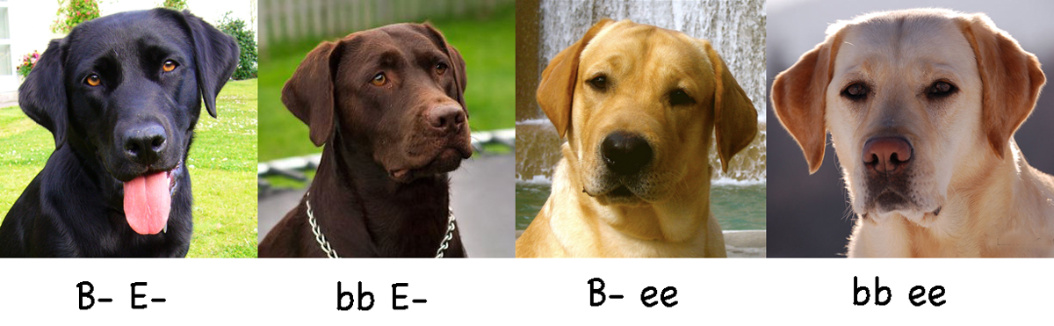
Black Chocolate Yellow Yellow
A black lab (genotype BbEe) mates with a chocolate lab (bbEe). What are the odds that they will have yellow lab puppies? NOTE: Complete the dihybrid Punnett square first. Then answer the question below.
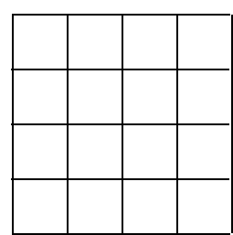
- Complete the Punnett Square (1 pt). Remember to use FOIL.
- What are the odds that they will have yellow lab puppies?
  - 0%
  - 25%
  - 50%
  - 100%
  - None of the above.
- Could two labs, both with genotype bbee have black lab or
a chocolate lab puppies?
  - Yes b. No
- Could two labs, both with genotypes BBEE, have yellow lab
puppies?
  - Yes b. No

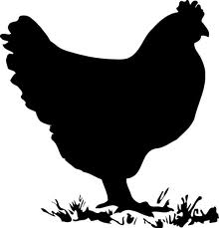
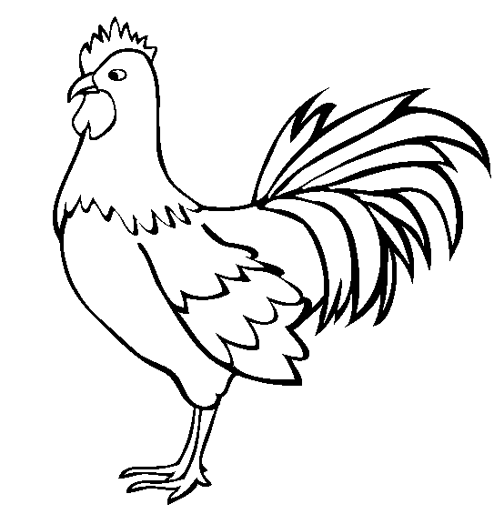
In a breed of chickens called Kohnneranians, color has an epistatic relationship. These chickens can either be brown, yellow, or albino (no color). Color is dominant to albino, and brown is dominant to yellow. To summarize:
Brown: BbYy, BbYY, BBYY, or BBYy
Yellow: BByy or Bbyy
Albino: bbyy, bbYy, bbYY
Chicken A with genotype BbYy is crossed with Chicken B with genotype bbYy. Use this information to answer the questions below.
Complete the dihybrid Punnett Square before continuing
- Show your work in the square to the right (1 pt). Remember to use FOIL.
- What color is Chicken A?
  - Brown b. Yellow c. Albino
- What color is Chicken B?
  - Brown b. Yellow c. Albino
- What are the odds that any given chick will be brown?
  - 16/16 b. 8/16 c. 6/16 d. 4/16 e. 2/16
- What are the odds that any given chick will be yellow?
  - 16/16 b. 8/16 c. 6/16 d. 4/16 e. 2/16
- What are the odds that any given chick will be albino?
  - 16/16 b. 8/16 c. 6/16 d. 4/16 e. 2/16
- Could two brown chickens have a yellow baby?
  - Yes b. No
- Could two yellow chickens have a brown baby?
  - Yes b. No
- Could two albino chickens have a colored baby?
  - Yes b. No
- Could two colored chickens have an albino baby?
  - Yes b. No
- DNA encodes the instructions to create a/an…
  - Amino acid b. Protein c. Sugar molecule d. Cell membrane
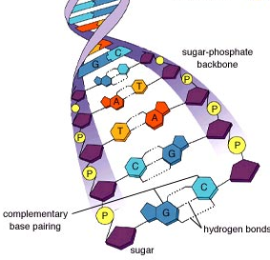
- A gene is…
  - A tightly-wound package of DNA

  - A section of DNA that codes for a specific protein
  - A visible trait
  - All of the above
IV
- In the picture at the right, this is I
  - Phosphate
  - Nitrogenous Base
  - Deoxyribose sugar
I
  - Nucleotide
- In the picture at the right, this is II
  - Phosphate b. Nitrogenous Base
c. Deoxyribose sugar d. Nucleotide
III
II
- In the picture at the right, this is III
  - Phosphate b. Nitrogenous Base c. Deoxyribose sugar d. Nucleotide
- In the picture at the right, this is IV
  - Phosphate b. Nitrogenous Base c. Deoxyribose sugar d. Nucleotide
- This item in the picture could represent Adenine, Cytosine, Thymine, or Guanine
a. I b. II c. III d. IV
- This structure contains the 5’ and 3’ carbons that give DNA its sense of direction
a. I b. II c. III d. IV
- Which of the following accurately indicates the correct pairing of bases?
  - A – C; G – T b. A – G; C – T c. G – C; T – A d. G – G; C – C; A - T
- Specific combinations of bases exist because…
  - They can’t fit in any other combination
  - They can’t bond in any other combination
  - Both A and B
  - None of the above are correct
- Which has 3 bonding sites?
  - Adenine & Thymine b. Cytosine & Guanine c. Adenine & Guanine d. Cytosine & Thymine
Use the picture at the right for the following questions.
B
- This structure is DNA
A. B. C. D.
A
- This structure is mRNA
A. B. C. D.
- This structure is the ribosome
A. B. C. D.
- This structure is tRNA
A. B. C. D.
- This structure is created by polymerase during transcription.
A. B. C. D.
- This structure is opened by helicase
A. B. C. D.
C
- This structure delivers amino acids
A. B. C. D.
D
- This structure reads copies of DNA and creates proteins
A. B. C. D.
B
- How does RNA differ from DNA?
  - The G’s in DNA become U’s in RNA
  - DNA is double stranded; RNA can be single stranded
  - RNA has an extra –OH molecule
  - All of the above are correct
- A codon is a….
  - String of amino acids
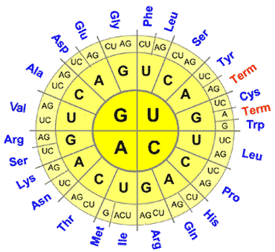
  - A kind of amino acid
  - The structure that reads mRNA and makes a protein
  - A group of three nucleotide bases
- Which would be the correct mRNA version of this strand of DNA?
3' CCC-GTA-ATG-GCA-TAA-ATC 5'
  - 3’ CCC – GTA – ATG – GCA - TAA - ATC 5’
  - 5’ CCC – GTA – ATG – GCA – TAA - ATC 3’
  - 3’ GGG – CAU – UAC – CGU – AUU - UAG 5’
  - 5’ GGG – CAU – UAC – CGU – AUU - UAG 3’
- What is the correct amino acid sequence for the mRNA above?
  - Gly – His – Tyr – Arg – Ile – Term
  - Term – Ile – Arg – Tyr – His – Gly
  - Ile – Leu – Cys – His – Tyr – Gly
  - Ala – Asp – Glu – Gly – Phe – Leu
- Transcription is the process in which…
  - A protein is made from amino acids based on what was copied by mRNA
  - The strand of DNA leaves the nucleus and becomes the amino acids that create a protein
  - A strand of mRNA is copied from DNA by polymerase
  - Helicase creates a protein out of amino acids
- Translation is the process in which…
  - A protein is made from amino acids based on what was copied by mRNA
  - The strand of DNA leaves the nucleus and becomes the amino acids that create a protein
  - A strand of mRNA is copied from DNA by polymerase
  - Helicase creates a protein out of amino acids
- Transcription occurs in the…
  - Ribosome b. Mitochondria c. Chloroplast d. Nucleus
- Translation occurs in the…
  - Ribosome b. Mitochondria c. Chloroplast d. Nucleus
- These are a part of transcription:
  - DNA and mRNA
  - DNA and a ribosome
  - mRNA, tRNA, and a ribosome
  - All of the above
- These are a part of translation:
  - DNA and mRNA
  - DNA and a ribosome
  - mRNA, tRNA, and a ribosome
  - All of the above
- If an organism’s tRNA were to become dysfunctional, which of the following would most likely occur?
  - They wouldn’t be able to create a mRNA copy of DNA
  - The ribosome would not be able to read mRNA
  - Amino acids could not be delivered to the ribosome to make a protein
  - All of the above
- Which of the following amino acids forms a special bond called a disulfide bond, a bond which causes it to bind to other amino acids that are the same kind as itself?
  - Glutamine b. Tyrosine c. Serine d. Cysteine
- The shape of a protein determines its…
  - Amino acid sequence b. Function c. Lifespan d. Location
- Hydrophilic amino acids will always move to the of a protein
  - Inside b. Outside c. Top d. Bottom
- Hydrophobic amino acids will always move to the of a protein
  - Inside b. Outside c. Top d. Bottom
- Oppositely charged amino acids will always…
  - Bond with each other
  - Repel each other
  - Move to the inside
  - Move to the bottom
- Similarly charged amino acids will always…
  - Bond with each other
  - Repel each other
  - Move to the inside
  - Move to the bottom
- The primary structure of an amino acid refers to…
  - The overall structure of the protein
  - The combination of alpha helixes and beta sheets
  - The order of amino acids
  - The formation of an alpha helix or a beta sheet
- The tertiary structure of an amino acid refers to…
  - The overall structure of the protein
  - The combination of alpha helixes and beta sheets
  - The order of amino acids
  - The formation of an alpha helix or a beta sheet
- A frameshift mutation is one that…
  - Causes a deletion
  - Causes an insertion
  - Causes all of the bases downstream to shift
  - Causes no change to the protein structure
- A frameshift mutation will change the of a protein
  - Shape b. Function c. Secondary and Tertiary structure d. All of the above
Y
X
- Which of the following is shown in X to the right?
  - Alpha Helix b. Beta Sheet c. Amino Acid d. Polypeptide
- Which of the following is shown in Y to the right?
  - Alpha Helix b. Beta Sheet c. Amino Acid d. Polypeptide
- X and Y together would make which of the following?
  - Alpha Helix b. Beta Sheet c. Amino Acid d. Polypeptide

- Which of the following would be the correct transcribed mRNA molecule for the DNA sequence below?
. 3’ TAC-TTA-CGA-TGG-TAC-ACG-TGT-ACC-TTG-AAC-CTG-ACT 5’
  - 5’ – ATG-AAT-GCT-ACC-ATG-TGC-ACA-TGG-AAC-TTG-GAC-TGA- 3’
  - 5’ – AUG-AAU-GCU-ACC-AUG-UGC-ACA-UGG-AAC-UUG-GAC-UGA- 3’
  - 3’ – ATG-AAT-GCT-ACC-ATG-TGC-ACA-TGG-AAC-TTG-GAC-TGA- 5’
  - 3’ – AUG-AAU-GCU-ACC-AUG-UGC-ACA-UGG-AAC-UUG-GAC-UGA- 5’
- Which of the following would be the correct order of translated amino acids from the mRNA strand above?
  - Met – Asn – Ala – Thr – Met – Cys – Thr – Trp – Asn – Leu – Asp
  - Ser – Gln – Val – Gln – Gly – Thr – Arg – Val – Pro – Ser- Term
  - Asn – Ala – Thr – Met – Trp – Pro – Arg – Val – Met – Asp – Trp
  - Ile – Phe – Ser – Cys – His – Arg – Val – Ala – Asp – Glu – Leu - Term

