Reproductive Anatomy Notesheet C. Kohn, Waterford WI
Name: Hour Date:
Date Assignment is due: Why late? Score: + ✓ -
^{Day of Week} ^{Date} If your project was late, describe why
Directions: Use the accompanying PowerPoint (available online) to complete this sheet. This sheet will be due upon the completion of the PowerPoint in class. These assignments are graded on a +/✓/- scale.
- Why is animal reproduction important to a farm?
- Rates of reproduction are a major determinant of the
- The faster the rate at which an animal can , the greater the
of that animal.
- is one of the most that
limit animal and and result in of dollars in lost profits annually.
- A major challenge facing many producers is
to improve without compromising the production
of .
- Briefly summarize six factors that can lead to inefficient reproduction. Reword and shorten to make them fit:
- How has intense breeding pressure for milk or meat traits affected the reproductive performance of cattle?
- Why are advanced scientific strategies that incorporate knowledge of reproductive anatomy and endocrinology necessary for animal agriculture? Why can’t farmers just use natural methods of reproduction in most cases?
- This has become due to widespread adoption of in many fields of animal agriculture.
- What is artificial insemination?
- How is this different from natural insemination?
- How has the use of AI enabled livestock genetics to change so quickly?
- Successful artificial insemination programs are based on a of
- To breed an animal using AI, you must understand and be able to
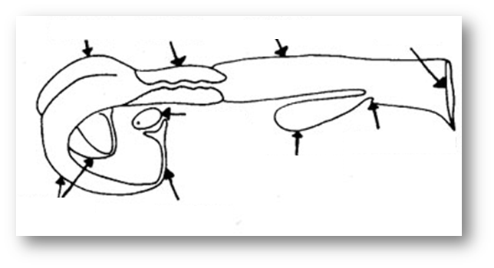
- To determine when to breed an animal, you must understand its
in order to
- Label each arrow:
- Briefly summarize the four functions of the vulva:
- The vulva is primarily composed of the , or outer and inner .
- How does the appearance of the vulva change when the cow is in heat vs. when it is not?
- The bovine vagina is a behind the and in front of
the , and it extends about into the cow.
- What are five roles or functions of the vagina?
- Why is the vagina a common site of infection?
- The cervix is a 4-5 inches long between the vagina and
the uterus. It is composed of
- What are the annular rings?
What do they do?
- Most of the time the cervix is . Why?
- The cervix will only open at two times:
- When a cow is pregnant, the cervix will form a to the cervix shut.
- What is the fornix?
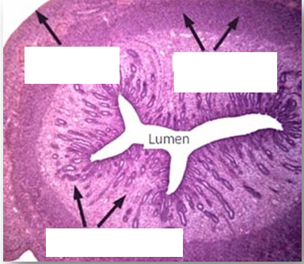
- The main function of the uterus is to
- Label each blank in the photo to the right
The is
the epidermal
layer of the uterus.
The is
the .
The is
the .
- During artificial insemination, the uterus is the
- How does the myometrium assist with conception?
- How does the myometrium assist with birthing?
- After a successful insemination, the fertilized embryo will
which will form , or , where
the of the calf will attach to
to the calf as it grows.
- Caruncles will form on the ( ) of the uterus;
endometrium secretions also
before it .
- The oviducts enable the
- Oviducts are also known as
- Summarize the key functions and characteristics of the three regions of the oviducts:
UTJ:
Isthmus:
Ampulla:
- What is the infundibulum and what does it do?
- What is the purpose of the cilia on the infundibulum?
- The primary reproductive organ of a cow are the .
- What are the two functions of the ovaries?
- List AND summarize the two types of structures found on the ovaries:
- The of the ovary is covered by a that
- True or False: a cow will continue to produce egg cells with each estrus cycle. Explain:
- These immature egg cells are each surrounded by a
that will eventually form the as the egg matures and is ready to be released.
- What is an ovum?
- What are two ways in which ova are different from sperm?
- True or false: the ovum has half the number of chromosomes of the rest of the cells in the cow’s body
- Why is this necessary?
- What is oogenesis?
- Summarize the process in which the egg cell is matured and released. Shorten by rewriting in your own words:
- Recognition of is vital for successful reproduction.
- What is estrus?
- What will happen if a breeder inseminates a cow when she is not in estrus?
- What are six signs of estrus?
- Summarize how the cow’s reproductive tract will physically change during estrus:
- Summarize and provide the symptoms and causes of each of the following. Shorten and abbreviate as needed:
Ovarian Cyst:
Anestrus:
Repeat Breeding:
Abortion:
Freemartin:
Blind/Closed Cervix:
Dystocia:
Endometritis, Metritis, and Pyometra:
Retained Placenta:
Uterine Prolapse:
Vaginal Prolapse:

Unit Wrap-up C. Kohn, Agricultural Sciences - Waterford WI
This page is designed to help raise your grade while enabling you to develop skills you will need for after high
school. You will need to complete every question and blank in order to receive full credit for your notes. Note: if you cannot come up with a strategy to remember a difficult concept on your own, see your instructor for help.
- What is a topic or concept from this unit that you found to be more challenging? Write or describe below:
In the space below, create a mnemonic, rhyme, analogy, or other strategy to help you remember this particular concept:
- What is a 2nd topic or concept from this unit that you found to be more challenging? Write or describe below:
In the space below, create a mnemonic, rhyme, analogy, or other strategy to help you remember this particular concept:
- What is a 3rd topic or concept from this unit that you found to be more challenging? Write or describe below:
In the space below, create a mnemonic, rhyme, analogy, or other strategy to help you remember this particular concept:
- Circle the most appropriate response. You will only be graded on whether or not you completed this section.
Circle one: I used my notes outside of class to prepare for the quiz. Definitely – Yes – Sort of - No
Circle one: I took extra notes in the margins for very difficult concepts. Definitely – Yes – Sort of - No
Circle one: I created a personal strategy for at least three difficult items. Definitely – Yes – Sort of - No
Circle one: I was very involved and actively studying during the quiz review. Definitely – Yes – Sort of - No
Circle one: I think I will be satisfied with the quiz grade I received this week. Definitely – Yes – Sort of - No
Circle one: I might need to meet with the instructor outside of class. Definitely – Yes – Sort of - No

