Cellular Respiration Notesheets by C. Kohn, Waterford WI

Name: Hour Date:

Date Assignment is due: Why late? Score: + ✓ -  
 Day of Week Date If your project was late, describe why

# Unit Preview

1. What are some activities that occur in the cell that need energy in order to occur?
2. How does the food you eat become the energy your body’s cells use to function?

**Units**

1. Radish Races

2. Lab Safety

3. Carbon Cycle

4. Science Writing

5. Cell Biology

6. Cell Respiration

7. Photosynthesis

8. C3/C4 Plants

9. Research Statistics

10. Plants and Climate

11. Final Experimental Project

12. Parli. Pro.

**Weekly Schedule**

*Page through this notesheet. Then answer the questions below:*  
Circle one: *I need to review my notes & practice before the quiz.* Definitely – Yes – Sort of - No

Circle one: *I have never seen or heard of some of these concepts.* Definitely – Yes – Sort of - No

Circle one: *This may be a challenging unit for me personally.* Definitely – Yes – Sort of - No

Circle one: *I may need extra strategies for some topics/vocab.* Definitely – Yes – Sort of - No

1. How is what you breathe in and what you breathe out related to cellular respiration?
2. What sorts of foods are high in energy? How are all these foods similar to each other?

Notes C. Kohn, Agricultural Sciences - Waterford WI

**Directions**: Use the accompanying PowerPoint (<http://bit.ly/cell-resp-notes>) to complete this sheet.   
This is graded on a + ✓- scale.

1. Describe cellular respiration in your own words:   
     
   _
2. What are three key points about respiration?  
     
   1_   
     
   2_   
     
   3_
3. What is the simplest carbohydrate? What is a carbohydrate   
     
   _
4. Is glucose used to power cellular activity? Explain:   
     
   _
5. Glucose is the way in which living organisms get into   
     
   _ Those hydrogen atoms are used to   
     
    . ATP Synthase produces
6. If glucose DOES NOT power cellular activity, what does?
7. All carbohydrates are made of . The longer the chain of   
     
   glucose, the more
8. Why do simple sugars break down more easily in our bodies than fiber and whole grains?   
     
   _
9. What must happen to all carbohydrates before they can be absorbed into the bloodstream?   
     
   _
10. Why is it necessary to break down all carbohydrates into individual glucose molecules?   
      
    _
11. What happens to glucose after it moves from the blood into the cytosol of the cell?   
      
    _
12. What is a pyruvate?
13. Where is the pyruvate completely broken down?
14. Draw and label the following 🡪  
    Mitochondria  
    Outer membrane  
    Intermembrane Space  
    Inner Membrane  
    Matrix  
    Hydrogen  
    ATP Synthase
15. Where is the intermembrane space located?   
      
    _
16. What is stored in the intermembrane space? Why is this store here?   
      
    _
17. What would we find on the inner membrane of the mitochondria?
18. 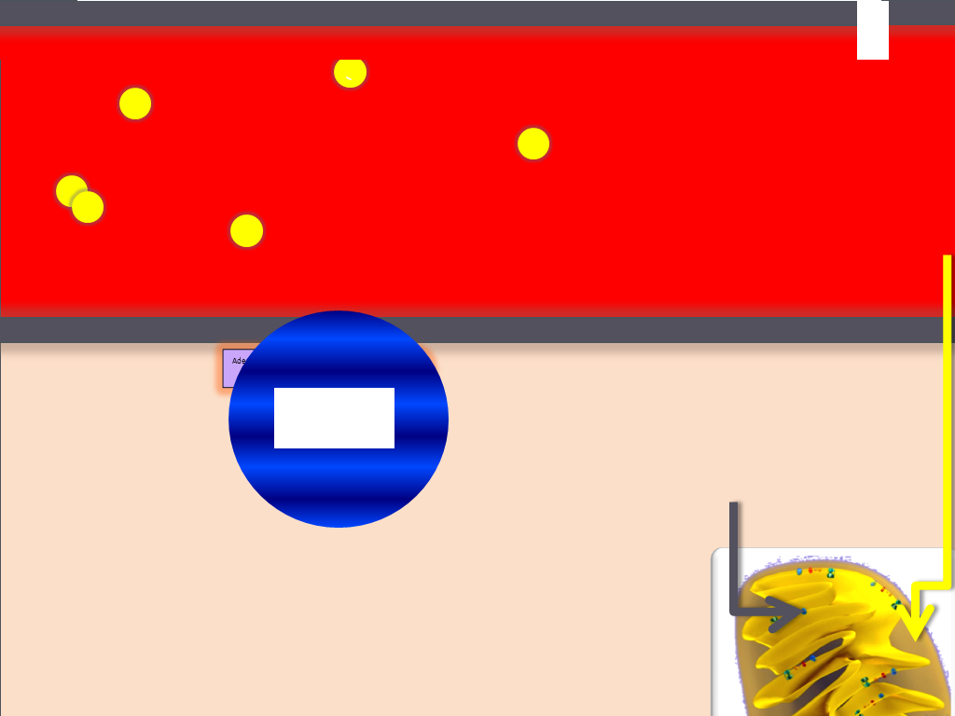Label the following in the picture:   
    Outer membrane, inner membrane,   
    intermembrane space, ATP Synthase,   
    hydrogen protons, flow of hydrogen,   
    ATP, ADP, Pi.
19. The main point of cellular respiration  
      
    is to obtain   
      
    in order to power   
      
    _
20. A series of are necessary to break down   
      
     in order to the atoms.
21. List AND describe the four steps of cellular respiration in 10 words or less:  
      
    Step 1: Description:   
      
    _   
      
    Step 2: Description:   
      
    _

Step 3: Description:   
  
_

Step 4: Description:   
  
_

1. In glycolysis, glucose ( ) becomes ( ) and   
     
   _ .
2. It takes to break apart a molecule. What energy is used for this?   
     
   __________. ATP is recreated in Glycolsis using
3. What is Substrate Level Phosphorylation?   
     
   _
4. How is ATP production in Glycolysis in the cytosol different from ATP production in the mitochondria?  
     
   _   
     
   _
5. Draw Substrate Level Phosphorylation here 🡪
6. What happens in the TCA Cycle?
7. What 2 molecules move H+ from pyruvate to the intermembrane space? &
8. NAD+ and FAD+ are sort of like for hydrogen.
9. How many CO2 are produced during the TCA cycle? Where does this CO2 come from?   
     
   _
10. What is the main purpose of the Electron Transport System?   
      
    _
11. The inner membrane of the mitochondria has that get   
      
    _ from and and cram it into the   
      
    _
12. What powers the proteins that pump H+ into the intermembrane space?
13. What happens in Oxidative Phosphorylation?
14. What is the only way out of the intermembrane space for a H+ proton?
15. As hydrogen atoms move past they it, powering the   
      
    production of from .
16. What does “phosphorylation” mean?
17. Where do the hydrogen protons go after powering ATP Synthase?   
    1. What happens here?
18. How is oxidative phosphorylation in the mitochondria different from substrate-level phosphorylation in the cytosol?  
      
    _   
      
    _
19. In agriculture, plants and animals that produce more will produce
20. What would happen if there was not oxygen to remove hydrogen from the matrix of the mitochondria?   
      
    _
21. If a cell stopped producing ATP in the mitochondria, what would happen?   
      
    _
22. What is fermentation?   
      
    _
23. If you could choose, which pathway would be better for acquiring the maximum amount of ATP, oxidative phosphorylation or substrate level phosphorylation? Why?   
      
    _   
      
    _
24. What are 5 ways to maximize ATP Production?  
      
    1_   
      
    2_   
      
    3_   
      
    4_   
      
    5_
25. Write a summary of cellular respiration in the spaces below:  
      
    1_   
      
    2_   
      
    3_   
      
    4_   
      
    5_

6_   
  
7_

Unit Wrap-up C. Kohn, Agricultural Sciences - Waterford WI

1. 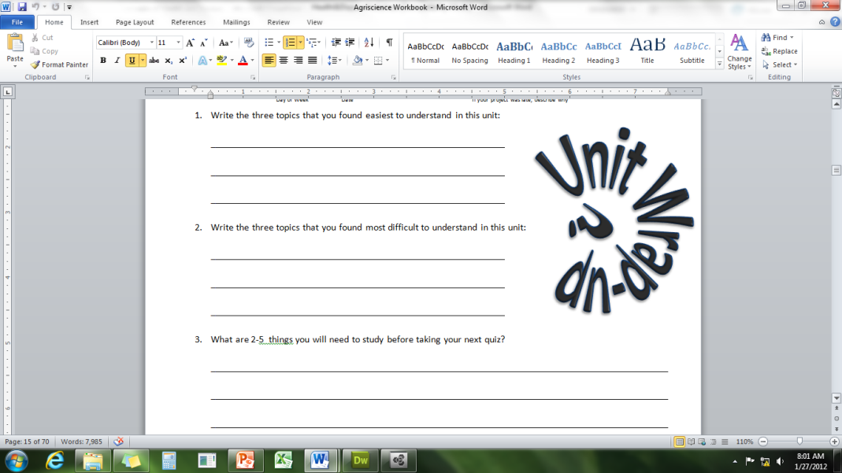Write the 3 topics that you most need to review before the quiz:  
     
   1_   
     
   2_   
     
   3_
2. Create 3 **high-level questions** related to this material   
   (*These questions could be something you still don’t know or questions that reflect understanding that you have now that you did not have before.*)  
     
   1_   
     
   2_   
     
   3_
3. List 6 **vocabulary words** that you did not know before or have not used very often prior to this unit:  
     
   1_ 2 3

4 5 6

1. In the spaces below, fully write three strategies that will help you to remember specific vocabulary words or topics from this unit. **NOTE**: A strategy is *not* an activity such as reviewing your notes, studying hard, etc. A strategy is a mnemonic, rhyme, analogy, or other brain-based device that is specific to one item from the unit.

1._   
  
2._   
  
3._

1. Circle the most appropriate response. You will only be graded on whether or not you completed this section, so be entirely honest with yourself when completing this section.

Circle one: *I used my notes outside of class to prepare for the quiz.* Definitely – Yes – Sort of - No

Circle one: *I took extra notes in the margins for very difficult concepts.* Definitely – Yes – Sort of - No

Circle one: *I created a personal strategy for at least three difficult items.* Definitely – Yes – Sort of - No

Circle one: *I was very involved and actively studying during the quiz review.* Definitely – Yes – Sort of - No

Circle one: *I think I will be satisfied with the quiz grade I received this week.* Definitely – Yes – Sort of - No