Case-It! Instructions – Sickle Cell Anemia
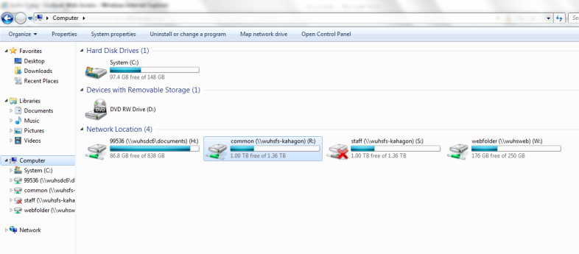
Overview: Case-It! is a simulation created by the University of Michigan and the University of Wisconsin-River Falls. The purpose of Case-It is to simulate, as closely as possible, how genetic tests such as PCR Electrophoresis and ELISA are performed by enabling students to conduct the tests themselves. In this first experiment, you will be practicing with a murder trial. You will have to match the genetic fingerprints of DNA samples found at the scene of the crime with the genetic fingerprints of suspects in the case to make a determination of who is most likely guilty.
Directions:
- On your computer, click on My Computer.
  - Open the Common (R:) Drive
  - Open the “Agriscience” Folder
  - Open the Case-It Folder
  - Open “Case It v606”
  - Double Click “Case It 606”
- A window should open.
  - Click “Click here to begin”
  - Click “Click to Continue”
  - Click “Lab Bench” in the
lower left of the screen.
  - Your screen should
now look like this
  - On the tools menu (top of screen)
select “Setup” and
select “Quick Setup”
- On the top menu bar, select “DNA” and
then “Select DNA samples”
  - Select “Cases”
  - Select “Genetic disease cases”
  - Select “Sickle cell ”
    - Then select “Sickle Case A”
    - Select the first DNA sample. Hold SHIFT and simultaneously select the last DNA sample.
    - Click Open
- Now you will need to acquire your restriction enzyme. To do this, click
“Site” on the upper menu bar.
  - Select “Open up to 4 enzyme tubes”
  - Select “Open enzyme file for DNA digest”
  - Scroll down and select “Enzyme MstII (cctNagg)”
*Note – your sample of DNA already has primers, polymerase, and bases for PCR. You only need to add the restriction enzyme.
- You should now have 7 tubes on your lab bench: 6 DNA and 1 Enzyme (MstII)
- To open your tubes, double click them. Pick up your micropipette (on the top shelf; the blue thing on the right).
  - Click on the micropipette and hold.
  - Dip the pipette into the box of pipette tips (center shelf on the right).
  - You will need to add enzyme to each of the 5
DNA samples.
    - To do this, dip the micropipette w/ tip into the tube of enzyme.
    - Click the plunger to such up enzyme
    - Lower the micropipette into DNA 1 and click the plunger to release.
    - Dip your tip into the biohazard bin.
  - You will need to repeat these steps (starting with a new pipette tip each time) for all 6 DNA samples.
- After you have added enzyme to all 6 tubes, close each tube (by double-clicking them). Click and drag each DNA tube into the heat block (the box on the center shelf, left-hand side)
  - Click the “Power” switch on the upper left of the heat block to “High”
  - Click on “Click to Remove Tubes”
  - Your DNA has now been processed; the enzymes have cut your DNA anywhere it saw the sequence AAGCTT. Polymerase, primers, and bases (previously added to the sample) enabled your single sample of DNA to be multiplied billions of times (for the sake of convenience, the program doesn’t make us wait the hours it would take in a lab).
  - Your processed DNA samples can now be added to an electrophoresis gel.
- Dip your micropipette in the pipette tip box to get a new green tip.
  - Double-click your DNA tubes to open them
  - Dip your micropipette into DNA 1 and suck up a sample of DNA by clicking the plunger
  - Lower your micropipette into Well one of the gel (bottom shelf, lower right) until the yellow box appears that says “Click Plunger”. Click it to add the DNA to that well of the gel.
  - Discard your micropipette tip in the Biohazard bin and continue these steps for all 5 samples of processed DNA until all 5 wells of the gel have been loaded.
- When all 6 wells have been loaded with all 5 DNA samples, click “run gel” on the power source in the lower left.
- A blue screen should appear showing your gel from above. You will notice the ‘chunks’ of DNA spreading across the gel from the negative side to the positive side with the current.
  - In reality, this would never occur this fast. Again, the program speeds up the process for us for the sake of convenience.
- In the center of your screen will be various dyes. Choose one to make your DNA fragments more visible.
- In the “Loaded” window on the lower left-hand side of your screen, it will tell you what is in each well. Two of your samples will be controls – one is a positive control that shows what the bands will look like if an individual has sickle cell anemia. The other is a negative control – it shows what banding patterns occur for individuals without the disease.
  - Use this information to determine which family members have the disease.
  - Answer the questions on the next page.

Sickle Cell Case-It Questions
Name: Hour Date:
Date Assignment is due: Same Day Why late? Score:
^{Day of Week} ^{Date} If your project was late, describe why
Background: Sickle cell anemia is a disease of red blood cells. It is caused by a mutation in the hemoglobin gene. A single base change results in a single amino acid substitution. This mutation causes the hemoglobin to change its conformation to a more elongated form under certain conditions, distorting the red blood cells and impairing their ability to carry oxygen. Sickle cell anemia is considered a recessive trait, since both chromosomes have to carry the mutation in order for the full blown disease symptoms to appear.
The sickle cell mutation also eliminates a restriction enzyme site - the recognition site for the enzyme MstII. To detect the sickle cell mutation, a patient’s DNA is digested with MstII. The presence or absence of the sickle cell gene mutation can be determined based on the banding patterns created by gel electrophoresis.
Case A: Steve and Martha are expecting their second child. They know that sickle cell anemia runs in both of their families. They want to know whether this child could be affected. Neither they nor their 10-year-old daughter, Sarah, have shown any symptoms of the disease. They decide to have DNA tests to determine the status of the fetus, as well as to find out whether they in fact are carriers of the disease gene.
DNA samples: | Steve (father)
 | Martha (mother)
 | Sarah (daughter)
 | Fetus
 | Control DNA, homozygous for sickle cell mutation
 | Control DNA, homozygous normal, without sickle cell mutation
Digest each of these DNA samples with MstII. What conclusions can you draw from the results?
- Based on the reading above, briefly describe what causes sickle cell anemia:
- How does sickle cell anemia affect the body?
- How does PCR and Electrophoresis enable us to detect whether or not someone has sickle cell anemia?
- Why do we have to use the MstII restriction enzyme? Why can’t we use another restriction enzyme?
- Based on your results from this genetic test, does the unborn child of Steve and Martha have sickle cell anemia? Explain how you know:
- If someone were to have the sickle cell anemia disease, are they homozygous dominant, homozygous recessive, or heterozygous? How do you know?
- If Steve and Martha are carriers of sickle cell anemia, are they homozygous dominant, homozygous recessive, or heterozygous? How do you know?
- Compare the banding patterns of their daughter, Sarah, to the patterns of each parent and the patterns created by the normal control. Is Sarah homozygous dominant, homozygous recessive, or heterozygous for this trait? How do you know?
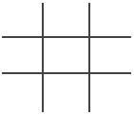
- Complete the Punnett Square below for Steve and Martha for this trait. Draw a circle around the offspring genotype that would represent Sarah. Draw an arrow pointing to the offspring genotype that belongs to the unborn fetus.

